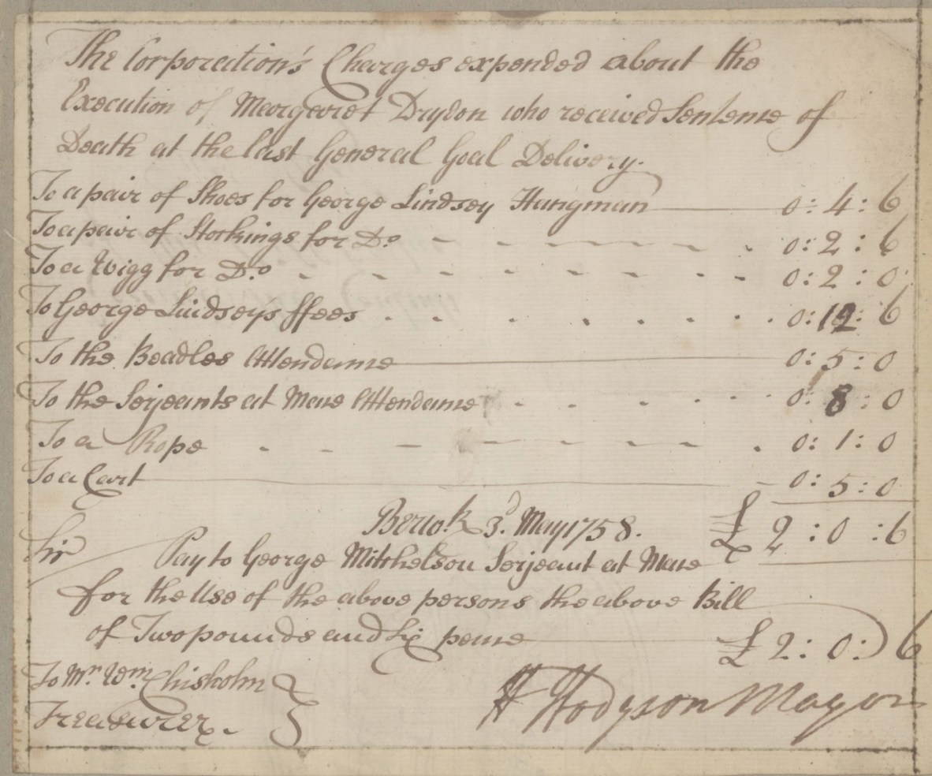

Account of the Hanging of Margaret Drydon/Dryden, 1758
Reference: BA/G/2/13/133 | Suggested age groups: KS2, KS3, KS4, lifelong learners |Topic areas: Crime and Punishment

The Hanging of Margaret Drydon
Warning: some distressing content
Quarter Sessions were a Royal Court of Justice that were held four times a year. Assizes courts tried more serious crime such as murder, rape and highway robbery and were held twice a year. Some Quarter Sessions in boroughs, including Berwick’s, were granted the right to try these more serious cases.
Within the Quarter Sessions records which form part of the Berwick-upon-Tweed Borough Archives, there are a number of papers relating to the case of Margaret Dryden, who was accused of murdering her child in 1758. Margaret pleaded not guilty to the charge brought against her that she had “borne alive” a female child which she had then murdered by cutting its throat with a knife (value 6d).
This is the only official reference to the child’s throat being cut although it is referred to in the draft letter of 14 March 1758:
“The Throat of it appeared to have been Cut with a Ragged Instrument, and upon Searching the House of the said Drayden, a large Ragged Knife was found…”
After hearing the evidence and considering the case, the jury found Margaret guilty of the charge and said:
“that she be carried from hence to the place from whence She came from thence that she be carried to the place of Execution where she shall be hanged by the Neck until her Body be dead”.
However, instead of carrying out the sentence that day, it was to take place on 3 May 1758. Margaret was taken by cart to Gallow’s Knowe (at the bottom of Castle Terrace, Berwick-upon-Tweed), where all executions took place, and there the sentence was carried out by the hangman. Among the Corporation’s accounts, a bill of expenses has survived which lists all of the expenses for the hanging. George Lindsey was paid 12s 6d for his services. He also obtained new shoes, stockings and a wig for the occasion. In total the expenses for the hanging amounted to £2-00-06 (about £360 today).

Other online resources
The National Archives education website, page for Crime and Punishment: https://www.nationalarchives.gov.uk/education/candp/default.htm
Bank of England website, historic inflation calculator: https://www.bankofengland.co.uk/monetary-policy/inflation/inflation-calculator
Our Criminal Ancestors website, page for Quarter Sessions: https://ourcriminalancestors.org/quarter-sessions/
Berwick Friends newsletter: http://www.berwickfriends.org.uk/wp-content/uploads/2014/01/Newsletter-1995-September1.pdf

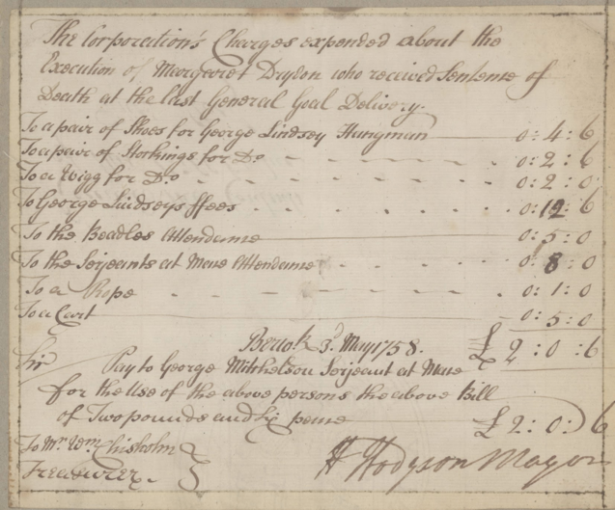
Learning Activities – Account of the Hanging of Margaret Drydon, 1758

Topic: Crime and Punishment
Subject areas: History, Maths, Citizenship, Literacy

Background | Activity | Resources
Margaret Dryden was accused of murdering her child in 1758. Margaret pleaded not guilty to the charge brought against her that she had “borne alive” a female child which she had then murdered by cutting its throat with a knife (value 6d). The jury found Margaret guilty and sentenced her to hang. | See: What crime was Margaret Drydon accused of?  See: How did she plead to this accusation?  See: After hearing the evidence, did the jury find Margaret guilty of the charge?  See: How did the jury say Margaret was to be punished?  See: Where did executions take place in Berwick?  See: Who was the hangman? | https://www.nationalarchives.gov.uk/education/candp/default.htm  https://ourcriminalancestors.org/quarter-sessions/  https://www.capitalpunishmentuk.org/  https://www.historyextra.com/period/modern/a-brief-history-of-capital-punishment-in-britain/  https://www.politics.co.uk/reference/capital-punishment
Think: What is capital punishment?
Think: When was capital punishment used in Britain?
Think: Why was capital punishment used?
Think: Why was capital punishment ended in Britain?
Think: How would Margaret Drydon have been punished if she had committed murder today?
Think: Are there countries that still use capital punishment today?
Think: Is the death penalty ever justified? In pairs or small groups discuss whether or not the death penalty should still be used today. Should it have been used in the past?
Do: Research countries that still use capital punishment today. Create a map of the world showing the countries that still use capital punishment. Create a chart showing how many executions there have been in these countries over the last few years.
Do: Create a piece of argumentative writing arguing either for or against the use of the death penalty. Try to include facts and statistics.
Do: Create a poster arguing either for or against the use of the death penalty.
Do: Should Margaret Drydon have been hanged? As a class or in small groups, role play a trial of Margaret Drydon. How should she be punished?
After 1971 the UK moved to a new decimalisation system and brought currency into line with the metric systems used in Europe, which are based on a system of factors of 10. | See: How much was the knife worth that Margaret used in the murder?  See: How much was George Lindsey paid for his services?  See: What else did George Lindsey obtain for the hanging?  See: How much were the overall expenses of the hanging in currency from the time? | https://www.projectbritain.com/moneyold.htm  https://www.bankofengland.co.uk/monetary-policy/inflation/inflation-calculator  https://www.nationalarchives.gov.uk/currency-converter/
Think: What unit of currency is d?
Think: What unit of currency is s?
Think: What other units of currency were used in Britain in 1758?
Think: When did Britain change to using the decimal currency system that we currently use?
Think: What are the costs associated with a hanging?
Do: Use the currency convertors to find out how much the different hanging expenses equate to in present-day currency. Do you need to consider inflation too?
Do: Use the National Archives currency convertor to find out how many days pay for a skilled tradesman George Lindsey’s fee would be equivalent to.
The Normans introduced surnames to England in 1066. Names were frequently spelled differently as many of our ancestors did not read or write, and clerks and other scribes wrote names down in different ways. Names were written down phonetically as they were heard by the individual. | See: How many different ways is Margaret’s surname spelled in this document?  See: What are the different ways Margaret’s surname is spelled? | https://www.google.co.uk/amp/s/blogs.ancestry.com/cm/how-the-history-of-surnames-affects-your-ancestry/amp/
Think: Why would Margaret’s surname appear in different ways in the records?
Think: When were surnames introduced in Britain?
Think: How were surnames initially given?
Think: What does phonetically mean?
Do: Write down the different ways that your surname could be spelled. How could you spell it phonetically?
Do: Try saying your surname with different accents. Does this change the way that you could spell your surname?
Do: Look up the meaning of your surname; what could you learn about your ancestors from this?

