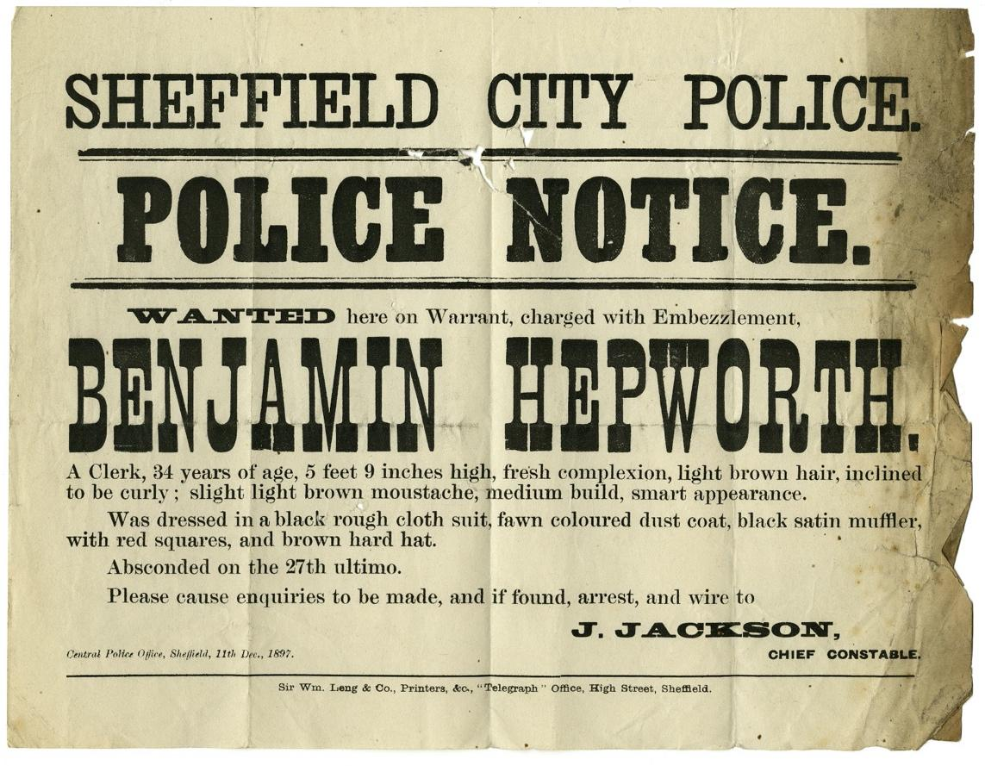

Police Wanted Poster for Benjamin Hepworth, 1897
Reference: BA/C/PO/15/11/68 | Suggested age groups: KS2, KS3, KS4, lifelong learners |Topic areas: Crime and Punishment, Victorians, Clothing/Fashion in the Past

Wanted posters
In the late nineteenth and early twentieth centuries police forces sent out posters like this to other police stations across the country. They were designed to inform and to alert the local police about criminals or runaways that might come into their area.
These posters were collected by the Berwick Borough Police, who were probably on the lookout for English criminals trying to get to Scotland and Scottish criminals trying to escape to England.
The posters often have a detailed description and image of the wanted person, the stolen goods or the crime being investigated. Later posters included photographs.
Along with the posters, a number of postcards confirming that a crime has been solved are in this collection. Some of the posters were written on by the Berwick Police to show that they had carried out a search for the person on the poster.

Money
The research of one of our archivists shows that Benjamin was caught and tried for stealing £1000 (worth over £130,000 today) from Sheffield City Council.

Other online resources
Blog post about the wanted posters: https://www.northumberlandarchives.com/2019/02/04/twixt-thistle-and-rose-4/
Bank of England inflation calculator (works out the worth of money in the past): https://www.bankofengland.co.uk/monetary-policy/inflation/inflation-calculator

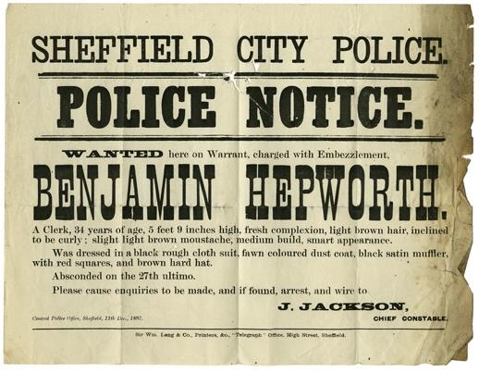
Learning Activities – Police Wanted Poster for Benjamin Hepworth

Topic: Crime and Punishment, Victorians, Clothing/Fashion in the Past
Subject areas: History, Literacy, Maths, Art
Background | Activity | Resources
In the late nineteenth and early twentieth centuries police forces sent out posters like this to other police stations across the country. They were designed to inform and to alert the local police about criminals or runaways that might come into their area. | See: What crime did Benjamin Hepworth commit?  See: Which city police department issued the wanted poster?  See: Why did police forces send out wanted posters? | http://www.bbc.co.uk/history/british/victorians/crime_  https://www.northumberlandarchives.com/2019/02/04/twixt-thistle-and-rose-4/  http://forreadingaddicts.co.uk/language/dictionary-full-victorian-slang/13565  https://www.bbcamerica.com/anglophenia/2014/08/20-victorian-terms-seem-oddly-modern  https://www.historic-uk.com/CultureUK/Victorian-Words-And-Phrases/  https://www.vocabulary.com/lists/143077
Think: Why did wanted posters need to include a description of the person?
Think: Why doesn’t the wanted poster have a photograph of Benjamin Hepworth?
Think: What does the word “ultimo” mean? Make a list of any of the words on the wanted poster that are unfamiliar to you and look up their definitions.
Do: Using the description, draw a portrait of Benjamin Hepworth to be included on the wanted poster.
Do: Create a piece of descriptive writing to describe your appearance as if it were to be included on a wanted poster. Who else could you write a description of this way? Could you include some Victorian words in the description?
Do: Swap descriptions with someone else. Using their description, draw a portrait and turn this into a wanted poster.
Do: Words in the English language evolve and go in and out of use over time. Research some of the terms used in Victorian times that are no longer used today.
After 1971 the UK moved to a new decimalisation system and brought currency into line with the metric systems used in Europe, which are based on a system of factors of 10. | See: How much money did Benjamin Hepworth steal?  See: Who did Benjamin Hepworth steal from? | https://www.projectbritain.com/moneyold.htm  https://www.bankofengland.co.uk/monetary-policy/inflation/inflation-calculator  https://www.nationalarchives.gov.uk/currency-converter/  https://www.bbc.co.uk/news/uk-england-27763842  https://www.northumberlandarchives.com/2019/02/04/twixt-thistle-and-rose-4/
Think: What unit of currency was used in Britain during the 1800s?
Think: When did Britain change to using the decimal currency system that we currently use?
Think: What is inflation and how does it affect how much money is worth over time?
Do: What is the inflation rate between 1897 and today?
Do: Can you work out what the equivalent of the stolen money is today, giving consideration to inflation?
Do: Look at the other wanted posters on the Northumberland Archives blog post. Can you work out the present-day worth of the money on the wanted posters? How does the inflation rate change over the different years on the wanted posters?

