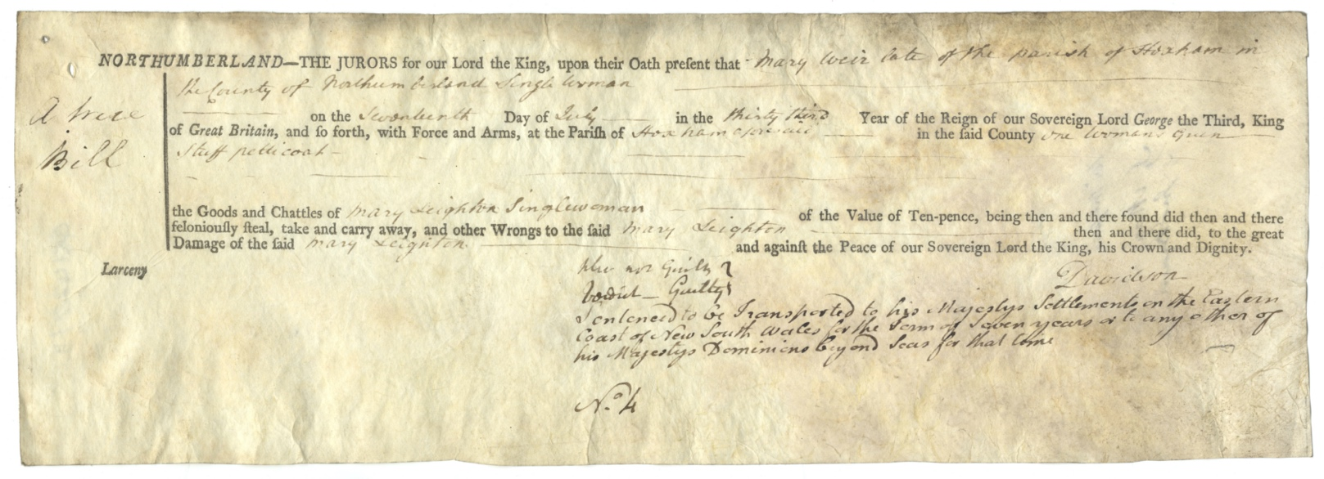
Indictment to Northumberland Quarter Sessions – Mary Weir, 1793
Reference: Q/S/1427/11| Suggested age groups: KS2, KS3, KS4, lifelong learners | Topic areas: Crime and Punishment, Court Process and Transportation

The courts
Northumberland Quarter Sessions court was held in the county from 1388 until 1972. It was a Royal Court of Justice that was held four times a year. There were sessions at Morpeth, Hexham and Alnwick. It was not unusual for large counties to hold sessions at different towns so that justice could be done for the whole of the county.
Assizes courts tried more serious crime such as murder, rape and highway robbery and were held twice a year. In the 1730s petty sessions courts were introduced to try minor (or petty) crimes.

Indictments
Indictment was the most common way of an alleged criminal being brought to court. Anyone could “bring” an indictment as long as they had “probable cause” and as long as they weren’t being malicious; they had to have proof and they couldn’t make an accusation because of a grudge.
The name of the accused (could be one or more people) and their alleged crimes were written on a piece of parchment and given to the Grand Jury (between thirteen and twenty-three male householders aged 21–60). The Grand Jury considered the indictment and decided on the verdict under the direction of the judge.
Not all of the indictments were on a printed form like the ones here. The fact that there were pre-printed forms for the crime of larceny (stealing) probably shows how common it was. The indictments here also have the verdict and sentence noted on them.

Parchment
Indictments were written on pieces of parchment, which is made from animal skins. The skins are cured and scraped so that they are very thin. The best quality parchment is called vellum and is made from calfskin. Parchment is very durable; if it is kept in the right conditions it can last for centuries. The oldest parchment document dates from 2000 BC.

Mary Weir
Mary Weir was convicted of stealing “a woman’s green stuff petticoat” from Mary Leighton, even though she claimed not to be guilty. A petticoat was worn under a skirt and this one was made of “green stuff”, or material.
Mary Weir was “sentenced to be transported to His Majesty’s settlements on the Eastern Coast of New South Wales for the term of seven years or to any other of His Majesty’s Dominions beyond Seas for that time”. (See bottom handwritten section of indictment.)
Although she was convicted on 18 July 1793, Mary did not set sail for Australia until October 1795. She may have been kept on a prison hulk (an old ship that was not fit for sailing), although this was more common for male prisoners. The opening scenes of Great Expectations by Charles Dickens features prison hulks (see link below).
Along with 132 other female prisoners, Mary sailed to New South Wales on the Indispensable. They stopped for fresh water at Rio de Janeiro in January 1796. Two women died during the journey.
The Indispensable arrived in Australia on 30 April 1796. Mary Weir appears on the Australian census for 1811, 1814, 1819. According to the “Felon or Free Settler” website, Mary married John Larkham in Parramatta, near Sydney.

Other online resources

Courts
Our Criminal Ancestors website (University of Hull), page for Quarter Sessions: https://ourcriminalancestors.org/quarter-sessions/
Our Criminal Ancestors website (University of Hull), page for Assizes: https://ourcriminalancestors.org/assizes/
Our Criminal Ancestors website (University of Hull), page for timelines: https://ourcriminalancestors.org/category/timelines/

Transportation
Our Criminal Ancestors website (University of Hull), page about researching transported criminals: https://ourcriminalancestors.org/source-guide-for-tracing-your-transported-convict-ancestorss/
BBC Bitesize website, page about transportation: https://www.bbc.co.uk/bitesize/guides/z938v9q/revision/4
The History Press website, page about transportation to America: https://www.thehistorypress.co.uk/articles/the-land-of-the-free-criminal-transportation-to-america/

Indispensable (Convict Ship)
Free Settler or Felon website, page about Indispensable (including details of convicts): https://www.jenwilletts.com/convict_ship_indispensable_1796.htm
Convict Records of Australia website, page for Indispensable: https://convictrecords.com.au/ships/indispensible/1795

Great Expectations
British Library website, page about crime in Great Expectations: https://www.bl.uk/romantics-and-victorians/articles/crime-in-great-expectations

Parchment
BBC news website, story about vellum used to print laws: https://www.bbc.co.uk/news/magazine-35569281

History Today website, page about parchment: https://www.historytoday.com/archive/parchment#:~:text=From%20remote%20times%20skins%20were,2000%20B.C.)%20kept%20in%20Berlin

YouTube website, BBC film about making parchment: https://www.youtube.com/watch?v=2-SpLPFaRd0

Cornell University blog, page about process of making parchment: https://blogs.cornell.edu/culconservation/2015/04/03/parchment-making/

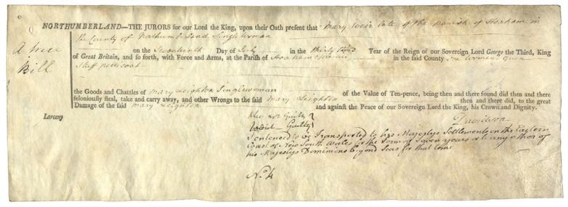
Learning Activities – Indictment to Northumberland Quarter Sessions – Mary Weir, 1793

Topic: Victorian Crime and Punishment, Transportation
Subject areas: History, Literacy, Geography, Art
Background | Activity | Resources
Northumberland Quarter Sessions court was held in the county from 1388 until 1972. It was a Royal Court of Justice that was held four times a year. Indictment was the most common way of an alleged criminal being brought to court. Anyone could “bring” an indictment as long as they had “probable cause”. Mary Weir was convicted of stealing “a woman’s green stuff petticoat”. Mary Weir was “sentenced to be transported to His Majesty’s settlements on the Eastern Coast of New South Wales for the term of seven years or to any other of His Majesty’s Dominions beyond Seas for that time”. | See: What was the Northumberland Quarter Sessions court?  See: Which types of crimes did the Assizes court try?  See: What is an indictment?  See: What was Mary Weir indicted for?  See: Who accused Mary Weir?  See: What was Mary Weir accused of stealing?  See: How did Mary Weir plead?  See: What was Mary Weir’s sentence?  See: What was a “hulk”? | http://vcp.e2bn.org/justice/section2196-transportation.html  https://www.nationalarchives.gov.uk/education/candp/punishment/g09/g09cs1.htm  https://www.bbc.co.uk/bitesize/guides/z938v9q/revision/4  https://www.jenwilletts.com/convict_ship_indispensable_1796.htm  https://convictrecords.com.au/ships/indispensible/1795
Think: What was transportation?
Think: When was transportation used?
Think: Why was transportation used?
Think: What crimes was transportation used as a punishment for?
Think: Where were criminals sent and what did they do while they were there?
Think: Why would the prisoners be kept on a hulk before transportation?
Think: Why did so much time pass between Mary Weir’s conviction and her setting sail for Australia?
Do: Create a map showing the different places that criminals were sent during transportation. Plot routes on the map showing the routes ships took from Britain.
Do: Many convict lives were lost on the long transportation journeys, particularly in the early days of transportation. Research the conditions on transportation ships. Write a diary entry as though you are a convict being transported on a ship with poor conditions. Describe your surroundings and what the journey has been like so far.
Do: Transportation became a controversial form of punishment. It was costly, crime rates did not fall because of it and residents from transportation countries resented having prisoners sent to them. In groups debate the pros and cons of transportation as a method of punishment.
Do: Research what happened to convicts after their transportation sentence ended.
Palaeography is the study of old handwriting. Not all of the indictments were on a printed form like the ones here. The fact that there were pre-printed forms for the crime of larceny (stealing) probably shows how common it was. The indictments here also have the verdict and sentence noted on them.  Indictments were written on pieces of parchment, which is made from animal skins. | See: What is palaeography?  See: How is the indictment of Mary Weir written – printed or handwritten?  See: Why are some parts of the indictment printed and some written by hand?  See: Why are some parts of the indictment printed and some written by hand?  See: What were indictments written on?  See: What was parchment made of?  See: How long does parchment last?  See: What is the best quality parchment? | https://www.nationalarchives.gov.uk/palaeography/default.htm  https://www.prepressure.com/printing/history/1700-1749  https://www.prepressure.com/printing/history/1750-1799  https://kinderart.com/category/art-lessons/printmaking/  https://www.bbc.co.uk/news/magazine-35569281  https://www.historytoday.com/archive/parchment#:~:text=From%20remote%20times%20skins%20were,2000%20B.C.)%20kept%20in%20Berlin  https://www.youtube.com/watch?v=2-SpLPFaRd0  https://blogs.cornell.edu/culconservation/2015/04/03/parchment-making/  https://www.teachervision.com/print-making/paper-making
Think: Why were a lot of documents written by hand?
Think: Why is it important for historians and archivists to learn palaeography?
Think: What types of printing were used in Britain in the 1700s?
Think: What type of parchment might the indictment have been written on?
Think: How is parchment made?
Think: Can you describe what it might be like to hold a piece of parchment? What might it smell like? How might it feel?
Do: Can you transcribe the indictment of Mary Weir?
Do: Look at Mary Weir’s indictment and other examples of old handwriting from the National Archives. Can you recreate the handwriting? Have a go at making an alphabet or writing your name using old-fashioned handwriting. What other types of documents can you make in this style?
Do: Have a go at making your own paper. You could do this using pulp made from recycled paper or linen rags. Could you make this look like a parchment indictment?
Do: Create a print, this could be a lithograph, etching, relief print, etc., inspired by something Mary Weir may have seen on her journey to Australia or while she was serving her sentence.

