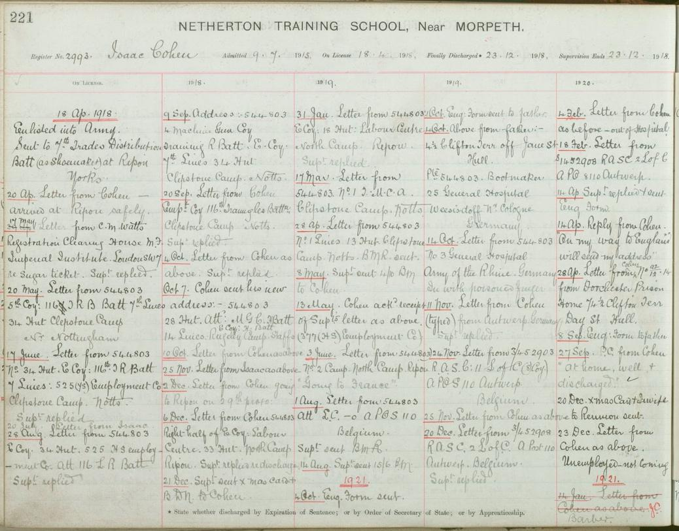

Discharge Register Entry for Isaac Cohen, 1918–21
Reference: NRO/00820/B/26 p. 221 | Suggested age groups: KS2, KS3, KS4, lifelong learners |Topic areas: Crime and Punishment, History of Childhood, WW1

Netherton Reformatory
At the beginning of the nineteenth century a child who committed a crime was tried in the same court as an adult. If the judge or magistrate sentenced them to prison, they would be sent to the same prison as adult criminals.
Some campaigners, such as Mary Carpenter, argued that children should be kept away from adult criminals so that they did not learn bad habits from them. She also said that children should be given training and be allowed to play.
Pressure from campaigners led to Parliament passing the Reformatory Schools Act in 1854. The Act allowed reformatory schools to be set up and for them to be officially inspected. Magistrates could send children under the age of 16 to these schools, instead of to prison.
A reformatory school was set up in Newcastle in 1853, just before the Act passed through Parliament. The school was moved to Netherton, near Morpeth in 1857. In 1933 Netherton became an “Approved School”, which replaced reformatories and industrial schools. Netherton continued to be a residential school for boys well into the 1980s.

Discharge register – Isaac Cohen
When he entered Netherton, Isaac was sentenced to stay at the school until he was 19 years old, like most of the boys that were sent to the school.
When a boy left the school, the staff of the school kept in touch with them for a period of 3–4 years afterwards. The staff recorded their contact with Isaac in the pages that you can see here. We often think of reformatories as harsh places, but it is interesting to note that Isaac regularly wrote to the staff at Netherton once he left. This was not unusual.
Isaac left Netherton in April 1918, right at the end of the war. He joined the army as soon as he left the school. He started off his army career in Ripon where he became part of the “Trades Distribution Battalion (as shoemaker).”
Like most new recruits, he did not immediately go abroad. From 1918 to mid-1919, he moved from Yorkshire to Nottinghamshire and then to Staffordshire. In June 1919, he wrote to the school that he was going to France.
He did not go to France, but ended up in Antwerp, Belgium and near Cologne in Germany. In Germany he received treatment for a “poisoned finger”. When he was abroad, Isaac was part of the Royal Army Service Corps (RASC). The RASC were not directly involved in fighting, but provided transport and supplies to the troops.
Isaac’s time in the army did not end well. The letter that Isaac sent in April 1920 was from Dorchester Prison.
His Army Service record (from Ancestry.co.uk) shows that he was charged in November 1919 with stealing from a comrade (one of the other soldiers) and “masquerading as a corporal”. He pretended to be an officer when he was not, something that the army did not take kindly to. He was sentenced at a Court Martial (special military court) to nine months in prison with “hard labour”. After prison, he was discharged from the army. Even though he was forced to leave, he tried to join up to another part of the army, the Royal Engineers, in 1921. He lasted less than a month.

Related document
NRO 00820/B/10 p. 2993 Admission register entry for Isaac Cohen

Other online resources
The National Archives website, page on “Victorian Children in Trouble”: https://www.nationalarchives.gov.uk/education/resources/victorian-children-in-trouble/
Infed.org website, page about Mary Carpenter and her ideas about education: https://infed.org/mobi/mary-carpenter-reformatory-schools-and-education/
Northumberland Archives blog, page about Netherton Reformatory: https://www.northumberlandarchives.com/2015/03/30/netherton-reformatory-one-mans-first-world-war-story-david-eckstein/
Children’s Homes website, page with history of Netherton Reformatory: http://childrenshomes.org.uk/NethertonRfy/
Children’s Homes website, page with general information about reformatories: http://childrenshomes.org.uk/Rfy/
Children’s Homes website, page with model rules and regulations (1890): http://childrenshomes.org.uk/rules/Rfy.shtml
The Long Long Trail website (WW1 history), page about the Army Service Corps: https://www.longlongtrail.co.uk/army/regiments-and-corps/the-army-service-corps-in-the-first-world-war/
Ancestry (subscription) family history website, including WW1 Army Service papers: www.ancestry.co.uk

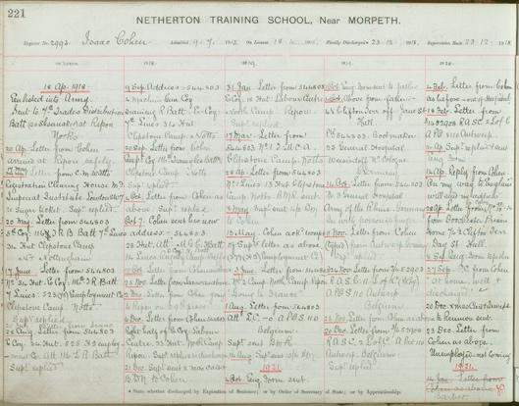
Learning Activities – Discharge Register Entry for Isaac Cohen, 1918–21

Topic: Crime and Punishment, History of Childhood, WW1
Subject areas: History, Literacy, Geography

Background | Activity | Resources
When a boy left the school, the staff of the school kept in touch with them for a period of 3–4 years afterwards. The staff recorded their contact with Isaac in the pages that you can see here. We often think of reformatories as harsh places, but it is interesting to note that Isaac wrote to the staff at Netherton once he left. This was not unusual. | See: How old was Isaac when he left Netherton?  See: Where did Isaac go when he left Netherton?  See: What major world event was coming to an end when Isaac left Netherton?  See: How long did the school keep in touch with Isaac after he left?  See: Did Isaac continue to commit crimes after he left the school?  See: How was Isaac punished in 1920? | https://www.northumberlandarchives.com/2015/03/30/netherton-reformatory-one-mans-first-world-war-story-david-eckstein/  http://childrenshomes.org.uk/NethertonRfy/  http://childrenshomes.org.uk/rules/Rfy.shtml
Think: Why did reformatories keep in touch with the boys after they left the school?
Think: What can we learn about the effectiveness of reformatory schools from discharge registers?
Think: What was the purpose of sending child criminals to reformatory school?
Think: Was this purpose achieved with Isaac Cohen?
Do: Imagine you are Isaac. Write a series of letters to Netherton to update them on your life between 1918 and 1921.
Do: Research some of the other boys from Netherton, along with other reformatory schools. Create a presentation showing how effective reform school was as a form of punishment and rehabilitation.
Do: Create a map showing the different places that Isaac visited after he left Netherton.
At the beginning of the nineteenth century a child who committed a crime was tried in the same court as an adult. If the judge or magistrate sentenced them to prison, they would be sent to the same prison as adult criminals. Pressure from campaigners led to Parliament passing the Reformatory Schools Act in 1854. The Act allowed reformatory schools to be set up and for them to be officially inspected. Magistrates could send children under the age of 16 to these schools, instead of to prison. | See: How were child criminals tried and sentenced in the early nineteenth century?  See: Why did campaigners want to keep child criminals separate from adult criminals?  See: What did Mary Carpenter say children should be given, rather than being sent to prison with adults?  See: When was the Reformatory Schools Act passed?  See: Who could be sent to reformatory school? | https://infed.org/mobi/mary-carpenter-reformatory-schools-and-education/  https://www.northumberlandarchives.com/2015/03/30/netherton-reformatory-one-mans-first-world-war-story-david-eckstein/  http://childrenshomes.org.uk/NethertonRfy/  http://childrenshomes.org.uk/rules/Rfy.shtml
Think: What were Mary Carpenter’s education principles and methods?
Think: How were Mary Carpenter’s education principles and methods different to the general principles of the time?
Think: What was the purpose of reformatory school?
Think: What were the conditions like in reformatory school?
Think: What were the rules and regulations of reformatory school?
Think: What would the children have spent their time doing at reformatory school?
Do: In small groups, debate whether or not introducing reformatory schools was the right way to punish child criminals.
Do: Using the information provided by the Children’s Homes website, draw up a plan of Netherton.

