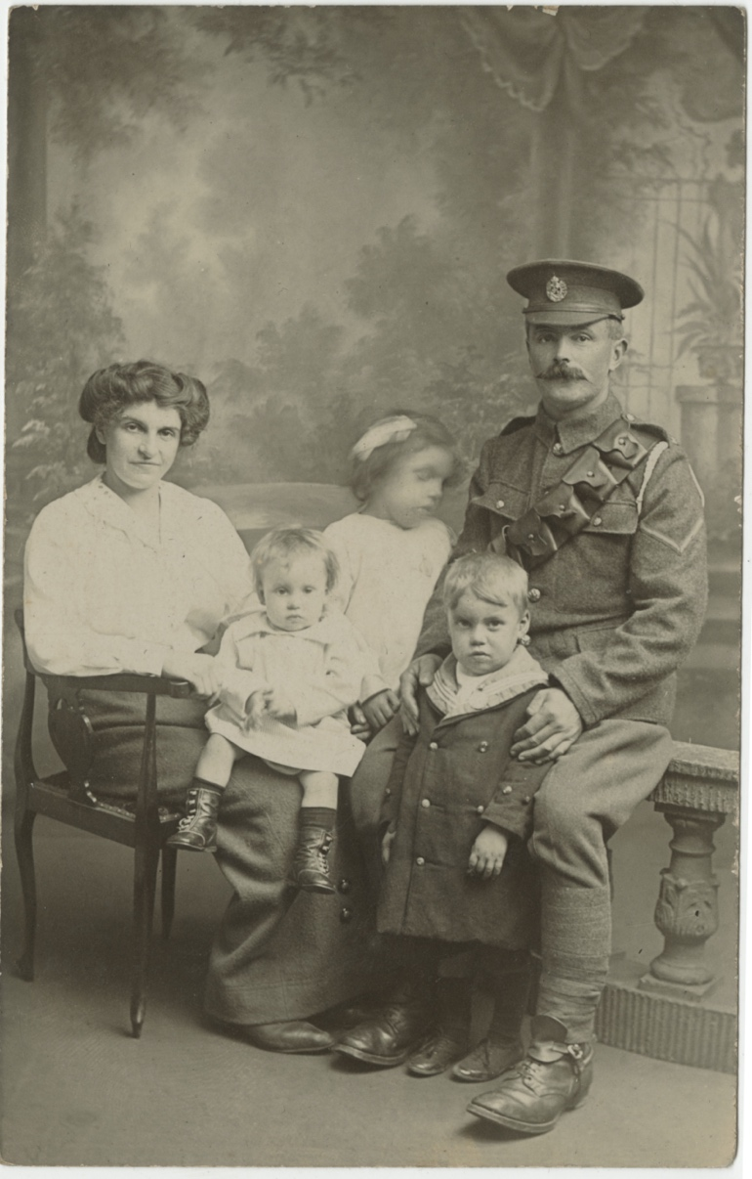
Photograph of a Soldier and His fAmily, No date (1914-1918)
Reference: NRO 10640/5 | Suggested age groups: KS1, KS2, KS3, KS4, lifelong learners |Topic areas: WW1, Photography, Technology, Inventions, History of Childhood
Although the name of this family has been lost, we can tell certain things about the soldier in the photograph: he is wearing spurs (have a look at his boots) and the chevrons of a lance corporal (see his sleeve). From his cap badge we can tell that he was probably a member of the Royal Engineers Regiment.
Many men went to a photographic studio before they shipped out, to have a portrait taken, like this one. The men going to war left photographs of themselves for their loved ones and took photographs of their families and friends with them, as keepsakes. The studios often had basic furniture (like the chair and columns here), backdrops and even clothes that their customers could borrow.

Photography
The child in the middle of the photograph is blurred. This is because of the long exposure times needed in photography at this time; sitters had to keep their pose for a long time in front of the camera.
By the outbreak of the First World War photography, as an invention, was less than 100 years old. Until the beginning of the 20th century equipment was bulky and expensive. It could only really be afforded by the wealthy or by professional photographers (like the studio photographer who took this picture). In 1900 Kodak released the “Box Brownie”, a mass-produced camera that the company designed to fit in the pocket. This made photography much more portable and affordable; men took cameras to the theatres of war with them. Although the army banned the taking of photographs at the Front, many men still did so (see the link to Northumberland Fusilier photographs below).

Other online resources
Northumberland Archives Flickr WW1 albums of photographs:
https://www.flickr.com/photos/99322319@N07/albums/72157644942508746
https://www.flickr.com/photos/99322319@N07/albums/72157642331512475
https://www.flickr.com/photos/99322319@N07/albums/72157642003621114

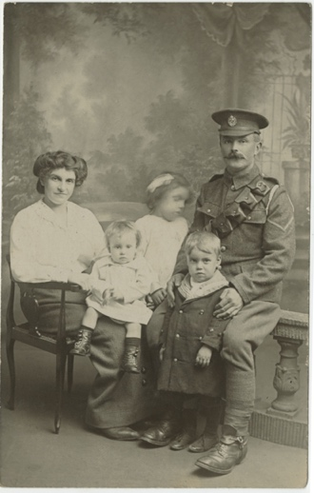
Photographs of Soldier and His Family, No Date (1914-1918)

Topic: WW1, Photography, Technology, Inventions, History of Childhood
Subject areas: History, Literacy, maths

Background | Activity | Resources
Although the name of this family has been lost, we can tell certain things about the soldier in the photograph: he is wearing spurs (have a look at his boots) and the chevrons of a lance corporal (see his sleeve). From his cap badge we can tell that he was probably a member of the Royal Engineers regiment.  Many men went to a photographic studio before they shipped out, to have a portrait taken, like this one. The men going to war left photographs of themselves for their loved ones and took photographs of their families and friends with them, as keepsakes. The studios often had basic furniture (like the chair and columns here), backdrops and even clothes that their customers could borrow. | See: What type of photograph is this?  See: What type of place was this photograph taken?  See: Who is in this photograph?  See: What type of uniform is the soldier wearing?  See: What rank is the soldier and what tells us this?  See; Which regiment did the soldier likely belong to?  See: Why is one of the children blurry? | https://www.bl.uk/world-war-one/articles/military-structures-and-ranks  http://www.hmdt.org.uk/hmdtmusic/trenchbrothersteaching/12-ranks-and-occupations/  https://www.longlongtrail.co.uk/soldiers/a-soldiers-life-1914-1918/british-army-rates-pay-1914/  https://www.nationalarchives.gov.uk/currency-converter/  https://www.nam.ac.uk/explore/corps-royal-engineers
Think: Why did families visit a photographic studio to have a portrait taken before shipping out to war?
Think: Why did soldiers take photographs of their family and friends with them to war?
Think: Why did the photographic studio have different backdrops and clothes that their customers could borrow?
Do: Research the rank of lance corporal. How senior did this soldier rank in the army?
Do: Research what the Royal Engineers Regiment did during WW1. Write a profile about what this soldier may have done and where he may have travelled during WW1.
Do: Using the information from the Long Long Trail website for the daily pay of a soldier in each regiment and rank, and the currency convertor from the National Archives, work out how much money this soldier likely earned in a day and convert it to today’s currency.
Do: Based on what you have found out about the rank and income of this soldier, write a statement arguing either that the soldier’s family are wearing their own clothes or have borrowed clothes from the photographic studio.
Do: Take a photograph of your family or household group. Make a list of the steps that it took for you to take your family photograph. Think about how many steps it might have taken to photograph the soldier and his family. Why do you think they went to a photographic studio rather than taking the photograph themselves?

