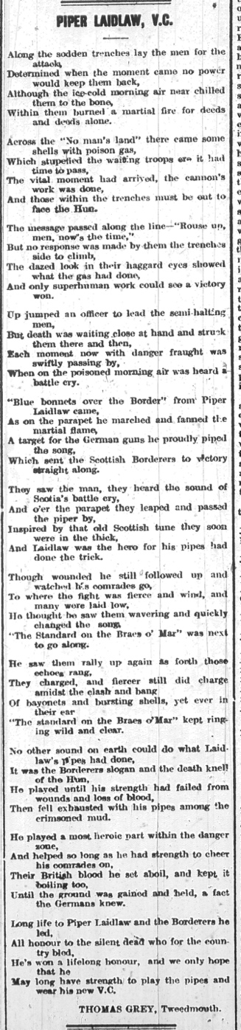
Piper Laidlaw, VC – Poem by Thomas Grey, 1915
Reference: Berwick Advertiser, 3 December 1915 | Suggested age groups: KS2, KS3, KS4, lifelong learners |Topic areas: WW1 Poetry
Thomas Grey was born in Shoreswood, near Berwick in 1863. He worked for North Eastern Railways as a train driver for many years. In his 40s he was forced to find other work due to ill health. In 1918 he started working for the Post Office, but left that job, too, because of illness.
Thomas seems to have written poetry all of his adult life. In 1906 he published a book of poems called Musings on the Footplate (the footplate is part of a steam engine that the driver stands on while driving the train.) It was the only book that he published during his lifetime, but the Berwick Advertiser regularly published his poems in the newspaper.
During the First World War Thomas was too old to fight, but three of his sons served in the armed forces. He often wrote about events during the war. After the war, he was part of the committee that put up the war memorial in Tweedmouth.
More about his life and poetry can be found by following the link below.

Piper Laidlaw
Daniel Laidlaw served with the King’s Own Scottish Borderers Regiment (KOSB) during the First World War. Although he was born in Scotland (Little Swinton), Daniel’s home was in Doddington, Northumberland.
Music was very important to the British Army. Bugles were often used to signal instructions to soldiers on the battlefield and regimental bands provided rhythms for marching, to raise morale and to help build a feeling of regimental pride.
Daniel Laidlaw played the bagpipes for the KOSB. He won the Victoria Cross, the British Army’s highest medal for bravery, for playing the bagpipes during the Battle of Loos. This poem is Thomas Grey’s celebration of that event.
The Battle of Loos (northern France) started on 25 September 1915. The British Army used poisoned gas for the first time during the Battle. It had been used by the Germans at the Battle of Ypres in April 1915. When the British released the gas at Loos, lots of it blew back into the British trenches, causing confusion. Daniel Laidlaw’s playing inspired the troops and encouraged them to leave the trenches and start their attack on the Germans.
Blue Bonnets Over the Border, the song played by Daniel Laidlaw, is a traditional Scottish marching song with lyrics by Sir Walter Scott (1771-1832). The Standard on the Braes of Mar’, is another traditional Scottish song. It was said to be used to gather clans together.

Other online resources

Piper Laidlaw
Northumberland Archives website, blog page about Piper Laidlaw: https://www.northumberlandarchives.com/tag/piper-laidlaw-vc/
North East War Memorials Project website, page about Piper Laidlaw: http://www.newmp.org.uk/article.php?categoryid=99&articleid=1502&displayorder=3
VC Online website, page about Piper Laidlaw: http://www.vconline.org.uk/daniel-l-laidlaw-vc/4587353341
YouTube website, film of interview with Piper Laidlaw: https://www.youtube.com/watch?v=CHYbYdfuyNs
BBC News website, page about Piper Laidlaw from 2015: https://www.bbc.co.uk/news/uk-scotland-34218923
King’s Own Scottish Borderers Museum, website: https://www.kosb.co.uk/

The Battle of Loos
BBC Podcast, Battle of Loos (oral histories from Imperial War Museum and BBC archives). Warning: distressing content: https://www.bbc.co.uk/programmes/b06kng0x

Thomas Grey
Friends of Berwick and District Museum and Archives website, page about Thomas Grey: http://www.berwickfriends.org.uk/history/thomas-grey-poet/

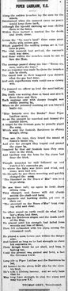
Piper Laidlaw, VC – Poem by Thomas Grey, 1915

Topic: WW1 Poetry
Subject areas: History, Literacy, art, Music

Background | Activity | Resources
Thomas Grey was born in Shoreswood, near Berwick in 1863. Thomas seems to have written poetry all of his adult life. During the First World War Thomas was too old to fight, but three of his sons served in the armed forces. He often wrote about events during the war. | See: Where is Thomas Grey from?  See: How long did Thomas write poetry for?  See: What did Thomas often write poetry about?  See: Why didn’t Thomas serve during WW1?  See: Where was this poem published? | http://www.berwickfriends.org.uk/history/thomas-grey-poet/
 | Think: Whose viewpoint is the poem told from?  Think: What influenced the poet to write this poem?  Think: What narrative is being told through the poem?  Think: What linguistic features are used to convey meaning in the poem?  Think: What is the form and structure of the poem?  Think: What is the purpose of the poem?  Think: How does the poem affect the reader?  Think: What impression do the poem give you of the war?  Think: How accurately do you think the poem portrays war?  Think: How accurately do you think the poem presents the experience of soldiers?  Think: Does knowing that the poet did not take part in the war change the meaning or effect of the poem? | http://www.berwickfriends.org.uk/history/thomas-grey-poet/
 | Do: Create a poster illustrating the narrative of the poem. Select key phrases or lines from the poem to include on the poster.  Do: Analyse the poem in depth. Consider the questions from the Think section and use them to help you annotate the poem.  Do: Write a statement about the poem discussing why the poet has chosen each feature to illustrate the meaning of the poem.  Do: Choose three words from the poem that sum it up. Use these three words to form the basis of your own poem.  Do: Write an alternative title for the poem. Does this change the meaning of the poem?  Do: Identify all of the nouns, verbs, adverbs and adjectives in the poem. Make a word cloud. Is there any sort of pattern? Try changing some of those words - what affect does it have on the mood of the poem?  Do: In a small group learn the words to the poem to perform to the rest of the class. Think about who says which line/word. Can you create emphasis by saying certain words together as a group? Will you say, whisper, shout or sing some words/lines?  Do: Close your eyes and listen to the poem being read out. Create an abstract continuous line drawing while listening to the poem responding to what you hear. Explain why you have drawn it that way.  Do: Write out the poem using the pattern of your abstract line drawing. Add colour and illustrations where necessary. Explain why you have chosen to present the poem this way. | http://www.berwickfriends.org.uk/history/thomas-grey-poet/
Daniel Laidlaw served with the King’s Own Scottish Borderers Regiment (KOSB) during the First World War.  Daniel Laidlaw played the bagpipes for the KOSB. He won the Victoria Cross, the British Army’s highest medal for bravery, for playing the bagpipes during the Battle of Loos. Daniel Laidlaw’s playing inspired the troops and encouraged them to leave the trenches and start their attack on the Germans. | See: Who was Piper Laidlaw?  See: Where was Piper Laidlaw from?  See: Which instrument did Piper Laidlaw play?  See: Which instrument was used to signal instructions to soldiers on the battlefield?  See: When was the Battle of Loos?  See: Which song did Piper Laidlaw play? | https://www.northumberlandarchives.com/tag/piper-laidlaw-vc/  http://www.newmp.org.uk/article.php?categoryid=99&articleid=1502&displayorder=3  https://www.bbc.co.uk/programmes/b06kng0x  https://wwi.lib.byu.edu/index.php/Soldier_Songs_of_World_War_I  https://www.historynet.com/the-music-of-war.htm
Think: Why was music important during the war?
Think: Why was Piper Laidlaw given the Victoria Cross for bravery?
Think: Why was a poem written about Piper Laidlaw?
Do: Write your own poem celebrating Piper Laidlaw.
Do: Create a piece of music to inspire soldiers on the battlefield.
Do: Listen to Blue Bonnets Over the Border, the song played by Daniel Laidlaw. Write a new set of lyrics to accompany the music.
Do: Research other soldiers from Northumberland or your local area who received the Victoria Cross. Write a poem to celebrate them.

