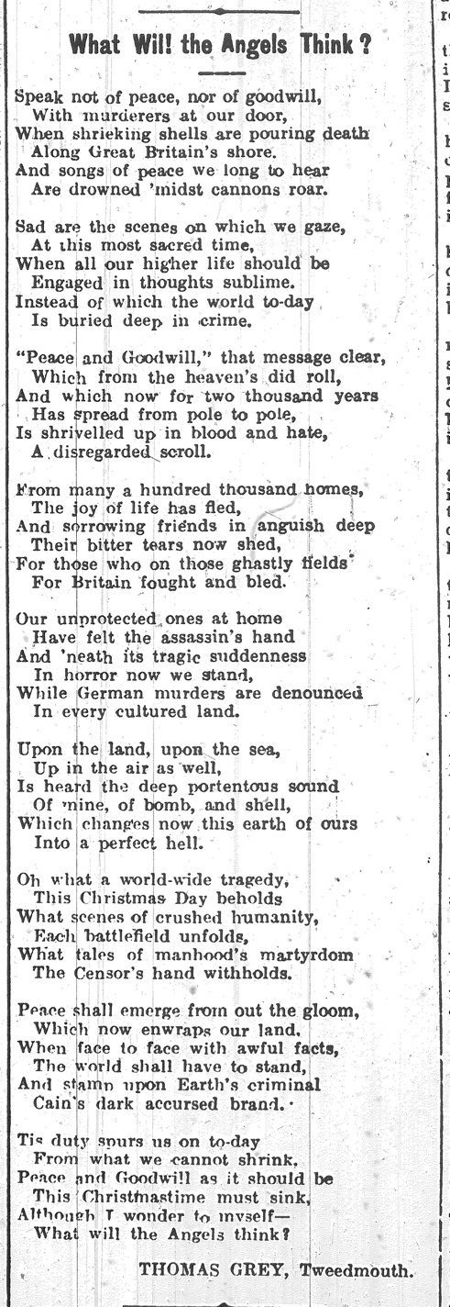
What Will The Angels Think? – Poem by Thomas Grey, 1914
Reference: Berwick Advertiser, 26 December 1914 | Suggested age groups: KS2, KS3, KS4, lifelong learners |Topic areas: WW1 Poetry
Thomas Grey was born in Shoreswood, near Berwick in 1863. He worked for North Eastern Railways as a train driver for many years. In his 40s he was forced to find other work due to ill health. In 1918 he started working for the Post Office, but left that job, too, because of illness.
Thomas seems to have written poetry all of his adult life. In 1906 he published a book of poems called Musings on the Footplate (the footplate is part of a steam engine that the driver stands on while driving the train.) It was the only book that he published during his lifetime, but the Berwick Advertiser regularly published his poems in the newspaper.
During the First World War Thomas was too old to fight, but three of his sons served in the armed forces. He often wrote about events during the war. After the war, he was part of the committee that put up the war memorial in Tweedmouth.
More about his life and poetry can be found by following the link below.

What Will The Angels Think?
Ten days before this poem was published in the Berwick Advertiser, ships from the Germany Navy fired on the British seaside towns of Scarborough, Whitby and Hartlepool.
On 16 December 1914, at 8am, over 1000 bombs fell on Hartlepool in about 40 minutes. Over 100 people were killed, many more injured, homes and schools were damaged. Both soldiers and civilians died in the bombardment. It was the first attack by a foreign power on the British mainland in over 200 years.
This poem reflects the shock and outrage that many people in Britain felt after the attack. The peace and hope of the Christmas message is contrasted with the “crimes” of the Germans.
This was not the only German attack that the area suffered. The North East was attacked by German airships on a number of occasions during the war. On 14 April 1915 an airship flew over Blyth, Cramlington and Bedlington, causing damage to a number of houses. (See links below.)

Other online resources

Bombardment of Hartlepool
Yorkshire and North East Film Archive website, page including newsreel film of bomb damage:
http://www.yorkshirefilmarchive.com/film/attack-hartlepools
Durham at War:
https://www.durhamatwar.org.uk/story/11212/
Hartlepool Then and Now:
https://www.hhtandn.org/notes/18/the-bombardment-of-the-hartlepools
National Portrait Gallery:
https://www.npg.org.uk/whatson/makingamark/teaching-resources/objects/bombardment-of-hartlepool

Zeppelin Attacks
Northumberland Archives Flickr, album of postcards showing Zeppelin bomb damage: https://www.flickr.com/photos/99322319@N07/albums/72157642003621114/with/12991004664/
The North East at War website, page for Zeppelin attack on Blyth, Cramlington and Bedlington: https://northeastatwar.co.uk/2019/02/05/zeppelin-bombs-blyth/

Thomas Grey
Friends of Berwick and District Museum and Archives website, page about Thomas Grey: http://www.berwickfriends.org.uk/history/thomas-grey-poet/

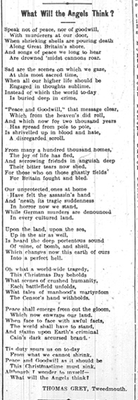
What Will the Angels Think? – Poem by Thomas Grey, 1915

Topic: WW1 Poetry
Subject areas: History, Literacy, geography, Art

Background | Activity | Resources
Thomas Grey was born in Shoreswood, near Berwick in 1863. Thomas seems to have written poetry all of his adult life. During the First World War Thomas was too old to fight, but three of his sons served in the armed forces. He often wrote about events during the war. | See: Where is Thomas Grey from?  See: How long did Thomas write poetry for?  See: What did Thomas often write poetry about?  See: Why didn’t Thomas serve during WW1?  See: Where was this poem published? | http://www.berwickfriends.org.uk/history/thomas-grey-poet/
 | Think: Whose viewpoint is the poem told from?  Think: What influenced the poet to write this poem?  Think: What narrative is being told through the poem?  Think: What linguistic features are used to convey meaning in the poem?  Think: What is the form and structure of the poem?  Think: What is the purpose of the poem?  Think: How does the poem affect the reader? | http://www.berwickfriends.org.uk/history/thomas-grey-poet/
 | Do: Create a poster illustrating the narrative of the poem. Select key phrases or lines from the poem to include on the poster.  Do: Analyse the poem in depth. Consider the questions from the Think section and use them to help you annotate the poem.  Do: Write a statement about the poem discussing why the poet has chosen each feature to illustrate the meaning of the poem.  Do: Choose three words from the poem that sum it up. Use these three words to form the basis of your own poem.  Do: Write an alternative title for the poem. Does this change the meaning of the poem?  Do: Identify all of the nouns, verbs, adverbs and adjectives in the poem. Make a word cloud. Is there any sort of pattern? Try changing some of those words - what affect does it have on the mood of the poem?  Do: In a small group learn the words to the poem to perform to the rest of the class. Think about who says which line/word. Can you create emphasis by saying certain words together as a group? Will you say, whisper, shout or sing some words/lines?  Do: Close your eyes and listen to the poem being read out. Create an abstract continuous line drawing while listening to the poem responding to what you hear. Explain why you have drawn it that way.  Do: Write out the poem using the pattern of your abstract line drawing. Add colour and illustrations where necessary. Explain why you have chosen to present the poem this way. | http://www.berwickfriends.org.uk/history/thomas-grey-poet/
Ten days before this poem was published in the Berwick Advertiser, ships from the Germany Navy fired on the British seaside towns of Scarborough, Whitby and Hartlepool.  On 16 December 1914, at 8am, over 1000 bombs fell on Hartlepool in about 40 minutes. Over 100 people were killed, many more injured, homes and schools were damaged. Both soldiers and civilians died in the bombardment. It was the first attack by a foreign power on the British mainland in over 200 years. This was not the only German attack that the area suffered. The North East was attacked by German airships on a number of occasions during the war. On 14 April 1915 an airship flew over Blyth, Cramlington and Bedlington, causing damage to a number of houses. | See: What happened ten days before this poem was published?  See: What happened in Hartlepool on 16 December 1914?  See: Who was killed during the bombardment?  See: Where else did the Germans attack in the North East?  See: What kind of damage did these attacks cause?  See: How long had it been since a foreign power had attacked mainland Britain before these attacks took place? | http://www.yorkshirefilmarchive.com/film/attack-hartlepools  https://www.durhamatwar.org.uk/story/11212/  https://www.hhtandn.org/notes/18/the-bombardment-of-the-hartlepools  https://www.flickr.com/photos/99322319@N07/albums/72157642003621114/with/12991004664/  https://northeastatwar.co.uk/2019/02/05/zeppelin-bombs-blyth/
Think: How do you think the people in the area felt after the attack?
Think: Why do you think the Germans chose to attack these areas?
Think: Why did the attacks target both soldiers and civilians?
Do: Create a map showing where the Germans attacked the North East.
Do: Write a monologue from the perspective of the voice of the poem. Expand on what is told in the poem and what you have learned about Germany attacking the North East coast of England.
Do: Write a poem from the perspective of one of the people who lived in one of the towns bombed by the Germans. You could use photographs of the attacked areas to inspire you.

