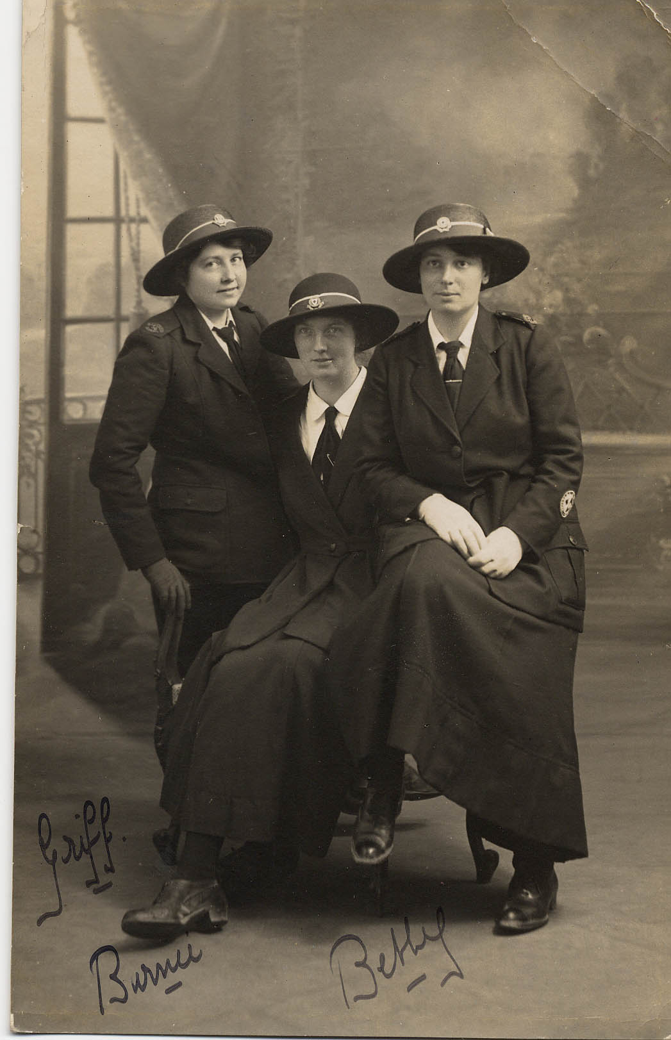
Photograph of Three Voluntary Aid Detatchment Volunteers, 1914-18
Reference: NRO 01449/15 | Suggested age groups: KS1, KS2, KS3, KS4, lifelong learners |Topic areas: WW1, Women at War, History of Medicine
The British Red Cross joined with Saint John Ambulance Brigade in 1909 to create the Voluntary Aid Detachment system. Local volunteers came together to practise first aid so that they would be ready to help at time of war.

At the beginning of the war, VAD hospitals were set up across the country. A list of the VAD hospitals in Northumberland can be found on the Donmouth website (see link below). Most of the volunteers for the VAD (they were known as VADs) worked in these local hospitals. A lot smaller number worked in hospitals near the Western Front.

VADs were not professional nurses, but volunteers with some first aid training. They did not usually do skilled medical jobs, but rather “auxiliary” tasks. They knitted socks, raised funds, cleaned, cooked, washed and drove ambulances, amongst other things.

The British Red Cross website (see below) includes a database of the registration cards that VADs had to fill in. A search can show the variety of things that VAD volunteers did during the First World War.

These three women are dressed in the “outdoor” uniform of the Voluntary Aid Detachment (VAD). They seem to be in the uniform of the Saint John Ambulance Brigade, rather than the Red Cross. Saint John Ambulance already had strong links in the region before the war because lots of miners did first aid training with the organisation. After 1911 mine owners had to provide emergency rescue services to their pits, but before that miners had to rely on each other.

Other online resources
The British Red Cross website, education page about VADs, including database: https://www.redcross.org.uk/get-involved/teaching-resources/world-war-one-centenary-resource

Donmouth website, page about VAD hospitals in Northumberland: http://www.donmouth.co.uk/local_history/VAD/VAD_hospitals.html

Scarlet Finders website (about nursing during WW1), page about VADs (also see links at the bottom of this page): http://www.scarletfinders.co.uk/181.html

Spartacus Education website, page about First World War nurses: https://spartacus-educational.com/FWWnurses.htm
Imperial War Museum “Voices of the First World War” podcasts, Women’s War work: https://www.iwm.org.uk/history/voices-of-the-first-world-war-womens-war-services

Saint John Ambulance Brigade website, blog about First World War: http://museumstjohn.org.uk/st-john-and-the-first-world-war/

The History Press website, page about the Red Cross pearls: https://www.thehistorypress.co.uk/articles/a-first-act-of-remembrance-the-red-cross-pearls/

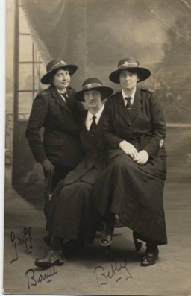
Photograph of Three Voluntary Aid Detatchment Volunteers, 1914-18

Topic: WW1, Women at War, History of Medicine
Subject areas: History, Literacy, Art

Background | Activity | Resources
The British Red Cross joined with Saint John Ambulance Brigade in 1909 to create the Voluntary Aid Detachment system. Local volunteers came together to practise first aid so that they would be ready to help at time of war.  At the beginning of the war, VAD hospitals were set up across the country. Most of the volunteers for the VAD (they were known as VADs) worked in these local hospitals. A lot smaller number worked in hospitals near the Western Front.  VADs were not professional nurses, but volunteers with some first aid training. They did not usually do skilled medical jobs, but rather “auxiliary” tasks. They knitted socks, raised funds, cleaned, cooked, washed and drove ambulances, amongst other things. | See: Who created the Voluntary Aid Detachment system?  See: When was the VAD system created?  See: Why was the VAD system created?  See: When were VAD hospitals set up?  See: Who worked in VAD hospitals? | http://www.donmouth.co.uk/local_history/VAD/VAD_hospitals.html  https://vad.redcross.org.uk/  https://www.iwm.org.uk/learning/resources/first-world-war-recruitment-posters  https://vad.redcross.org.uk/Auxiliary-Hospitals  https://vad.redcross.org.uk/Volunteers-during-WW1
Think: What were VAD hospitals?
Think: Who was cared for in VAD hospitals?
Think: Who volunteered to work in VAD hospitals?
Think: How were volunteers recruited?
Think: What types of personal or professional qualities might VADs have had?
Do: Using the information from the Donmouth website, create a map showing where the VAD hospitals were in the area.
Do: Using Google Maps, look up the areas were the WW1 VAD hospitals where. What do the areas look like now?
Do: Research VAD auxiliary hospitals. You could look up how many were set up during WW1, where they were set up, the types of services they provided, who provided care, who received care, and how they differed from military hospitals. Write a newspaper article as though you are reporting this information during the war.
Do: Write a volunteer profile for what you think are essential qualities for VADs to have. You could use the information from the registration cards to help.
Do: Create a recruitment poster for the VAD.
The British Red Cross joined with Saint John Ambulance Brigade in 1909 to create the Voluntary Aid Detachment system. Local volunteers came together to practise first aid so that they would be ready to help at time of war.  At the beginning of the war, VAD hospitals were set up across the country. Most of the volunteers for the VAD (they were known as VADs) worked in these local hospitals. A lot smaller number worked in hospitals near the Western Front.  VADs were not professional nurses, but volunteers with some first aid training. They did not usually do skilled medical jobs, but rather “auxiliary” tasks. They knitted socks, raised funds, cleaned, cooked, washed and drove ambulances, amongst other things. | See: What are VADs?  See: Where did most VADs work during WW1?  See: What types of training did VADs have?  See: What types of tasks did VADs do? | https://www.iwm.org.uk/history/voices-of-the-first-world-war-womens-war-services  https://vad.redcross.org.uk/What-we-did-during-the-war  https://vad.redcross.org.uk/Volunteers-during-WW1
Think: Why were VADs needed?
Think: Who might have volunteered for the VAD?
Think: How did women contribute to the war effort during WW1?
Think: What types of roles did women do during WW1?
Think: Did women always help on the Home Front or did they ever see conflict?
Do: Using the information from the Imperial War Museum website, write down a list of the wartime roles that women undertook.
Do: Using the information from the Imperial War Museum website, write down a list of the reasons that women wanted to contribute to the war effort.
Do: Using the information from the Imperial War Museum website, write down how the women felt about their role in the war.
Do: Choose one of the women’s stories from the Imperial War Museum website. Write a poem about their experience from their perspective.
Do: Using information from the Red Cross database, search for VADs from your area. Create registration cards using the information you find to show the personal information and job roles of several different people.
Do: Choose one of the people from the registration cards you have created. Write a monologue from their perspective about something they may have experienced during the war. Perform your monologue.

