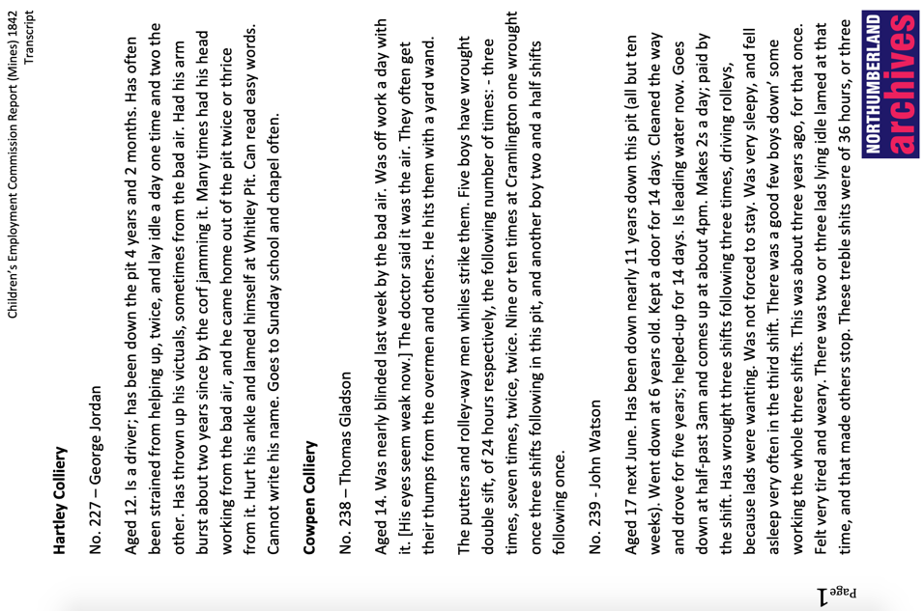
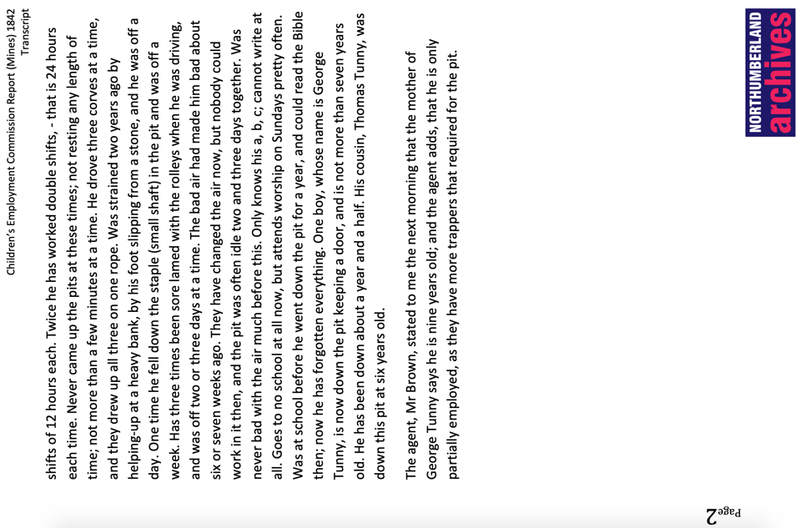
Transcript of First Report of Children’s Employment Commissioners (Mines), 1842
Reference: | Suggested age groups: KS1, KS2, KS3, KS4, lifelong learners |Topic areas: Victorians, technology, industrial revolution
In 1840 Parliament set up the Children's Employment Commission. The aim of the Commission was to investigate the working conditions of children under the age of 18. The first report included the commission’s findings on the state of child employment in mines, the second in other industries, and the third in factories.
The commission was set up by Lord Ashley, Earl of Shaftesbury. He also campaigned for improved conditions and education for children working in factories and for the banning of chimney sweeps.
The commission employed inspectors who were responsible for a region of the country. The inspectors gave out forms for owners to fill in about their employees (see Wylam Colliery form), but also talked to children and other adults involved in the industry.

Glossary
Corf – basket made of woven sticks used to transport coal and stone. Could be 10-30 pecks (90-270 litres) – plural - corves
Driver – boy employed to manage the horses underground
Helping up – boys who helped the putters (see below) when rolleys got stuck in a dip in the mine shaft
Keep a door – the job of a trapper (see below)
Leading water – removing water from coal working. Mines were often under the water table and water had to be pumped or hand bailed
Putter – someone who moves the corves (see above) of coal from the coal face to where they can be transported out the mine
Rolley – waggon used to move corves (see above), these would be pulled by horses on tracks underground
Rolley-way man – man who oversaw the rolleys (see above). He made sure that full loads could be moved out and empty corves (see above) would be ready when needed
Trapper – a little boy employed to open a door in the mine – they would be sprung to keep them closed, but had to be opened to let waggons through
Victuals – food (also known as “bait” in Northumberland)
Work/working – to ache. For example: “his head was working” – he had a headache

Other online resources
British Library article on Children’s Employment Commission (includes scans of some of the pages including illustrations):
https://www.bl.uk/collection-items/report-on-child-labour-1842
The Victorian Web site, page with testimonies printed in report of Children’s Employment Commission:
http://www.victorianweb.org/history/ashley.html
Spartacus Educational website, page for Lord Ashley, Earl of Shaftesbury: https://spartacus-educational.com/IRashley.htm
Spartacus Educational website, page for coal mining 1600-1925, includes sub-section on Children’s Employment Commission:
https://spartacus-educational.com/CoalIndustry.htm#section5
Newcastle University Library education and outreach website, page on children mine workers:
https://www.ncl.ac.uk/webtemplate/libraryassets/external/education-outreach-mining/
Durham Mining Museum website, page for mining terminology: http://www.dmm.org.uk/books/terms.htm
Durham Mining Museum website, page for Cowpen Colliery: http://www.dmm.org.uk/colliery/c031.htm
Durham Mining Museum website, page for Hartley Colliery (includes information Hartley Pit Disaster (1862)): http://www.dmm.org.uk/colliery/h018.htm

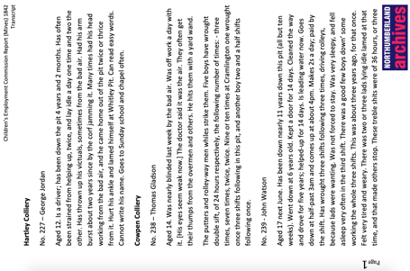
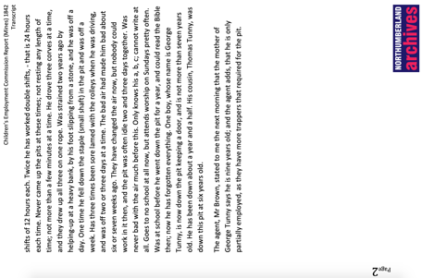
Transcript of First report of Children’S employment Commissioners (Mines), 1842

Topic: Victorians, technology, Industrial Revolution
Subject areas: History, Literacy, Science, music

Background | Activity | Resources
In 1840 Parliament set up the Children's Employment Commission. The aim of the Commission was to investigate the working conditions of children under the age of 18. The first report included the commission’s findings on the state of child employment in mines, the second in other industries, and the third in factories.  The commission was set up by Lord Ashley, Earl of Shaftesbury. He also campaigned for improved conditions and education for children working in factories and for the banning of chimney sweeps. | See: When did Parliament set up the Children’s Employment Commission?  See: What was the aim of the Children’s Employment Commission?  See: What did the Children’s Employment Commission investigate?  See: Who set up the Commission?  See: What did Lord Ashley, Earl of Shaftsbury campaign for? | https://www.bl.uk/collection-items/report-on-child-labour-1842  http://www.victorianweb.org/history/ashley.html  https://spartacus-educational.com/CoalIndustry.htm#section5  https://www.ncl.ac.uk/webtemplate/libraryassets/external/education-outreach-mining/
Think: Why was the Children’s Employment Commission set up?
Think: Why did children under 18 work in mines?
Think: What types of jobs did the children do in mines?
Think: What types of conditions did the children work in?
Think: What types of backgrounds do you think the children who worked in mines came from?
Think: Do you think the children chose to go to work in the mines or do you think some may not have been given a choice?
Do: Create a comic strip using the words from the glossary to illustrate their definitions.
Do: Imagine what it might have been like for a child in the mine. Think about what they might have felt, what job they might have had to do, what they could see, smell, hear, taste and touch. Write a poem or a monologue from the perspective of a child mine worker.
Do: Create an interpretive piece of music to play while you perform your poem or monologue. This could be inspired by the sounds that the children may have heard in the mine.
Do: Perform your poem or monologue with your accompanying piece of music. You could do this in a darkened room with the group sitting under their desks with their eyes closed so that they can think about how it might have felt to be inside a mine.
In 1840 Parliament set up the Children's Employment Commission. The aim of the Commission was to investigate the working conditions of children under the age of 18. The first report included the commission’s findings on the state of child employment in mines, the second in other industries, and the third in factories. | See: How long has George Jordan been working at Hartley Colliery?  See: How old was George when he began working?  See: What types of health issues is George described as having?  See: What caused Thomas Gladson to almost go blind?  See: How old was John Watson when he began working at Cowpen Colliery?  See: What types of jobs is John described as doing in the mine?  See: What types of injuries has John ha while working at Cowpen Colliery?  See: How long are John’s shifts? | https://www.livestrong.com/article/328220-the-average-height-and-weight-by-age/  https://www.nursingtimes.net/clinical-archive/public-health-clinical-archive/occupational-skin-and-lung-disease-in-coalfield-communities-17-06-2019/  https://www.healthline.com/health/depression/benefits-sunlight#benefits  http://www.dmm.org.uk/colliery/h018.htm
Think: Why do you think parents let their children go to work knowing that it might harm their health?
Think: Were the risks to children working in coal mines different to the risks to children working in factories?
Think: Think about photosynthesis in plants. What happens to a plant when it is left in a dark cupboard? Think about the children working for 12 hours underground in the mine. Do you think the lack of fresh air and sunlight would have an effect on them?
Do: What should the average healthy 12-year-old child be like today? Draw a figure of a typical healthy child and label/illustrate their qualities. You could think about height, weight, diet, health, access to education, amount of exercise and time spent outdoors.
Do: How does the average Victorian child mine worker compare to your labelled figure? Draw a figure of a Victorian child mine worker and label/illustrate their qualities. You could think about height, weight, diet, health, access to education, amount of exercise and time spent outdoors.
Do: What types of long-term health issues did miners suffer from? Create a health poster warning the children of these dangers. Think about the literacy levels of the children and how you would share this information with them.
Do: What were the short-term risks to child mine workers? Create a health poster warning the children of these dangers. Think about the literacy levels of the children had and how you would share this information with them.
Do: Research the health risks of the body not getting enough sunlight. How do these health issues compare to the health issues mentioned by the child mine workers?

