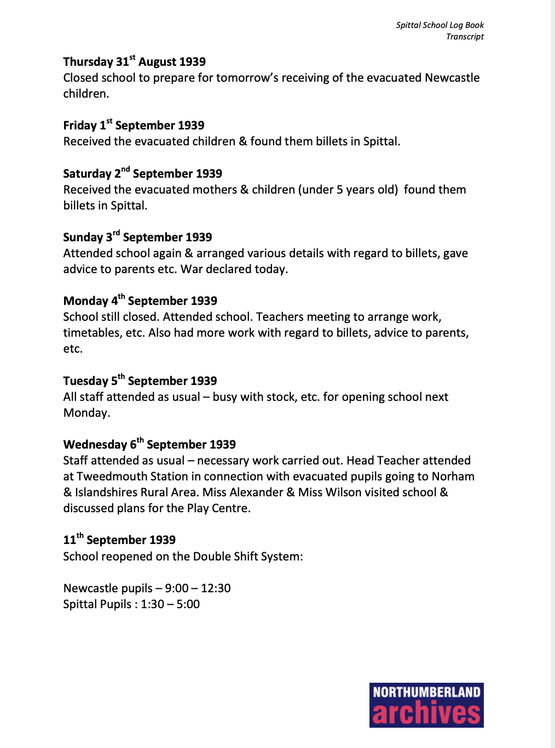
Log Book of Spittal County Primary School, 1939
Reference: CES/315/1/3| Suggested age groups: KS2, KS3, KS4, lifelong learners |Topic areas: WW2

Log Books
School log books are like a diary for a school; they record what happened on each day (also like a ship’s log). Most log books were written by the school’s headteacher.
This log book for Spittal County Primary School shows the preparations that the school made for children who were evacuated to Spittal. When the school reopened on 11 September, it used a two “shift” system. The children who were evacuated from Newcastle went to school in the morning and the children from Spittal went to school in the afternoon.
Billet – a place to stay (often used by the army)

transcript
This is a transcript of the log book. Transcripts are created by copying the text from the original document. Transcripts are usually made so they are easier to read. The handwriting in original documents is often difficult to make out. Transcripts that are produced on a computer can also be searched electronically.

Related Images
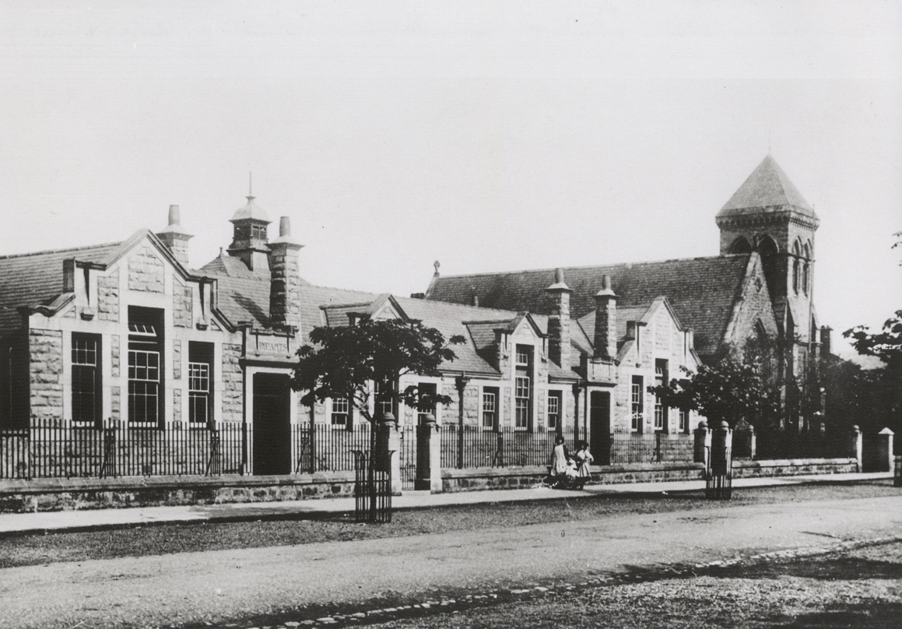
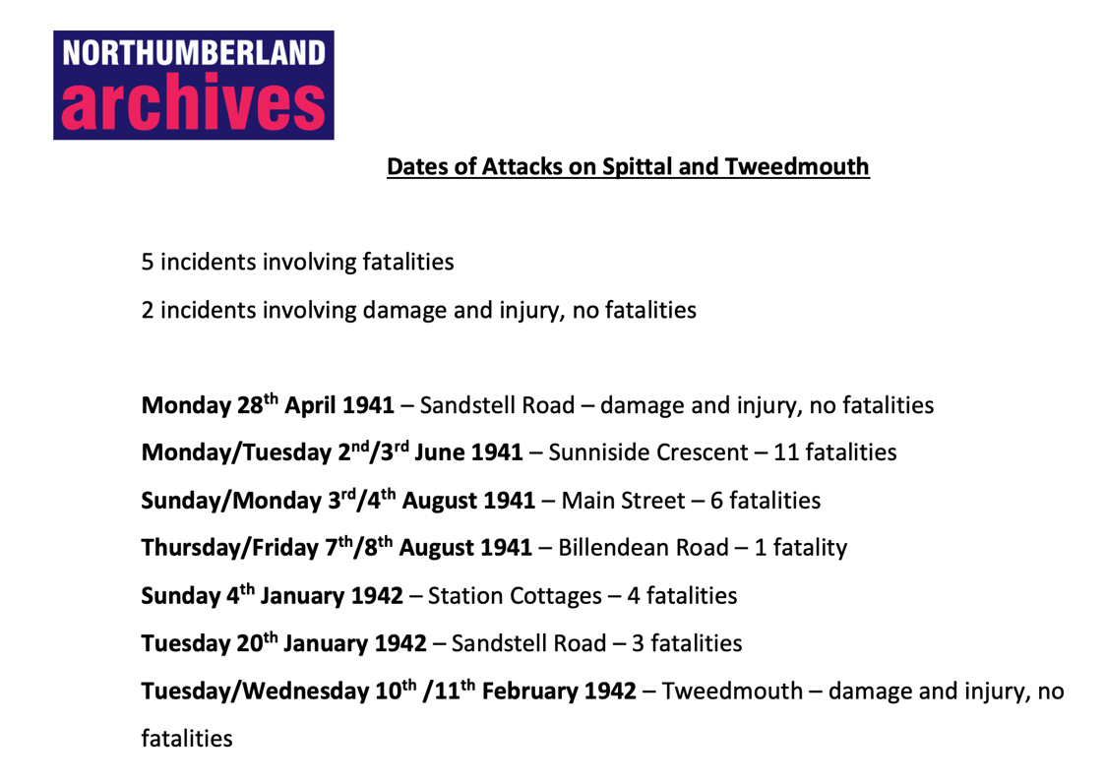
Photograph of Spittal County Primary School – BRO/426/P45/11 List of Air Raids on Spittal and Tweedmouth

Other online resources
Imperial War Museum website, page about child evacuation: https://www.iwm.org.uk/history/the-evacuated-children-of-the-second-world-war
YouTube website, British Pathe film of children being evacuated: https://www.youtube.com/watch?v=ZPs8hbksOg8
BBC Teach website, includes radio report of evacuation and interviews with children and host families: https://www.bbc.co.uk/teach/school-radio/history-ks2-world-war-2-clips-ww2-evacuation-index/zvs3scw
BBC website, an archive of Second World War memories from Tyneside and Northumberland: https://www.bbc.co.uk/history/ww2peopleswar/categories/c1156/index_6.shtml
Berwick Heritage Open Days website, Question 3 about Second World War bombings in Berwick, Tweedmouth and Spittal: http://berwickhods.org.uk/heritage-question-time-answers-from-our-experts/
North East Diary 1939-1945 website, https://ne-diary.genuki.uk/PindexS.html#S

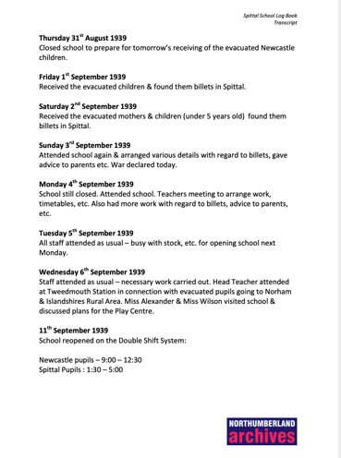
Log Book of Spittal County Primary School, 1939

Topic: WW2, Child’s War, Evacuees
Subject areas: History, Literacy, Geography, Art

Background | Activity | Resources
School log books are like a diary for a school; they record what happened on each day (also like a ship’s log). Most log books were written by the school’s headteacher.  This log book for Spittal County Primary School shows the preparations that the school made for children who were evacuated to Spittal. When the school reopened on 11 September, it used a two “shift” system. The children who were evacuated from Newcastle went to school in the morning and the children from Spittal went to school in the afternoon. | See: What are school log books?  See: Who are log books usually written by?  See: What was the two shift system used by the school?  See: When did the evacuees arrive in Spittal?  See: When did the school reopen? | https://www.youtube.com/watch?v=ZPs8hbksOg8  https://www.iwm.org.uk/history/the-evacuated-children-of-the-second-world-war  https://www.bbc.co.uk/teach/school-radio/history-ks2-world-war-2-clips-ww2-evacuation-index/zvs3scw  https://www.bbc.co.uk/bitesize/guides/z6ctyrd/revision/5
Think: Why might the school have used a two shift system?
Think: Do you think the two shift system affected the children’s education?
Think: How do you think the Spittal children felt about the evacuees coming to their school?
Think: How do you think the evacuees felt about staying in billets? How different would this have been to what they were used to at home?
Think: Do you think the Spittal and Newcastle children had the opportunity to mix together?
Think: How might moving to the country benefit wartime children from the city? Create a presentation showing the positive impact of evacuation.
Do: In groups, script a conversation between a group of evacuees showing their different thoughts about being evacuated, their new lodgings and their new school. Perform your conversation.
Do: In groups, script a conversation between a group of Spittal children showing their different thoughts about the evacuees coming to Spittal and sharing their school. Perform your conversation.
Do: Use Google Maps to find Spittal County Primary School. Is the school still there? How much do you think it will have changed since 1939?
Do: Plan an event that could bring the Spittal and Newcastle children together to mix.
Do: Design the interior of a billet.
Do: How do you think the evacuees spent their time when they were not at school? Create a timetable to plan their daily activities.
School log books are like a diary for a school; they record what happened on each day (also like a ship’s log). Most log books were written by the school’s headteacher.  This log book for Spittal County Primary School shows the preparations that the school made for children who were evacuated to Spittal. When the school reopened on 11 September, it used a two “shift” system. The children who were evacuated from Newcastle went to school in the morning and the children from Spittal went to school in the afternoon. | See: Where did the children come from who were evacuated to Spittal?  See: Where did the evacuees stay in Spittal?  See: Which other areas does the log book mention evacuees being transported to?  See: How did the evacuees travel?  See: Which station were the Newcastle evacuees transported to? | https://www.chroniclelive.co.uk/news/history/north-east-memories-day-world-11816858  https://www.iwm.org.uk/history/the-evacuated-children-of-the-second-world-war  https://www.nationalarchives.gov.uk/help-with-your-research/research-guides/evacuees/  https://www.thehistorypress.co.uk/articles/the-evacuation-of-children-during-the-second-world-war/  https://www.bbc.co.uk/history/ww2peopleswar/categories/c1156/index_6.shtml  http://www.warstateandsociety.com/Bombing-Britain  http://www.explore-northumberland.co.uk/Session%2010%20World%20War%20Two.pdf  http://berwickhods.org.uk/heritage-question-time-answers-from-our-experts/  https://ne-diary.genuki.uk/PindexS.html#S
Think: Why were children evacuated during the Second World War?
Think: Who else, other than children, were evacuated during the Second World War?
Think: What types of areas were people evacuated from?
Think: What types of areas were people evacuated to?
Think: What types of factors were taken into consideration when deciding where children were evacuated from and where they were taken to?
Think: Do you think it was a good idea to evacuate the children from Newcastle to Spittal?
Do: Do you live in an area that people would have been evacuated to or from? Take a survey of the people around you to find out the most popular answer. Plot the answers on a bar chart.
Do: Can you find evidence online of people being evacuated to or from your area?
Do: Create a map showing Spittal. Annotate your map showing the pros and cons of evacuating children to Spittal based on the natural environment, manmade structures and local characteristics.
Do: Look at the War State and Society Bombing Britain website. Use the data from Bombing Britain spreadsheet to find out how many bombings took place in Newcastle and how many took place in Spittal.
Do: Create a table comparing the number of bombings that took place in Newcastle and Spittal.
Do: Watch the section ‘Question 3 - Bombing in Berwick, Tweedmouth and Spittal’ from the Berwick Heritage Open Days website.
Do: Use the data from your table and what you have learned from the Berwick Heritage Open Days video to create a piece of argumentative writing either arguing for or against evacuating the children from Newcastle to Spittal. You could also use information from the North East Diary website to help you.
Do: Create a map showing the children’s journey from Newcastle to Spittal.
Do: Create an animation or series of drawings showing the views the children may have seen on their journey.

