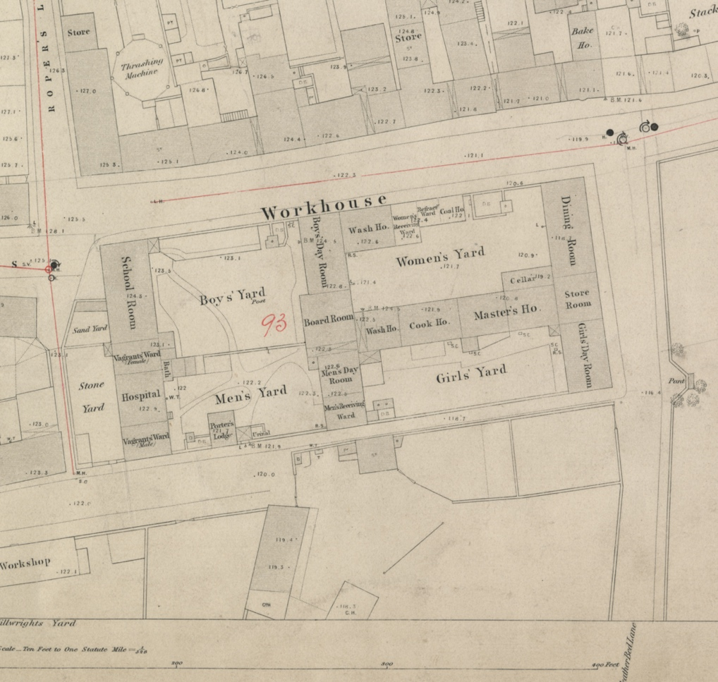
Plan of Berwick Workhouse, 1852
Reference: BA/U10/2 Sheet 2 | Suggested age groups: KS2, KS3, KS4, lifelong learners |Topic areas: Victorians, History of Childhood
Laws passed during the reign of Elizabeth I (1597, 1601) made the parish responsible for looking after the poor. Each parish (the area served by a parish church) had to appoint an “Overseer of the Poor”. It was the job of the Overseer to collect money (Poor Rate), which could be given to people from the parish who needed it. This money was called “Poor Relief”.

Some parishes built workhouses, where poor, old and sick people could stay. There was a parish workhouse in Tweedmouth in 1777 that had room for 36 people. Berwick Workhouse (see plan) was opened in 1803. The parish converted an old sack factory to house the poor.

In 1834 the poor laws were changed (or amended). These changes are often referred to as the New Poor Law. The new laws grouped parishes together into Poor Law Unions (there were seventeen parishes in the Berwick Poor Law Union). Each Union had to build a workhouse and could only give relief to poor people at the workhouse. Poor Law Unions were run by a group of people called the “Board of Guardians”.

In the workhouse, men and women were strictly separated. Children were also separated from adults, although very young children stayed with their mother. You can see on the plan that the workhouse buildings and open spaces are divided up between men and women, girls and boys.
Inmates who were physically able were expected to work. At Berwick Workhouse, men had to break rocks (see “stone yard” on plan). This was also work that was given to criminals in prison at the time. If workhouse inmates refused to work, they were not given food. Women and children would have been given lighter work, possibly in the wash-house cleaning clothes and bedding, or in the cook-house making meals.
Not all inmates stayed in the workhouse for long periods of time; some just stayed for a night or two. Homeless people, known as vagrants, sometimes used the workhouse as a place to stay while they were passing through. They had to work but were given a bed for a few nights and their meals. Lots of people passed through Berwick, travelling between England and Scotland to look for work.

Other online resources

Berwick Workhouse
Workhouses website, page for Berwick (includes history, photographs and lists on inmates): http://www.workhouses.org.uk/BerwickUponTweed/
A complete and accurate list of inmates at Berwick Workhouse from the late 1700s to 1911: http://www.berwickfriends.org.uk/record-office/catalogues/index-of-workhouse-names/
Minute Books and Correspondence from the Board of Guardians of Berwick-upon-Tweed Poor Law Union who were responsible for the workhouse: http://www.berwickfriends.org.uk/record-office/catalogues/

the New Poor Law
Workhouses website, page about New Poor Law: http://www.workhouses.org.uk/poorlaws/newpoorlaw.shtml
National Archives education website, page about Poor Law (including source exercise): https://www.nationalarchives.gov.uk/education/resources/1834-poor-law/
Spartacus Educational website, page about New Poor Law (includes primary source texts at bottom of page): https://spartacus-educational.com/Lpoor1834.htm
BBC Bitesize website, page for New Poor Law (includes revision notes and quiz): https://www.bbc.co.uk/bitesize/guides/zxj2dmn/revision/1

Children in Workhouses
Workhouses website, page about the life of children in workhouses: http://www.workhouses.org.uk/education/
Spartacus Educational website, page about the life of children in workhouses (includes primary source texts at end of page): https://spartacus-educational.com/IRworkhouse.htm

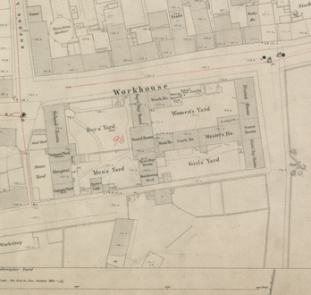
Plan of Berwick Workhouse, 1852

Topic: Victorians, History of Childhood√
Subject areas: History, Literacy, Art

Background | Activity | Resources
Laws passed during the reign of Elizabeth I (1597, 1601) made the parish responsible for looking after the poor. Each parish (the area served by a parish church) had to appoint an “Overseer of the Poor”. It was the job of the Overseer to collect money (Poor Rate), which could be given to people from the parish who needed it. This money was called “Poor Relief”.  In 1834 the poor laws were changed (or amended). These changes are often referred to as the New Poor Law. The new laws grouped parishes together into Poor Law Unions (there were seventeen parishes in the Berwick Poor Law Union). Each Union had to build a workhouse and could only give relief to poor people at the workhouse. Poor Law Unions were run by a group of people called the “Board of Guardians”. | See: What is a parish?  See: What did the Overseer of the Poor do?  See: What is Poor Relief?  See: What are workhouses?  See: When were the poor laws amended to become the New Poor Law?  See: What are Poor Law Unions?  See: Who could Poor Law Unions give relief to? | https://www.nationalarchives.gov.uk/education/resources/1834-poor-law/  http://www.workhouses.org.uk/poorlaws/newpoorlaw.shtml  https://www.bbc.co.uk/bitesize/guides/zxj2dmn/revision/2
Think: Why did the New Poor Law only allow Poor Law Unions to give relief to poor people at the workhouse?
Think: Using the plan of Berwick Workhouse, how big do you think the workhouse was?
Think: How many people do you think could have stayed at the workhouse?
Think: Why do you think the poor laws changed in 1834?
Think: Who might have been for the New Poor Law and why?
Think: Who might have been against the New Poor Law and why?
Do: Research the reasons why some Victorians welcomed the New Poor Law. Make a list of what they thought the positive aspects were.
Do: Research the reasons why some Victorians, such as Richard Oastler, were against the New Poor Law. Make a list of what they thought the negative aspects were.
Do: Create a poster showing different people’s reactions to the New Poor Law.
Do: In groups, debate the New Poor Law. Was it designed to help or punish poor people?
Do: Poor people often feared the threat of the workhouse. Create your own New Poor Law that could offer more support and less fear to poor people.
Do: Research what happens to families today who are unable to support themselves financially and what help is given to them. Compare this to the New Poor Law.
Do: Do you think people would accept the New Poor Law and workhouses today? In groups script a conversation showing how different people might react to it if the New Poor Law was reintroduced today. Perform your script.
In the workhouse, men and women were strictly separated. Children were also separated from adults, although very young children stayed with their mother. You can see on the plan that the workhouse buildings and open spaces are divided up between men and women, girls and boys.  Inmates who were physically able were expected to work. At Berwick Workhouse, men had to break rocks (see “stone yard” on plan). This was also work that was given to criminals in prison at the time. If workhouse inmates refused to work, they were not given food. Women and children would have been given lighter work, possibly in the wash-house cleaning clothes and bedding, or in the cook-house making meals. | See: How were the inmates of the workhouse divided?  See: What types of buildings and rooms were included in the workhouse?  See: Who was expected to work?  See: What types of work did men do?  See: What types of work did women and children do? | http://www.workhouses.org.uk/education/  http://www.workhouses.org.uk/BerwickUponTweed/  https://spartacus-educational.com/IRworkhouse.htm  https://www.bl.uk/romantics-and-victorians/articles/oliver-twist-and-the-workhouse  https://www.charlesdickenspage.com/twist-more.html  https://www.youtube.com/watch?v=7tOkpntQtBM&ab_channel=CreativeInventions  https://www.stlyrics.com/lyrics/oliver/oliver.htm
Think: Why do you think men, women and children were separated in the workhouse?
Think: The New Poor Law amendment categorised females under the age of 16 as “girls” and males under the age of 13 as “boys”. Why do you think girls were classified as children for longer than boys?
Think: What do you think inmates who were physically unable to work were expected to do?
Think: Do you think that the threat of not being given food if they refused to work would have led to those physically unable to work to attempt working?
Think: Do you think the inmates were treated like criminal prisoners?
Think: Do you think being in the workhouse gave inmates a better quality of life than they would have had if they were not at the workhouse?
Do: Using the descriptions from the Workhouses website, make a list of words used to describe the workhouse and what it was like to stay there.
Do: Use your list of words to create a descriptive piece of writing from the perspective of a child in the workhouse. Can you describe the area around you, how you feel about being there, how you are treated?
Do: Write a diary entry from the perspective of someone who has had to move into the Workhouse. Think about the work they have to do, how they feel about being separated from their families, the conditions in the workhouse and how they feel about being there.
Do: Can you find any Victorian literature that mentions children in the workhouse?
Do: How accurately do you think literature portrays what it was like in the Workhouse? You could compare the workhouse scene in Oliver Twist to the information on the Workhouses website.
Do: Watch the video clip of the workhouse scene from the 1968 film version of Oliver Twist where Mr Bumble sings Oliver. Write your own song lyrics for this scene from the perspective of Oliver.
Do: Using the descriptions and images from the Workhouses website and dimensions on the plan of Berwick Workhouse, create a drawing showing a room within the workhouse.
Do: Using Google Maps look up Berwick Workhouse. How do the buildings look now? How much of the Workhouse still stands today? How much do you think it will have changed from Victorian times? Draw an architectural plan showing the changes to the Workhouse site since 1852.

