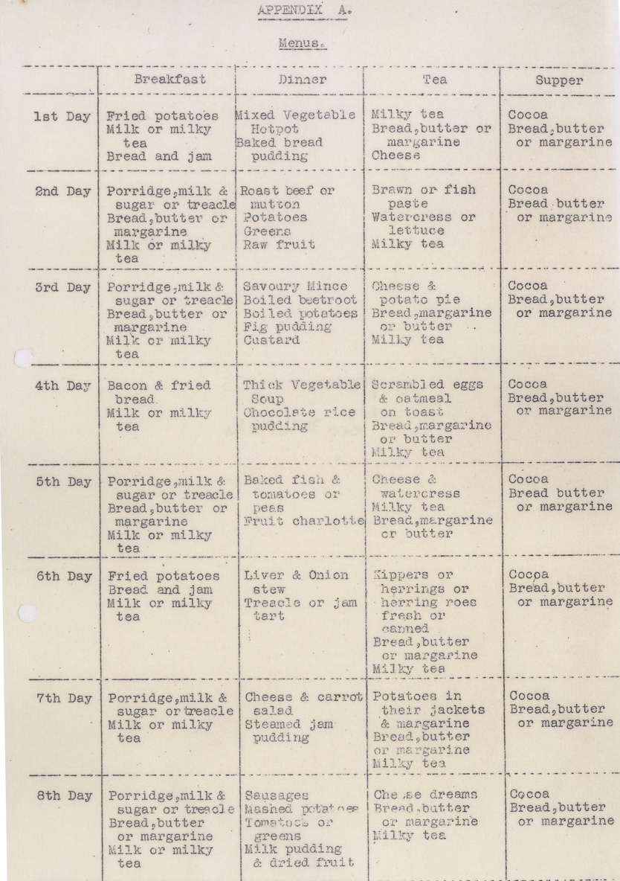
Planning menus with Second World War Evacuees
Food in an Evacuee Hostel, 1940 Reference: BA/C/TC/4/3/626

Evacuations during the Second World War
💡Why were children evacuated during the Second World War?
💡Why were children evacuated from Newcastle to North Northumberland?
🌍 Can you find Berwick, Wooler and Belford on a map? Do they look like a safe place for the children to be evacuated to?
💡 How do you think the children felt about being evacuees?
💡 Do you think the children staying with families felt differently to those staying in hostels?
💡 How would this make you feel?

During the Second World War children were evacuated from large cities and sent to the country or towns which were considered safer. Many children were evacuated from Newcastle to North Northumberland to places including Berwick, Wooler and Belford. Most children stayed with families but sometimes this wasn’t possible and so they stayed in hostels.

The menu
This is a menu for a hostel which was drawn up in 1940. It covers 8 days and suggests what can be served for breakfast, dinner tea and supper. It is quite varied and would at times have been more than the children would have received at home. It contains lots of protein and dinner was always a main course and a pudding.
💡How would you have felt about eating the foods served at the hostel?
💡Do you think the children were well fed?
💡 What do you think the children would have been served at home?
💡 What do you call the different meals of the day? Is it the same or different to their names on the hostel menu?
✏️ Come up with your ideal menu for each meal of the day. Can you write a recipe for each meal?
✏️ Create a menu card for each of your ideal meals. Ask your household to make menu cards for each of their ideal meals too. Can you come up with enough menu card ideas to cover every meal for 8 days?
🧑‍🍳Have a go at making each of your ideal meals. You could put each menu card into a bag and draw one out to make at random every mealtime.
✏️ Choose one of the dishes from the hostel menu. Can you find or write a recipe for it?
🧑‍🍳Have a go at making your recipe.

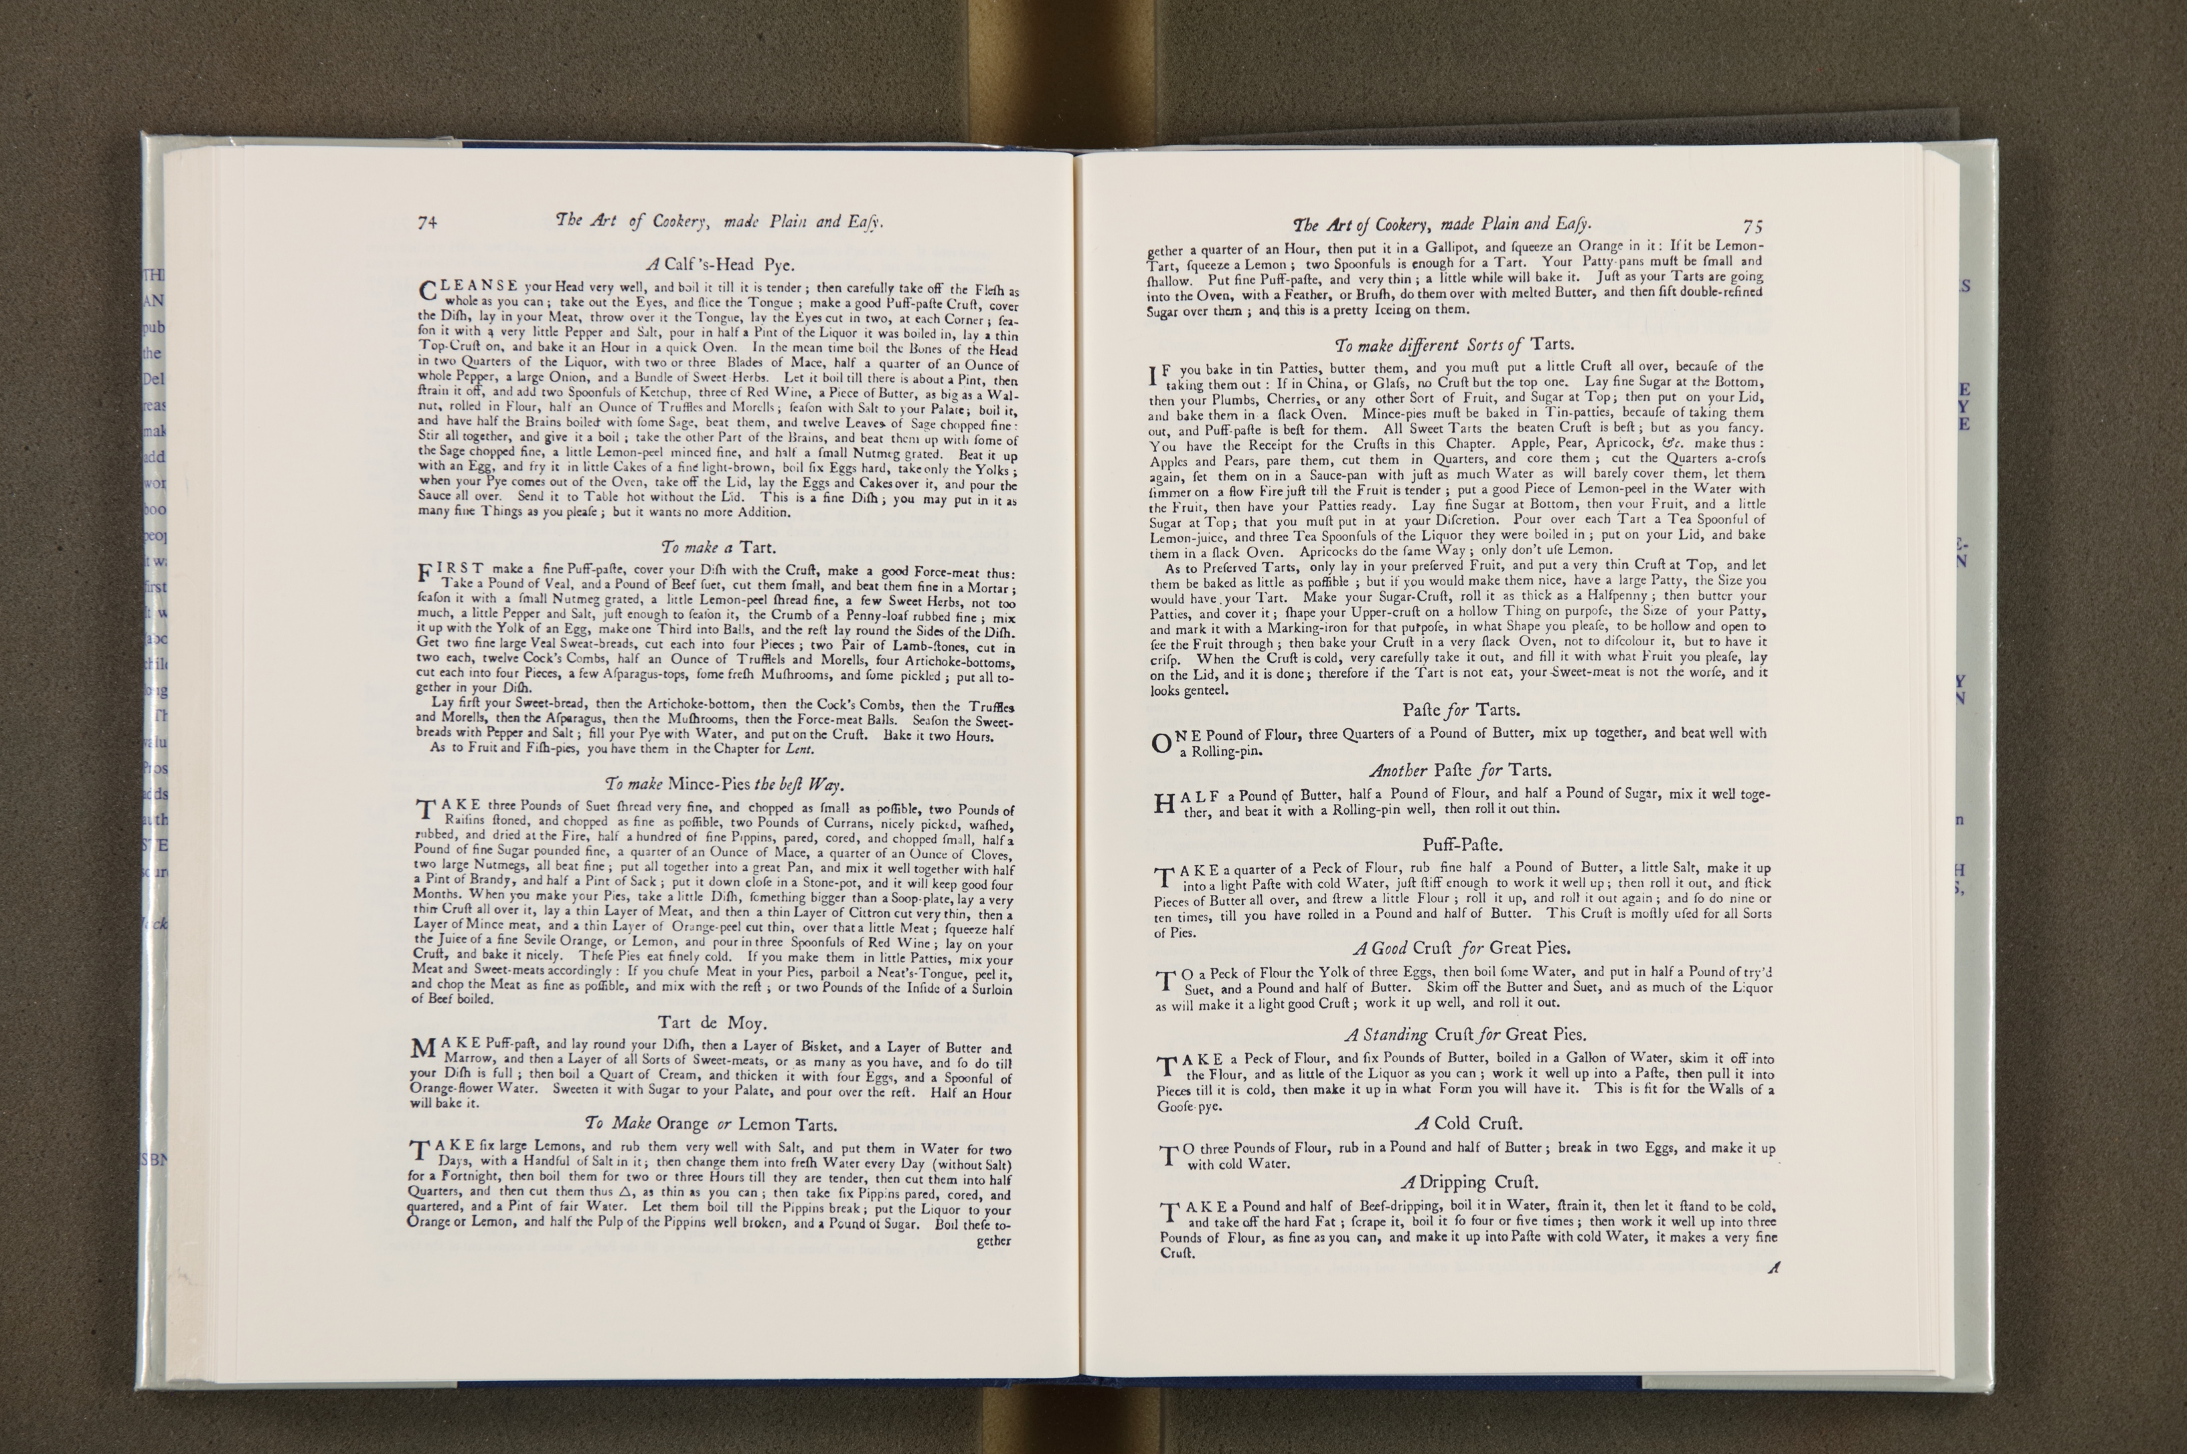
Making Tarts
Hannah Glasse (1708-1770), the daughter or Northumbrian landowner Isaac Allgood, was a cookbook author. In 1747 she published the cookery book The Art of Cookery Made Plain and Easy. In the book, Hannah provides instructions for making ‘different sorts of tarts’, and the pastry to go with them.
The evacuee hostel menu contains both treacle tart and jam tart.
💡Would you prefer a treacle tart or a jam tart?
💡What would be your ideal type of tart?
💡 Do you think Hannah’s recipe is easy to follow?
✏️ Choose a kind of tart. Can you come up with a recipe and write instructions on how to make it?
🧑‍🍳Have a go at making your tart.

