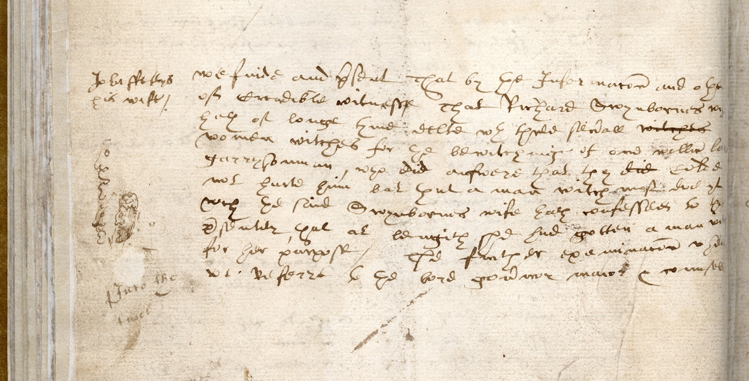
Information Regarding Witchcraft, About 1598-9
Reference: BA/C1/1/51 | Suggested age groups: KS2, KS3, KS4, lifelong learners |Crime & Punishment, Witchcraft, Historical Skills

The courts
During the early modern period, Berwick held a Bailiff’s Court. The Mayor, his deputy and some of the town’s Freemen heard complaints from the townspeople and handed out punishments. Freemen were men who had special privileges in medieval towns or cities such as being able to vote and be nominated for offices. In most towns and cities men could qualify to be a Freeman if their father had been a Freeman, if they had been apprenticed to a Freeman or if they bought a freedom.

The Bailiff’s Court dealt with minor or petty crimes in a similar way to the manor courts of the time. Both regulated order within their communities, including minor crimes against people, the running of alehouses and the maintenance of public health. The Bailiff’s Court also concerned itself with the security of the town. A number of the entries in the Bailiff’s Book related to Scottish people living or working in the town. They were seen as a threat and were actively discouraged.

In the 1730s petty sessions courts were introduced across the country to try minor, or petty, crimes.

The Bailiff’s Book
It is possible that the volume that you can see here was a working copy. Clerks (the people writing out the documents) would sometimes write out a quick version of the record and then write out a “fair copy”, which would be the official record. The merging of letters, the crossings out and the doodles in the margin of the document would suggest that they are not a “fair copy”. This page of the Bailiff’s Book does not contain a date, which would usually be present on a “fair copy”. Other entries in the pages around this entry are dated at about 1598–9.

The image here is part of one of the pages from the Bailiff’s Book. It is a large volume bound in leather. It is possible that the binding is not original – the pages have been very tightly bound, making it hard to read words on the inside edges of the pages. This makes it very unlikely that they were bound like this when they were written. It is even possible that the sheets were loose before they were bound together.

John Fettys and his Wife
This entry in the Bailiff’s Book records the information from John Fettys (or Fettis) and his wife. They inform the court that Richard Swynbourne’s wife (we don’t learn her first name) tried to “bewitch” William Law, a garrisonman (a soldier stationed in Berwick) with the help of three other women. The four women together could not bewitch William and so she called on the help of a “man witch”.

A man also appears in the list of witches executed on the Town Moor in Newcastle in August 1650 (EP 13/1). It seems widely accepted that both men and women could be witches, although more women were accused. The Bailiff’s Book entry suggests that men witches were more powerful than women.
At the end of this entry the case is referred to the Lord Governor (appointed by the monarch), Mayor and Council of Berwick. The Common Council of the town heard this case and others in Berwick at this time. In other towns, a “crime” like this would be transferred to a quarter sessions or assize court.

Transcription and Translation
Transcription is the writing out of an old document. A transcription is exactly as the document appears – the letters and spelling are copied directly. The transcriber sometimes adds letters that have been missed out in abbreviated words in the original document. These letters are shown with square brackets: [i]. This means that the way that the letters appear is preserved in the transcript, but that it is a little more readable. The transcriber also includes notes about the text in square brackets – in this transcript they have noted where words have been crossed out: in this case “witches” and “did”. The lines in the transcript finish at the same place as in the document.

A translation uses the modern spelling of the words. In this case, the lines finish in the same places so that you can directly compare the transcription and the translation.

Transcript
left hand margin
graffiti here – scribblings/faces

left hand of page
John ffetys (sic)
his wife

we finde and p[re]sent That by the Informac[i]on and othe
of Creadible witnesse That Richard Swynbornes wife
hath of longe tyme delte w[i]th three sev[er]all [witches crossed out]
women witches for the bewitchinge of one will[ia]m Law
garrysonman, who did answere that they [did crossed out] Colde
not hurte him but that a man witch mas doe yt
w[hi]ch the said Swynbornes wife hath confessed to this
p[re]sently, that at lengith she had gotten a man witch
for her purpose / The further examinac[i]on wheref[ore]
we Referre to the lord gov[er]nor maior & counsell

Translation
left hand of page
John Fettis
his wife

we find and present That by the Information and oath
of Credible witness That Richard Swynbornes wife
hath of long time dealt with three several [witches crossed out]
women witches for the bewitching of one william Law
garrisonman, who did answer that they [did crossed out] Could
not hurt him but that a man witch must do it
which the said Swynbornes wife hath confessed to this
presently, that at length she had gotten a man witch
for her purpose / The further examination wherefore
we Refer to the lord governor mayor & council

Handwriting
The style of the writing used in this document is typical of the time; it is called “Secretary Hand”. In this example not all of the letters are precisely formed; they run into each other, suggesting that they may have been written quickly.

Other online resources

Witch trials
The National Archives education website, page about witch trials: https://www.nationalarchives.gov.uk/education/resources/early-modern-witch-trials/
Haunted Palace Blog website, page about Newcastle Witch Trials: https://hauntedpalaceblog.wordpress.com/2013/09/02/king-coal-and-the-witch-pricker-the-newcastle-witch-trials-of-164950/
YouTube website, film about the Newcastle witch trials by Newcastle Castle (5 minutes): https://www.youtube.com/watch?v=GR-SnHHIreA
Teaching Women’s History website, page about early modern witch trials (includes teaching resources and PowerPoint to download): https://teachingwomenshistory.com/teaching-resources/early-modern-witchcraft/
BBC website, page for podcasts about Scottish witch trials: https://www.bbc.co.uk/programmes/p07rn38z/episodes/downloads
BBC Teach website, page with short film extract from “The Ascent of Woman” (2 minutes 55 seconds): https://www.bbc.co.uk/teach/class-clips-video/history-ks3--gcse-why-were-there-witch-hunts-in-the-seventeenth-century/zcxrf82
BBC Bitesize website, page about witch trials: https://www.bbc.co.uk/bitesize/guides/zy7nqhv/revision/4
BBC Bitesize website, page about beliefs and superstitions: https://www.bbc.co.uk/bitesize/guides/zmjnb9q/revision/3
BBC website, short film about Pendle witch trials “Interpretations of Witchcraft”, presented by young people (3 minutes): https://www.bbc.co.uk/programmes/p00w4p7y

Witchcraft in Northumberland
Newcastle University website, page for public lecture “Thinking with Anne Armstrong” by Professor James Sharpe (audio and Powerpoint slides – 1 hour): https://www.ncl.ac.uk/events/public-lectures/archive/item/2015thinkingwithannearmstrong.html
Northumberland Archives website, blog page for “Witchcraft in Northumberland”: https://www.northumberlandarchives.com/2020/04/14/witchcraft-in-northumberland/
Northumberland Archives website, blog page for “Men Were Witches Too”: https://www.northumberlandarchives.com/2020/04/06/men-were-witches-too/

Manor Couts
Spartacus Educational website, page about manor courts: https://spartacus-educational.com/YALDmanorcourt.htm
BBC Bitesize website, page about crime and punishment before 1500 (including manor courts): https://www.bbc.co.uk/bitesize/guides/z9f4srd/revision/1
Northumberland Archives blog about manor courts: http://www.northumberlandarchives.com/2016/08/24/its-our-custom/

Handwriting
The National Archives education website, page about reading old handwriting: https://www.nationalarchives.gov.uk/education/resources/palaeography/

Berwick
Northumberland Archives website, page about Elizabethan Berwick, including the Bailiff’s Book: https://northumberlandarchives.com/exhibitions/Berwick_in_10/3.html
The History of Parliament website, page about Berwick, including information about the governance of the town:
https://www.historyofparliamentonline.org/volume/1509-1558/constituencies/berwick-upon-tweed

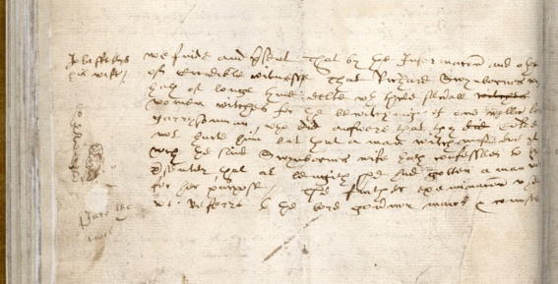
Information Regarding Witchcraft, About 1598-9

Topic: Crime & Punishment, Witchcraft
Subject areas: History, Literacy, Geography, Art & Design
Background | Activity | Resources
During the early modern period, Berwick held a Bailiff’s Court. The Mayor, his deputy and some of the town’s Freemen heard complaints from the townspeople and handed out punishments. The Bailiff’s Court dealt with minor or petty crimes in a similar way to the manor courts of the time.  The image here is part of one of the pages from the Bailiff’s Book. It is a large volume bound in leather. It is possible that the binding is not original – the pages have been very tightly bound, making it hard to read words on the inside edges of the pages. This makes it very unlikely that they were bound like this when they were written. It is even possible that the sheets were loose before they were bound together. It is possible that the volume that you can see here was a working copy. | See: What type of court did Berwick have during the early modern period?  See: Who heard complaints and handed out punishments at a Bailiff’s Court?  See: What types of crimes were dealt with at a Bailiff’s Court?  See: What is a Freeman?  See: What evidence suggests that this copy of the Bailiff’s Book is a working copy?  See: What evidence suggests that this copy of the Bailiff’s Book does not have its original binding? | https://spartacus-educational.com/YALDmanorcourt.htm  https://www.bbc.co.uk/bitesize/guides/z9f4srd/revision/1  https://blog.bookstellyouwhy.com/bid/230074/a-quick-history-of-book-binding  https://www.teachengineering.org/activities/view/make_recycled_paper  http://www.readwritethink.org/files/resources/printouts/HowToBindBook.pdf
Think: What types of crimes might be described as minor or ‘petty’ crimes?
Think: What types of punishments might Bailiff’s Courts have handed out?
Think: What types of court would have tried more serious crimes?
Think: How might Bailiff’s Courts regulating the order of the community have affected the behaviour of the people living there?
Think: Why might a Bailiff’s Book have a working copy and a fair copy?
Think: Why might this book have been rebound?
Think: What type of paper would the record have been written on?
Do: Create a list of petty crimes that would be tried in a Bailiff’s Court.
Do: Choose one of the petty crimes and create a scenario for an accusation that could be taken to the Bailiff’s Court.
Do: In groups, role play a Bailiff’s Court to present your petty crime accusation. The Mayor, their deputy and some Freemen should decide on the verdict and punishment. Allocate someone to write a record to be included in the Bailiff’s Book. You could continue this activity using the different scenarios you have created so that everyone has a chance to do each role.
Do: Have a go at making your own paper. You could do this using pulp made from recycled paper or linen rags. Could you make this look like the paper in the Bailiff’s Book?
Do: Using the records made during the role play activity, create a fair copy of each record. You could write this on the paper you have made.
Do: Research different methods of book binding.
Do: Have a go at binding your fair copy records together to make a Bailiff’s Book.
This entry in the Bailiff’s Book records the information from John Fettys (or Fettis) and his wife. They inform the court that Richard Swynbourne’s wife (we don’t learn her first name) tried to “bewitch” William Law, a garrisonman (a soldier stationed in Berwick) with the help of three other women. The four women together could not bewitch William and so she called on the help of a “man witch”. | See: Who is the accuser in this entry from the Bailiff’s Book?  See: Who is being accused in this entry from the Bailiff’s Book?  See: What crime has allegedly been committed?  See: Who is the victim in this entry from the Bailiff’s Book?  See: What did Richard Swynbourne’s wife confess to doing? | https://www.ncl.ac.uk/events/public-lectures/archive/item/2015thinkingwithannearmstrong.html  https://inews.co.uk/opinion/comment/the-long-and-underappreciated-history-of-male-witches-and-the-countries-where-more-people-accused-of-witchcraft-were-men-354563  https://listverse.com/2017/10/02/10-unusual-male-witch-trials-from-europe/  https://qz.com/1183992/why-europe-was-overrun-by-witch-hunts-in-early-modern-history/
Think: Why might Richard Swynbourne’s wife have wanted to bewitch William Law?
Think: Why might a “man witch” be more likely to be able to bewitch William Law, when four women could not?
Think: Why do we not learn the name of Richard Swynebourne’s wife?
Think: How might Richard Swynebourne’s wife have been punished for this crime?
Do: Look at the entry in the Bailiff’s Book. Are there any words that are recognisable to you?
Do: Read the transcription aloud. Can you write a summary of what it is saying?
Do: Write a newspaper article reporting this case.
Do: Imagine you are Richard Swynebourne’s wife, write an enchantment that could be used to bewitch William Law.
Do: Create a profile showing the percentage of men and women tried for witchcraft, typical traits of witches how witches were found and how witches were punished in Britain during the early modern period.
Do: Research and make a list of countries where more men were tried for witchcraft than women in the early modern period.
Do: Make a profile for different countries in Europe during the early modern period to show the percentage of men and women tried for witchcraft, typical traits of witches in each country, how witches were found and how witches were punished.
Do: Make a note of similarities and differences between how different counties viewed witchcraft.
Do: In groups, debate what the reasons might be for these differences.

