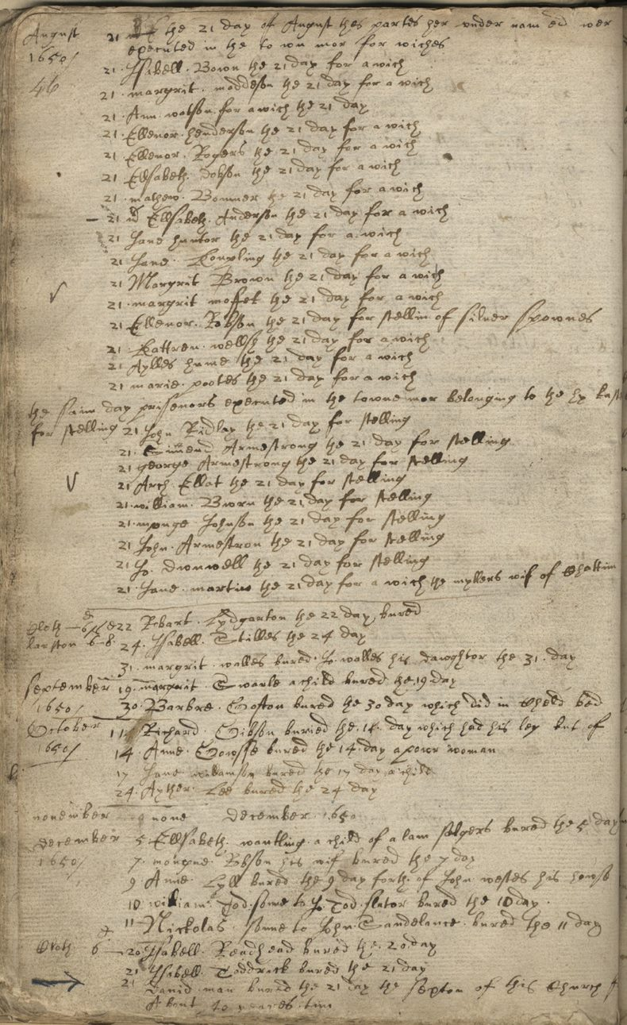
Parish Register of Baptism, Marriages and Burials for Newcstle Saint Andrew
Reference: EP13/1 p.46 | Suggested age groups: KS2, KS3, KS4, lifelong learners |Crime & Punishment, Witchcraft, Historical Skills

Parish Registers
Henry VIII ordered that parish registers of baptisms, marriages and burials be kept from 1538. Very few have survived from this date. Elizabeth I repeated her father’s order in 1558 and then ordered that parish registers be kept on parchment (rather than more vulnerable paper) in 1597. More registers survive from this date.

In some registers the vicar made notes about entries that he made or about other happenings in the area. For example, in this register there are no baptisms between October 1644 and September 1645. A note explains this was due to the siege of Newcastle during the Civil War.

Newcastle Witches
At the end of the register appears a list of people executed on 21 August 1650 on the Town Moor. Of the first sixteen names listed, all but one person were hung for witchcraft “for a wich”. Ellenor Robson was hanged for “stellin of sliver spownes” (stealing silver spoons). Not all of the witches were women, Mathew Bowner was also hanged “for a wich”.

After the list of people hanged for witchcraft is a further list of eight people hanged for “stelling” or stealing. At the bottom of this list (the ninth person), is Jane Martin who was also hanged “for a wich”. It is noted that she was the wife of the miller from Chatton.

The parish register shows that sixteen people were executed for witchcraft on 21 August 1650 in Newcastle. This is the largest number of people executed for that “crime” on any one day in English history. The sixteen were hanged – witchcraft was a felony in England, which meant that it was punished by hanging rather than being burnt as in other European countries.

Contemporary account – Ralph Gardiner
Most of what we know today about the Newcastle witch trials comes from a book written in 1655, just five years after the executions. A copy of “England’s Grievance Discovered” can be found on Google Books (see link). The index page on Google Books contains hyperlinks which will navigate straight to the chapter about the witch trials.

According to Ralph Gardiner, the people of Newcastle appealed to the council to get rid of any witches in the town (Newcastle became a city in 1882). The council invited a witch-finder from Scotland to come and root out any witches. The witch-finder used a pin on any people (but mostly women) that were brought to him. If the suspected witch bled, they were innocent. If they didn’t bleed, they were witches. The witch-finder was paid 20 shillings (£1) for every witch. Gardiner claims that the witch-finder was later found to be a conman and was executed in Scotland, although the witch-finder isn’t named in this account.

Ralph Gardiner was in dispute with the town council of Newcastle when he wrote his book. He wrote “England’s Grievance” to send to Oliver Cromwell to try and persuade the Lord Protector that the council was corrupt.

Transcript
August 1650
The 21 day of August thes partes her under nam ed wer
executed in the to wn mor for wiches
21 Isabell Bown the 21 day for a wich
21 margrit maddeson the 21 day for a wich
21 Ann Wotson for a wich the 21 day
21 Ellenor henderson the 21 day for a wich
21 Ellenor Rogers the 21 day for a wich
21 Ellsabeth Dobson the 21 day for a wich
21 mathew Bowner the 21 day for a wich
21 Ellsabeth Anderson the 21 day for a wich
21 Jane hunter the 21 day for a wich
21 Jane Koupling the 21 day for a wich
21 Margrit Brown the 21 day for a wich
21 margarit moffet the 21 day for a wich
21 Ellenor Robson the 21 day for stellin of silver spownes
21 Kattren wellsh the 21 day for a wich
21 Aylles hume the 21 day for a wich
21 marie pootes the 21 day for a wich
…
21 Jane martin the 21 day for a wich the myllers wif of Chattim

Other online resources

Ralph Gardiner
Ralph Gardiner “England’s Grievance Discovered”, 1849 Google books:
https://books.google.co.uk/books/about/England_s_Grievance_Discovered.html?id=b11HAAAAYAAJ&redir_esc=y
The Royal Collection Trust website, page about “England’s Grievance”: https://www.rct.uk/collection/1192151/englands-grievance-discovered-in-relation-to-the-coal-trade-with-the-map-of-the

Witch Trials
The National Archives education website, page about witch trials: https://www.nationalarchives.gov.uk/education/resources/early-modern-witch-trials/
Haunted Palace Blog website, page about Newcastle Witch Trials: https://hauntedpalaceblog.wordpress.com/2013/09/02/king-coal-and-the-witch-pricker-the-newcastle-witch-trials-of-164950/
YouTube website, film about the Newcastle witch trials by Newcastle Castle (5 minutes): https://www.youtube.com/watch?v=GR-SnHHIreA
Teaching Women’s History website, page about early modern witch trials (includes teaching resources and PowerPoint to download): https://teachingwomenshistory.com/teaching-resources/early-modern-witchcraft/
BBC website, page for podcasts about Scottish witch trials: https://www.bbc.co.uk/programmes/p07rn38z/episodes/downloads
BBC Teach website, page with short film extract from “The Ascent of Woman” (2 minutes 55 seconds): https://www.bbc.co.uk/teach/class-clips-video/history-ks3--gcse-why-were-there-witch-hunts-in-the-seventeenth-century/zcxrf82
BBC Bitesize website, page about witch trials: https://www.bbc.co.uk/bitesize/guides/zy7nqhv/revision/4
BBC Bitesize website, page about beliefs and superstitions:
https://www.bbc.co.uk/bitesize/guides/zmjnb9q/revision/3
BBC website, short film about Pendle witch trials “Interpretations of Witchcraft”, presented by young people (3 minutes): https://www.bbc.co.uk/programmes/p00w4p7y

Handwriting
The National Archives education website, page about reading old handwriting: https://www.nationalarchives.gov.uk/education/resources/palaeography/

Witchcraft in Northumberland
Newcastle University website, page for public lecture “Thinking with Anne Armstrong” by Professor James Sharpe (audio and PowerPoint slides – 1 hour): https://www.ncl.ac.uk/events/public-lectures/archive/item/2015thinkingwithannearmstrong.html
Northumberland Archives website, blog page for “Witchcraft in Northumberland”: https://www.northumberlandarchives.com/2020/04/14/witchcraft-in-northumberland/
Northumberland Archives website, blog page for “Men Were Witches Too”: https://www.northumberlandarchives.com/2020/04/06/men-were-witches-too/

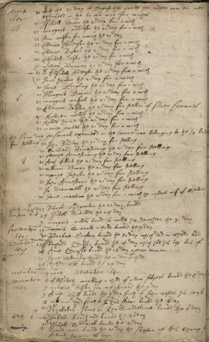
Parish Register of Baptism, Marriages and Biruals for NEwcastle Saint Andrew

Topic: Crime & Punishment, Witchcraft, Historical Skills
Subject areas: History, Literacy

Background | Activity | Resources
Henry VIII ordered that parish registers of baptisms, marriages and burials be kept from 1538. Very few have survived from this date. Elizabeth I repeated her father’s order in 1558 and then ordered that parish registers be kept on parchment (rather than more vulnerable paper) in 1597. More registers survive from this date.  At the end of the register appears a list of people executed on 21 August 1650 on the Town Moor. Of the first sixteen names listed, all but one person were hung for witchcraft. | See: When did Henry VIII order that parish registers of baptisms, marriages and burials must be kept?  See: How did Elizabeth I’s orders about parish registers help more registers to survive?  See: Where is this register from?  See: When is this register from?  See: What date is this excerpt of the register from?  See: What does this excerpt of the register show? | https://www.nationalarchives.gov.uk/education/resources/palaeography/
Think: Why do you think Henry VIII ordered parish registers of baptisms, marriages and burials to be kept?
Think: What type of paper do you think these records were kept on before 1595?
Think: Why is it important to keep records of baptisms, marriages and burials?
Think: How can these documents be useful to historians?
Think: How can these documents be challenging to use?
Think: What might cause these types of documents to be difficult for people today to read?
Think: Do we still keep records of baptisms, marriages and burials?
Think: How might these records be made and stored today?
Think: What is phonetic spelling?
Do: Look at the image of the register before reading the transcript. Identify any letters, words or numbers that look familiar to you.
Do: Can you use the letters, words or numbers that you have identified to start to make sense of other words or sentences?
Do: Try reading the register out loud. Does this make it easier to understand?
Do: Look through the list of names in the register. Write down all of the names that you can identify.
Do: Underline all of the names in your list that are spelled differently to how those names are spelled today.
Do: Say your name out loud. Think about how the letters sound. Imagine you are in a time where there is no standardised spelling. Write down the different ways that your name could be spelled if someone wrote it based on hearing it alone. Would different accents change how it might be spelled?
Do: Create a modern English translation of the register using modern spellings for the old text.
Do: Do you think the data in the register gives enough information for you to work out what happened to each person in the list? What other types of information might you need to know more about the witch hangings?
Do: Imagine you are in charge of writing this register in 1650. Recreate it including the information that you think would tell people more about the hangings. You could research some of the reasons that people were accused of or hanged for witchcraft in Newcastle to help you.
At the end of the register appears a list of people executed on 21 August 1650 on the Town Moor. Of the first sixteen names listed, all but one person were hung for witchcraft “for a wich”. Ellenor Robson was hanged for “stellin of sliver spownes” (stealing silver spoons). Not all of the witches were women, Mathew Bowner was also hanged “for a wich”.  The parish register shows that sixteen people were executed for witchcraft on 21 August 1650 in Newcastle. This is the largest number of people executed for that “crime” on any one day in English history. The sixteen were hanged – witchcraft was a felony in England, which meant that it was punished by hanging rather than being burnt as in other European countries. | See: What crimes were the people listed in the register hanged for committing?  See: How many of the people listed were hanged for witchcraft?  See: Where did the hangings take place?  See: On what date did the hangings take place?  See: How many women were hanged for witchcraft?  See: How many men were hanged for witchcraft? | https://www.bbc.co.uk/bitesize/guides/zrpcwmn/revision/1  https://tudorblogger.wordpress.com/2013/05/02/witchcraft-and-the-reformation-2/  https://www.bl.uk/shakespeare/articles/witchcraft-in-shakespeares-england#  https://www.bbc.co.uk/teach/teach/shakespeare-witchcraft-and-the-supernatural/zvfyd6f#:~:text=In%20Shakespeare's%20day%20those%20accused,a%20new%20Act%20in%201562.  https://www.youtube.com/watch?v=GR-SnHHIreA  https://www.nationalarchives.gov.uk/education/resources/early-modern-witch-trials/  https://www.northumberlandarchives.com/2020/04/14/witchcraft-in-northumberland/
Think: Why do you think more women were hung for witchcraft than men?
Think: Were you surprised to see a man’s name on the list being hanged for witchcraft?
Think: For what reasons might people have been accused of witchcraft?
Think: What types of people were more likely to be accused of witchcraft?
Think: What methods did witch-finders use to find “witches”?
Think: What events in Britain during this time period may have led to an increase in witch hunts or caused people to think the event was a result of witchcraft?
Think: Think about events that have taken place more recently, such as during your lifetime. Which of these events could people from the 17th Century have blamed on witchcraft because they would not have understood the actual cause?
Do: Look at the different witchcraft accusations on the Northumberland Archives “Witchcraft in Northumberland” blog post. Choose one accusation and write a script of the incident described. Perform your script.
Do: Create a profile showing the types of people most commonly accused of witchcraft.
Do: Make a list of different works of fiction from this time period where witchcraft was featured.
Do: Research the witch trials in Newcastle. Write down a list of the reasons people were accused of witchcraft.
Do: Witches or scapegoats? In groups, debate whether you think the accusations were justified as witchcraft, or if witchcraft was used as an excuse to explain something that people did not understand at that time.
Do: Write a statement discussing to what extent the Reformation was responsible for witch hunts.

