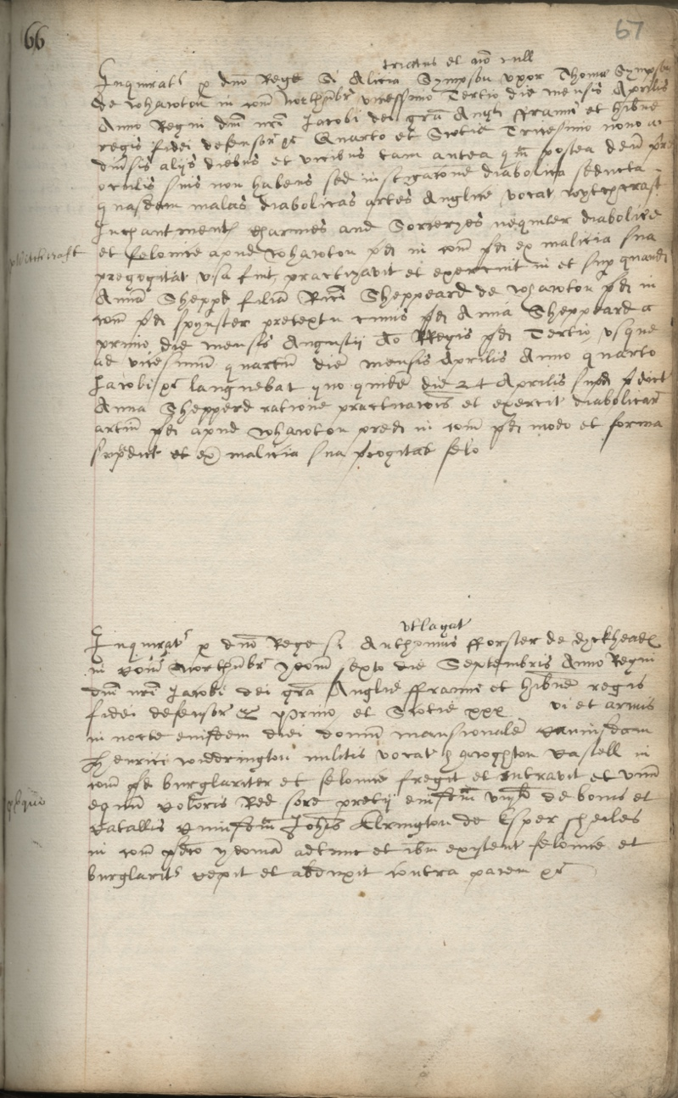
Indictment for Witchcraft, 1606
Reference: QSI 1 p.67 | Suggested age groups: KS2, KS3, KS4, lifelong learners |Crime & Punishment, Witchcraft, Historical Skills

The courts
Northumberland Quarter Sessions court was held in the county from 1388 until 1972. It was a Royal Court of Justice that was held four times a year. There were sessions at Morpeth, Hexham and Alnwick. It was not unusual for large counties to hold sessions at different towns so that justice could be done for the whole of the county. Berwick was not included as it had its own court.

Assizes courts tried more serious crime such as murder, rape and highway robbery and were held twice a year. In the 1730s petty sessions courts were introduced to try minor (or petty) crimes.

Indictments
Indictment was the most common way of an alleged criminal being brought to court. Anyone could “bring” an indictment as long as they had “probable cause” and as long as they weren’t being malicious; they had to have proof and they couldn’t make an accusation because of a grudge.
The name of the accused (could be one or more person) and their alleged crimes were written on a piece of parchment and given to the Grand Jury (between thirteen and twenty-three male householders aged 21-60). The Grand Jury considered the indictment and decided on the verdict under the direction of the judge.

The earliest indictments (1580-1630) that we hold at Northumberland Archives are not the original pieces of parchment. The indictments were copied out into a volume. The handwriting would suggest that they were copied at around the time that the indictments were first presented to the court.

Alice Simpson
This indictment is dated 23 April 1606 and relates to Alice, wife of Thomas Simpson of Whalton. She is accused of using witchcraft, enchantments, charms and sorcery (this is written in Latin but also translated into English) on Ann/Anna daughter of Richard Sheppard, also living in Whalton. This didn’t happen on just one occasion. Instead, the document states it continued from 1 August 1605 right up until the date of the indictment. There is no indication whether she was found guilty or not.

Language
This indictment is in Latin. Official documents, such as court records, used Latin until 1733. There was a short gap during the Commonwealth (1650-1660) when English was used.

Handwriting
The style of the writing used in this document is typical of the time; it is called “Secretary Hand”.

Additional Resource
Because of the difficulty of reading Secretary Hand and of translating from Latin, an extra PowerPoint and teacher’s notes PDF has been created about this document.

Other online resources

Witch trials
The National Archives education website, page about witch trials: https://www.nationalarchives.gov.uk/education/resources/early-modern-witch-trials/
Haunted Palace Blog website, page about Newcastle Witch Trials: https://hauntedpalaceblog.wordpress.com/2013/09/02/king-coal-and-the-witch-pricker-the-newcastle-witch-trials-of-164950/
YouTube website, film about the Newcastle witch trials by Newcastle Castle (5 minutes): https://www.youtube.com/watch?v=GR-SnHHIreA
Teaching Women’s History website, page about early modern witch trials (includes teaching resources and PowerPoint to download): https://teachingwomenshistory.com/teaching-resources/early-modern-witchcraft/
BBC website, page for podcasts about Scottish witch trials: https://www.bbc.co.uk/programmes/p07rn38z/episodes/downloads
BBC Teach website, page with short film extract from “The Ascent of Woman” (2 minutes 55 seconds): https://www.bbc.co.uk/teach/class-clips-video/history-ks3--gcse-why-were-there-witch-hunts-in-the-seventeenth-century/zcxrf82
BBC Bitesize website, page about witch trials: https://www.bbc.co.uk/bitesize/guides/zy7nqhv/revision/4
BBC Bitesize website, page about beliefs and superstitions: https://www.bbc.co.uk/bitesize/guides/zmjnb9q/revision/3
BBC website, short film about Pendle witch trials “Interpretations of Witchcraft”, presented by young people (3 minutes): https://www.bbc.co.uk/programmes/p00w4p7y

Witchcraft in Northumberland
Newcastle University website, page for public lecture “Thinking with Anne Armstrong” by Professor James Sharpe (audio and Powerpoint slides – 1 hour): https://www.ncl.ac.uk/events/public-lectures/archive/item/2015thinkingwithannearmstrong.html
Northumberland Archives website, blog page for “Witchcraft in Northumberland”: https://www.northumberlandarchives.com/2020/04/14/witchcraft-in-northumberland/
Northumberland Archives website, blog page for “Men Were Witches Too”: https://www.northumberlandarchives.com/2020/04/06/men-were-witches-too/

Latin
Gov.uk blog site, page about the use of language (including Latin) in government: https://history.blog.gov.uk/2017/04/19/the-language-of-government-and-the-power-of-plain-english/
The National Archives website, page for Latin tutorial: http://nationalarchives.gov.uk/latin/

Handwriting
The National Archives education website, page about reading old handwriting: https://www.nationalarchives.gov.uk/education/resources/palaeography/

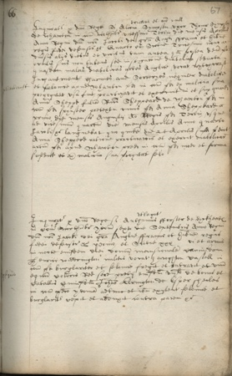
Indictment for Witchcraft, 1606

Topic: Crime & Punishment, Witchcraft
Subject areas: History, LITERACY, Language

Background | Activity | Resources
Indictment was the most common way of an alleged criminal being brought to court. Anyone could “bring” an indictment as long as they had “probable cause” and as long as they weren’t being malicious; they had to have proof and they couldn’t make an accusation because of a grudge.  The name of the accused (could be one or more person) and their alleged crimes were written on a piece of parchment and given to the Grand Jury (between thirteen and twenty-three male householders aged 21-60). The Grand Jury considered the indictment and decided on the verdict under the direction of the judge. | See: What was the Northumberland Quarter Sessions court?  See: Which types of crimes did the Assizes court try?  See: What is an indictment?  See: Who could bring an indictment?  See: What was needed to bring an indictment?  See: What language is this indictment written in?  See: Can you see any words written in English that might tell you what this indictment is about?  See: What is Secretary Hand? | https://history.blog.gov.uk/2017/04/19/the-language-of-government-and-the-power-of-plain-english/  http://nationalarchives.gov.uk/latin/  http://rycote.bodleian.ox.ac.uk/Palaeography-Guide-alphabet  https://latin-dictionary.net/
Think: Why is this indictment written in Latin?
Think: What might the words “uxor” and “filia” mean?
Think: Why were women referred to in relation to their father or husband?
Think: How would this indictment have been used, and who would have used it?
Do: Using the additional resource PowerPoint and PDF, work through the document to see if you can understand who is being accused of what in this indictment.
Do: Using a Latin dictionary, can you find any other words in Latin that could translate as daughter or wife?
Do: Write your own indictment for an accusation of witchcraft.
Do: Look at the Secretary Hand alphabet, have a go at writing out the letters.
Do: Try writing your indictment in Secretary Hand.
Do: Try translating some of your indictment into Latin.
This indictment is dated 23 April 1606 and relates to Alice, wife of Thomas Simpson of Whalton. She is accused of using witchcraft, enchantments, charms and sorcery (this is written in Latin but also translated into English) on Ann/Anna daughter of Richard Sheppard, also living in Whalton. This didn’t happen on just one occasion. Instead, the document states it continued from 1 August 1605 right up until the date of the indictment. There is no indication whether she was found guilty or not. | See: Who was accused in this indictment?  See: What was Alice Simpson accused of?  See: When is Alice first accused of using witchcraft against Ann Sheppard?  See: How long is Alice accused of using witchcraft against Ann for? | https://www.nationalarchives.gov.uk/education/resources/early-modern-witch-trials/  https://www.bbc.co.uk/bitesize/guides/zmjnb9q/revision/3
Think: What types of witchcraft might Alice have used against Ann?
Think: What types of evidence might Ann and Richard used to accuse Alice of witchcraft?
Think: Do you think Alice might have been found guilty?
Think: How might the court have decided whether or not Alice was guilty?
Think: If Alice was found guilty, how might she have been punished?
Do: Look through the document, try to find the names Alice, Thomas Simpson, Ann and Richard Sheppard. Can you also find the words “witchcraft, enchantments, charms and sorcery”?
Do: Write your own charm or enchantment.
Do: Write a script of the events that took place between Ann and Alice.
Do: In groups, imagine you are the jury who have been presented with this indictment. Would you find Alice guilty of bewitching Ann, and if so, how would she be punished?

