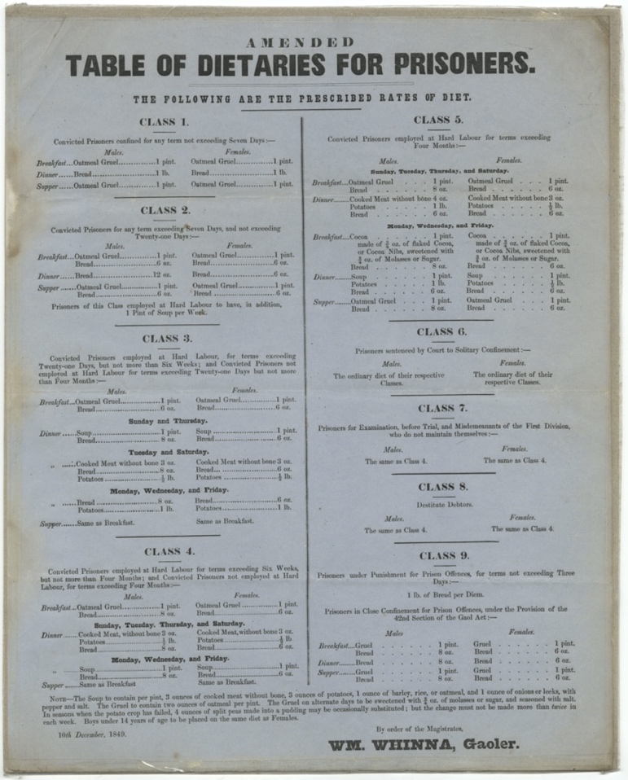
Writing “Dietaries” with Berwick Gaol
Dietaries of Prisoners for Berwick Gaol, December 1849 Reference: BA/C/GA/2/6

Berwick Gaol Dietaries
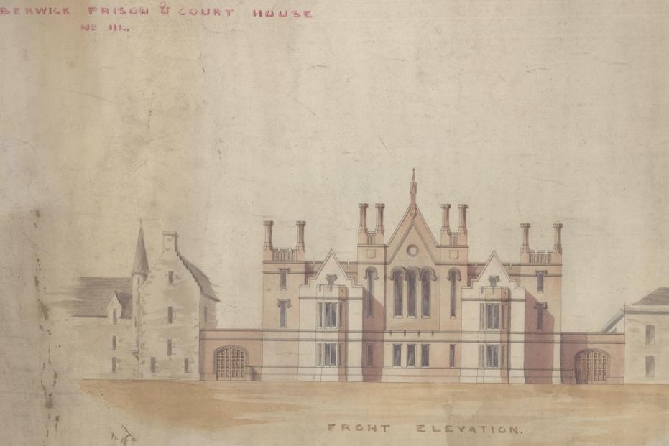
This “Dietaries of Prisoners” was drawn up for the new Jail in Berwick which was opened in late November 1849. The prisoners were given different amounts of food depending on how long they were staying there, what type of work they were doing and sometimes because of what they had done. For example, Class 2 prisoners who were staying between 7 and 21 days were only fed oatmeal gruel and bread the whole time. If they had to do hard labour (breaking stones), they also got an extra pint of soup a week.
BA/C/GA/1/11
The diet for Class 4 prisoners who were doing hard labour and staying between 6 weeks and four months was more varied. Breakfast and supper were always oatmeal gruel (porridge and bread) whilst dinner was more varied – depending on the day of the week. On Saturdays, Sundays, Tuesdays and Thursdays there was some meat with bread and potatoes whilst on the other days it was just soup and bread. Men and women also received different amounts of food – normally the women were given less bread. Class 9 prisoners who had done something wrong when they were in prison were given even less food. For three days, they were only fed bread and presumably water.
The recipe for the oatmeal gruel and soup was also regulated and can be found at the bottom of the page. In March 1851 when the census was taken, there were 8 prisoners in the jail – 5 men and 3 women.
💡 What do you think about the food that the prisoners were served? How would you feel if it is what you were given to eat?
💡 What different dietary needs do men, women and children have?
💡 Can you use a calorie calculator, such as the one offered by the NHS, to work out how many calories men, women and children should consume each day? Were the prisoners consuming enough calories?
💡 Do you think the prisoners were given a healthy variety of foods?
💡 How often do you repeat what you have for each meal?
✏️ Keep a journal of all the food you eat for a week. Make a note each time you have the same food item during the week.
🌍 What do you think Berwick Gaol looks like today? Do you think it is still there? How might the building be used?
✏️Can you make a drawing of what the building looks like now in the same style as the illustration of the Gaol?
👩‍🍳 Have a go at making the gruel or soup recipe noted at the bottom of the dietary. How can you improve the recipes? What will you change?
✏️ Write down your new, improved soup or gruel recipe.

