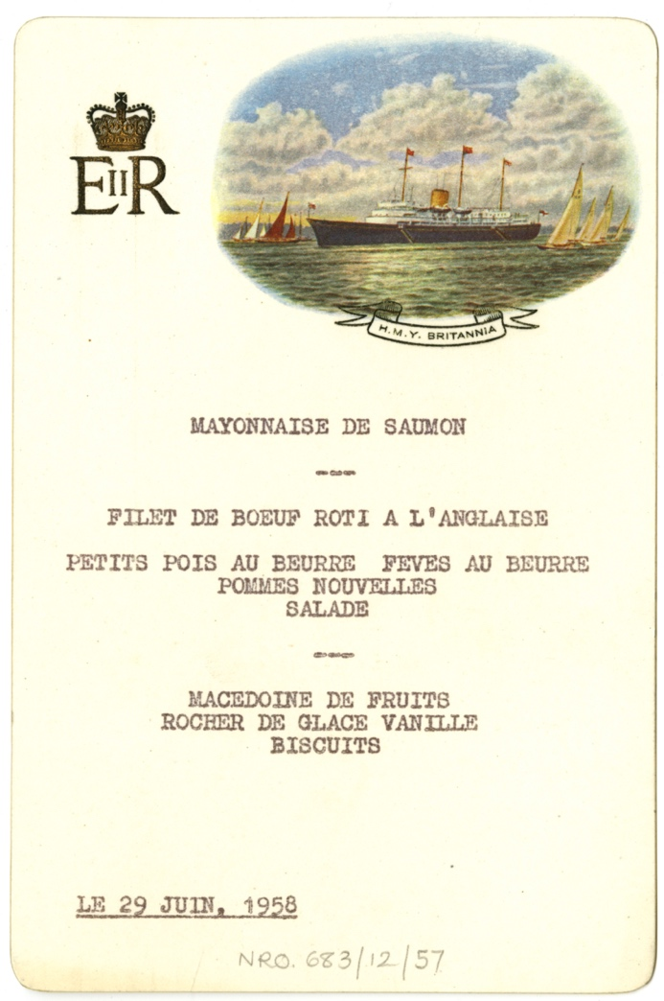
Lunching with The Queen on Holy Island
Menu of a meal served on the Royal Yacht Britannia, 29th June 1958, Reference: NRO 683/12/57

A Royal Visit
On 29 June 1958, the Royal Yacht, Britannia was moored off Holy Island in North Northumberland. That morning Queen Elizabeth II and the Duke of Edinburgh Prince Philip visited the Island. Many people came to see them.
They arrived at the Lifeboat Station at 10.30am, brought in on the Royal Barge and visited various places on the Island including the Church and the Castle. Prince Philip could not stay the whole time – instead, he had to rush off to play in a polo match at Windsor.
💡 Why do you think the Queen visited Holy Island?
💡 How do you think Prince Philip travelled back to Windsor for his polo match?
🌍 Did you know, you can visit Holy Island, including the Church, Priory and the Castle. How much do you think it will have changed since the Royal visit in 1958?

The visit finished at 12.30 pm after which the Queen was accompanied back to the royal yacht by 15 guests including Major Crossman and his wife, Lady Rose. They were entertained to lunch.

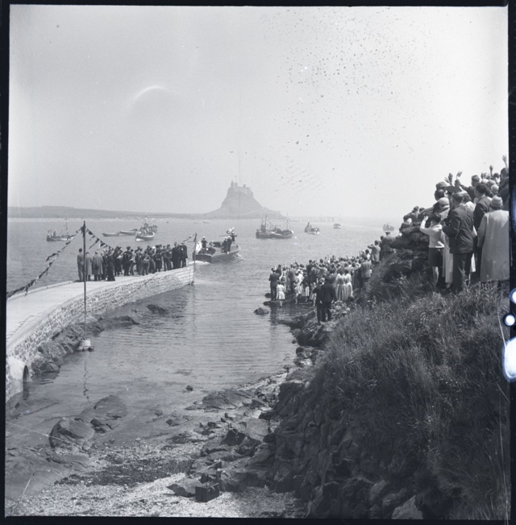
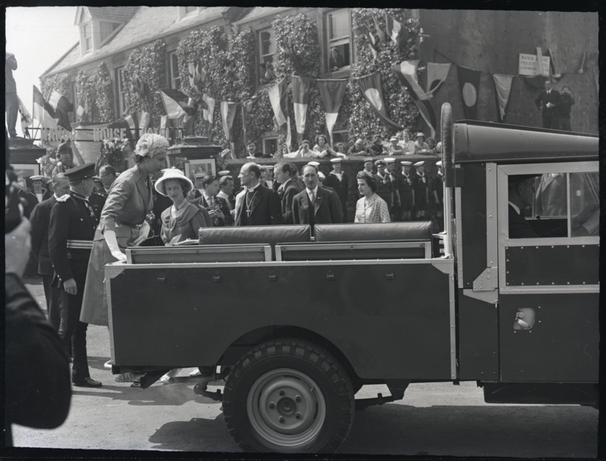
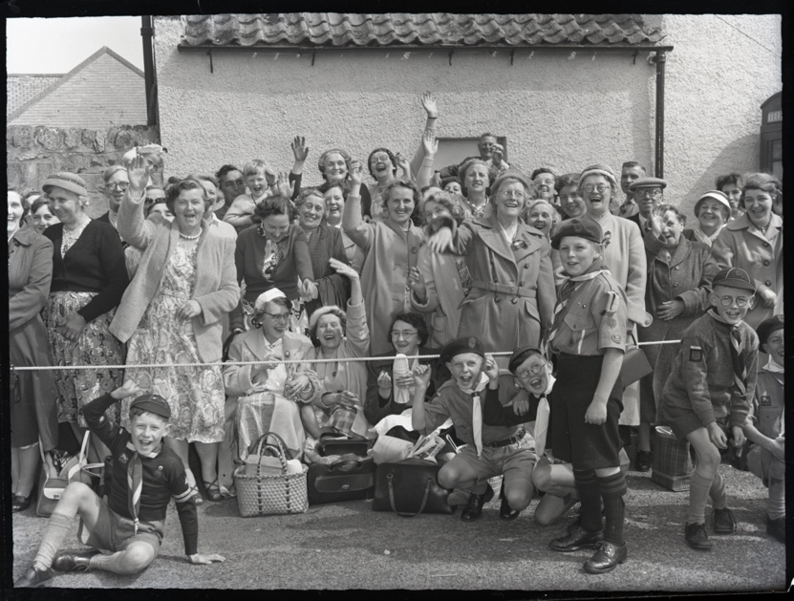
BRO 1944/1/2006/6, 7, 16

💡 What do you think the people watching the Royal visit on Holy Island had in their picnic hampers and flasks? How different would this be to the menu served on the Royal Yacht Britannia?
✏️ Imagine you’re going to Holy Island to watch the Royal visit. Plan a lunch menu to take in your picnic hamper. What drink would you take in your flask?
🧺Have a go at making your own picnic hamper. You could weave one using paper, or make one using a shoe box, as shown in the following link: https://www.100directions.com/make-a-cute-shoebox-picnic-basket/
👩‍🍳 Have a go at making your picnic menu and serve it in your basket.

The Menu
This menu is part of the Crossman family papers kept at the Berwick Record Office. Typed up in French, it tells us that the guests ate salmon mayonnaise, followed by Roast Beef fillet “a l’Anglaise” served with peas, butter beans, new potatoes and salad. Dessert was fruit salad, vanilla ice cream and “biscuit”.
💡 Why do you think the menu is written in French?
💡 Does the menu sound appealing? Are there any dishes you would like to have tried?
✏️ What would you serve the Queen for lunch on Holy Island? Can you come up with a menu? You could think about local produce from the area.

Ice Cream
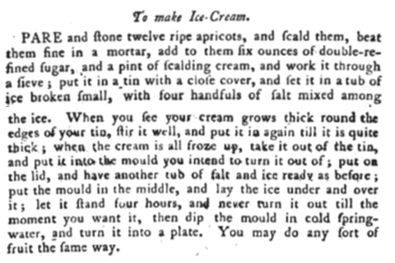
Hannah Glasse (1708-1770), the daughter of Northumbrian landowner Isaac Allgood, was a cookbook author. In 1747 she published the cookery book ‘The Art of Cookery made Plain and Easy’. The 1774 edition of the book contains a recipe for apricot ice cream.
💡 Is this how ice cream is still made? What equipment do we have access to that Hannah would not have had?
✏️ Can you modernise and re-write Hannah Glasse’s ice cream recipe?
👩‍🍳 Have a go at making ice cream. Which flavour will you make? Apricot like Hannah? Vanilla as served on the Royal Yacht Britannia? Or something else?

