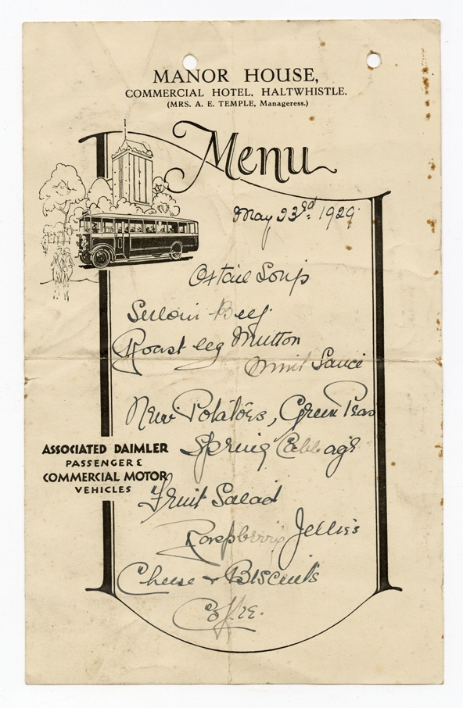
Creating menus with The Manor house Hotel
Illustrated menu card for the Manor House Hotel in Haltwhistle, 1929, Reference: ZBL 276/12

The Manor House Hotel
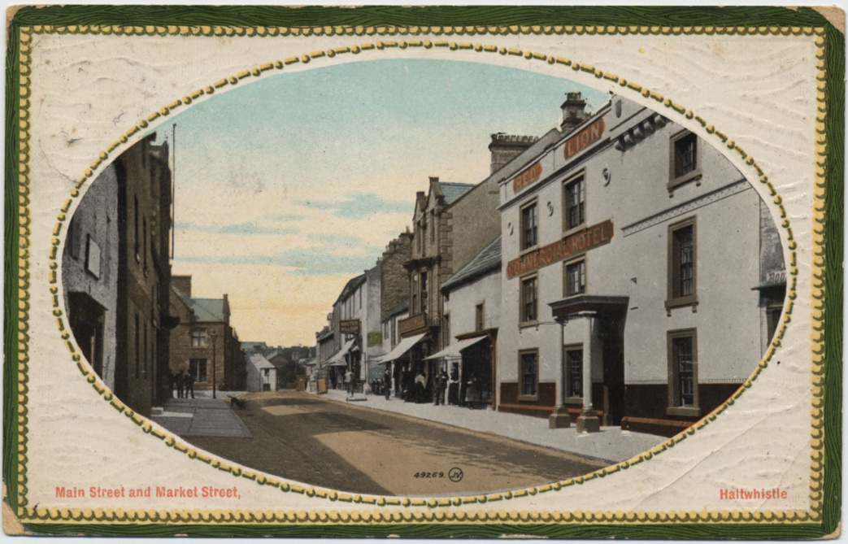
The Manor House Hotel was and still is situated on the Main Street of Haltwhistle. It has been in existence since at least the 1840s and was a coaching inn. In the 1920s, Haltwhistle was a thriving small market town near the border with Cumberland. Being on the Main Street and in the centre of the town, the Manor House Hotel was well used and frequented by visitors.
NRO 2409/139

💡 How much do you think the Manor House Hotel and Haltwhistle will have changed since the 1840s? How well visited do you think it currently is?
💡 Are you surprised that the hotel has been in existence for so long?
🔍 Can you find the oldest buildings and businesses in your local area? How much have they changed since they came into existence?

The Menu
This menu shows us what was being served at the Manor House Hotel on Thursday 23rd May 1929. Guests could start with oxtail soup followed by either beef or lamb with mint sauce, both accompanied by new potatoes, green peas and spring cabbage. To follow there was fruit salad, raspberry jellies or cheese and biscuits and then coffee.
This menu is amongst the archive papers of the Blackett family of Matfen. We don’t know why it was kept.
💡 Why do you think the Blackett family kept the menu card?
💡 Would you have kept the menu card? Do you keep mementos from days out?
💡 What would you have ordered from the menu? Does it sound appealing?
💡 Do you think this menu is similar or different to the Manor House Hotel’s current menu?
✏️ Imagine you are making a new menu for the Manor House Hotel. What dishes would you include on it?
✏️ Have a go at designing the menu with illustrations representing the history of the building.

Seasonal Produce
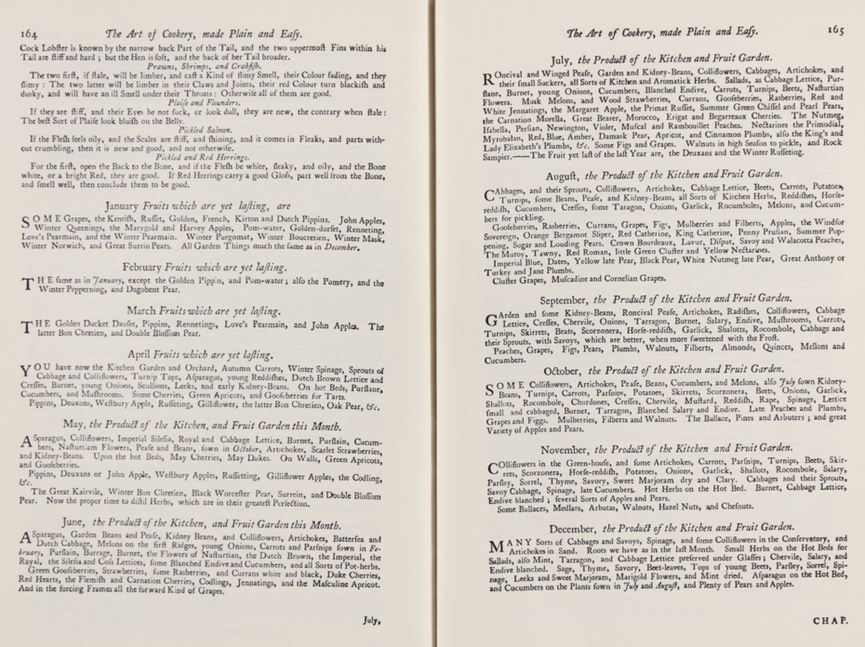
Hannah Glasse (1708-1770), the daughter of Northumbrian landowner Isaac Allgood, was a cookbook author. In 1747 she published the cookery book ‘The Art of Cookery made Plain and Easy’. Chapter XXI of the book describes which fruits, vegetables and herbs are in season each month of the year.
✏️ Using the information about which foods were in season from Hannah Glasse’s book, have a go at writing an alternative menu that the Manor House Hotel could have served in May. Can you turn this into an illustrated menu card?
👩‍🍳 Have a go at cooking some of the dishes on your menu.
🔍 Go on a nature walk, how many seasonal fruits, vegetables and herbs can you identify?
✏️ Create a seasonal guidebook showing the different seasonal foods you saw growing during your nature walk. You could make note of where they can be found, drawings of how they look, and include recipe suggestions of how each could be used.
✏️ Think about what month it currently is. Come up with a seasonal dinner meal to make for your family. How many courses will you serve? Can you turn this into an illustrated menu card?
👩‍🍳 Have a go at making the dishes on your family dinner menu.

