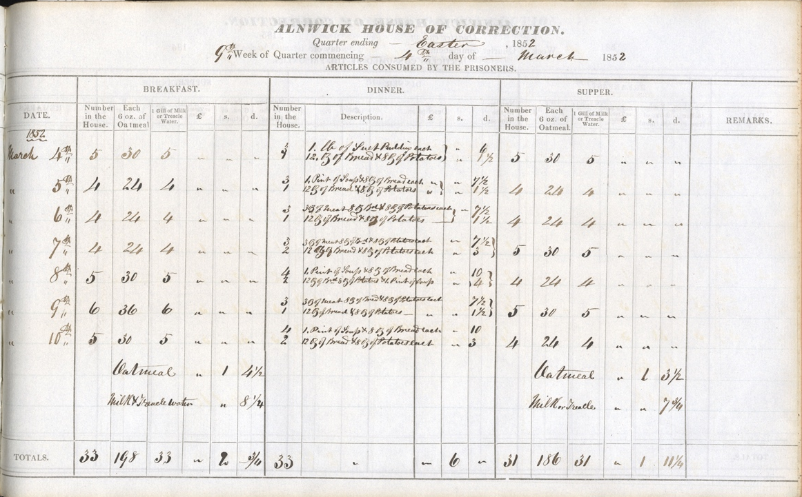
Dietary of Alnwick House of Correction, 4th March 1852
Reference: NRO 304/53| Suggested age groups: KS2, KS3, KS4, Lifelong Learners |Topic areas: Food & Cookery, Crime & Punishment

Alnwick House of Correction
Alnwick House of Correction was situated in Green Batt and was opened in 1807. Poor people were sent there if they refused to work. It also acted as a prison for criminals who had committed minor crimes and were sentenced to hard labour – normally breaking stones.

The Food
In 1853, 73 people were committed to this prison. The prisoners were all served the same food. The document notes the food eaten by the prisoners between 4th and 10th March 1852. Breakfast each day was oatmeal with either milk or treacle water. This was probably a form of porridge.
Dinner was a bit more varied depending on the day of the week. On Thursdays, there was suet pudding, bread and potatoes. On Mondays, Wednesdays and Fridays there was soup with bread and potatoes whilst on Tuesdays, Saturdays and Sundays a little bit of meat was served with more bread and potatoes. Supper was exactly the same as breakfast.
It cost 10 shillings to feed the prisoners that week, equivalent to about £40 today.

Other online resources
Alnwick House of Correction https://alnwickcivicsociety.org.uk/2019/08/02/alnwick-house-of-correction/

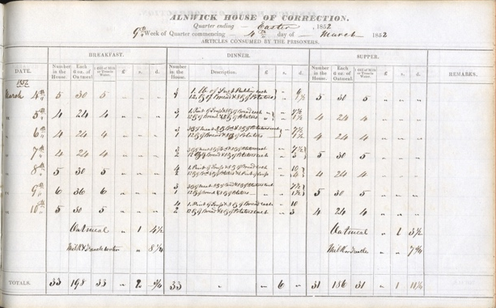
Learning Activities – Dietary of Alnwick House of Correction, 4th March 1852

Topic: Food & Cookery, Crime & Punishment
Subject areas: Cookery, History, Science
Background | Activity | Resources
Alnwick House of Correction was situated in Green Batt and was opened in 1807. Poor people were sent there if they refused to work. It also acted as a prison for criminals who had committed minor crimes and were sentenced to hard labour – normally breaking stones. | See: Where was the house of correction located in Alnwick?  See: Why were people sent to a house of correction?  See: What types of food were served in the house of correction?  See: How much did it cost to feed the prisoners? What is this equivalent to in today’s money? | https://www.bbc.co.uk/bitesize/guides/zyp6sg8/revision/2  https://www.bbc.co.uk/bitesize/guides/z7yttv4/revision/1
Think: Do you think it was right to send poor people who refused to work, and criminals who had committed minor crimes to the House of Correction?
Think: Do you think it was right to sentence the inmates to hard labour?

Think: Do you think hard labour would have caused the inmates to work up an appetite?

Think: Do you think the inmates were served enough food?

Think: What are macro nutrients and food groups? Can you work out the different types of food your body needs?

Think: Would you want to eat any of this food?
Do: Can you find where the House of Correction would have been on a map of Alnwick?
Do: Create a table showing the different micronutrient categories and their purpose.
Do: Can you organise the inmates’ food into different food group and macro nutrient categories? Do you think they were getting enough variety?
Do: Create a table showing the recommended food intake requirements for men, women and children.
Do: Create a weekly food plan and shopping list for your household. Can you work out how much this would cost?
Do: Imagine you’ve been given a £40 budget to feed your household for a week. Create a weekly meal plan and shopping list sticking to the budget. Is this achievable? Can you get enough food with enough variety?
Do: Have a go at reimagining one of the meals served to the inmates. Write a recipe for a modernised, healthy version and then cook your dish.

