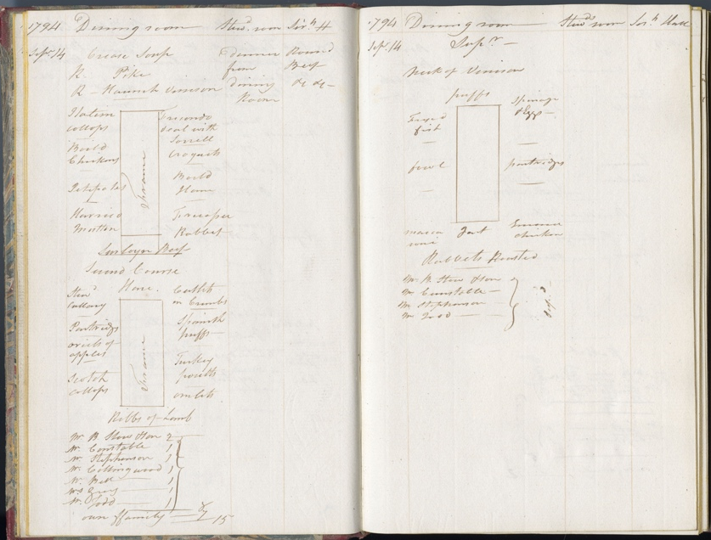
Book of Daily Bills of Fare, 14th & 15th September 1794
Reference: 2DE 30/11| Suggested age groups: KS2, KS3, KS4, Lifelong Learners |Topic areas: 18th Century Food & Cookery

The Delaval Family
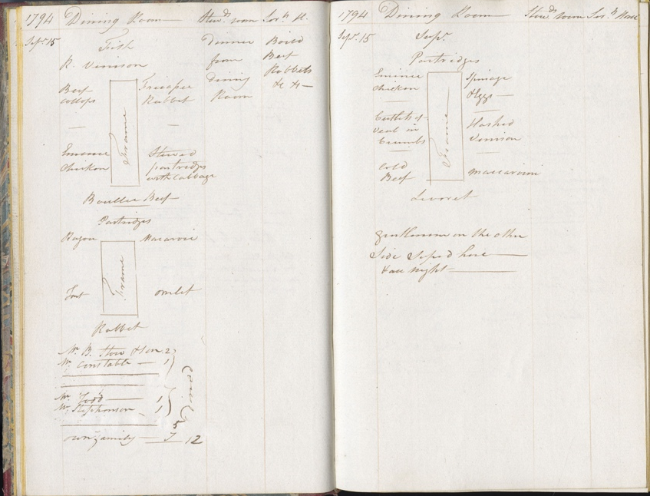
The Delaval family lived at Seaton Delaval in south east Northumberland but also had estates in the late 18th century at Ford (North Northumberland) and Doddington (Lincolnshire). At this time the 1st Baron Delaval, John Hussey Delaval was living at Seaton Delaval Hall. He was involved in politics and for various periods between 1754 and 1786, he was an MP for Berwick. The family were renowned for their parties and lavish entertaining at Seaton Delaval Hall.

Sunday 14th September 1794
These documents tell us what the family ate on a daily basis. The books may have been written up by the housekeeper or butler and are divided into menus for the Dining Room (the family), Steward’s Room (the upper servants) and Servants Hall (the other servants). They didn’t all eat the same thing.
Two meals a day are listed – dinner which was probably in the middle of the day and supper. The menu for dinner in the dining room often indicates who was eating with the family. On Sunday 14th September 1794, 15 people had dinner at Seaton Delaval – seven family members and eight other people - Mr B Stow and Son; Mr Constable; Mr Stephenson; Mr Collingwood; Mr Bell; Mr Todd and Mrs Grey.
The menu was very lavish and consisted of several courses of numerous dishes. This page shows what was served and how it was set out. Following soup, there was a first course choice of boiled chicken or ham, rabbit, mutton and sirloin beef with croquettes. The dishes offered in the second course included cutlets in crumbs, scotch collops; omelettes; Spanish puffs and ribs of lamb. Dessert is not mentioned.
The Stewards room were served the same as the dining room whilst the Servant’s Hall ate Round Beef and some unidentified dishes. The food eaten at dinner sounds a lot, but supper was also served in the Dining Room later on and included spinach and eggs; roasted rabbit; fried fish; partridges and macaroni. Only five of the guests stayed for supper.

Monday 15th September
The five guests must have stayed overnight as their names are listed as guests the next day – Monday 15th September. The menu that day is less lavish, but dinner still consists of a number of courses with various choices including roasted venison, stewed partridge with cabbage, ragout, omelette and macaroni. Again, the Stewards Room ate the same food as those in the Dining Room whilst the Servants Hall ate Boiled Beef and rabbits. The guests also stayed to supper and could eat hashed venison, cold beef and cutlets of veal in crumbs.

Additional Image
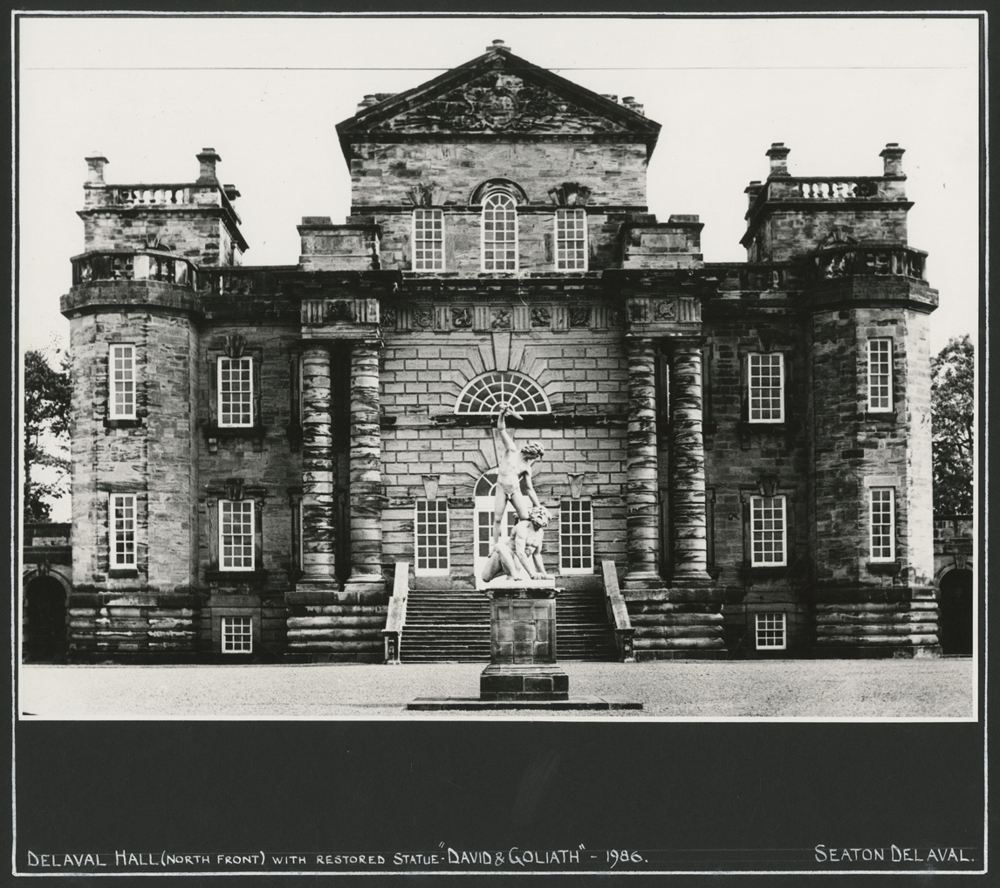
Seaton Delaval Hall – NRO 05729/F/01/03

Other online resources
National Archives currency converter - https://www.nationalarchives.gov.uk/currency-converter
Seaton Delaval Hall - https://www.nationaltrust.org.uk/seaton-delaval-hall

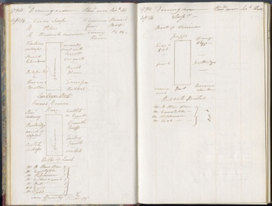
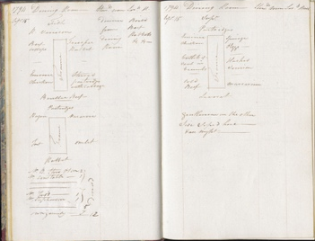
Learning Activities – Book of Daily Bills of Fare, 14th & 15th September 1794

Topic: 18th Century Food and cookery
Subject areas: Cookery, History, Art, Literacy
Background | Activity | Resources
On Sunday 14th September 1794, 15 people had dinner at Seaton Delaval – seven family members and eight other people - Mr B Stow and Son; Mr Constable; Mr Stephenson; Mr Collingwood; Mr Bell; Mr Todd and Mrs Grey. The five guests must have stayed overnight as their names are listed as guests the next day – Monday 15th September. | See: Who dined at Seaton Delaval Hall on Sunday 14th September 1794?  See: What were the names of the guests?  See: How many guests stayed overnight?  See: How many courses were served?  See: Which dishes were served?  See: Was everyone in the household served the same thing? | http://umich.edu/~ece/student_projects/food/rules.htm  https://carnegiemuseums.org/magazine-archive/1996/sepoct/feat5.htm  https://engl3164.wordpress.com/2012/11/05/18th-century-table-setting/
Think: What kind of parties and lavish entertainment do you think the Delaval family hosted?
Think: How different do you think they were from parties today?
Think: How often do you host guests for meals and overnight?
Think: How often do you think the Delavals hosted guests?
Think: How did the guests travel to Seaton Delaval Hall?
Think: Why were different meals served in different parts of the house?
Think: Are the dishes served similar to what we eat now?
Do: Research dining during this time period. Can you come up with a design of how the table setting may have looked?
Do: Research some of the dishes served. Can you find a recipe and have a go at making it? You may want to modernise the dish.
Do: Imagine you have been asked to write a menu for a Delaval dinner party. Come up with several dishes to serve over a number of courses.
Do: Have a go at creating some of the dishes from your menu.
Do: Can you create a table setting design and lay out your dishes as though they are being presented to the Delaval family and their guests.

