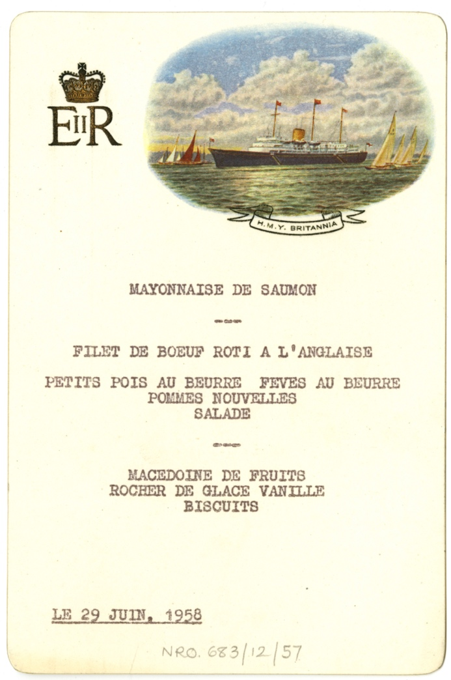
Menu of a Meal Served on the Royal Yacht Britannia, 29th June 1958
Reference: NRO 683/12/57| Suggested age groups: KS1, KS2, KS3, KS4, Lifelong Learners |Topic areas: Food & Cookery

A Royal Visit
On 29 June 1958, the Royal Yacht, Britannia was moored off Holy Island in North Northumberland. That morning Queen Elizabeth II and the Duke of Edinburgh Prince Philip visited the Island. Many people came to see them.
They arrived at the Lifeboat Station at 10.30am, brought in on the Royal Barge and visited various places on the Island including the Church and the Castle. Prince Philip could not stay the whole time – instead, he had to rush off to play in a polo match at Windsor.
The visit finished at 12.30 pm after which the Queen was accompanied back to the royal yacht by 15 guests including Major Crossman and his wife, Lady Rose who were entertained to lunch.

the Menu
This menu is part of the Crossman family papers kept at the Berwick Record Office. Typed up in French, it tells us that the guests ate salmon mayonnaise, followed by Roast Beef fillet “a l’Anglaise” served with peas, butter beans, new potatoes and salad. Dessert was fruit salad, vanilla ice cream and “biscuit”.

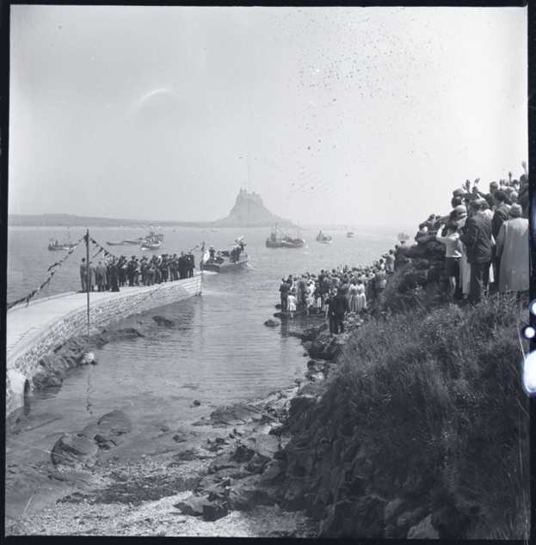
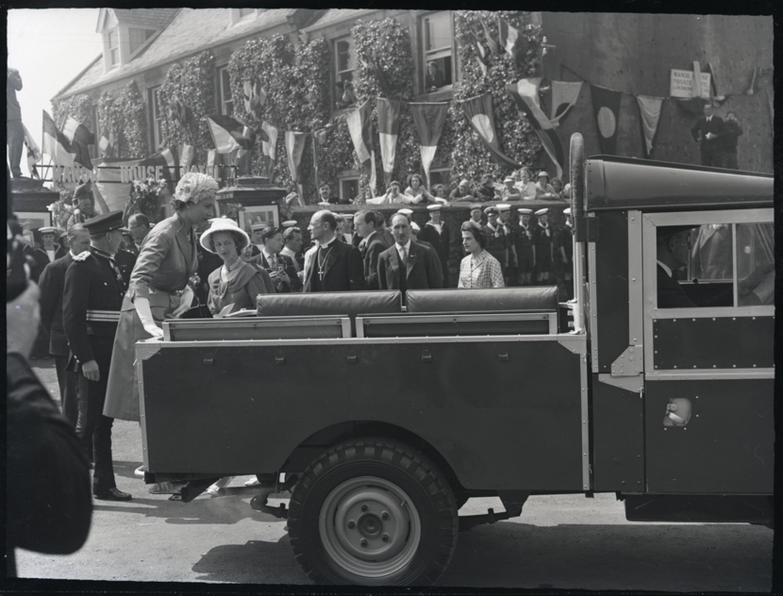
Related Images
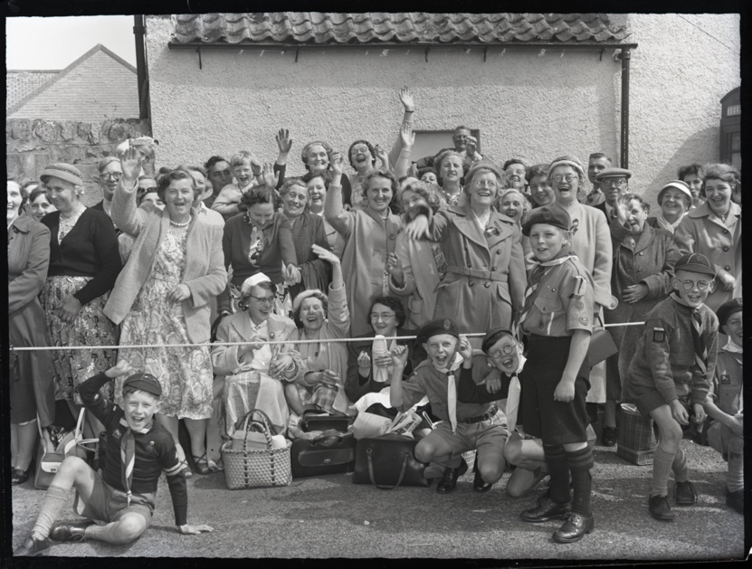
BRO 1944/1/2006/6 ,7, 16

Other online resources

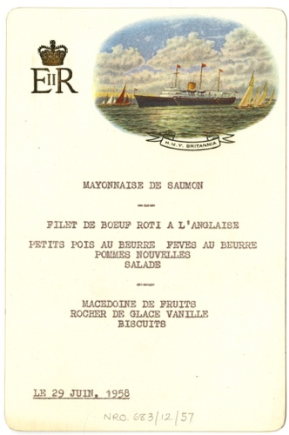
Learning Activities – Menu of a meal served on the Royal Yacht Britannia, 29th June 1958

Topic: Food & Cookery

Subject areas: Cookery, History, French

Background | Activity | Resources
On 29 June 1958, the Royal Yacht, Britannia was moored off Holy Island in North Northumberland. That morning Queen Elizabeth II and the Duke of Edinburgh Prince Philip visited the Island. Many people came to see them.  The Queen was accompanied back to the royal yacht by 15 guests including Major Crossman and his wife, Lady Rose who were entertained to lunch.  Typed up in French, the menu tells us that the guests ate salmon mayonnaise, followed by Roast Beef fillet “a l’Anglaise” served with peas, butter beans, new potatoes and salad. Dessert was fruit salad, vanilla ice cream and “biscuit”. | See: Where is this menu from?  See: Who was the menu served to?  See: Where were the Queen and Prince Philip visiting?  See: What language is the menu written in?  See: Which dishes are included on the menu? | https://www.100directions.com/make-a-cute-shoebox-picnic-basket/
Think: Why did the Queen visit Holy Island?
Think: Why do monarchs make royal visits?
Think: Why do you think the menu is written in French?

Think: What do you think the Queen did while on Holy Island?

Think: Why did so many people go to watch the visit?

Think: Do you think crowds of people would still gather to see a royal visit?
Think: What do you think the spectators might have had in their picnics?
Do: Can you translate the menu into English?
Do: Try to write a recipe for one of the dishes from the menu.
Do: Imagine you’re going to watch the royal visit. Plan a lunch menu to take in your picnic hamper. You could illustrate the menu.
Do: Have a go at making your own picnic hamper.
Do: Create the dishes from your picnic menu and serve it in your hamper.
Do: Imagine you are preparing the lunch on the Royal Yacht Britannia. Plan your menu, you may like to illustrate the menu.
Do: Create a budget or account sheet for a lunch menu. Think about how many people are to attend the lunch and how many ingredients you would need.
Do: Create the dishes from your menu. You may want to think about presentation and table layout.

