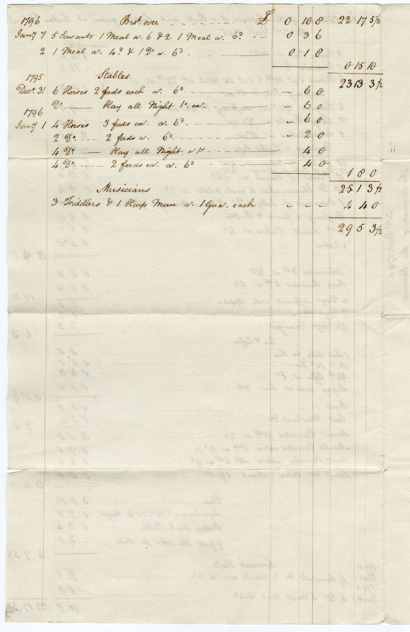
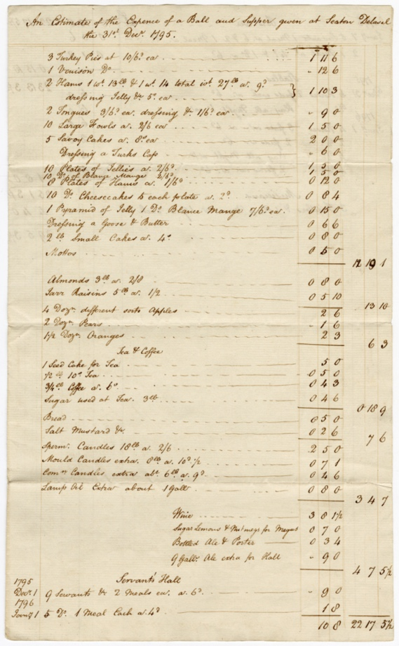
Delaval Family Costs for a Ball, 31 December 1795
Reference: 2DE 30/15/5A&B | Suggested age groups: KS2, KS3, KS4, Lifelong Learners |Topic areas: 18th Century Food & Cookery

The Delaval Family
The Delaval family lived at Seaton Delaval in south east Northumberland but also had estates in the late 18th century at Ford (North Northumberland) and Doddington (Lincolnshire). At this time the 1st Baron Delaval, John Hussey Delaval was living at Seaton Delaval Hall. He was involved in politics and for various periods between 1754 and 1786, he was an MP for Berwick. The family were renowned for their parties and lavish entertaining at Seaton Delaval Hall.

Seaton Delaval Hall New Year’s eve Ball and Supper
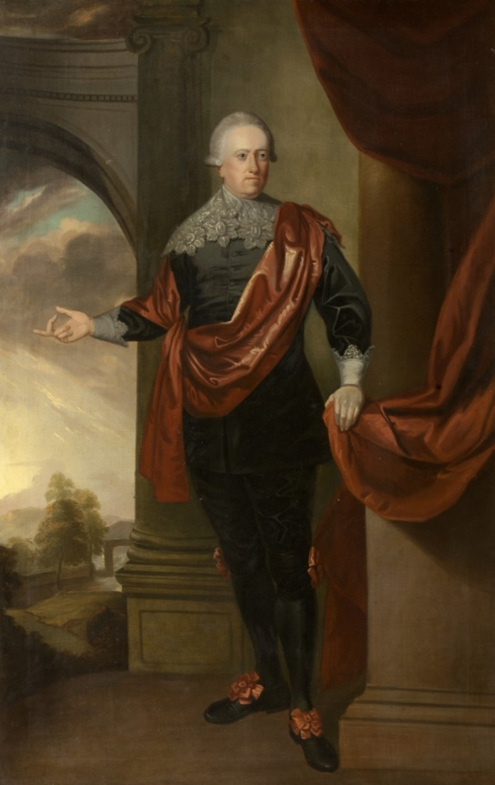
This document is an estimate of the expenses for a Ball and Supper held at Seaton Delaval Hall on New Year’s Eve in 1795. The financial account doesn’t tell us how many people were there but some of them must have brought their servants and stayed overnight as the record shows meals for servants and hay for horses.
The food listed helps us see what was served at a large supper at a Ball in the late 18th century. There must have been a large buffet consisting of various pies (turkey) and meats (venison, ham and tongue), probably cold because of the reference to jelly. There were also sweet dishes including savoy cakes, cheesecakes and small cakes as well as a variety of fruits – almonds, raisins, apples pears and oranges. The guests were also offered wine to drink as well as tea and coffee, bottled beer and porter. The ingredients for a drink called “Megus” are also listed, some form of cocktail which included lemons, sugar and nutmeg. This may be the 18th century drink “Negus” which was wine mixed with hot water, lemons, spices and sugar.
Music for dancing was provided by 3 fiddlers and a harpman who were paid one guinea each and even the cost of the lighting is added in – candles and whale oil for larger lamps.
Baron Delaval. With permission of The National Trust.

Additional Image
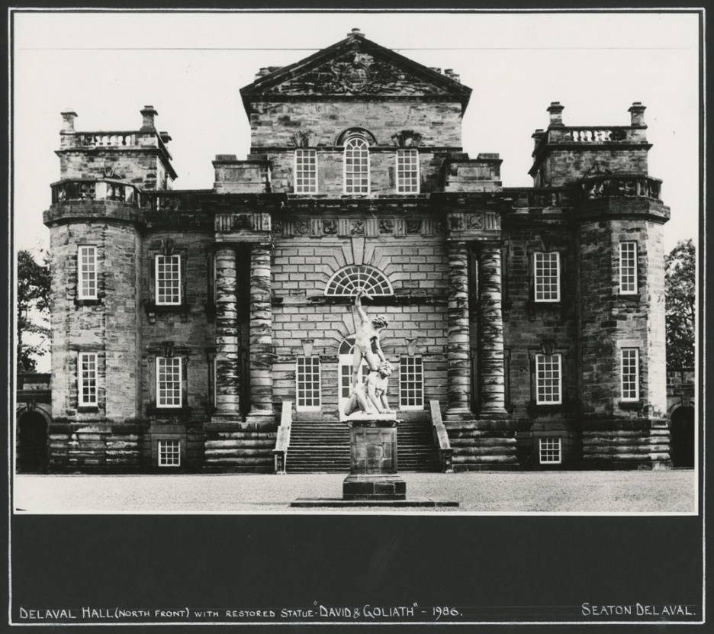
Seaton Delaval Hall – NRO 05729/F/01/03

Other online resources
Savoy cakes - https://www.historicfood.com/Savoy%20Cake%20Recipe.htm
Negus - https://www.food.com/recipe/jane-austens-negus-404531
National Archives currency converter - https://www.nationalarchives.gov.uk/currency-converter
Seaton Delaval Hall - https://www.nationaltrust.org.uk/seaton-delaval-hall

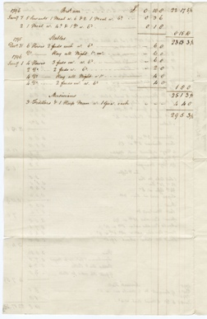
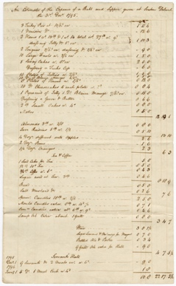
Learning Activities – Delaval Family Costs for a Ball, 31 December 1795

Topic: 18th century food & Cookery

Subject areas: Cookery, History, Literacy, Art, Maths, Music, dance
Background | Activity | Resources
This document is an estimate of the expenses for a Ball and Supper held at Seaton Delaval Hall on New Year’s Eve in 1795. The financial account doesn’t tell us how many people were there but some of them must have brought their servants and stayed overnight as the record shows meals for servants and hay for horses.  The food listed helps us see what was served at a large supper at a Ball in the late 18th century.  Music for dancing was provided by 3 fiddlers and a harpman who were paid one guinea each and even the cost of the lighting is added in – candles and whale oil for larger lamps. | See: What food was served at the ball?  See: Who provided music for dancing?  See: What other expenses are listed?  See: How much did the ball cost?  See: What is the cost equivalent to in today’s money? | https://chertseymuseum.org/Dressed_For_Best  http://www.vam.ac.uk/page/0-9/18th-century-fashion/  https://danceinhistory.com/2015/03/02/ballroom-dancing-in-the-18th-century/  https://www.youtube.com/watch?v=m4oDi4fd39E&ab_channel=SmithsonianChannel
Think: Do you think the ball was expensive? Would it have cost more, less, or the same amount if held today?
Think: How many people do you think might have attended the ball?
Think: How do you think people travelled to the ball?
Think: What type of music might have been played at the ball?
Think: What type of dancing might have taken place at the ball?
Do: Try reading the document. Can you pick out some of the items bought for the ball?
Do: Read the document out loud. Does this make it easier to understand?

Do: Choose a dish from the ball. Find a recipe and have a go at making it. You may want to modernise or put your own twist on the dish.

Do: Imagine you are hosting your own ball and supper. Create a menu to be served. You may want to put together a selection of recipes to help make the menu.

Do: Create an invitation for your ball and supper.

Do: Create an expenses document for your ball and supper – you could set a budget such as the cost of the Delaval ball. Think about how many guests will be attending and staying overnight. How much food you will need to buy and how much it will cost to cook and serve – will you need to pay for kitchen staff and serving staff? You will also need to include costs for entertainment and additional expenses such as lighting and amenities. Do you need to rethink your menu based on the budget and expenses?

Do: Have a go at making some of the dishes from your menu.

Do: Research the clothes worn during this time period. Can you design and make an outfit that could have been worn to the ball?
Do: Imagine you attended the ball. Write a diary account of your experience.
Do: Have a go at 18th century ballroom dancing.
Do: Have a go at composing your own 18th century style music to dance to.

