The Seaside through Time: Newbiggin Beach, 1925 & 2021
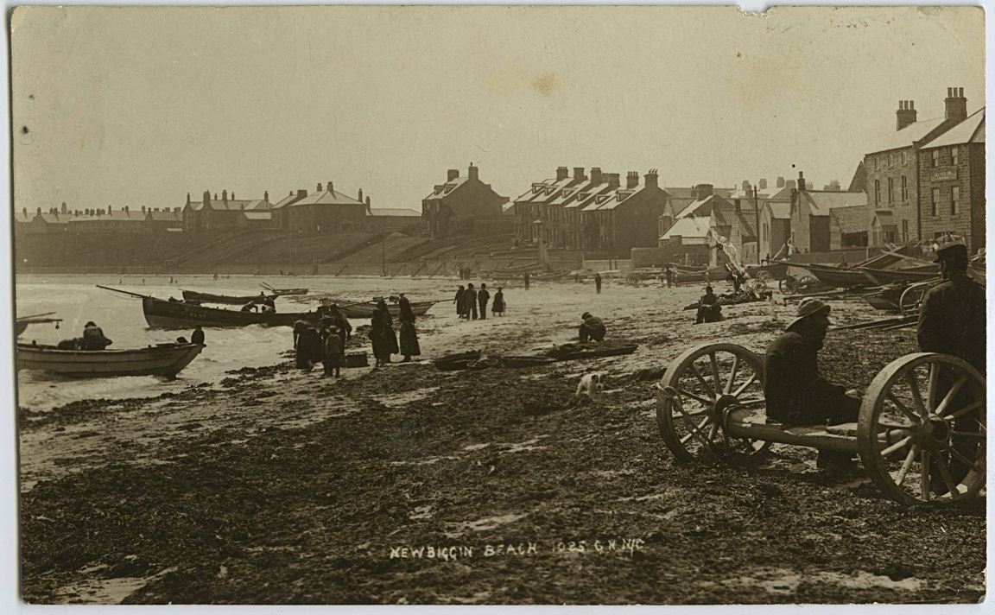
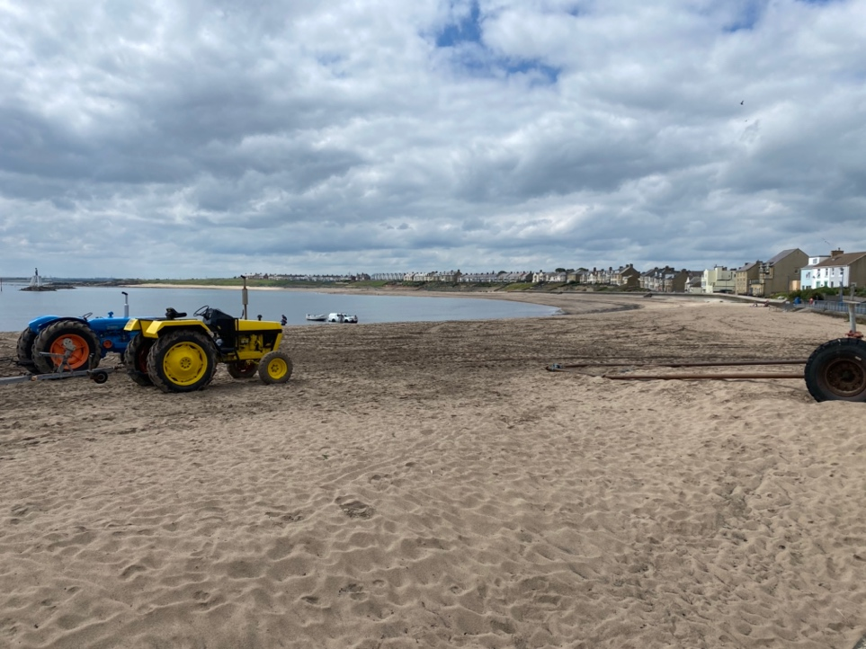
Reference: NRO 5283/A/211 | Suggested age groups: EYFS, KS1 | Topic areas: At the Seaside, Then and Now

Newbiggin Beach
The first photograph was taken in 1925 and shows the sea front at Newbiggin. There are boats on the beach, and you can see the promenade.

The second picture of the beach was taken in July 2021. You can see tractors, and a car towing a boat out of the sea.

Question Prompts
🔍 What is different in these two photographs?
🔍 Is there anything the same in both photographs?
🔍 What colour are the two photographs?
🔍 Are the people wearing similar clothes in each photograph?
💡Are their clothes similar to what you would wear to go to the beach?
🔍 How many people are wearing hats?
🔍 Can you find the dog?
💡What do you think the cart the man is sitting on in the 1925 photograph was used for?
🔍 How many tractors can you see?
🔍 What colour are the tractors?

💡Why do you think the tractors are on the beach?
🔍 How many boats can you see?
💡Have you ever seen boats that look like these ones?
💡Have you ever been on a boat? – Did you enjoy it? What would it be like?
💡Have you ever seen a fisherman at the beach?
💡Have you ever seen any fish at the seaside?
💡Have you ever tried to catch a fish?
💡What would you use to catch it?
💡Have you ever been rock pooling? What did you find?
💡What other types of animals have you seen at the seaside?

Key Words
📝 Tractor – A vehicle used to pull things.
📝 Promenade – A path along the seafront made for taking leisurely walks.
📝 Compare – To find things that are the same and different.

Reading suggestions
📚The Rainbow Fish by Marcus Pfister
📚The Storm Whale by Benji Davies
📚Sharing a Shell by Julia Donaldson
📚Under the Sea by Allison Black
📚Dolphin Boy by Michael Morpurgo
📚The Secret of Black Rock by Joe Todd-Stanton
📚The Mousehole Cat by Nicola Barber

Additional Activities
🎵 Sing sea shanties and traditional songs and rhymes.
🐠 Talk about sea creatures, where they live and how to take care of them.
🐠 Visit an aquarium.
🐠 Make a rainbow fish collage using different materials.
🎣 Play the magnetic fishing game.
⛵Experiment with floating and sinking with objects from around the classroom.
⛵ Ask children to bring in items from the beach, experiment with which items float or sink.
⛵ Make a fishing boat using an item that floats (cork, plastic bottle etc.).
⛵ Have a boat race.

Planning
Learning objectives:
- To introduce children to the concept of going on holiday and visiting the beach
- To look at what the beach was like in the past and compare it with today.
Newbiggin Beach
Communication & Language
Mathematics
Expressive Art & Design
Literacy
Understanding the World
- Counting from photographs
- Time

- Key words
- Comparing photographs
- Discussing the seaside
- Discussing what can be seen in the photographs
- Discussing sea creatures
- Book suggestions

- Understanding past and present
- Comparing holidays from the early 20th century to now
- Comparing clothes then and now
- Understanding sea creatures
- Floating and sinking
- Making collages
- Singing sea shanty’s
- Making boats

