The Seaside through Time: Newbiggin Seafront, 1910 & 2021
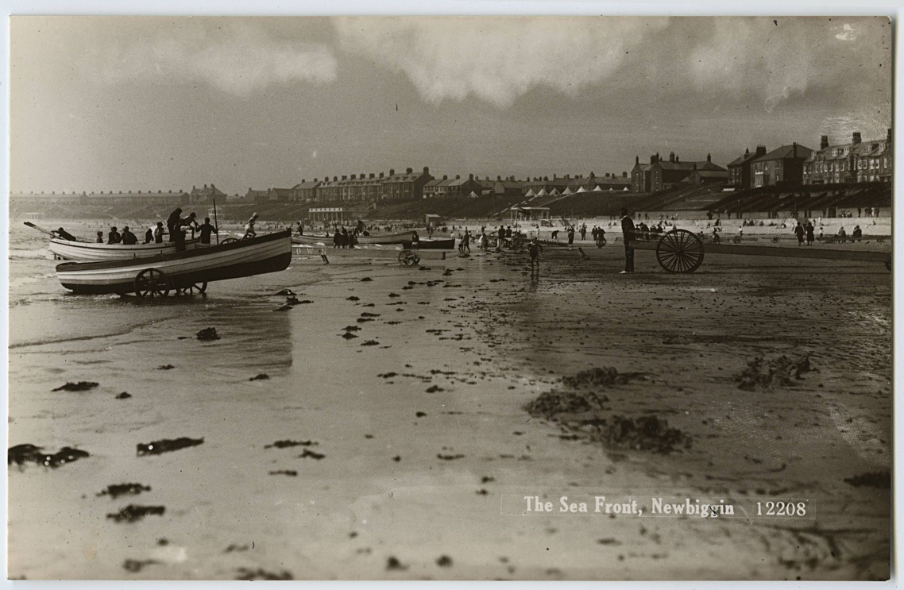
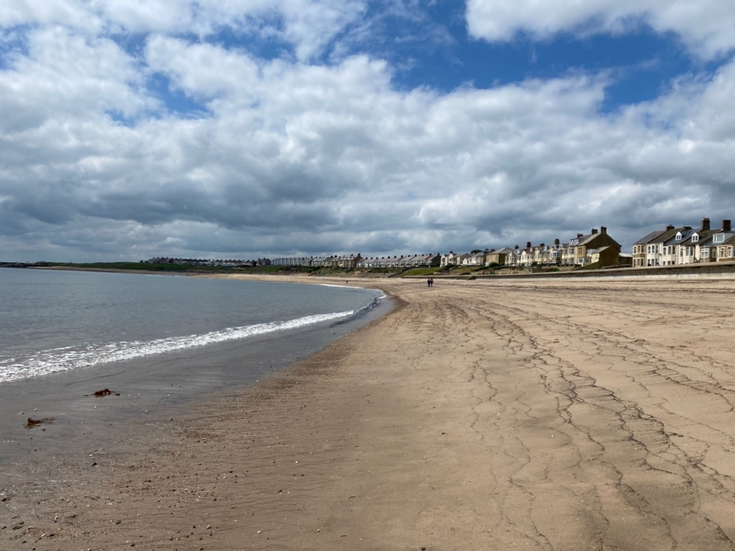
Reference: NRO 5283/A/229 | Suggested age groups: EYFS, KS1 | Topic areas: At the Seaside, Then and Now

Newbiggin Seafront
The first photograph shows Newbiggin beach in the early 1900s. This postcard was sent in 1910. There are fishing boats in the water and some fishermen are sitting on the cart.
The second photograph shows Newbiggin seafront looking south and was taken in July 2021.

Question Prompts
🔍 What is different in these two photographs?
🔍 Is there anything the same in these two photographs?
🔍 What colour are the photographs?
🔍 What kind of plant is on the sand in the 1910 photograph?
💡 Have you ever seen seaweed on a beach?
💡 What else might you find on the beach?
💡Have you ever been rock pooling? What did you find?
🔍 How many boats can you see?
🔍 What types of activities can you see taking place on the beach?
🔍 What do you think is in the white tents in the background of the 1910 photograph?

🔍 Can you find the dog?
💡What types of animal might you see at the beach?
🔍 What are the people wearing on the beach in the 1910 photograph?
💡Are their clothes similar to what you would wear to go to the beach?
🔍 How many people are on the boats?
💡Why are the boats on wheels?
🔍 Why are there black wavy lines on the sand in the 2021 photograph?
💡Would you rather walk or play on a shingle, stone, or sand beach?

Key Words
📝 Seaweed – A plant that grows in the sea.
📝 Compare – To find things that are the same and different.

Reading suggestions
📚 Billy’s Bucket by Kes Grey
📚 Sneakers the Seaside Cat by Margaret Wise Brown
📚 Where the Sea Meets the Shore by Kate Messner
📚 Salty Dogs by Matty Long
📚 Splash, Anna Hibiscus! by Atinkue
📚 Duck & Goose go to the Beach by Tad Hills
📚 Bobby’s Beach Day by Samantha Ball

Additional Activities
🪨Talk about taking care of the beach.
🪨 Talk about erosion.
🎵 Play sound recordings of the sea. Count the beats of the waves and move in time with them.
🖍️ Practice drawing wavy lines to mimic the movement of the sea.
🖍️ Use chalks/pastels/charcoal to make wave drawings.
🎵 Play sound recordings of sea creatures – try to guess which animal is making which noise.
🐙 Discuss favourite sea creatures.
🐙 Make sea creature mobiles, e.g., octopus mobile using handprints.
🏖️ Talk about different types of beaches (sand/stone/shingle). Fill trays with each, compare by sight and feel.
🏖️ Add water to each of the beach trays to see what happens when they get wet.
🏖️ Go beach combing and try to find different items in the sand - or bury them in beach trays.
🏖️ Use a metal detector to look for hidden items in the sand – at the beach or in the trays.
🖍️ Find a pebble at the beach, or elsewhere, and decorate it.

Planning
Learning objectives:
- To introduce children to the concept of going on holiday and visiting the beach
- To look at what the beach was like in the past and compare it with today.
Newbiggin Seafront
Communication & Language
Mathematics
Expressive Art & Design
Literacy
Understanding the World
- Counting from photographs
- Counting waves
- Time

- Key words
- Comparing photographs
- Discussing holidays and the seaside
- Discussing what can be seen in the photographs
- Discussing sea creatures
- Discussing beach types
- Book suggestions

- Wave drawings
- Mobiles
- Pebble art
- Understanding past and present
- Comparing the seaside from the early 20th century to now
- Comparing clothes then and now
- Understanding different beach environments
Physical Development
- Beach combing
- Wave movement

