The Seaside Through Time: Spittal Beach and Promenade, 1950s, 2009 & 2021
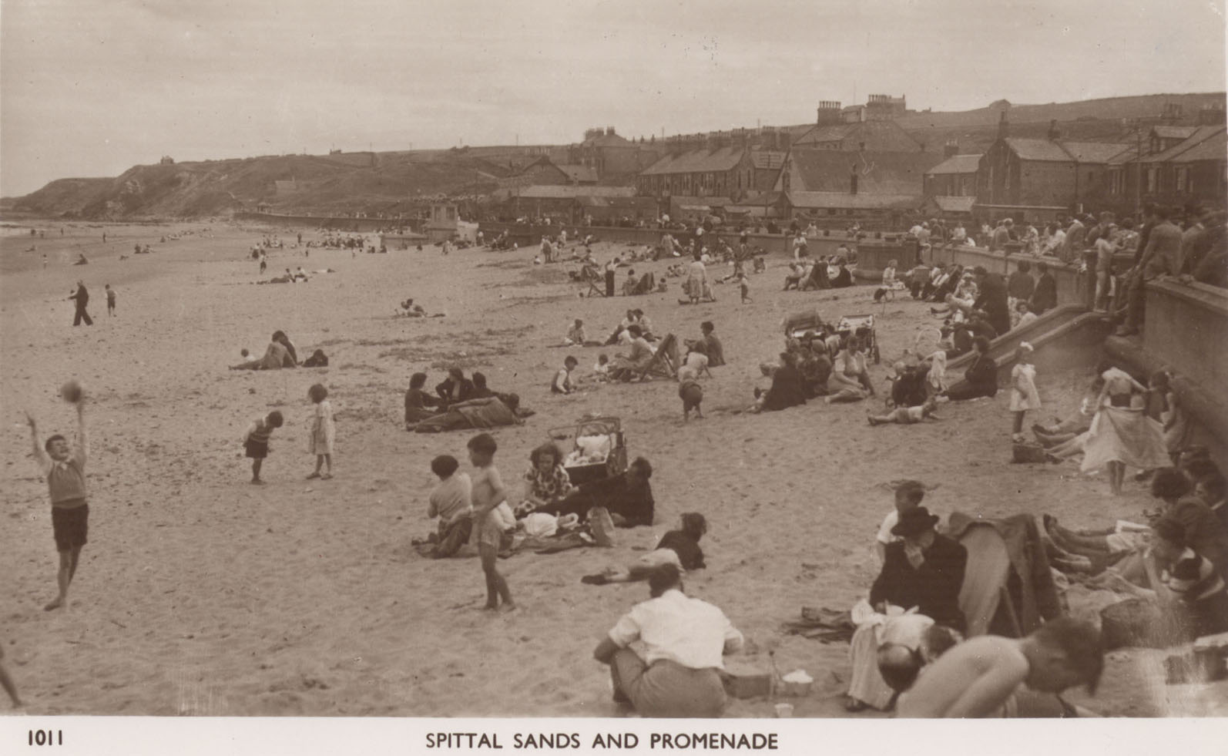
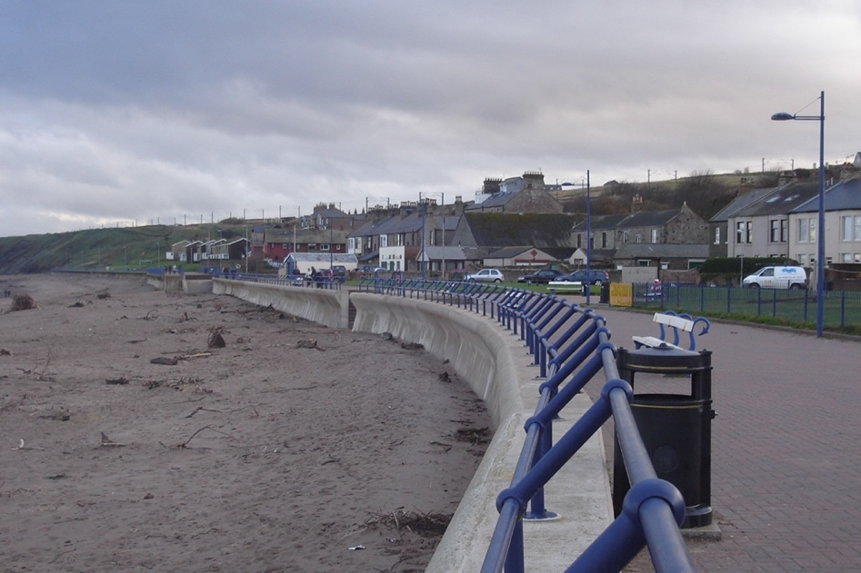
Reference: BRO 426/875 | Suggested age groups: EYFS, KS1 | Topic areas: At the Seaside

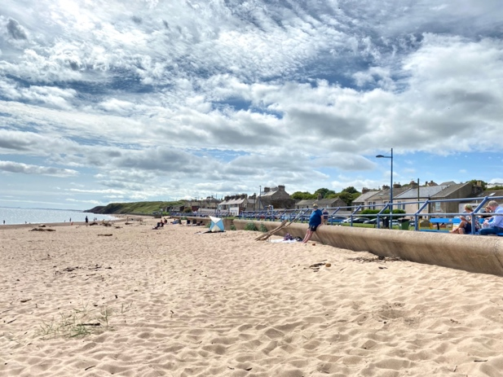
Spittal Beach and Promenade
The first photograph of Spittal beach was taken in the 1950s. It shows children playing on the beach and various family groups. Note the clothes that people were wearing on the beach.
The second photograph shows Spittal beach and promenade in 2009, looking south towards Cocklawburn.
The third photograph shows Spittal beach and promenade in July 2021.

Question Prompts
💡Have you been to the seaside for a holiday?
💡Where have you been on holiday?
🔍 What is different in these three photographs?
🔍 Is there anything the same in these three photographs?
🔍 What colour is the 1950s photograph?
🔍 What colour are the 2009 and 2021 photographs?
🔍 What types of activities can you see taking place on the beach?
🔍 Can you find the boy playing with the ball?
💡 What do you do at the beach?
💡Do you play any ball games at the beach?
🔍 Can you find the beach tent?

🔍 Are the people at the beach in big or small groups?
🔍 Which is the biggest group you can find?
🔍 How many people can you see in the 2009 photo?
💡Who do you go to the beach with?
💡Do you go to the beach in a big or a small group?
💡How do you travel to the beach?
🔍 What are the people wearing at the beach?
🔍 How many people are wearing coats or jackets?
💡Are their clothes similar to what you would wear at the beach?
💡 What do you take to the beach?

Key Words
📝 Promenade – A path along the seafront made for taking leisurely walks.
📝 Compare – To find things that are the same and different.

Reading suggestions
📚Miranda’s Beach Day by Holly Keller
📚Magic Beach by Alison Lester
📚Beach Feet by Kiyomi Konagaya
📚Noni the Pony Goes to the Beach by Alison Lester
📚Seal Surfer by Michael Foreman
📚The Sea Saw by Tom Percival
📚Steven Seagull Action Hero by Elys Dolan

Additional Activities
⚽ Practice throwing and catching with beachballs and frisbees.
⚽ Play the parachute game with a large beach towel.
⚽ Hold the beach towel like in the parachute game. Place a beach ball in the middle of the beach towel and see how high it can bounce by wafting the towel.
🧮 Use different sized containers to pour water/sand. Count how many small containers it takes to fill a large one.
🏃 Have a bucket relay. Fill a large container with sand or water. Divide children into groups, give them an empty container and an item such as a cup, spoon or large shell. Children take it in turns to fill their cup with water/sand and take it back to empty into their container. The first group to fill their container wins.
🐚Visit the beach and collect different natural items such as shells, stones and driftwood. Or ask the children to bring in items they have found at the beach.
🐚 Count and sort shells.
🐚 Make a mosaic of a beach scene using shells.
🔬Use a digital microscope to look more closely at items collected from the beach.
🖍️Make rubbings of different textured beach items.
🧺 Ask the children to bring in healthy snacks to make a beach picnic.
🖍️Make pictures using things you have found at the beach.

Planning
Learning objectives:
- To introduce children to the concept of going on holiday and visiting the beach
Spittal Beach & Promenade
Communication & Language
Mathematics
Expressive Art & Design
Literacy
Understanding the World
- Filling containers of different sizes
- Counting while filling containers
- Counting from photographs
- Time
- Counting and sorting shells
- Book suggestions
- Texture rubbings
- Shell mosaics
- Beach pictures
- Key words
- Comparing photographs
- Discussing holidays and the seaside
- Discussing what can be seen in the photographs
- Relay teamwork
- Understanding past and present
- Comparing holidays from the early 20th century to now
- Comparing clothes then and now
Physical Development
- Throwing and catching
- Parachute games
- Bucket relay
- Healthy picnic foods

- To look at what the beach was like in the past and compare it with today.

