The Seaside Through Time: Fishermen on Spittal Beach, Late 1800s & 1970s
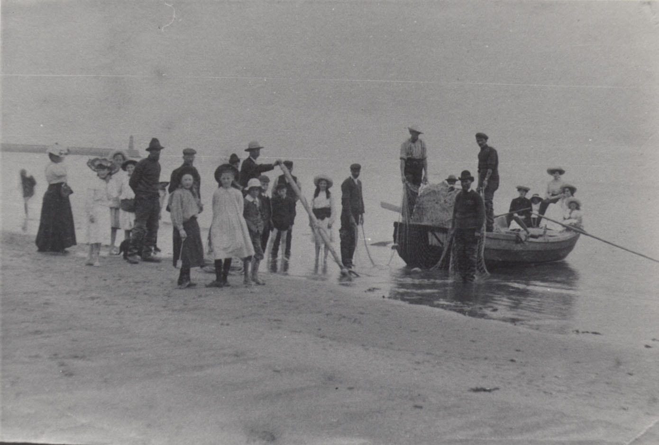
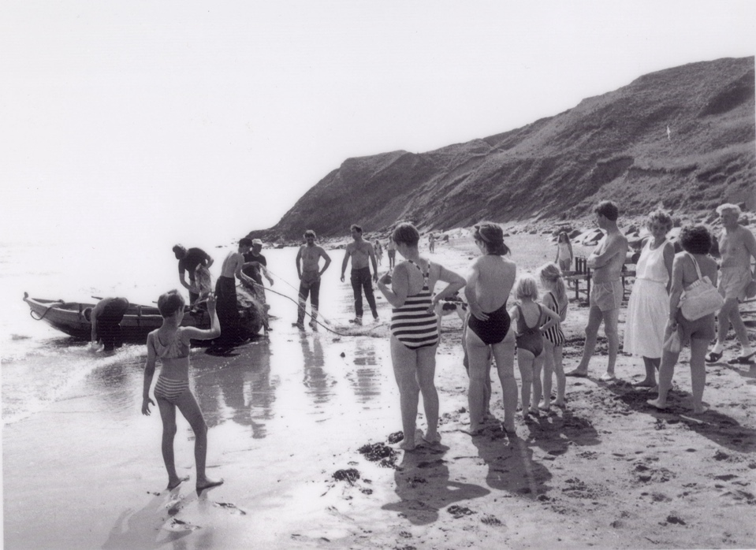
Reference: BRO 426/SL/97 | Suggested age groups: EYFS, KS1 | Topic areas: At the Seaside

Fishermen on Spittal Beach
The first photograph was taken in the late 1800s and shows the salmon fishermen pulling in their nets whilst various people watched them on the beach. The boat used by the salmon fishermen is called a coble. The fishermen worked in teams. Note the clothes worn by the children.
The second photograph was taken in the 1970s and shows the salmon fishermen pulling in their nets at Hudshead fishery at the south end of Spittal Beach.

Question Prompts
🔍 What is different in these two photographs?
🔍 Is there anything the same in these two photographs?
🔍 What colour are the two photographs?
🔍 Are the people wearing similar clothes in each photograph?
🔍 What are the children wearing in each photograph?
💡Are their clothes similar to what you would wear to go to the beach?
🔍 How many people are wearing hats?
🔍 How many people are wearing striped swimming costumes?
🔍 Can you find the lady carrying the white beach bag?
💡Have you ever been rock pooling? What did you find?
🔍 How many boats can you see?
🔍 Do the boats look the same in both photographs?
💡Have you ever seen boats that look like these ones?
💡Have you ever been on a boat? – Did you enjoy it? What would it be like?
💡Have you ever seen a fisherman at the beach?
💡Have you ever tried to catch a fish?
💡What would you use to catch it?
🔍 What are the fishermen holding?
🔍 Can you see any fish?
💡Have you ever seen any fish at the seaside?
💡What other types of animals have you seen at the seaside?

Additional Activities

Key Words
📝 Coble – A flat-bottomed fishing boat usually rowed by oars.
📝 Fisherman – A person who catches fish as a job or for fun.
📝 Fishing net – A large net used to catch fish from a boat.
📝 Compare – To find things that are the same and different.

Reading suggestions
📚The Rainbow Fish by Marcus Pfister
📚The Storm Whale by Benji Davies
📚Sharing a Shell by Julia Donaldson
📚Under the Sea by Allison Black
📚Dolphin Boy by Michael Morpurgo
📚The Secret of Black Rock by Joe Todd-Stanton
📚The Mousehole Cat by Nicola Barber

Additional Activities
🎵 Sing sea shanties and traditional songs and rhymes.
🐠 Talk about sea creatures, where they live and how to take care of them.
🐠 Visit an aquarium.
🐠 Make a rainbow fish collage using different materials.
🎣 Play the magnetic fishing game.
⛵Experiment with floating and sinking with objects from around the classroom.
⛵ Ask children to bring in items from the beach, experiment with which items float or sink.
⛵ Make a fishing boat using an item that floats (cork, plastic bottle etc.).
⛵ Have a boat race.

Planning
Learning objectives:
- To introduce children to the concept of the seaside and visiting the beach.
- To look at what the beach was like in the past and compare it with today.
Fishermen on Spittal Beach
Communication & Language
Mathematics
Expressive Art & Design
Literacy
Understanding the World
- Counting from photographs
- Time

- Key words
- Comparing photographs
- Discussing the seaside
- Discussing what can be seen in the photographs
- Discussing sea creatures
- Book suggestions

- Understanding past and present
- Comparing holidays from the early 20th century to now
- Comparing clothes then and now
- Understanding sea creatures
- Floating and sinking

- Making collages
- Singing sea shanty’s
- Making boats

