The Seaside Through Time: Spittal Paddling Pool, 1960s, 2009 & 2021
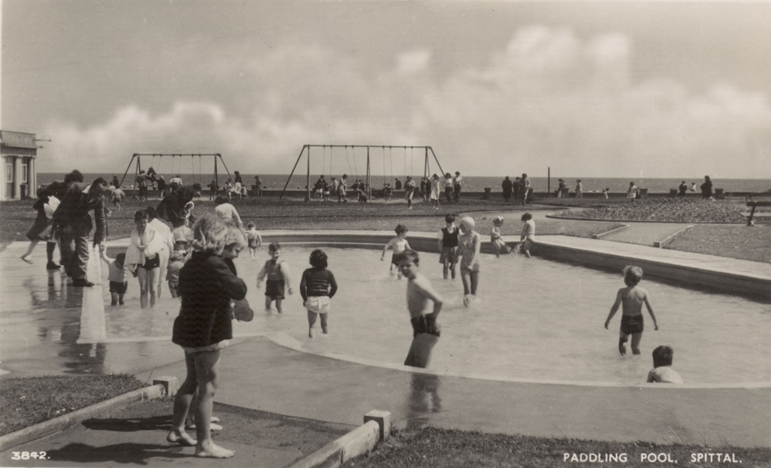
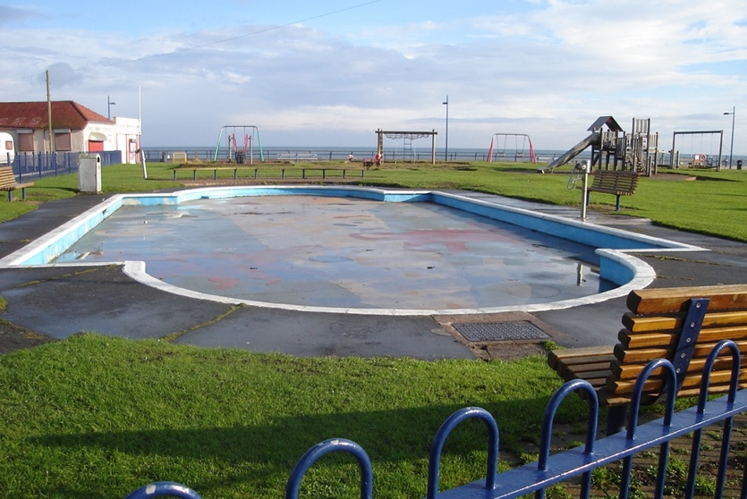
Reference: BRO 426/862 | Suggested age groups: EYFS, KS1 | Topic areas: At the Seaside

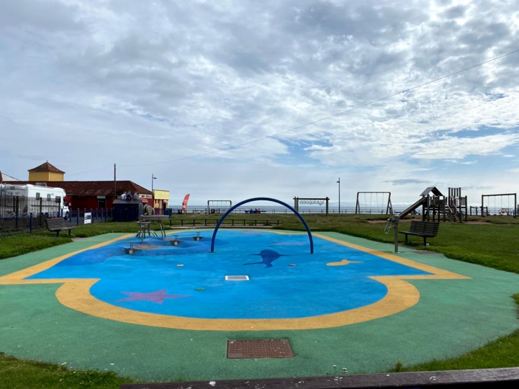

Spittal Paddling Pool
The first photograph of Spittal paddling pool was taken in the 1960s when lots of people went there for their holidays. The children’s swings can be seen in the background.
The second photograph shows the paddling pool in 2009 with the children’s play park in the background.
The third picture shows this area in 2021 where the pool has been changed into a Splash Park.

Question Prompts
🔍 What is different in these photographs?
🔍 Is there anything the same in the photographs?
🔍 What colour are the photographs?
💡Have you ever been to a play park at the beach?
💡Have you ever been in a public paddling pool?
🔍 What are the children wearing in the 1960s photograph?
💡 Is this the same as what you would wear to go in a paddling pool?
💡Do you think it was warm or cold the day the 1960s photograph was taken?
💡Do you think the water would be warm or cold in each photograph?

🔍 How many people are wearing coats or jackets?
🔍 How many people are in the water?
🔍 Can you find the girl wearing the swimming cap?
🔍 What can you see at the play park?
🔍 What colour are the swings in the 2009 photograph?
💡Is the playground similar to play parks that you have been to?
💡What is your favourite thing to play on at the play park?
💡Can you swim?
💡If you can’t swim what would you wear to help you float in the water?

Key Words
📝 Paddling pool – A small pool of water for people to paddle in.
📝 Swimming cap – A tight elastic cap worn in the water.
📝 Play park – An outdoor play area often with rides such as slides and swings.
📝 Compare – To find things that are the same and different.

Reading suggestions
📚Paddling Pool by Anne-Marie Duff
📚The Whale in My Swimming Pool by Joyce Wan
📚The Deep by Tim Winton
📚There’s a Sea in my Bedroom by Margaret Wild
📚Sergio Makes a Splash by Edel Rodriguez

Additional Activities
🏊Talk about swimming and water safety.
🏊 Make a paddling pool using a container.
🏊 Count how many cups it takes to fill the paddling pool container.
⛵Experiment with floating and sinking objects in the paddling pool container.
⛵ Make a tinfoil boat.
⛵ Float the tinfoil boat in the paddling pool container.
⛵ See how many coins can be placed on the tinfoil boat before it sinks.
⛵ Make a sail for your boat. What happens if you blow on it?
🧽 Place items such as a swimming cap, sponge and face cloth into a container of water. Talk about how the items change when wet.
🏖️ Make a seaside themed playground assault course.
🏖️ Play a seaside playground themed dice game. E.g., if 1 is rolled bounce as though on a seesaw, if 2 is rolled swoop like a seagull, if 3 is rolled glide as though on a slide, if 4 is rolled pretend to be on a climbing frame.

Planning
Learning objectives:
- To introduce children to the concept of the seaside and visiting the beach.
Spittal Paddling Pool
Communication & Language
Mathematics
Expressive Art & Design
Literacy
Understanding the World
- Counting from photographs
- Time
- Counting while filling containers

- Key words
- Comparing photographs
- Discussing the seaside
- Discussing what can be seen in the photographs
- Discussing swimming and water safety.
- Book suggestions

- Making paddling pools
- Making boats

Physical Development
- Dice game
- Assault course
- To look at what the beach was like in the past and compare it with today.

- Understanding past and present
- Comparing holidays from the early 20th century to now
- Comparing clothes then and now
- Understanding sea creatures
- Floating and sinking
- Wet and dry textures

