The Seaside Through Time: Spittal Promenade Postcards, 1913 & 1920s
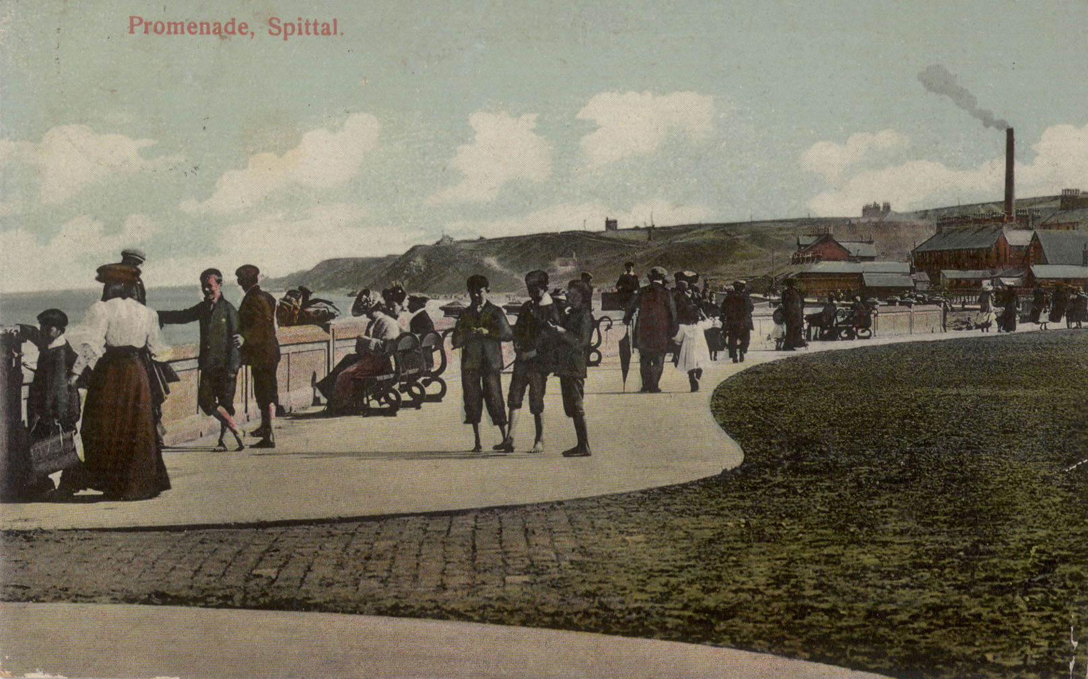
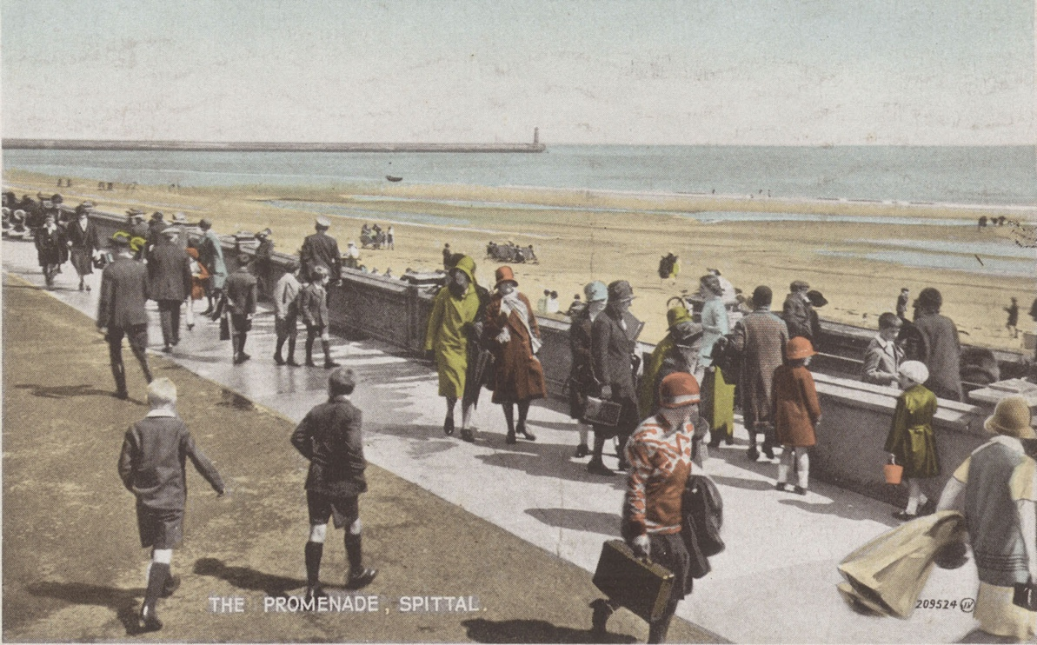
Reference: BRO 426/815, BRO 426/880 | Suggested age groups: EYFS, KS1 | Topic areas: At the Seaside, Then and Now

Spittal Promenade Postcards
The first postcard which was sent from Spittal in 1913 shows people walking along the Promenade. The image was taken in the direction of Cocklawburn and the south end of the beach. Note their style of dress.
Spittal was a popular holiday resort in the early 1900s. The second postcard was produced in the 1920s and shows people walking along the Promenade in the opposite direction. Note their style of dress and what they are carrying.

Question Prompts
💡Have you been to the seaside for a holiday?
💡Where have you been on holiday?
💡 Do you know what a postcard is?
💡Have you ever sent a postcard while you were on holiday?
💡Has anyone ever sent you a postcard while they were on holiday?
🔍 What is different in these two postcards?
🔍 Is there anything the same in both postcards?
🔍 What are the people wearing in each postcard?
🔍 What are the people carrying in each postcard?
🔍 Can you find the man carrying the umbrella?
💡 Do you think the people walking on the promenade also went on the beach? Would they dress differently for this?
💡 Are people’s clothes different or the same as what you would wear to go to the beach?
💡How would you feel on a hot day wearing the clothes shown in the postcards? Would it be comfortable?

🔍 How many people are wearing hats in each postcard?
🔍 What types of buildings can you see in each postcard?
🔍 Can you find the lighthouse?
💡What is a lighthouse?
💡How do lighthouses work?
🔍 What colour is the girl’s bucket in the 1920s postcard?
💡Have you ever made a sandcastle?
💡What would you use to make a sandcastle?

Key Words
📝 Promenade – A path along the seafront made for taking leisurely walks.
📝 Holiday resort – A place where lots of people go on holiday.
📝 Postcard - A small card that can be mailed without an envelope. Postcards often have a picture on one side and space for a message, address, and stamp on the other. People send postcards to family and friends while on holiday.
📝 Lighthouse - A tower with a flashing light for guiding ships and warning them of dangers in the water.
📝 Sandcastle – A castle made on a beach by moulding wet sand. Sometimes made using a castle shaped bucket.
📝 Compare – To find things that are the same and different.

Reading suggestions
📚At the Beach by Roland Harvey
📚Stringbean’s Trip to the Shining Sea by Vera and Jennifer Williams
📚Meerkat Mail by Emily Gravett
📚The Lighthouse Keeper’s Lunch by Ronda and David Armitage
📚Gracie the Lighthouse Cat by Ruth Brown
📚A New Home for a Pirate by Ronda Armitage
📚The Sandcastle that Lola Built by Megan Maynor
📚Little Kipper’s Sandcastle by Mick Inkpen
📚The Sand Horse by Ann Turnbull

Additional Activities
🖍️ Draw your own postcard from the seaside using the template.
✍️Ask someone to write your message on the back of your postcard for you.
✍️Write your name at the bottom of your postcard.
🧰Make a lighthouse using Lego or recycled items.
🧰Make a small scale or large scale collage of a lighthouse using a variety of different materials.
⚓Discuss safety at the seaside, role of lifeguards, warning signs/flags.
⚓Visit the lifeboat station, discuss the role of lifeboats.
🪣Make sandcastles of different shapes and sizes.
🪣Explore the different textures of wet and dry sand.
🪣Draw pictures in wet sand using different items.
🪣Use coloured sand to make patterns.
🗣️ Stand back-to-back with someone and describe what you can each see. Draw what they describe.

Postcard Template

Front
Back
To
From
Stamp
Address

Planning
Learning objectives:
- To introduce children to the concept of going on holiday and visiting the beach
- To look at what the beach was like in the past and compare it with today.
Expressive Art & Design
Communication & Language
Literacy
Mathematics
Understanding the World
- Book suggestions
- Writing their name
- Drawing postcards
- Lighthouse model
- Lighthouse collage
- Drawing in sand
- Making patterns with coloured sand
- Key words
- Comparing postcards
- Dictating a postcard message
- Discussing holidays and the seaside
- Discussing what can be seen in the postcards
- Describe what they see
- Making different sized and shaped sandcastles
- Making different sized collages
- Counting hats
- Time
- Understanding past and present
- Comparing holidays from the early 20th century to now
- Comparing clothes then and now
Spittal Promenade Postcards

