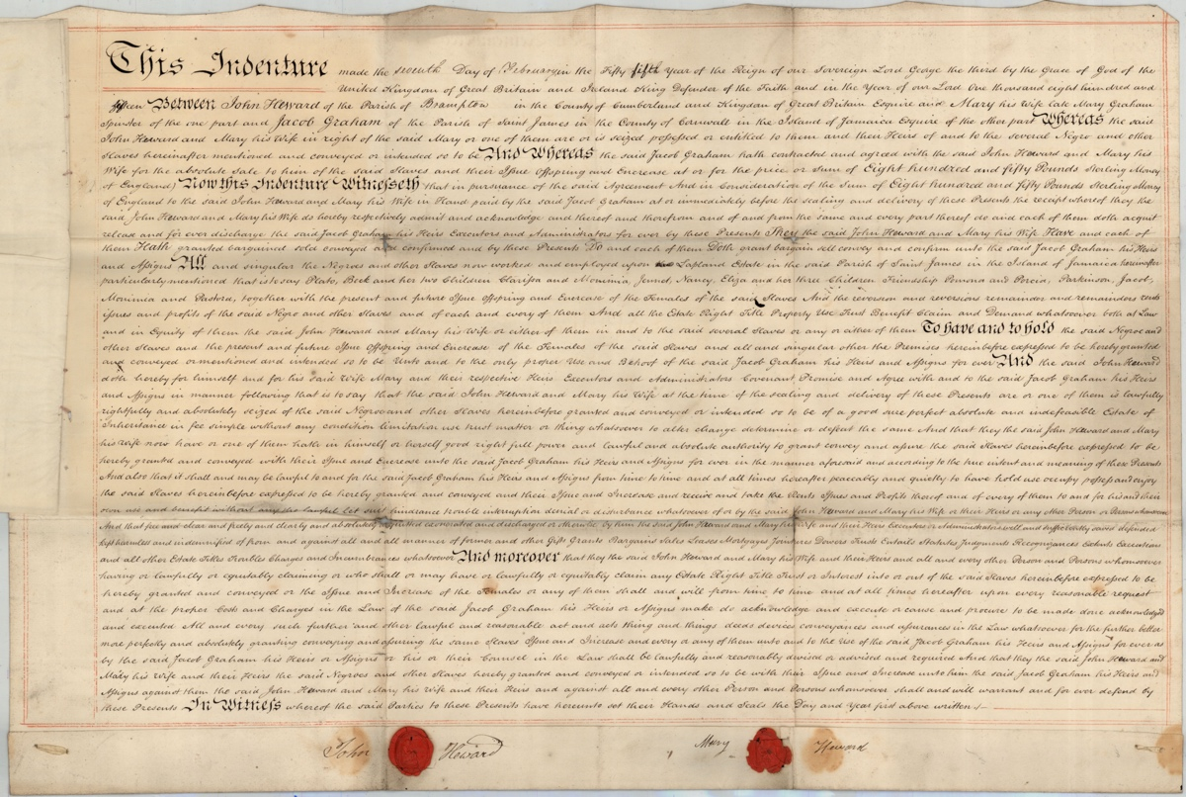
Deed Recording the Sale of Enslaved People in Jamaica, 1815
Reference: SANT DEE/05/01 | Suggested age groups: KS2, KS3, KS4, lifelong learners | Topic areas: Slave Trade, Ownership of Enslaved People

Indenture
This type of document is called an indenture. Two copies of the document were written on the same piece of parchment and cut apart with a wavy line. They were divided like this so that it would be possible to put the two back together again. This helped to ensure that the document was genuine.
This indenture records the sale of 14 enslaved people to Jacob Graham from Mary Heward and her husband, John. It is most likely that Mary had been the slaveholder and that she “owned” the enslaved people before her marriage to John.

Jacob Graham and Mary Heward
Jacob Graham (born 1726) moved to Jamaica from Cumberland (present Cumbria) in 1746. It seems likely that he spent some time working for other people on the island while saving money and buying up pieces of land. By the time of his death in 1816, he owned several plantations producing coffee and sugar, including Lapland, which is mentioned in this indenture. At the time of his death, his plantations contained 157 enslaved people.
As chattel property under Jamaican Law, enslaved women had no legal right to give or deny sexual consent. Jacob Graham had at least seven children by two enslaved women on his plantations. He had these children baptised and manumitted (legally made free). However, Statira, the mother of four of his children was still enslaved at the time of his death and he left her in his will to one of his older children.
The indenture mentions that Mary Heward’s name was Mary Graham before her marriage. Mary Heward was Jacob Graham and Statira’s daughter. Legally, Mary was born an enslaved person, as her mother was before her.
Although Jacob Graham left property and money to his Jamaican children, he left the major part of estate to his nephew, John Graham Clarke (see Provenance below).

Names
The indenture lists the enslaved people being sold by name. The names appear here.
In the British colonies, slaveholders often gave the enslaved names with a classical origin. A note has been made of them:
Plato (Greek philosopher)
Beck with her children; Clarissa (popular eighteenth-century novel) and Monima (Macedonian Greek woman died 72BC, known for intelligence and beauty)
Jennet
Nancy
Eliza with her children; Friendship, Pomona (Roman goddess of trees and nuts) and Porcia (wife of Brutus)
Parkinson
Jacob
Monima
Pastora (name of “coy shepherdess” in eighteenth-century opera)
However, these are unlikely to have been the names these people gave to each other; they would have been chosen by the owners or the overseers of the plantations. Their birth names may well have been different; there are no names of African origin here (see section on Slave Registers).
As well as the women listed, the deed states that “…the present and future issue offspring and Encrease of the Females…” also belong to Jacob Graham.

Slave registers
In 1807 the African slave trade was abolished by Britain. However, many of its colonies had developed as economies based on enslaved labour. The buying and selling of enslaved people within those colonies was not outlawed.
To try and ensure that people were no longer being taken from Africa, the British authorities began to keep registers of the enslaved people in their colonies. The registers are now kept at the National Archives and can be searched using Ancestry.
The first slave registers for Jamaica are dated 1817 – two years after the indenture. The enslaved people of the Lapland Plantation are listed in the register. As Jacob Graham had died in 1816, the executors of his will* are named in the record.
Several of the enslaved people listed in the deed can also be found recorded in the slave register. The slave registers made a record of the name of the enslaved person, their age (usually approximate), their “colour” and whether they had been born in Africa or on the island. If they had been born in Jamaica they were characterised as “creole”.
From the register (1817) we have the following additional information:
Pluto - age 40, born in Africa
Parkinson - age 13, born in Jamaica
Jacob – age 11, born in Jamaica

Pastora – age 67, born in Africa or age 9, born in Jamaica
Jennet – age 14, born in Jamaica
Eliza – age 40, born in Africa
Eliza’s children from the deed; Friendship, Pomona and Porcia are not listed, but other children are - Jupiter, one month old; Jurve(?), 7.
Clarissa Graham – age 17, born in Jamaica
Monima – age 9, born in Jamaica
Both of these two girls are noted to be the daughters of Beck, but Beck herself doesn’t seem to be present. It is interesting to note that Clarissa has the surname Graham on this list – suggesting that her father may have been a Graham. Enslaved people in the registers were not often ascribed family names.
The slave registers were updated every three years. However, the owners or overseers of the plantations didn’t always list all of the enslaved people, but declared who had been lost (died, runaway, manumitted or sold) and who gained (born or bought). In 1826, Parkinson was recorded as having died at the age of 22, from a “bowel complaint”.
*The people given responsibility for carrying out the wish of the person that wrote a will.

Maroons
A newspaper article shows that one of Jacob’s plantations was attacked by Maroons in 1795. (See transcript.)
The British took control of Jamaica from the Spanish in 1655. Some of the Africans who had been enslaved by the Spanish took this opportunity to run away into the dense Jamaican jungle and set up communities. They came to be known as Maroons. Further runaways from British plantations added to their numbers. During the late 1600s and early 1700s the Maroons were in conflict with the British. Between 1728 and 1739 (The First Maroon War) and 1795-6 (The Second Maroon War) they were at war. The Maroons used guerrilla tactics against the British, whose troops had greater numbers and more technologically advanced weapons.

Money
According to the Bank of England Inflation calculator £850 in 1815 would buy the equivalent of at least £77,000 worth of goods and services in 2020.

Provenance
The provenance of the document is the history of where it came from and who owned it. The provenance of a document is important to archivists as it helps us to determine authenticity, identify links with other documents and describe documents in the catalogues we produce.
Although this document relates to people who lived in Cumbria and Jamaica, it is now held at Northumberland Archives. It is not unusual for a county archive to hold records that relate to other parts of the country or to other parts of the world. Families, businesses and other organisations often held land, or had other financial interests in other places. Rather than transfer every single item that relates to a place outside of that area, country record offices usually keep whole collections together.
This deed is part of the collection of the Newcastle Society of Antiquaries. It is likely that the Society, or one of its members, collected this deed, because of its links to Newcastle. Jacob Graham was the uncle of John Graham Clarke and left the largest part of his property, including Lapland, to John in his will. John Graham Clarke was a merchant based in Newcastle, where he owned breweries, glassworks, sugar house and held shares in banking. His boats sailed from Newcastle to trade with the West Indies. In 1816 the Newcastle Chamber of Commerce voted him their president.
John Graham Clarke owned (or had some financial stake in) around 13 plantations on Jamaica by the time of his death. Many 100s of enslaved people worked on his lands. In Newcastle Graham Clarke donated money to Newcastle Infirmary and Assembly Rooms. His granddaughter was the poet Elizabeth Barrett-Browning, who campaigned for abolition.

Bath Chronical and Weekly Gazette – 19 November 1795
An article from the Bath Chronical and Weekly Gazette on 19th November 1795 reads: “The Maroons in Jamaica are not yet subdued: in September last they set fire to the dwelling and negro-houses of Messrs George Gordon, John Mand, and Stephens and Bernard; and the large coffee plantations of Mr Jacob Graham and Mr Trough. Mr Skinner, of Savanna-le-Mer, was murdered by some of these villains that lay in ambush; and Mr Tomlinson and Capt Leigh of the regulars, have fallen in action.”

Other Online Resources
Northumberland Archives blog, page about “owner” of enslaved people: https://www.northumberlandarchives.com/2020/10/07/slave-owners-of-northumberland-margaret-landell/

Jacob Graham
University College London website, database of people receiving compensation following abolition, results for Jacob Graham: https://www.ucl.ac.uk/lbs/person/view/2146652565
Sean Creighton “’The Black Indies’: The Northeast Connection with the Slavery Business”, published as part of History and Social Action Publications, August 2020 (talks about the Graham and Clarke Graham families): https://seancreighton1947.files.wordpress.com/2020/08/part-2.-black-indies.pdf
Warwick University website, page with PhD of Christer Petley “Boundaries of Rule, Ties of Dependency: Jamaican Planters, Local Society and the Metropole, 1800 -1834”, 2003 (includes extensive research about Jacob Graham): http://wrap.warwick.ac.uk/57052/1/WRAP_thesis_Petley_2003.pdf

Maroons
Maroon Sovereignty Project (Harvard) website, page about the history of the Maroons: https://cyber.harvard.edu/eon/marroon/history.html
National Geographic website, page about Maroon communities in Jamaica: https://www.nationalgeographic.com/travel/article/legendary-community-that-fought-for-its-freedom-in-Jamaica
University of Miami student website, pages about resistance in the Caribbean including the Maroons: https://scholar.library.miami.edu/slaves/Maroons/individual_essays/leanna.html

Slave Registers
Ancestry website, includes searchable database and scans for Slave registers (subscription site): www.ancestry.co.uk
(Ancestry can be accessed for free via Northumberland Libraries – library card needed). https://northumberland.spydus.co.uk/
The National Archives website, page with research guide on records of enslaved people and slave owners: https://www.nationalarchives.gov.uk/help-with-your-research/research-guides/slavery-or-slave-owners/
The National Archives online catalogue, page about Office of Registry of Colonial Slaves and Slave Compensation Commission (scroll down to “Administrative / biographical background” for more about context to these records: https://discovery.nationalarchives.gov.uk/details/r/C13808

The Bank of England
Bank of England website, statement apologising for links to slave trade: https://www.bankofengland.co.uk/news/2020/june/statement-in-relation-to-the-banks-historical-links-to-the-slave-trade
Positive Money website, page about the Bank of England’s apology: https://positivemoney.org/2020/07/the-bank-of-england-and-the-slave-trade-why-apologies-are-not-enough/
Guardian Newspaper website, page about Bank of England apology: https://www.theguardian.com/business/2020/jun/18/bank-of-england-apologises-for-role-of-former-directors-in-slave-trade
Bank of England website, page with historical inflation calculator: https://www.bankofengland.co.uk/monetary-policy/inflation/inflation-calculator

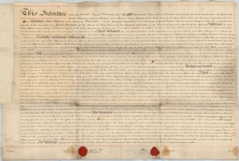
LEarning Activities: Deed Recording the Sale of Enslaved People in Jamaica, 1815

Topic: Slave Trade, Ownership of enslaved people

Subject areas: History, Literacy

Background | Activity | Resources
This indenture records the sale of 14 enslaved people to Jacob Graham from Mary Heward and her husband, John. It is most likely that Mary had been the slaveholder and that she “owned” the enslaved people before her marriage to John.  Several of the enslaved people listed in the deed can also be found recorded in the slave register. The slave registers made a record of the name of the enslaved person, their age (usually approximate), their “colour” and whether they had been born in Africa or on the island. If they had been born in Jamaica they were characterised as “creole”. | See: What is an indenture?  See: What does this document show?  See: Who “owned” the enslaved people sold in this document?  See: Was Mary Heward ever enslaved?  See: Could enslaved women legally give or deny sexual consent?  See: What are the names of the enslaved people listed in this document? | https://www.thirteen.org/wnet/slavery/experience/legal/history.html  www.ancestry.co.uk  https://www.nationalarchives.gov.uk/help-with-your-research/research-guides/slavery-or-slave-owners/  https://discovery.nationalarchives.gov.uk/details/r/C13808
Think: What are the roots of the listed enslaved people’s names?
Think: Why were the enslaved people given these names?
Think: Why were enslaved people not given names of African origin?
Think: Who named enslaved people?
Think: Did enslaved mothers get to name their children?
Think: Why didn’t enslaved women have the right to deny or give sexual consent?
Think: Was it usual for slaveholders to forcibly impregnate enslaved women?
Think: Where enslaved people legally given any rights?
Think: Were the names given to enslaved people used ironically?
Think: Did names show a hierarchy within groups of enslaved people?
Think: Why might Mary Heward have become a slaveholder despite being born enslaved?
Think: Does it surprise you that Mary was involved in the trade of enslaved people?
Think: What does manumission mean?
Think: What is the difference between manumission and emancipation?
Think: What did the enslaved people get for being free?
Think: What was life like for a former enslaved person once they had been freed?
Do: Explore the slave registers. What can you find out from them about enslaved people?
Do: Use the slave registers to search the names of each of the enslaved people listed in the document. Can you find any details about them?
Do: Create a profile for each person. How old were they when this document was made; were they born in Jamaica or were they part of the slave trade; can you trace their families?
Do: Can you find any evidence of enslaved people with names of African descent listed in the slave registers?
Do: Compare this document to the bill listing items bought by Robert Roddam from George Paplay in Kingston, Jamaica. Discuss whether it is worse for the for the enslaved people to be sold nameless belonging to a boat, or to be addressed by a name give ironically by their “owner”.
Do: Discuss how a name relates to personal identity. How might the enslaved people have felt about either being nameless or named ironically? How might mothers have felt about not being able to name their own child? How would you feel if your name was taken away?
Do: Consider the question “were all slaveholders inherently bad, or were some slaveholders good people despite “owning” enslaved people?” Debate your response to this question.
A newspaper article shows that one of Jacob’s plantations was attacked by Maroons in 1795.  The British took control of Jamaica from the Spanish in 1655. Some of the Africans who had been enslaved by the Spanish took this opportunity to run away into the dense Jamaican jungle and set up communities. They came to be known as Maroons. Further runaways from British plantations added to their numbers. During the late 1600s and early 1700s the Maroons were in conflict with the British. Between 1728 and 1739 (The First Maroon War) and 1795-6 (The Second Maroon War) they were at war. The Maroons used guerrilla tactics against the British, whose troops had greater numbers and more technologically advanced weapons. | See: Who were the Maroons?  See: Where did the Maroons set up communities?  See: Who added to the numbers of Maroons?  See: When was the First Maroon War?  See: When was the Second Maroon War?  See: What types of tactics did the Maroons use?  See: Why were guerrilla tactics used?  See: What does the article in the Bath Chronical and Weekly Gazette report that the Maroons had done? | https://www.penn.museum/sites/expedition/guerilla-warfare-in-eighteenth-century-jamaica/  https://birminghamwarstudies.files.wordpress.com/2012/05/maroon-map.gif  https://www.thoughtco.com/guerrilla-warfare-definition-tactics-examples-4586462#guerrilla-warfare-tactics  https://www.britannica.com/topic/guerrilla-warfare/Strategy-and-tactics  https://www.britannica.com/topic/guerrilla-warfare  https://www.washingtonpost.com/archive/opinions/2003/04/06/rules-between-guerrilla-warfare-and-war-crimes/4125b046-b977-4e4f-83d6-b87c75578a2e/  https://cyber.harvard.edu/eon/marroon/history.html  https://www.nationalgeographic.com/travel/article/legendary-community-that-fought-for-its-freedom-in-Jamaica
Think: How were Maroon communities set up?
Think: How were Maroon communities sustained?
Think: Were there Maroon communities outside of Jamaica?
Think: Do Maroon communities still exist today?
Think: How do Maroon communities celebrate their culture?
Think: What are guerrilla tactics?
Think: When and why might guerrilla tactics be used?
Think: Are guerrilla tactics illegal?
Think: Why have guerrilla tactics been compared to terrorism?
Think: Are guerrilla tactics successful?
Think: How did the British respond to the guerrilla tactics used by the Maroons?
Think: What was the purpose of the Maroon Wars?
Do: Create a map showing the Maroon areas of Jamaica.
Do: Make a list of different types of guerrilla tactics.
Do: Research the Maroon Wars. Can you find examples of the different types of guerrilla tactics employed by the Maroons?
Do: Read the article from the Bath Chronical and Weekly Gazette on 19th November 1795.
Do: Consider who the article might have been written by and who the intended audience might have been. What impression does the article give of the Maroons, their actions, and their targets?
Do: Analyse the language used in the newspaper article. Why do you think the author of the article made these language choices?
Do: Discuss what you think the aim of the article might have been.
Do: Rewrite the newspaper article from the perspective of someone on the side of the Maroons. How might the way the events are reported, and the language used differ?
Do: Debate whether it was ethical for the Maroons to use the tactics reported in the newspaper article.
Do: Discuss how individual acts of defiance can lead to a change in the system.
Do: Discuss how the Maroons demonstrate the strength of will against slaveholders.
Do: Research the outcomes of the First and Second Maroon Wars. What were the outcomes, consequences, and impact of each?
Do: Research how Maroon culture is celebrated in Jamaica today.
Do: Can you find evidence of contemporary Jamaican opinions towards the Maroons?
Do: Research the seven National Heroes of Jamaica. How many of these recognised National Heroes were part of the Maroons?
Do: Research Nanny the Maroon’s role in the First Maroon War.
Do: Research how other National Heroes of Jamaica contributed towards Black rights.
Do: Discuss the role of women in the resistance and rebellion of enslaved people.

