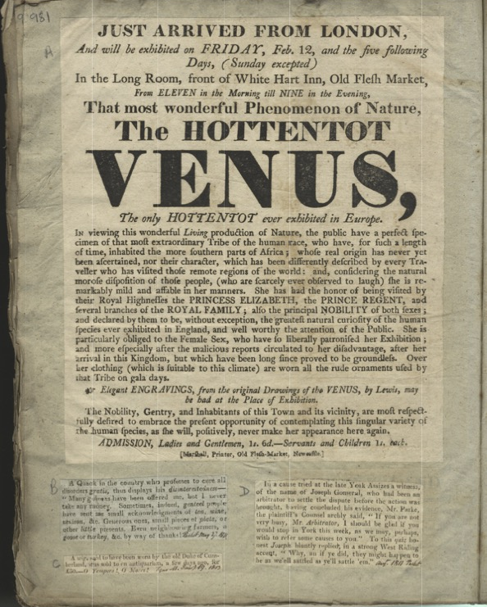
Advertisement for the “Hottentot venus”, 1813
Reference: SANT PRI/05/07/981 | Suggested age groups: KS3, KS4, lifelong learners | Topic areas: Black Presence

Sarah Baartman
Sarah (sometimes Saartijie) Baartman was born at the end of the 18th-century in South Africa. She was born into the Khoikhoi people who were known in England at the time as the Hottentots (now a derogatory term).

Court Case
Little is known for definite about her life in Africa. It has been suggested that she was a widow and that she worked as a “servant” for a Dutch (Boer) household. What is known about her life mainly comes from the court case that took place in 1810, brought by the African Institute.
According to Hendik Cesar, he “procured” Sarah from a group of Boers (South Africans of Dutch origin). Cesar then seems to have worked with a middle-man, Alexander Dunlop, who tried to interest the owner of the Liverpool Museum in Piccadilly, London in purchasing her. Dunlop offered the owner of the “museum” Sarah for two years, in a deal which also involved a leopard skin. It seems as if this deal fell through.
From the report of the case in the newspapers, it seems clear that Cesar treated Sarah as his property. However, he did claim that he had a contract with Sarah, which she had willingly signed, and that she received a share of the profits.
Cesar brought Sarah to London and began to show her in Piccadilly at the price of 2 shillings per person. Sarah looked like she was naked during the showings and members of the audience were encouraged to touch her.
The court struggled to get a statement from Sarah. She did not speak any English and she refused to talk to translators in front of Cesar. When she was eventually interviewed alone, she confirmed Cesar’s story that she had a contract, she was given a share of the profits and that she was happy.

Morning Chronicle, 26 November 1810
Morning Chronicle, 26 November 1810
Report of case at Court of King’s Bench
Affidavit of Mr McCartney, Secretary of the African Institution
This gentleman went to the place of exhibition, where he found an elevated stage, with a recess, out of which the female in question came, dressed in a thin tight dress, almost the colour of her person, so as to make it appear as much as possible that she was naked.
…this unfortunate female was shewn as any beast, as a bear led by a chain. Her keeper ordered her to place herself in any position he desired, and she was obliged to obey. That she was in a state of absolute control, was apparent; but that she was happy or comfortable, under her confinement, or was willingly so confined, it was equally plain was not the case. Through she could not converse with any one, it was impossible to observe her gestures – to hear her deep sighs – to mark the sullen reluctance with which, when exhausted, she complied with the mandate of her keeper to play on a musical instrument, and not to be satisfied that she was unhappy, uncomfortable, and under a system of restraint, which could not be tolerated in this country.

Regional tour
After the court case, Sarah was taken on a tour of provincial cities. There are newspaper reports of showings in Bristol, Hull and Ipswich. While in Manchester in 1811, it was reported that she had been baptised and married.
Although the year is not printed on this advertisement, it is possible to work out that it appeared in 1813. Flesh Market was the area of Newcastle where many of the butchers had their businesses. It was often quite an unpleasant part of any town or city. The text seems to refer to the court case of 1810, as it mentions:
…the malicious reports circulated to her disadvantage, after her arrival in this Kingdom, but which have long since proved to be groundless.
She was moved to Paris in September 1814 and was once again exhibited.

Death of Sarah Baartman
Sarah died in Paris on 2 January 1816. Some of the newspaper reports suggest that she died of small pox. After her death, her body was dissected and plaster casts taken of her body. These moulds were put on display in the Musée de l’homme (Museum of Man) in Paris. The exhibition of Sarah’s body was eventually taken down in 1974 and her remains were buried in South Africa in 2002.

Typography
The lower case letter “s” on this poster looks like the letter “f”. This is typical of the time.

Other Online Resources
BBC website, page about Sarah Baartman: https://www.bbc.co.uk/news/magazine-35240987
British Museum website, page with short biography (see also related items tab on this page): https://www.britishmuseum.org/collection/term/BIOG45022
YouTube website, video lecture “Story of Sarah Baartman” by Dr. Natasha Gordon-Chipembere (includes mention of sexual body parts), about 15 minutes: https://www.youtube.com/watch?v=UgT1ctCuyyM
YouTube website, video about an exhibition about Sarah Baartman at University of Cape Town, South Africa, includes poem and art work: https://www.youtube.com/watch?v=GQqp7twXvBw
Tyne and Wear Historic Environment Record website, page about Flesh Market/Corn Market: https://twsitelines.info/SMR/6496
Internet Archive website, scan of Rules and Regulations of African Institution: https://archive.org/details/rulesandregulat00englgoog/page/n14/mode/2up
Debating Matters website, page on whether western museums should repatriate cultural artefacts. Includes background and lots of links to articles:
https://debatingmatters.com/topic/western-museums-should-repatriate-cultural-artefacts/
News24 website (South African news site), page with article about repatriation:
https://www.news24.com/news24/Analysis/repatriation-why-western-museums-should-return-african-artefacts-20190518
Guardian website, page about calls to British Museum to repatriate Ethiopian altars:
https://www.theguardian.com/culture/2021/oct/11/uk-urged-return-religious-treasures-hidden-away-150-years-ethiopia

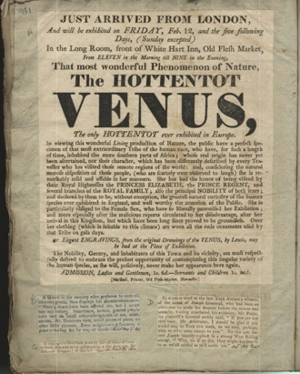
LEarning Activities: Advertisement for the “Hottentot venus”, 1813

Topic: Black Presence

Subject areas: History, Literacy

Background | Activity | Resources
Sarah (sometimes Saartijie) Baartman was born at the end of the 18th-century in South Africa. She was born into the Khoikhoi people who were known in England at the time as the Hottentots (now a derogatory term). | See: Who was Sarah Baartman?  See: What was Sarah sometimes known as?  See: Where was Sarah born?  See: How do we know details about Sarah?  See: Why was Sarah involved in a court case?  See: How was Sarah exhibited?  See: How was Sarah treated while being exhibited? | https://www.nationalarchives.gov.uk/pathways/blackhistory/culture/docs/macaulay_affadavit.htm  https://www.blackpast.org/global-african-history/baartman-sara-saartjie-1789-1815/  https://www.youtube.com/watch?v=UgT1ctCuyyM
Think: Was slavery legal in Britain at this time?
Think: What was the purpose of court case?
Think: What was the outcome of the court case?
Think: Was Sarah’s contract used as a loophole?
Think: How much choice did Sarah have?
Think: Did Sarah actually receive a share of the profits?
Think: Why did Sarah corroborate Cesar’s account? Does that mean he was telling the truth?
Think: Why did Sarah become an exhibition?
Think: Why would people visit an exhibition such as this?
Think: How would it feel to be continuously watched and continuously on display?
Think: How would it feel to witness someone being exploited in that way?
Do: Consider the words “servant” and “procured”. What do they imply?
Do: Research the court case. What evidence can you find that was used in the case by both sides?
Do: Debate whether you think the contract and Sarah’s testimonies were reasonable proof for dismissal in the case. Use evidence to back up your opinion.
Do: Analyse the language used in this advertisement. How does it try to dispel the accusations made during the court case?
Do: Analyse the language used in this advertisement. Does any of it support the accusations made during the court case?
Do: Analyse the language used in the document. What connotations and attitudes towards people of African descent are shown through the language choices?
Do: Analyse the language used in this document. What impression does it give of Sarah?
Do: Discuss how this document implies that Black people were seen as less than animals.
Do: Consider animals in the zoo. How do people respond to seeing the animals upset, distressed and continuously being watched?
Do: Compare Sarah’s exhibition to the practice of observing animals in the zoo. Did people respond differently to seeing Sarah exhibited than they would to seeing animals in the zoo?
Do: Consider Sarah’s exhibition. Discuss what implications this has on the value and worth of a person.
Sarah died in Paris on 2 January 1816. Some of the newspaper reports suggest that she died of small pox. After her death, her body was dissected and plaster casts taken of her body. These moulds were put on display in the Musée de l’homme (Museum of Man) in Paris. The exhibition of Sarah’s body was eventually taken down in 1974 and her remains were buried in South Africa in 2002. | See: When did Sarah die?  See: What happened to Sarah’s body after her death?  See: Where were the moulds of Sarah’s body displayed?  See: When was the exhibition of Sarah’s body taken down?  See: When were Sarah’s remains buried in South Africa? | https://wakespace.lib.wfu.edu/bitstream/handle/10339/82162/Lowe_wfu_0248M_11092.pdf  https://thefactsofwhiteness.org/the-black-gaze/  https://blogs.umass.edu/afroam391g-shabazz/files/2010/02/George-Yancy-on-the-Return-of-the-Black-Body.pdf  https://www.thegoodtrade.com/features/reclaiming-body-autonomy-for-women  https://www.cambridge.org/core/journals/cambridge-law-journal/article/abs/nature-and-significance-of-the-right-to-bodily-integrity/79703F3BE9C5C21BB76338C050E951BC  https://www.disrespectnobody.co.uk/consent/what-is-consent/  https://blogs.ucl.ac.uk/researchers-in-museums/2017/03/28/should-human-remains-be-displayed-in-museums/  https://www.theposthole.org/read/article/350  https://www.prm.ox.ac.uk/critical-changes  https://debatingmatters.com/topic/western-museums-should-repatriate-cultural-artefacts/  https://www.news24.com/news24/Analysis/repatriation-why-western-museums-should-return-african-artefacts-20190518  https://www.theguardian.com/culture/2021/oct/11/uk-urged-return-religious-treasures-hidden-away-150-years-ethiopia
Think: What is consent?
Think: Why is consent so important?
Think: Who is able to give consent?
Think: What might lead to someone being unable to give consent?
Think: What is bodily autonomy?
Think: What is bodily integrity?
Think: Why was Sarah’s body seen as a public spectacle?
Think: Did Sarah have autonomy over her own body?
Think: Was Sarah in a position where she could give consent over what happened to her body, either while alive or after her death?
Think: How was Sarah communicated with in England since she didn’t speak the language?
Think: Was Sarah made aware of what would happen to her while being exhibited?
Think: Was Sarah aware of what would happen to her body after her death?
Think: Was Sarah exploited?
Think: Why were casts taken of Sarah’s body?
Think: Why were Sarah’s remains exhibited?
Think Why were death masks common practice?
Think: What is repatriation?
Think: Why is repatriation important?
Think: How did British museums obtain colonial artefacts?
Think: How many colonial artefacts are displayed in British museums?
Do: Debate whether you think Sarah was in a position to either give or deny consent when it came to being exhibited, exposed and touched.
Do: Research Oppositional Gazes. You could look at White Gaze, Imperial Gaze, Post-Colonial Gaze and Black Gaze.
Do: Using what you have learned about Gazes, what can you infer about the gaze on the black body from this document?
Do: Compare the language used to describe Sarah’s body with the representation of and language used to reference the bodies of Black women in the media today. How are these women’s bodies continuing to be exploited?
Do: Compare this document to the Advertisement for Boxing Lessons. Was there a scale of choice available to Black people at the time based on the options available to them?
Do: Research the practice of displaying human remains in museums.
Do: Discuss whether displaying human remains in museums is an ethical issue.
Do: Discuss whether you think human remains should be displayed in museums.
Do: Discuss how displaying the remains of people of African descent in European museums could contribute to continued exploitation.
Do: Research why there is a debate about Britain returning colonial artefacts.
Do: Using evidence to back up your opinion, debate whether you think Britain should return colonial artefacts.
Do: Discuss what precedent Britain returning colonial artefacts might set.

