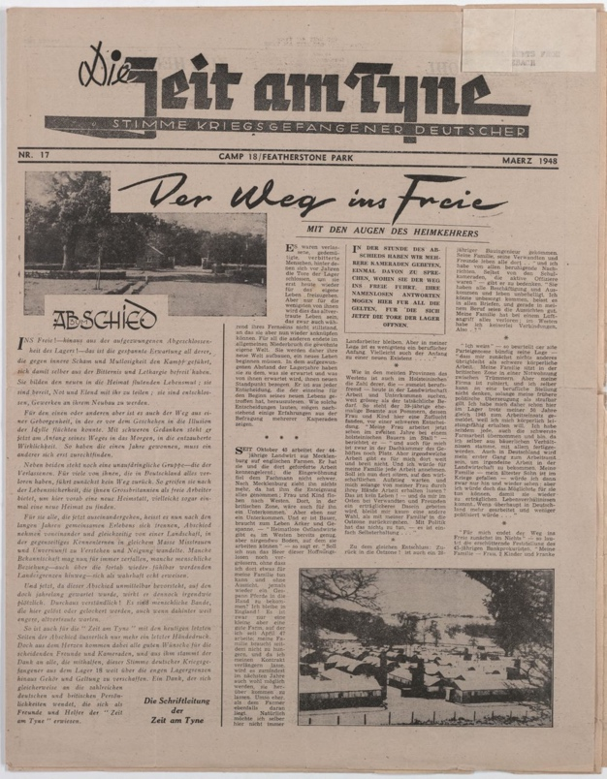
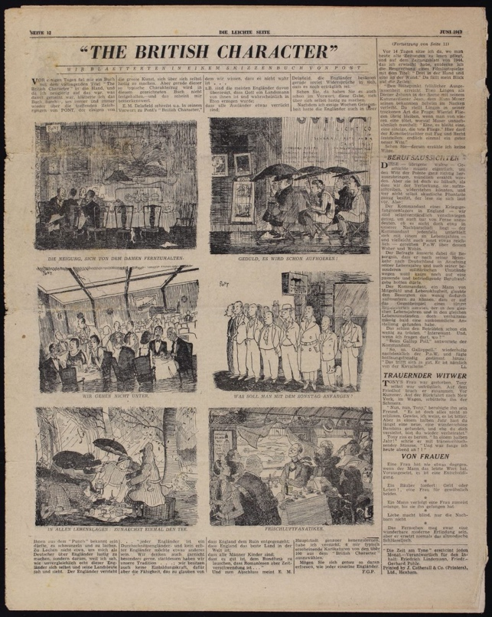
Die Zeit am Tyne Newspaper, March 1948
Reference: NRO 04906/12 & 17 | Suggested age groups: KS2, KS3, KS4, lifelong learners | Prisoners of War, WW2, Post-War Europe, German, Languages, Journalism

Prisoners of War
Prisoners of war, often shortened to POW, are soldiers who have been captured and held prisoner by enemy forces during an armed conflict or war.
Enemy forces captured and held POWs for a number of legitimate and illegitimate reasons. Reasons include, to isolate soldiers away from their own side; to show they have won the conflict; to punish or prosecute soldiers for war crimes; to exploit them for labour; to collect military and political information about their opponent; and to recruit the POWs to their own side.
The Third Geneva Convention gives POWs many different rights. The original Geneva Convention dated from 1864 and was added to in 1899, 1907 and 1949 (after the Second World War). The earlier conventions defined the expected treatment of injured enemy soldiers by the international powers that signed them. The Hague Convention of 1929 was the first to address the needs of prisoners of war.
POWs rights under the Third Geneva Convention include:
- They must be treated decently, with respect.
- They must be allowed to tell their families and the International Committee of the Red Cross that they are a POW.
- They have the right to communicate with their families and get packages.
- They have the right to keep their clothing, eating utensils, and personal things.
- They must be given adequate food, clothing, housing, and medical attention.
- If their captors make them work, POWs must be paid for the work they do.
- If they are going to be charged with a crime, they must be given a trial.
- If they are very sick or hurt, prisoners of war have the right to be let go.
- After a war ends, all POWs must be let go quickly.
Prisoners of war also have the right not to:
- Give their captors any information, except for their name, age, rank, and service number (a military identification number).
- Have their money or valuable things stolen
- Do forced labour, military work, or work that is dangerous, unhealthy, or degrading.

Prisoner of War Camps in Britain
English Heritage have identified over 1000 possible sites of Second World War POW camps in the British Isles. Including seven in Northumberland (see link to Guardian article):
- Featherstone Camp near Haltwhistle
- Darras Hill, Ponteland
- Wooler Camp, Wooler
- Hetton House Camp, Chatton
- Kitty Brewster Camp, Blyth
- Lord Mayor’s Camp, Amble
- Byrness Camp, Redesdale, Otterburn

Wylam was not included on this list, even though we know that there was a camp in the village. Wylam was a small camp and may well have been seen as a part of one of the larger camps in the area.
Around 400,000 POWs lived in British camps during the Second World War. When they were finally released, large numbers decided to stay in this country. Some estimates say 25,000 former prisoners made a new life for themselves here.
The British government encouraged POWs to stay in this country. Especially if they were working on farms producing food (see Hansard link). Conditions for ordinary people in Germany were hard. Most of the towns and cities had been heavily bombed, food and other essentials were scarce.
Boredom was the main problem for most inmates in prisoner of war camps during the Second World War. Rudi Kuhnbaum’s photographs and oral history show that the prisoners at Wylam passed their time by making a miniature castle and a fountain for the village. The prisoners at Featherstone produced the Die Zeit am Tyne newspaper.

Die Zeit Am Tyne
Die Zeit is a German newspaper which was first published in Hamburg in February 1946. Die Zeit am Tyne was published between June 1946 and March 1948 (after the end of the war). Die Zeit also means “the time” – this was probably a play on words as the German prisoners had lots of time to fill in the camps. “Am Tyne” means “on the Tyne”.

Two pages of the newspaper can be seen here. The earlier one from June 1947 (NRO 4906/12), shows a cartoon of the habits and traditions of English people that the German prisoners saw and found strange: “The British Character”. The second paper shows the front page of the last edition of Die Zeit am Tyne.
The main headline “Der Weg ins Freie: mit den Augen des Heimkehrers” translates as “The Way (or Path) to Freedom: with the eyes of the home comers”. The article is made up of the view of men from the camp about being set free and what their plans for the future are.
The other article on the page is under the headline “Zum Abschied” (farewell or leaving taking). It puts the men into three groups:
- Those keen to leave the shame and lethargy of being a prisoner and start to help rebuild Germany.
- Those who found security in being a POW and dreamt of Germany in a perhaps unrealistic way.
- Those who intended to stay in England.

Other Online Resources
Hague Conventions 1929: https://ihl-databases.icrc.org/ihl/INTRO/305
Hansard website, page with commons debate on the repatriation of POWs: https://api.parliament.uk/historic-hansard/commons/1947/apr/22/ex-prisoners-of-war
History.com website, page “8 things you should know about WWII’s Eastern Front”: https://www.history.com/news/8-things-you-should-know-about-wwiis-eastern-front
Imperial War Museum website, page about the Eastern Front: https://www.iwm.org.uk/history/operation-barbarossa-and-germanys-failure-in-the-soviet-union
YouTube website, video from US about state of post-war German, 1947 (16 minutes) https://www.youtube.com/watch?v=kjSBZLSpD8Q
YouTube website, clip from Sendung Mit Der Maus (German children’s TV programme) about post-war Germany. Shows photographs of Cologne after the war and in the late 1990s/early 2000s. In German (4 minutes): https://www.youtube.com/watch?v=h-nJGbjIWkg

Prisoners of War
Imperial War Museum website, page about British Prisoners of War in Germany during WW2: https://www.iwm.org.uk/history/what-life-was-like-for-pows-in-europe-during-the-second-world-war
Imperial War Museum website, page about enemy Prisoners of War in Britain during WW2: https://www.iwm.org.uk/history/a-short-history-of-german-and-italian-pows-in-britain
Historic England website, page about Prisoner of War camps in England and Wales: https://historicengland.org.uk/research/current/discover-and-understand/military/prisoner-of-war-camps/
The Guardian website, page with location database of Prisoner of War camps: https://www.theguardian.com/news/datablog/2010/nov/08/prisoner-of-war-camps-uk#data
Irish Times website, article about German Prisoner of War in Britain: https://www.irishtimes.com/culture/books/the-untold-story-of-britain-s-pow-camps-1.3169823
BBC website, article about German and Italian Prisoners of War in Britain: https://www.bbc.co.uk/news/uk-england-nottinghamshire-52547324

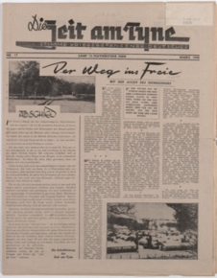
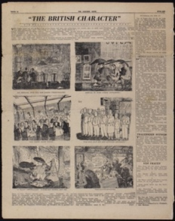
Lerning Activities: Die Zeit am Tyne Newspaper, March 1948

Topic: WW2, Prisoners of War, Post-War Europe, German, Languages, Journalism
Subject areas: History, Literacy, Geography, Art, German

Background | Activity | Resources
Prisoners of war, often shortened to POW, are soldiers who have been captured and held prisoner by enemy forces during an armed conflict or war.  Enemy forces captured and held POWs for a number of legitimate and illegitimate reasons. Reasons include, to isolate soldiers away from their own side; to show they have won the conflict; to punish or prosecute soldiers for war crimes; to exploit them for labour; to collect military and political information about their opponent; and to recruit the POWs to their own side.  English Heritage have identified over 1000 possible sites of Second World War POW camps in the British Isles. Including seven in Northumberland. | See: What are prisoners of war?  See: Who can be made a POW?  See: Why are people made to become POWs?  See: What does the Geneva Convention say about POWs?  See: What does the Hague Convention address about POWs?  See: How many WW2 era POW camps are thought to have existed in the British Isles?  See: How many of these British WW2 POW camps were in Northumberland? | https://www.iwm.org.uk/history/a-short-history-of-pows-during-the-second-world-war  https://www.nationalarchives.gov.uk/pathways/citizenship/brave_new_world/immigration.htm  https://www.bbc.co.uk/bitesize/guides/zx93tyc/revision/1  https://www.bbc.co.uk/news/uk-politics-51134644  https://historicengland.org.uk/research/current/discover-and-understand/military/prisoner-of-war-camps/  https://www.iwm.org.uk/history/a-short-history-of-german-and-italian-pows-in-britain  https://www.bbc.co.uk/history/british/britain_wwtwo/german_pows_01.shtml  https://www.bbc.co.uk/news/uk-england-nottinghamshire-52547324  https://www.nationalarchives.gov.uk/help-with-your-research/research-guides/prisoners-of-war-british-hands/  https://www.historyandpolicy.org/policy-papers/papers/germany-1945-1949-a-case-study-in-post-conflict-reconstruction  https://europe.unc.edu/the-end-of-wwii-and-the-division-of-europe/  https://www.britannica.com/place/Germany/The-era-of-partition
Think: Is it right to take POWs?
Think: Why were civilians taken as POWs?
Think: Is there a difference in taking members of the armed forces as POWs than taking civilians as POWs?
Think: What rights do POWs have?
Think: Why were POWs repatriated in Britain?
Think: Why might POWs have wanted to stay in Britain?
Think: Were POWs accepted into local communities?
Think: What was life like in post-war Britain?
Think: Why did post-war Britain have a shortage of workers?
Think: What was life like in post-war Germany?
Think: What challenges did post-war Germany have to face that post-war Britain didn’t?
Do: Create a map showing the different WW2 era POW camps in the British Isles.
Do: Use Google Maps to look at what each of the former POW camp sites look like now. How much have they changed?
Do: Design an art piece which could be displayed at a former POW camp site to remember those who were kept there and their heritage.
Do: Research WW2 POW camps in other countries. Compare this to information you have learned about POW camps in the British Isles. How did different countries treat their POWs and what conditions were they kept in?
Do: Research the Geneva Conventions and Hague Convention. Create a poster showing the rights and expected treatments of POWs.
Do: Using your research about POW camps, can you find evidence of the Geneva Convention and Hague Convention expectations not being met?
Do: Using your research about POW camps, can you find evidence of the Geneva Convention and Hague Convention expectations being met?
Do: Research the political, social, and economic climate of post-war Britain and post-war Germany. Create a table comparing their similarities and differences.
Do: Discuss how the Second World War contributed to a rise in immigration to Britain.
Do: Research what it means to be ‘displaced’. Discuss how a POW might have feelings of displacement.
Do: Write the script for a conversation between a British person and a German POW who has decided to remain in Britain. How might they feel about each other; how might they react to each other; what questions might they have for each other; would there be any barriers for communication?
Die Zeit is a German newspaper which was first published in Hamburg in February 1946. Die Zeit am Tyne was published between June 1946 and March 1948 (after the end of the war). Die Zeit also means “the time” – this was probably a play on words as the German prisoners had lots of time to fill in the camps. “Am Tyne” means “on the Tyne”.  Two pages of the newspaper can be seen here. The earlier one from June 1947 (NRO 4906/12), shows a cartoon of the habits and traditions of English people that the German prisoners saw and found strange: “The British Character”. The second paper shows the front page of the last edition of Die Zeit am Tyne.  The main headline “Der Weg ins Freie: mit den Augen des Heimkehrers” translates as “The Way (or Path) to Freedom: with the eyes of the home comers”. The article is made up of the view of men from the camp about being set free and what their plans for the future are.  The other article on the page is under the headline “Zum Abschied” (farewell or leaving taking). It puts the men into three groups:  - Those keen to leave the shame and lethargy of being a prisoner and start to help rebuild Germany.  - Those who found security in being a POW and dreamt of Germany in a perhaps unrealistic way.  - Those who intended to stay in England. | See: What is Die Zeit?  See: Where and when was Die Zeit first published?  See: When was Die Zeit Am Tyne published?  See: What does the name of the newspaper mean?  See: What is shown in the first newspaper excerpt?  See: What is shown in the second newspaper excerpt? | http://npvm.archaeologicalpractice.co.uk/objects/50/index.htm  https://www.iwm.org.uk/collections/item/object/1500090363  https://www.pegasusarchive.org/pow/cB_FeatherstonePk.htm  https://www.heritagegateway.org.uk/Gateway/Results_Single.aspx?uid=1393661&resourceID=19191  https://www.northumberlandarchives.com/2019/02/15/escape-from-camp-18/
Think: Why might the prisoners have decided to make this newspaper?
Think: What might the aim of the newspaper have been?
Think: How might the newspaper have been made? What resources did the prisoners have access to?
Think: Who might have read the newspaper?
Think: What can you learn about the prisoners from these two newspaper excerpts?
Think: What can you learn about the prisoners’ attitudes towards being prisoners?
Think: What can you learn about the prisoners’ attitudes towards Britain and British people?
Think: What can you learn about the prisoners’ attitudes towards Germany?
Think: Why might the prisoners have had different attitudes and opinions about Britain and Germany?
Do: Choose a section of the newspaper and try to translate it from German to English. What can you learn from this section of the newspaper?
Do: Create a reproduction of the newspaper translated into English.
Do: Look at the “Zum Abschied”. Create a translation of this section if you have not already done so. Create a table showing the opinions of the men in the three different groups.
Do: Script a conversation between three men – one from each group in the “Zum Abschied” article, discussing their reasons for their opinions and their plans for the future. Think about questions they may have for each other and how they might respond to this.
Do: Imagine you are a POW being interviewed for the “Zum Abschied” article. Which group do you think you would have been a part of and what might your reasons have been?
Do: Come up with an idea for your own article in Die Zeit Am Tyne. Have a go at writing your article and translating it to German.
Do: Imagine you are a British POW being held abroad. Come up with ways that you could build comradery and celebrate your culture amongst your fellow POWs, such as the Featherstone prisoners did by creating Die Zeit Am Tyne.
Do: Imagine you are a British POW abroad. In groups discuss the thoughts and feelings you might have about being set free and your plans for the future, either at home or remaining abroad.

