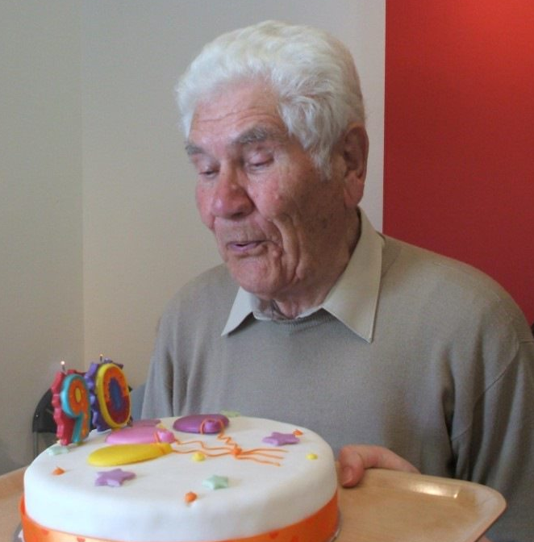
Oral History of Rudi Kuhnbaum, Former Prisoner of War, 2008
Reference: T/497 | Suggested age groups: KS2, KS3, KS4, lifelong learners | Oral History, Prisoners of War, WW2, Post-War Europe

Prisoners of War
Prisoners of war, often shortened to POW, are soldiers who have been captured and held prisoner by enemy forces during an armed conflict or war.
Enemy forces captured and held POWs for a number of legitimate and illegitimate reasons. Reasons include, to isolate soldiers away from their own side; to show they have won the conflict; to punish or prosecute soldiers for war crimes; to exploit them for labour; to collect military and political information about their opponent; and to recruit the POWs to their own side.
The Third Geneva Convention gives POWs many different rights. The original Geneva Convention dated from 1864 and was added to in 1899, 1907 and 1949 (after the Second World War). The earlier conventions defined the expected treatment of injured enemy soldiers by the international powers that signed them. The Hague Convention of 1929 was the first to address the needs of prisoners of war.
POWs rights under the Third Geneva Convention include:
- They must be treated decently, with respect.
- They must be allowed to tell their families and the International Committee of the Red Cross that they are a POW.
- They have the right to communicate with their families and get packages.
- They have the right to keep their clothing, eating utensils, and personal things.
- They must be given adequate food, clothing, housing, and medical attention.
- If their captors make them work, POWs must be paid for the work they do.
- If they are going to be charged with a crime, they must be given a trial.
- If they are very sick or hurt, prisoners of war have the right to be let go.
- After a war ends, all POWs must be let go quickly.
Prisoners of war also have the right not to:
- Give their captors any information, except for their name, age, rank, and service number (a military identification number).
- Have their money or valuable things stolen
- Do forced labour, military work, or work that is dangerous, unhealthy, or degrading.

Prisoner of War Camps in Britain
English Heritage have identified over 1000 possible sites of Second World War POW camps in the British Isles. Including seven in Northumberland (see link to Guardian article):
- Featherstone Camp near Haltwhistle
- Darras Hill, Ponteland
- Wooler Camp, Wooler
- Hetton House Camp, Chatton
- Kitty Brewster Camp, Blyth
- Lord Mayor’s Camp, Amble
- Byrness Camp, Redesdale, Otterburn

Wylam was not included on this list, even though we know that there was a camp in the village. Wylam was a small camp and may well have been seen as a part of one of the larger camps in the area.
Around 400,000 POWs lived in British camps during the Second World War. When they were finally released, large numbers decided to stay in this country. Some estimates say 25,000 former prisoners made a new life for themselves here.
The British government encouraged POWs to stay in this country. Especially if they were working on farms producing food (see Hansard link). Conditions for ordinary people in Germany were hard. Most of the towns and cities had been heavily bombed, food and other essentials were scarce.
Boredom was the main problem for most inmates in prisoner of war camps during the Second World War. Rudi Kuhnbaum’s photographs and oral history show that the prisoners at Wylam passed their time by making a miniature castle and a fountain for the village. The prisoners at Featherstone produced the Die Zeit am Tyne newspaper.

Oral History
These sound files are extracts (short, edited pieces) from longer oral history interviews preserved by Northumberland Archives. This interview was made as part of a project to collect the memories of people who lived through the Second World War in Northumberland. You can also read the summary of this interview.

Rudi Kuhnbaum
Rudi was a German soldier during the Second World War. He joined up in 1939 and fought on the Russian Front. The fighting between the German and Russian forces in the East was particularly brutal. The extreme cold of the Russian winters and the problems of supplying troops with food meant that the German Army lost many men in the East. Rudi fought on the Russian Front for two years.
Rudi was transferred to France towards the end of the war. He was injured and captured by the British, becoming a prisoner of war. Rudi landed in Britain and lived in several prisoner of war camps (see oral history summary for more details). Eventually he was transferred to the camp at Wylam. At the camp he helped to make the miniature castle, which can be seen on the photographs. The prisoners also made a fountain for the community centre in the village (see photographs).
After a while Rudi started working on local farms. He went to live with the Laws family at Heddon on the Wall. Rudi enjoyed working for the family and stayed working on the farm after the end of the war, when he chose to stay in England rather than go back to Germany.

Rudi Kuhnbaum Oral History Summary
Rudi Kuhnbaum interviewed by Liz O’Donnell about his life as a POW.

Clip 1: Introduction
Rudi talks about how he became a prisoner of war and his journey from France to the Northeast.
He describes the reception of the POWs in England.
He talks about arriving in Newcastle as the best part of his life.
MP3, 2.3MB, 3 minutes.

Clip 2: Rudi talks about working for the Laws on their farm at Heddon-on-the-Wall.
He describes communication difficulties (in spite of Rudi being able to speak English) and the breakfast the family gave him.
He talks about social events that he attended in the village.
MP3, 1.96MB, 2 minutes 31 seconds.

Clip 3: Rudi talks about his time at Wylam. He stayed at the camp and walked to the farm that he worked on.
Talks about his room at the farm – he had the bacon hanging around his bed!
Describes the making of the castle by the POWs.
Talks about buying NAAFI (Navy Army and Air Forces Institute) cake and how much he earned.
MP3, 1.96MB, 2 minutes 32 seconds.

Clip 4: Liz asks Rudi if he ever received any unpleasant treatment because he was German.
Rudi says the English treated him well, but a family of Americans threw him out of their car.
He talks about the end of the war – going back to Germany for a month and then returning here to live.
Describes making a life in the Northeast – getting married and having a family, working as a butcher
MP3, 2.7MB, 3 minutes 30 seconds.

You can read a full summary of Rudi’s oral history on our online catalogue.

Other Online Resources
Hague Conventions 1929: https://ihl-databases.icrc.org/ihl/INTRO/305
Hansard website, page with commons debate on the repatriation of POWs: https://api.parliament.uk/historic-hansard/commons/1947/apr/22/ex-prisoners-of-war
History.com website, page “8 things you should know about WWII’s Eastern Front”: https://www.history.com/news/8-things-you-should-know-about-wwiis-eastern-front
Imperial War Museum website, page about the Eastern Front: https://www.iwm.org.uk/history/operation-barbarossa-and-germanys-failure-in-the-soviet-union
YouTube website, video from US about state of post-war German, 1947 (16 minutes) https://www.youtube.com/watch?v=kjSBZLSpD8Q
YouTube website, clip from Sendung Mit Der Maus (German children’s TV programme) about post-war Germany. Shows photographs of Cologne after the war and in the late 1990s/early 2000s. In German (4 minutes): https://www.youtube.com/watch?v=h-nJGbjIWkg
AAFI website, page about their history https://naafi.co.uk/history/
BBC WW2 People’s War website, page with story of young women who worked in NAAFI canteen:
https://www.bbc.co.uk/history/ww2peopleswar/stories/97/a4001897.shtml
Forces War Records website, page about NAAFI: https://www.forces-war-records.co.uk/units/1792/naafi

Prisoners of War
Imperial War Museum website, page about British Prisoners of War in Germany during WW2: https://www.iwm.org.uk/history/what-life-was-like-for-pows-in-europe-during-the-second-world-war
Imperial War Museum website, page about enemy Prisoners of War in Britain during WW2: https://www.iwm.org.uk/history/a-short-history-of-german-and-italian-pows-in-britain
Historic England website, page about Prisoner of War camps in England and Wales: https://historicengland.org.uk/research/current/discover-and-understand/military/prisoner-of-war-camps/
The Guardian website, page with location database of Prisoner of War camps: https://www.theguardian.com/news/datablog/2010/nov/08/prisoner-of-war-camps-uk#data
Irish Times website, article about German Prisoner of War in Britain: https://www.irishtimes.com/culture/books/the-untold-story-of-britain-s-pow-camps-1.3169823
Kiddle Encyclopaedia page about Prisoners of War: https://kids.kiddle.co/Prisoner_of_war
BBC website, article about German and Italian Prisoners of War in Britain: https://www.bbc.co.uk/news/uk-england-nottinghamshire-52547324

Oral History
Website for Oral History Society, includes definition of oral history: https://www.ohs.org.uk/
University of Leicester information sheet on oral history (pdf). Although the language isn’t the most accessible it does discuss value and reliability of oral histories: https://www.le.ac.uk/ur/emoha/training/no1.pdf
Website for Glasgow Women’s Library, blog discussing oral history project, includes definition: https://womenslibrary.org.uk/2017/08/09/what-are-oral-histories-and-why-are-they-important/
British Library website, page for oral history collections: https://www.bl.uk/collection-guides/oral-history
British Library Sounds website, includes oral history recordings: https://sounds.bl.uk/Oral-history
Imperial War Museum website page for oral history collections, one of the biggest oral history collections in the country. Many can be searched and listened to online: https://www.iwm.org.uk/collections/sound

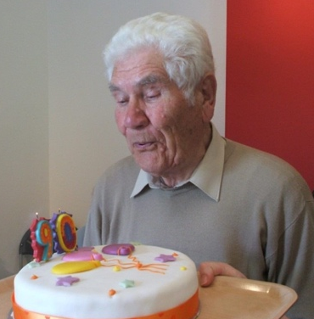
Lerning Activities: Oral History of Rudi Kuhnbaum, former prisoner of war, 2008

Topic: WW2, Prisoners of War, Post-War Europe, Oral History
Subject areas: History, Literacy, Geography, Art

Background | Activity | Resources
Prisoners of war, often shortened to POW, are soldiers who have been captured and held prisoner by enemy forces during an armed conflict or war.  Enemy forces captured and held POWs for a number of legitimate and illegitimate reasons. Reasons include, to isolate soldiers away from their own side; to show they have won the conflict; to punish or prosecute soldiers for war crimes; to exploit them for labour; to collect military and political information about their opponent; and to recruit the POWs to their own side.  English Heritage have identified over 1000 possible sites of Second World War POW camps in the British Isles. Including seven in Northumberland.  Rudi was a German soldier during the Second World War. He joined up in 1939 and fought on the Russian Front. Rudi was transferred to France towards the end of the war. He was injured and captured by the British, becoming a prisoner of war. | See: What are prisoners of war?  See: Who can be made a POW?  See: Why are people made to become POWs?  See: What does the Geneva Convention say about POWs?  See: What does the Hague Convention address about POWs?  See: How many WW2 era POW camps are thought to have existed in the British Isles?  See: How many of these British WW2 POW camps were in Northumberland?  See: When and where was Rudi taken as a POW?  See: Which POW camps was Rudi kept at?  See: What work did Rudi do as a POW? | https://www.iwm.org.uk/history/a-short-history-of-pows-during-the-second-world-war  https://www.nationalarchives.gov.uk/pathways/citizenship/brave_new_world/immigration.htm  https://www.bbc.co.uk/bitesize/guides/zx93tyc/revision/1  https://www.bbc.co.uk/news/uk-politics-51134644  https://historicengland.org.uk/research/current/discover-and-understand/military/prisoner-of-war-camps/  https://www.iwm.org.uk/history/a-short-history-of-german-and-italian-pows-in-britain  https://www.bbc.co.uk/history/british/britain_wwtwo/german_pows_01.shtml  https://www.bbc.co.uk/news/uk-england-nottinghamshire-52547324  https://www.nationalarchives.gov.uk/help-with-your-research/research-guides/prisoners-of-war-british-hands/  https://www.historyandpolicy.org/policy-papers/papers/germany-1945-1949-a-case-study-in-post-conflict-reconstruction  https://europe.unc.edu/the-end-of-wwii-and-the-division-of-europe/  https://www.britannica.com/place/Germany/The-era-of-partition
Think: Is it right to take POWs?
Think: Why were civilians taken as POWs?
Think: Is there a difference in taking members of the armed forces as POWs than taking civilians as POWs?
Think: What rights do POWs have?
Think: Why were POWs repatriated in Britain?
Think: Why might POWs have wanted to stay in Britain?
Think: Were POWs accepted into local communities?
Think: What was life like in post-war Britain?
Think: Why did post-war Britain have a shortage of workers?
Think: What was life like in post-war Germany?
Think: What challenges did post-war Germany have to face that post-war Britain didn’t?
Think: What impression do you have of Rudi’s POW experience?
Think: What attitude does Rudi have towards being a POW?
Think: Do you think Rudi’s experience was similar to the experiences had by other POWs?
Do: Create a map showing the different WW2 era POW camps in the British Isles.
Do: Use Google Maps to look at what each of the former POW camp sites look like now. How much have they changed?
Do: Create a map showing the journey Rudi made from his capture in France until his arrival in Wylam.
Do: Design an art piece which could be displayed at a former POW camp site to remember those who were kept there and their heritage.
Do: Research WW2 POW camps in other countries. Compare this to information you have learned about POW camps in the British Isles. How did different countries treat their POWs and what conditions were they kept in?
Do: Research the Geneva Conventions and Hague Convention. Create a poster showing the rights and expected treatments of POWs.
Do: Using your research about POW camps, can you find evidence of the Geneva Convention and Hague Convention expectations not being met?
Do: Using your research about POW camps, can you find evidence of the Geneva Convention and Hague Convention expectations being met?
Do: Choose one section of Rudi’s oral history. Imagine you are Rudi, write a diary entry from Rudi’s perspective describing what has taken place. Consider how he might have felt about it.
Do: Research the political, social, and economic climate of post-war Britain and post-war Germany. Create a table comparing their similarities and differences.
Do: Discuss how the Second World War contributed to a rise in immigration to Britain.
Do: Research what it means to be ‘displaced’. Discuss how a POW might have feelings of displacement.
Do: Write the script for a conversation between a British person and a German POW who has decided to remain in Britain. How might they feel about each other; how might they react to each other; what questions might they have for each other; would there be any barriers for communication?
These sound files are extracts (short, edited pieces) from longer oral history interviews preserved by Northumberland Archives. This interview was made as part of a project to collect the memories of people who lived through the Second World War in Northumberland. You can also read the summary of this interview. | See: Why were these oral histories recorded?  See: Who took part in these oral history interviews?  See: What is included in the oral history extracts? | https://www.ohs.org.uk/  https://www.le.ac.uk/ur/emoha/training/no1.pdf  https://womenslibrary.org.uk/2017/08/09/what-are-oral-histories-and-why-are-they-important/  https://www.bl.uk/collection-guides/oral-history  https://sounds.bl.uk/Oral-history  https://www.iwm.org.uk/collections/sound
Think: What is an oral history?
Think: Why is it important to record oral histories?
Think: What is the value of oral histories?
Think: What useful information can we learn from Rudi’s oral history?
Think: Who might use oral histories?
Think: How might Rudi’s oral history be used and by whom?
Think: How reliable are oral histories?
Think: What types of oral histories might be recorded?
Do: Imagine you are about to interview a someone who was a POW for an oral history. Write down a list of questions or talking points that you might use to prompt them during the interview.
Do: Write down a list of events that have taken place during your lifetime that you think it would be important to create oral history records of.
Do: Write down a list of events that have taken place before your lifetime that you think it would be important to have oral history records of.
Do: Look at the British Library, British Library Sounds and Imperial War Museum websites. Can you find oral history recordings about the events from your lists?
Do: Think of an event that you have experienced first-hand. In pairs, interview each other about your chosen events and create oral history recordings.
Do: Do you think oral history recordings should be made using second-hand stories or should they be made using only first-hand events? Debate this in groups.

