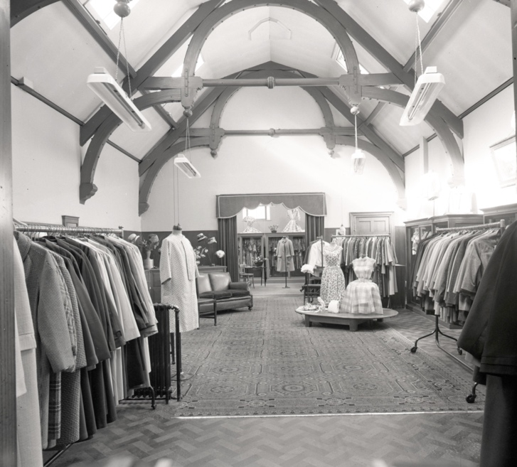
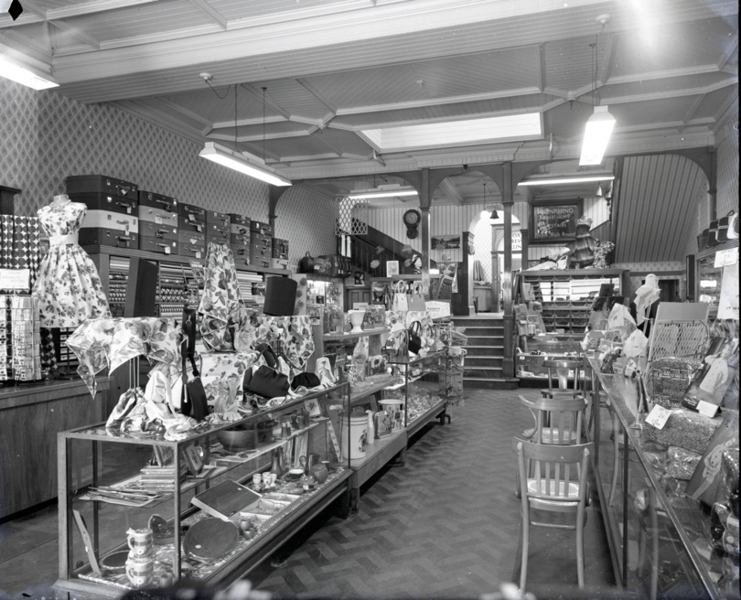
Photographs of Shop Interiors in Berwick, 1958-1966
Reference: BRO 1944/1/3435/14, BRO 1944/1/3435/7, BRO 1944/1/2072/14, BRO 1944/1/4658/11| Suggested age groups: KS2, KS3, KS4, Lifelong Learners |Topic areas: Photography, Interior Architecture, Advertising, Shopping

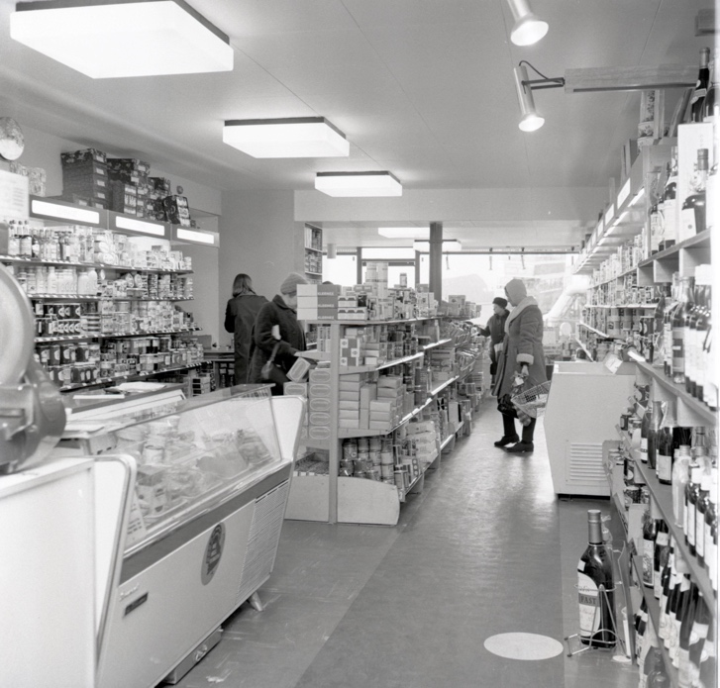
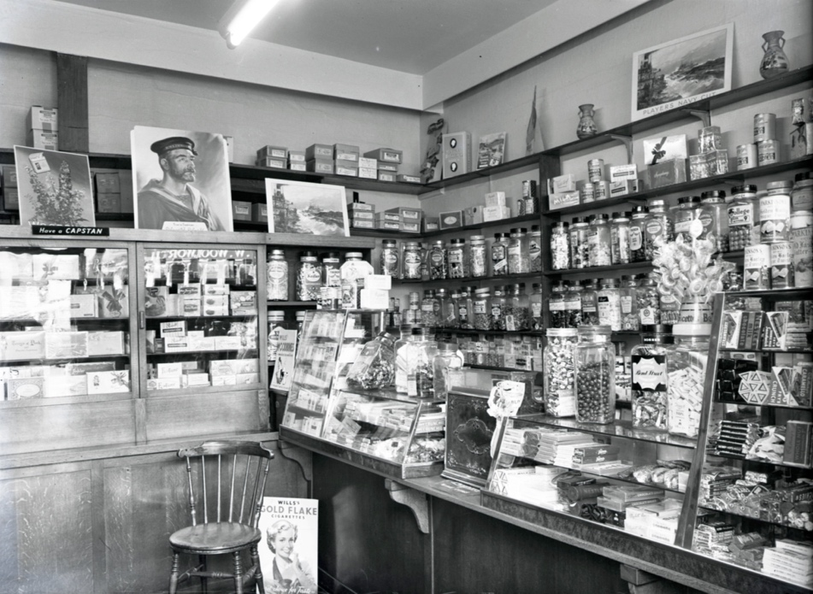
Berwick Photo Centre
Originally founded in 1951 as the Photo-News Service, the Photo Centre in Berwick was a staple of town life for over 65 years as a family-run press agency and photo studio.
Their premises at 17 Bridge Street had a well-equipped studio above the shop where commercial photography took place. The business also covered newsworthy events in the area and recorded family occasions and celebrations, marking milestones in the lives of several generations of townspeople.

Photographs of Shop Interiors in BErwick
This collection of photographs depicts the interiors of several shops in Berwick during the late-1950s to mid-1960s.
The first photograph (BRO 1944/1/3435/14) of Paxton & Purves, drapers was taken on 7th April 1962. The shop had operated on these premises near Scotsgate since the 1880s. This photograph shows the ladies gown department. Customers who had an account with the shop could take articles home “on appro”.

The second photograph (BRO 1944/1/3435/7) also shows Paxton & Purves and was taken on 7th April 1962. The business operated from several shops and the middle one sold clothing, drapery, and fancy goods. The layout of the shop remained largely unchanged since the 1890s

The third photograph (BRO 1944/1/4658/11), taken in 1966 shows Stoddart’s at the corner of Marygate and Golden Square. Stoddart’s, an old-established business in Berwick was founded in 1834 and specialised in high-class groceries, local produce, wines, and spirits. The shop’s layout in this photograph reflects the change in shopping habits that came with refrigerated goods and self-service. The shop closed in 1988.

The final photograph (BRO 1944/1/2072/14), taken in August 1958 shows Towers & Bishop, a confectioners and sweet shop on Marygate. The shop was founded in 1867 by Mr John Bishop and it both manufactured and sold sweets. The shop stopped trading in the 1960s.

Shopping in BEriwck
Today, most people shop at supermarkets where they expect to buy groceries, clothes and newspapers or books in the one shop or go to out of town retail sites. However, it was very different in the past with most people shopping in a high street location. Up until the mid to late 1960s shopping in Berwick was a very different experience to today. Very few shops were run by national chains. Although there were branches of Woolworths and Boots, most businesses were independent shops run by local people.

A walk down Marygate in the late 1950s would have taken you past butchers; fishmongers, bakers; jewellers; grocers; chemists; clothes and shoe shops; local department and furniture stores. Everything could be bought there but in individual shops. This started to change in the 1960s with the advent of supermarkets and larger national chain stores. Shopping facades were modernised and many of the original buildings were pulled down to build larger, modern looking shops for Boots and the Co-op. Today Marygate in Berwick looks very different – very few independent businesses but lots of national chains, coffee shops, charity shops and empty premises.

Interior Architecture Photography
Interior architecture photography, sometimes known as interior photography or interior design photography, is the practice of photographing indoor spaces. Images can focus on capturing the insides of buildings and structures on a large scale; specific areas such as the renderings of a staircase; or focusing on the décor or furniture within the space.
Interior architecture photography is important for brand building, design showcasing, and advertising. It can be used to illustrate interior designs, for example by being showcased in design magazines; to promote or advertise a business or brand, for example the work of an architect or furniture designer; to advertise a space, for example a hotel, restaurant, or retail establishment; and is also used for the purposes of selling spaces, for example images used by estate agents.

Other Online Resources

Early Photography
Science Museum website, page about history of photography: https://www.scienceandmediamuseum.org.uk/objects-and-stories/history-photography
British Library website, page about invention of photograph (Henry Fox Talbot): https://www.bl.uk/collection-items/invention-of-photography
Bodleian website, biography of Henry Fox Talbot: https://talbot.bodleian.ox.ac.uk/talbot/biography/

PhotoCentre
Portrait of a Town exhibition: https://www.photocentreberwick.co.uk/portrait-of-a-town/work-and-industry
Photocentre workshop resources: https://www.photocentreberwick.co.uk/learning

Interior Architecture Photography
Photoarchitects webpage about the importance of interior photography: https://thephotoarchitects.com/why-architecture-and-interior-photography-is-so-important-for-your-brand/
Shootfactory website, page about tips for architecture photographs: https://www.shootfactory.co.uk/professional-tips-for-high-quality-interior-and-architectural-photography/
Webpage about photographing retail interiors: https://www.kalory.co.uk/london-retail-interior-photographer/
Article about the design and style of interior photography: https://contrastly.com/the-art-and-style-of-architectural-and-interior-design-photography/

Artist Bank – Interior Architecture Photographers

Andreas Gursky
Andreas Gursky is a German artist known for his large scale, digitally-manipulated images. Gursky’s photographs capture built and natural environments, often taken from a high vantage point, digitally spliced together from multiple images of the same scene. This results in Gursky’s characteristic style of surreal repetition and abstractions.
Example images: 99 Cent, 1999; Dior Homme, 2004; Storage, 2014

Marco Joe Fazio
Italian born Marco Joe Fazio began his career working in architecture, interior and lighting design before becoming a photographer and designer in 2008. Fazio is a strong believer in the power of visual concepts and describes himself as a ‘storyteller’. He works across genres, marrying together architecture, natural environments, fashion, and food.
Interior portfolio: https://marcojoefazio.com/habitat-hospitality

Brandon Barré
Brandon Barré is a leader in the field of luxury and high-end interior photography, and food & drink photography. He has worked with some of the most prestigious brands and designers throughout his career. He has a recognisable signature style in lighting, detail and digital retouching.
Interior portfolio: https://www.brandonbarre.com/

Magda Biernat
Magda Biernat is a contemporary art photographer specialising in architecture and interiors. Her commercial work has been featured in top tublications such as the New Yorker, National Geographic, and Interior Design magazines. Her fine art photographs have been exhibited internationally.
Architecture portfolio: https://www.magdabiernat.com/

Brittany Ambridge
Brittany Ambridge is known for her authentic style, capturing the essence of her subject, whether it’s the personality of a space or a person. She photographs in a subtle style.
Interior portfolio: http://www.brittanyambridge.com/

Kris Tamburello
Kris Tamburello is a photographer, videographer and multi-disciplined artist. He has an eye for detail and technical proficiency, with bold and graphic photographs.
Interior portfolio: https://kristamburello.com/interior-photography

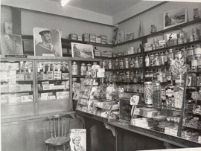
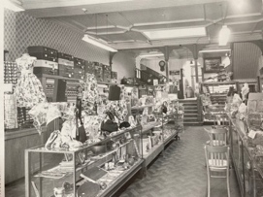
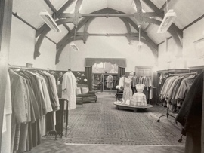
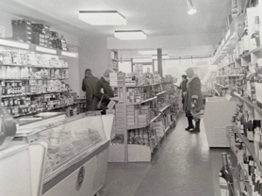
Learning Activities – Photographs of Shop Interiors in Berwick, 1958-1966

Topic: Photography, Interior Architecture, Advertising, Shopping
Subject areas: Photography, Literacy, History, maths

Background | Activity | Resources
Today, most people shop at supermarkets where they expect to buy groceries, clothes and newspapers or books in the one shop or go to out of town retail sites. However, it was very different in the past with most people shopping in a high street location. Up until the mid to late 1960s shopping in Berwick was a very different experience to today. Very few shops were run by national chains. Although there were branches of Woolworths and Boots, most businesses were independent shops run by local people.  A walk down Marygate in the late 1950s would have taken you past butchers; fishmongers, bakers; jewellers; grocers; chemists; clothes and shoe shops; local department and furniture stores. Everything could be bought there but in individual shops. This started to change in the 1960s with the advent of supermarkets and larger national chain stores. Shopping facades were modernised and many of the original buildings were pulled down to build larger, modern looking shops for Boots and the Co-op. Today Marygate in Berwick looks very different – very few independent businesses but lots of national chains, coffee shops, charity shops and empty premises. | See: Where do most people shop today?  See: Where did most people shop up until the mid- to late 1960s?  See: Were there mostly national chains or independent local stores on Berwick’s high street until the mid- to late 1960s?  See: What types of shops would have been found on Marygate in Berwick during the late 1950s?  See: What changes took place to shops on Marygate during the 1960s?  See: What is Marygate like today? How does this differ from the 1950s and 1960s? | https://www.yorkshirepost.co.uk/news/austerity-affluence-decade-changed-expectations-1958708  https://www.historic-uk.com/CultureUK/The-1960s-The-Decade-that-Shook-Britain/  https://www.historycrunch.com/history-of-consumerism.html#/  https://nostalgiacentral.com/pop-culture/food-drink/shopping-1960s/  http://news.bbc.co.uk/1/hi/magazine/6707573.stm  https://ukandeu.ac.uk/uk-high-street-reveals-key-issues-facing-the-economy-after-covid-19-and-brexit/  https://www2.deloitte.com/content/dam/Deloitte/uk/Documents/consumer-business/deloitte-uk-what-next-for-the-high-street-part1.pdf  https://www.thegrocer.co.uk/high-street/how-can-we-stop-britains-high-streets-becoming-ghost-towns/654096.article
Think: What did high streets look like in the 1960s?

Think: Where did most people do their shopping during the 1960s?

Think: How did the emergence of chain retailers impact the local high street?

Think: How did the emergence of chain retailers impact people’s shopping habits?

Think: How did the emergence of online retailers impact the local high street?

Think: How did the emergence of online retailers impact people’s shopping habits?

Think: What is consumerism?

Think: What does austerity mean?

Think: What does affluence mean?

Think: Where do you do most of your shopping?
Think: Where did most people shop in the 1960s?
Think: Do you mostly shop in person or online?
Think: How has consumerism changed between now and the 1960s?
Think: How has consumerism changed within the last 10 years?
Think: How do people’s shopping habits differ now to those in the 1960s?
Do: Research Britain’s financial situation during the 1950s and 1960s. Discuss how this led to the emergence of shopping culture.

Do: Research the British high street. How has this changed since the 1960s? What challenges and successes does it face today?

Do: Research brands and shops that emerged in Britain during this time. How many still exist today?

Do: Research your local high street. Can you find a list of which shops were there during the 1960s?

Do: Create a survey of the shops from the 1960s. Which services did they provide?

Do: Create a survey of the shops from the 1960s. How many are independent local shops and how many are national/international chain shops? How many stores were empty?

Do: Visit your local high street. Create a survey, when did each of the shops open? Are any still there that were open during the 1960s? How many of the stores are empty?
Do: Create a survey of the shops on your local high street. Which services do they provide? How many are independent local shops and how many are national/international chain shops?
Do: Create charts comparing the two sets of data. You could repeat the activities for additional years to see a wider trend over time if you would like to.
Do: Use this data to write about how your local high street has changed between the 1960s and today. Does this fit with the general trend of high streets in Britain? Can you use evidence to state why these changes might have taken place?
Do: Discuss the challenges faced by high streets today.
Do: Make a proposal of how British high streets could be revitalised.
Do: Find some older photographs of shops in your local area. Take a modern photograph from the same angle and compare the two images. What are the differences and similarities?
Do: Visit your local high street and take photographs you think could be used to promote it. Create a leaflet using the photographs to encourage people to visit your high street.
This collection of photographs depicts the interiors of several shops in Berwick during the late-1950s to mid-1960s. Interior architecture photography, sometimes known as interior photography or interior design photography, is the practice of photographing indoor spaces. Images can focus on capturing the insides of buildings and structures on a large scale; specific areas such as the renderings of a staircase; or focusing on the décor or furniture within the space. | See: What is shown in these photographs?  See: When were these photographs taken?  See: What style of photography are these images an example of?  See: What is interior architecture photography?  See: What is the purpose of interior architecture photography?  See: How might interior architecture photographs be used? | https://thephotoarchitects.com/why-architecture-and-interior-photography-is-so-important-for-your-brand/  https://www.shootfactory.co.uk/professional-tips-for-high-quality-interior-and-architectural-photography/  https://www.kalory.co.uk/london-retail-interior-photographer/  https://contrastly.com/the-art-and-style-of-architectural-and-interior-design-photography/
Think: What is the focus of each of these photographs

Think: Why do you think these photographs were taken?

Think: Where might these photographs have appeared?

Think: How do these photographs compare to images taken by the photographers in the artists bank?

Think: What is your favourite style of interior architecture photography?
Do: Experiment with taking a range of different interior architecture photographs in the style of these photographs, and in the style of some of the photographers from the artist bank.
Do: Make a list of criteria of what makes a successful interior architecture photograph.
Do: Choose one of the Berwick shop interior photographs. Analyse it against your list – is this a successful interior architecture photograph?

Do: Choose an interior architecture photograph by one of the photographers in the artists bank. Analyse it against your list – is this a successful interior architecture photograph? Compare this with the first photograph you analysed.

Do: Choose an interior architecture photograph you have taken in the style of the Berwick shop interiors and artists from the artist bank. Analyse it against your list – is this a successful interior architecture photograph? Compare this with the previous two photographs you analysed.

Do: Does a criteria need to be followed to create a successful image? Discuss whether you think these rules should be followed or whether more interesting images can be produced by breaking them.

Do: Design an interior architecture shoot following your criteria for a successful image using the space of your choice. You could focus on the space as a whole or focus on a specific section.

Do: Design a second shoot in the same space with the same focus, but this time break the rules.

Do: Compare the two shoots. Which do you prefer and why?

Do: Look at the work of Andreas Gursky. Experiment with the use of shape, scale, repetition, and digital manipulation in interior architecture photography.
Do: How would you design interior architecture shoots differently to meet the needs of different clients or purposes? For example, promoting a high-profile globally renowned restaurant compared to a small-scale local café; a design spread for an interior design magazine compared to images for an estate agent; a retail advertising billboard compared to a fine art print exhibited in a gallery. Mock-up some example shoots for each client.

Do: Use what you have learned about interior architecture photography to design a shoot with a focus of your choosing. Write your own brief for this shoot thinking about the client, purpose, and final presentation of the images.

Do: Undertake your shoot and prepare the images to be presented in the way specified in your brief.

Do: Present your images in your chosen way e.g. exhibition, magazine spread etc.

Do: Analyse your final images and their presentation against your brief. Did you meet the brief or did the plan change?

