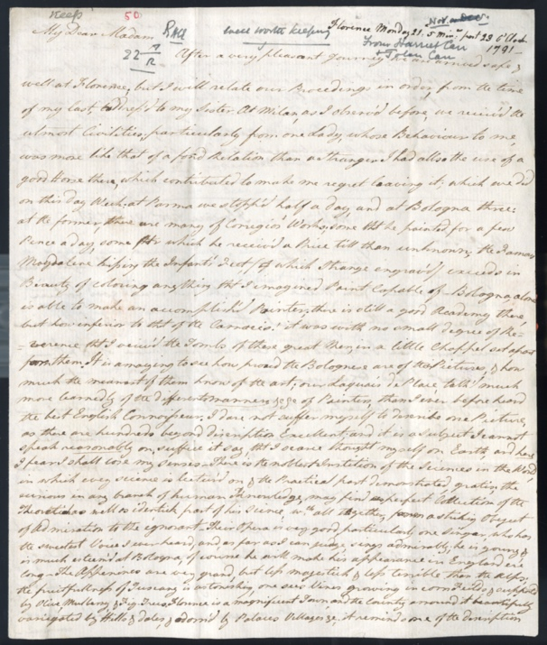
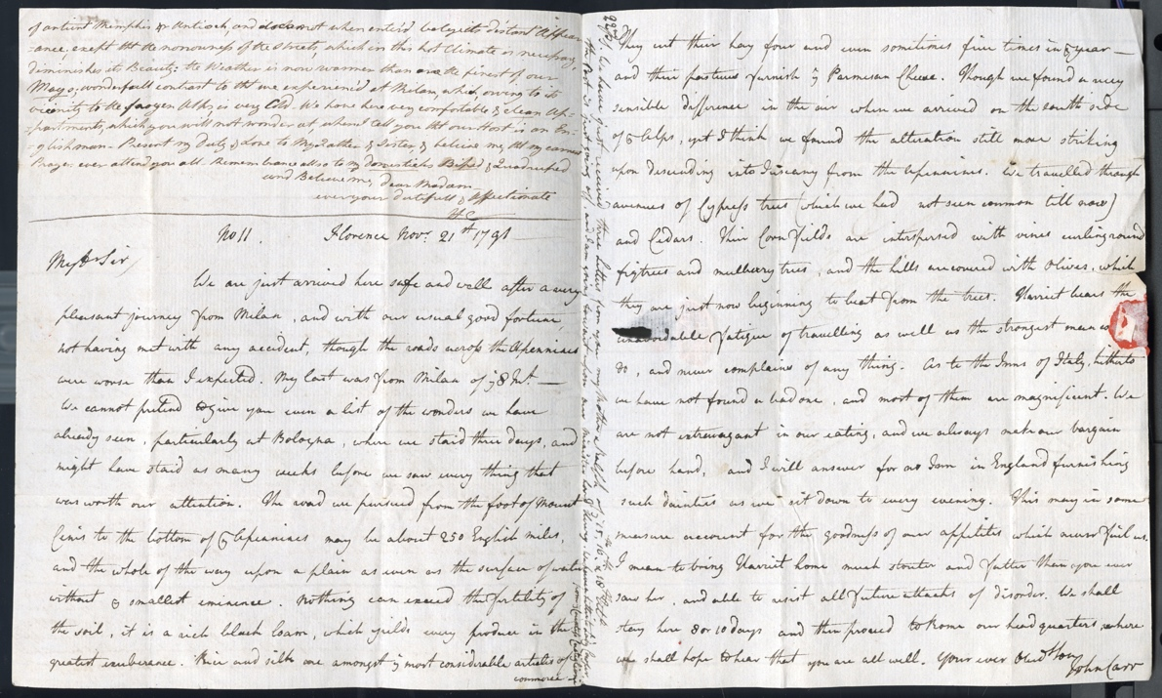
Letters from John and Harriet Carr About Travelling during the Grand Tour 1791
Reference: ZCE F/1/1/1/117 | Suggested age groups: lifelong learners | The Grand Tour, Travel Writing, Arts & Culture

Letter from John and harriet Carr to Ralph and Isabella Carr
This letter, written from Florence, follows a format often used by John and Harriet Carr, one sibling writing to one parent and the other sibling to the other. The letters were sent as one to their parents. In this letter of 21 November 1791, John Carr writes to his father, Ralph, and Harriet to her mother, Isabella. Paper and postage were expensive so this would have been an economical way of writing to both parents.
We learn that John and Harriet have recently arrived in Florence having travelled from Milan through Parma and Bologna. John writes of the poor state of the roads across the Apennine MountaIns. There were few passable roads across the Mountains and in winter they were often blocked by snow. John’s letter tells us more about their journey – ‘The road we pursued from the foot of Mount Cenis to the bottom of the Apennines may be about 250 English miles, and the whole of the way upon a plain as even as the surface of water without ye smallest eminence’. John takes a traveller’s interest in the countryside they pass through, describing the soil – ‘… it is a rich black loam, which yields every produce in the greatest exuberance. Rice and silk are amongst the most considerable articles of commerce. They cut their hay four and even sometimes five times in the year - and their pastures furnish the Parmesan Cheese’. He goes on to describe the produce of the district – ‘We travelled through avenues of Cypress trees (which we had not seen common till now) and Cedars. Their Corn fields are interspersed with vines curling round figtrees(sic) and mulberry trees, and the hills are covered with Olives, which they are just now beginning to beat from the trees’. He also writes about their accommodation – ‘As to the Inns of Italy, hitherto we have not found a bad one, and most of them are magnificent. We are not extravagant in our eating, and we always make our bargain before hand, and I will answer for no Inn in England furnishing such dainties as we sit down to every evening. This may in some measure account for the goodness of our appetites which never fail us’. John’s reference to his not being extravagant may be a reassurance to his father that the siblings are managing their budget for the trip carefully.
Almost all of Harriet’s Grand Tour letters include reference to her interest in art and her efforts to improve her own artistic knowledge and skills. She reports that in Parma ‘… there was many of Corregios' (sic) Works; some th[a]t he painted for a few Pence a day, some for which he receive'd a Price till then unknown; the Famous Magdalene kissing the Infant's Feet, (which Strange engrav'd) exceeds in Beauty of coloring anything th[a]t I imagined Paint capable of’. The artist she refers to is Antonio Allegri da Correggio (1489-1534), known as Correggio, the name of the town in which he was born. Correggio spent much of his career in Parma and the city houses many of his important works. She refers to the Academy or School of Art in Bologna being ‘inferior to that of the Carracio’. This is a reference to the Academy established by the Carracci family of artists, brothers Annibale and Agostini and their cousin Ludovico, in Bologna around 1582. Harriet clearly holds them in high regard writing that she visited their tombs whilst in the city.
Harriet writes that ‘…our Laquais de Place, talk'd much more learnedly of the different manners &c &c of Painters, than I ever before heard the best English Connoisseur’. A Laquais de Place was a guide or cicerone. Tourists would hire a guide in the larger cities visited. Guides were known to try to defraud tourists and would take commissions from hotels and other services required by the tourist.
Harrier’s interests weren’t restricted to art. In this letter she writes of Bologna's Academy of Science and its free lectures, ‘…the noblest Instition (sic) of the Sciences in the World’. The Academy was founded around 1690. The letter gives an impression of Harriet’s interests, her desire to widen her knowledge and her enjoyment of the Grand Tour. By the end of the 18th century it became more common for women, accompanied by male relatives, to undertake the Tour. Upper class women did not attend school at this time and were educated at home by governesses. Home education was often limited, focussing on ‘accomplishments’ such as dancing and needlework. Harriet’s letter demonstrates that the Grand Tour provided women with exposure to the arts and science and the opportunity to undertake serious study.

Transcript
Florence Monday 21: 5 Min[ut]es past 23. o'Clock 1791

My Dear Madam
After a very pleasant Journey we are arrived safe & well at Florence; but I will relate our Proceedings in order, from the time of my last, address'd to my Sister. At Milan, as I observ'd before, we receive'd the utmost Civilities; particularly from one Lady, whose Behaviour to me, was more like that of a fond Relation than a Stranger I had allso the use of a good Horse there, which contributed to make me regret me leaving it; which we did on this day Week: at Parma we stopp'd half a day, and at Bologna three: at the former, there was many of Corregios' (sic) Works; some th[a]t he painted for a few Pence a day, some for which he receive'd a Price till then unknown; the Famous Magdalene kissing the Infant's Feet, (which Strange engrav'd) exceeds in Beauty of coloring anything th[a]t I imagined Paint capable of. Bologna, alone is able to make an accomplish'd Painter; there is still a good Academy there, but how inferior to that of the Carracio! it was with no small degree of Reverence that I view'd the Tombs of these great Men, in a little Chappel set apart from them. It is amazing to see how proud the Bolognese are of their Pictures, & how much the meanest of them know of the art; our Laquais de Place, talk'd much more learnedly of the different manners &c &c of Painters, than I ever before heard the best English Connoisseur. I dare not suffer myself to describe one Picture, as there are hundreds beyond description Excellent; and it is a Subject I cannot speak reasonably on; suffice it to say, that I scarce thought myself on Earth, and here I fear I shall lose my senses. There is the noblest Instition(sic) of the Sciences in the World, in which every science is lectur'd on & the Practical part demonstrated, gratis; the curious in any branch of human Knowledge, may find a perfect Collection of the Theoretical as well as the identick part of his Science, w[hi]ch all together, form a striking Object of Admiration to the ignorant. Their Opera is very good, particularly one Singer, who has the sweetest Voice I ever heard, and as far as I can judge, sings admirably; he is young, & is much esteem'd at Bologna, of course he will make his appearance in England er'e(sic) long. The Appenines(sic) are very grand, but less majestick & less terrible that the Alps; the fruitfullness of Tuscany is astonishing, one sees Vines growing in corn Fields & supported by Olive, Mulberry, & Fig Trees. Florence is a magnificent Town, and the Country arround(sic) it beautifully variegated by Hills & dales, & adorn'd by Palaces Villages &c; it reminds me of the description of antient Memphis or Antioch, and does not when enter'd belye its distant Appearance; except th[a]t the narrowness of the Streets, which in this hot Climate is necessary, diminishes its Beauty: the Weather is now warmer than are the finest of our Mays; wonderfull contrast to th[a]t we experienc'd at Milan, which, owing to its vicinity to the frozen Alps, is very Cold. We have here very comfortable & clean Appartments(sic), which you will not wonder at, when I tell you th[a]t our Host is an Englishman. Present my duty & Love to My Father & Sister & believe me, th[a]t my Prayers ever attend you all. Remembrance allso to my domesticks Biped & Quadruped and Believe me, dear Madam - ever your dutifull & Affectionate H C

No 11 Florence Nov[embe]r 21st 1791

My D[ea]r Sir
We are just arrived here safe and well after a very pleasant journey from Milan, and with our usual good fortune, not having met with any accident, though the roads across the Apennines were worse than I expected. My last was from Milan of the 8 In[stan]t. We cannot pretend to give you a list of the wonders we have already seen, particularly at Bologna, where we staid three days, and might have staid as many weeks before we saw every thing that was worth our attention. The road we pursued from the foot of Mount Cenis to the bottom of the Apennines may be about 250 English miles, and the whole of the way upon a plain as even as the surface of water without ye smallest eminence. Nothing can exceed the fertility of the soil, it is a rich black loam, which yields every produce in the greatest exuberance. Rice and silk are amongst the most considerable articles of commerce. They cut their hay four and even sometimes five times in the year - and their pastures furnish the Parmesan Cheese. Though we found a very sensible difference in the air when we arrived on the south side of the Alps, yet I think we found the alteration still more striking upon descending into Tuscany from the Apennines. We travelled through avenues of Cypress trees (which we had not seen common till now) and Cedars. Their Corn fields are interspersed with vines curling round figtrees(sic) and mulberry trees, and the hills are covered with Olives, which they are just now beginning to beat from the trees. Harriet bears the unavoidable fatigue of travelling as well as the strongest man w[ould] do, and never complains of any thing. As to the Inns of Italy, hitherto we have not found a bad one, and most of them are magnificent. We are not extravagant in our eating, and we always make our bargain before hand, and I will answer for no Inn in England furnishing such dainties as we sit down to every evening. This may in some measure account for the goodness of our appetites which never fail us. I mean to bring Harriet home much stouter and fatter than you ever saw her, and able to resist all future attacks of disorder. We shall stay here 8 or 10 days and then proceed to Rome our headquarters, where we shall hope to hear that you are all well. Your ever Obed[ien]t Son John Carr

22nd
PS. We have just received three Letters from you my Mother & Ralph of the 15th, 16th, & 18th Ult° the Post is just going off, and I am going to wait upon our Minister, Lord Hervey. We have a Letter to Lady Cowper from the Countess Castiglione

Further Reading

The Grand Tour and the Carr Family
Art Treasures in the North: Northern Families on the Grand Tour by Anne French (Unicorn Publishing Group, 2000)
John and Harriet Carr: A Brother and Sister from The North-East on The Grand Tour by Bill Purdue (Northern History, vol. 30, no. 1, 1994)
The British Abroad: The Grand Tour in the Eighteenth Century by Jeremy Black (The History Press, 1992)
Italy and the Grand Tour by Jeremy Black (Yale University Press, 2010)
Ladies of the Grand Tour by Brian Dolan (Flamingo, 2010)

