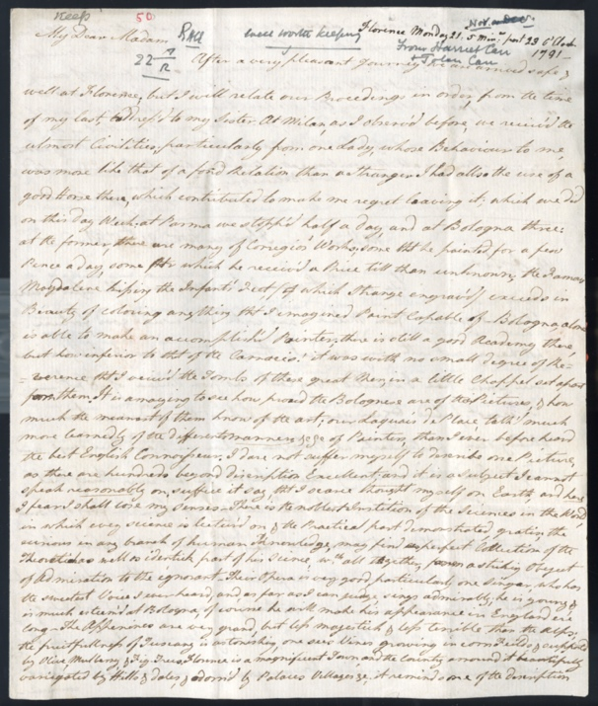
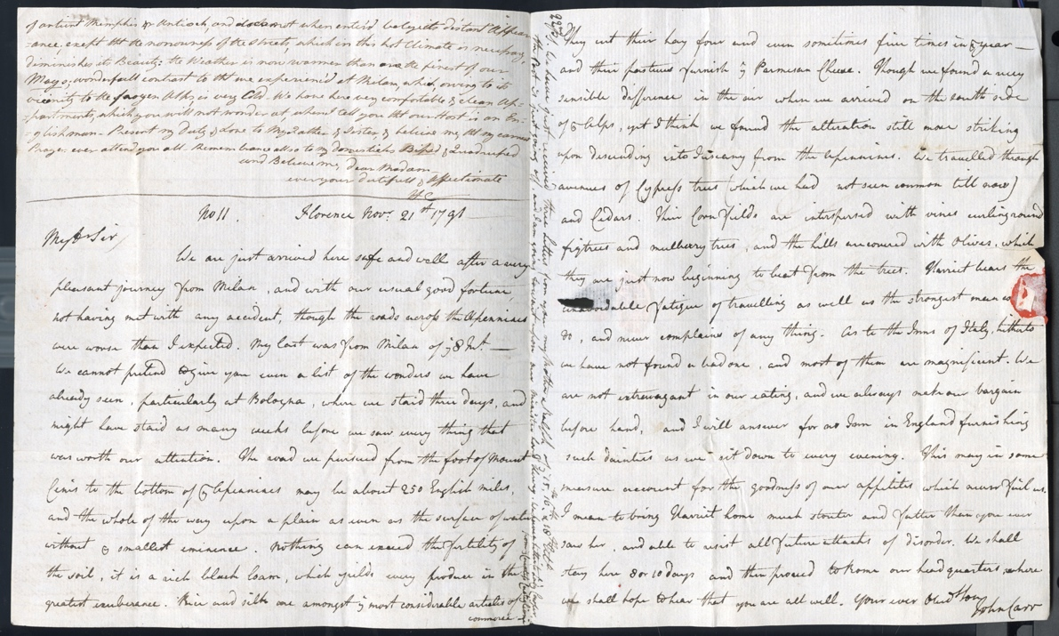
Letters from John and Harriet Carr About Travelling during the Grand Tour 1791
Reference: ZCE F/1/1/1/117 | Suggested age groups: KS2, KS3, Ks4, lifelong learners | The Grand Tour, Travel Writing, Arts & Culture, Women’s Education

The Grand Tour
During the 18th and 19th century, it was fashionable for wealthy British families to send their sons, and occasionally daughters, on a Grand Tour. This saw privileged young men and women setting off usually from London to travel across Europe. The tourists were affluent enough to spend multiple years on the Tour. They would often carry letters of introduction with them to integrate into society while abroad.

John and Harriet Carr
John Carr (1764-1817) and Harriet Carr (1771-1848) were siblings who set out on their Grand Tour in 1791, returning to England in 1794. They were the children of successful northern businessman Ralph Carr and his wife Isabella.
Ralph and Isabella were initially against Harriet going on the Grand Tour but eventually gave their approval because it was thought that the tour would benefit Harriet’s health – she had a cough thought to be tuberculosis. Some of their objections were around fears of the political situation in Europe and potential dangers to travellers. John and Harriet’s ultimate destination was Italy, travelling via France and Switzerland.
John and Harriet spent almost six months in Rome with short trips to Bologna, Florence, Naples, and Turin. They had planned to leave for England in early 1792 but the outbreak of the Franco-Austrian War prevented this. They returned to Florence in May 1792, staying there until November 1793. In December 1793 John and Harriet made a final visit to Rome before leaving for England and arriving home in the summer of 1794.

Letter writing
This document is two letters in one, written by the siblings to their parents. In the first section of the letter, John writes to their father Ralph Carr, in the second section, Harriet writes to their mother Isabella Carr. Paper and postage were expensive so this would have been the cheapest way of writing to both parents.

Letter from John to Ralph Carr
We learn that John and Harriet have recently arrived in Florence having travelled from Milan through Parma and Bologna. John writes of the poor state of the roads across the Apennine MountaIns. There were few passable roads across the Mountains and in winter they were often blocked by snow.
John’s letter tells us more about their journey – ‘The road we pursued from the foot of Mount Cenis to the bottom of the Apennines may be about 250 English miles, and the whole of the way upon a plain as even as the surface of water without ye smallest eminence’.
John takes a traveller’s interest in the countryside they pass through, describing the soil – ‘… it is a rich black loam, which yields every produce in the greatest exuberance. Rice and silk are amongst the most considerable articles of commerce. They cut their hay four and even sometimes five times in the year - and their pastures furnish the Parmesan Cheese’.
He goes on to describe the produce of the district – ‘We travelled through avenues of Cypress trees (which we had not seen common till now) and Cedars. Their Corn fields are interspersed with vines curling round figtrees(sic) and mulberry trees, and the hills are covered with Olives, which they are just now beginning to beat from the trees’.
He also writes about their accommodation – ‘As to the Inns of Italy, hitherto we have not found a bad one, and most of them are magnificent. We are not extravagant in our eating, and we always make our bargain before hand, and I will answer for no Inn in England furnishing such dainties as we sit down to every evening. This may in some measure account for the goodness of our appetites which never fail us’. John’ reference to his not being extravagant may be a reassurance to his father that the siblings are managing their budget for the trip carefully.

Letter from HArriet to Isabella Carr
Almost all of Harriet’s Grand Tour letters include reference to her interest in art and her efforts to improve her own artistic knowledge and skills.
She reports that in Parma ‘… there was many of Corregios' Works; some th[a]t he painted for a few Pence a day, some for which he receive'd a Price till then unknown; the Famous Magdalene kissing the Infant's Feet, (which Strange engrav'd) exceeds in Beauty of coloring anything th[a]t I imagined Paint capable of’.
The artist she refers to is Antonio Allegri da Correggio (1489-1534), known as Correggio, the name of the town in which he was born. Correggio spent much of his career in Parma and the city houses many of his important works. She refers to the Academy or School of Art in Bologna being ‘inferior to that of the Carracio’. This is a reference to the Academy established by the Carracci family of artists, brothers Annibale and Agostini and their cousin Ludovico, in Bologna around 1582. Harriet clearly holds them in high regard writing that she visited their tombs whilst in the city.
Harriet writes that ‘…our Laquais de Place, talk'd much more learnedly of the different manners &c &c of Painters, than I ever before heard the best English Connoisseur’. A Laquais de Place was a guide or cicerone. Tourists would hire a guide in the larger cities visited. Guides were known to try to defraud tourists and would take commissions from hotels and other services required by the tourist.
Harrier’s interests weren’t restricted to art. In this letter she writes of Bologna's Academy of Science and its free lectures, ‘…the noblest Instition (sic) of the Sciences in the World’. The Academy was founded around 1690.
The letter gives an impression of Harriet’s interests, her desire to widen her knowledge and her enjoyment of the Grand Tour. Upper class women did not attend school at this time and were educated at home by governesses. Home education was often limited, focussing on ‘accomplishments’ such as dancing and needlework. Harriet’s letter demonstrates that the Grand Tour provided women with exposure to the arts and science and the opportunity to undertake serious study.

Transcript
Florence Monday 21: 5 Min[ut]es past 23. o'Clock 1791

My Dear Madam
After a very pleasant Journey we are arrived safe & well at Florence; but I will relate our Proceedings in order, from the time of my last, address'd to my Sister. At Milan, as I observ'd before, we receive'd the utmost Civilities; particularly from one Lady, whose Behaviour to me, was more like that of a fond Relation than a Stranger I had allso the use of a good Horse there, which contributed to make me regret me leaving it; which we did on this day Week: at Parma we stopp'd half a day, and at Bologna three: at the former, there was many of Corregios' (sic) Works; some th[a]t he painted for a few Pence a day, some for which he receive'd a Price till then unknown; the Famous Magdalene kissing the Infant's Feet, (which Strange engrav'd) exceeds in Beauty of coloring anything th[a]t I imagined Paint capable of. Bologna, alone is able to make an accomplish'd Painter; there is still a good Academy there, but how inferior to that of the Carracio! it was with no small degree of Reverence that I view'd the Tombs of these great Men, in a little Chappel set apart from them. It is amazing to see how proud the Bolognese are of their Pictures, & how much the meanest of them know of the art; our Laquais de Place, talk'd much more learnedly of the different manners &c &c of Painters, than I ever before heard the best English Connoisseur. I dare not suffer myself to describe one Picture, as there are hundreds beyond description Excellent; and it is a Subject I cannot speak reasonably on; suffice it to say, that I scarce thought myself on Earth, and here I fear I shall lose my senses. There is the noblest Instition(sic) of the Sciences in the World, in which every science is lectur'd on & the Practical part demonstrated, gratis; the curious in any branch of human Knowledge, may find a perfect Collection of the Theoretical as well as the identick part of his Science, w[hi]ch all together, form a striking Object of Admiration to the ignorant. Their Opera is very good, particularly one Singer, who has the sweetest Voice I ever heard, and as far as I can judge, sings admirably; he is young, & is much esteem'd at Bologna, of course he will make his appearance in England er'e(sic) long. The Appenines(sic) are very grand, but less majestick & less terrible that the Alps; the fruitfullness of Tuscany is astonishing, one sees Vines growing in corn Fields & supported by Olive, Mulberry, & Fig Trees. Florence is a magnificent Town, and the Country arround(sic) it beautifully variegated by Hills & dales, & adorn'd by Palaces Villages &c; it reminds me of the description of antient Memphis or Antioch, and does not when enter'd belye its distant Appearance; except th[a]t the narrowness of the Streets, which in this hot Climate is necessary, diminishes its Beauty: the Weather is now warmer than are the finest of our Mays; wonderfull contrast to th[a]t we experienc'd at Milan, which, owing to its vicinity to the frozen Alps, is very Cold. We have here very comfortable & clean Appartments(sic), which you will not wonder at, when I tell you th[a]t our Host is an Englishman. Present my duty & Love to My Father & Sister & believe me, th[a]t my Prayers ever attend you all. Remembrance allso to my domesticks Biped & Quadruped and Believe me, dear Madam - ever your dutifull & Affectionate H C

No 11 Florence Nov[embe]r 21st 1791

My D[ea]r Sir
We are just arrived here safe and well after a very pleasant journey from Milan, and with our usual good fortune, not having met with any accident, though the roads across the Apennines were worse than I expected. My last was from Milan of the 8 In[stan]t. We cannot pretend to give you a list of the wonders we have already seen, particularly at Bologna, where we staid three days, and might have staid as many weeks before we saw every thing that was worth our attention. The road we pursued from the foot of Mount Cenis to the bottom of the Apennines may be about 250 English miles, and the whole of the way upon a plain as even as the surface of water without ye smallest eminence. Nothing can exceed the fertility of the soil, it is a rich black loam, which yields every produce in the greatest exuberance. Rice and silk are amongst the most considerable articles of commerce. They cut their hay four and even sometimes five times in the year - and their pastures furnish the Parmesan Cheese. Though we found a very sensible difference in the air when we arrived on the south side of the Alps, yet I think we found the alteration still more striking upon descending into Tuscany from the Apennines. We travelled through avenues of Cypress trees (which we had not seen common till now) and Cedars. Their Corn fields are interspersed with vines curling round figtrees(sic) and mulberry trees, and the hills are covered with Olives, which they are just now beginning to beat from the trees. Harriet bears the unavoidable fatigue of travelling as well as the strongest man w[ould] do, and never complains of any thing. As to the Inns of Italy, hitherto we have not found a bad one, and most of them are magnificent. We are not extravagant in our eating, and we always make our bargain before hand, and I will answer for no Inn in England furnishing such dainties as we sit down to every evening. This may in some measure account for the goodness of our appetites which never fail us. I mean to bring Harriet home much stouter and fatter than you ever saw her, and able to resist all future attacks of disorder. We shall stay here 8 or 10 days and then proceed to Rome our headquarters, where we shall hope to hear that you are all well. Your ever Obed[ien]t Son John Carr

22nd
PS. We have just received three Letters from you my Mother & Ralph of the 15th, 16th, & 18th Ult° the Post is just going off, and I am going to wait upon our Minister, Lord Hervey. We have a Letter to Lady Cowper from the Countess Castiglione

Other online Resources

The Grand Tour
The Grand Tour of Europe: https://www.thoughtco.com/grand-tour-of-europe-1435014
National Trust page about the Grand Tour: https://www.nationaltrust.org.uk/petworth-house-and-park/features/what-was-the-grand-tour
Britannica page on the Grand Tour: https://www.britannica.com/topic/Grand-Tour
History of the Grand Tour: https://educated-traveller.com/2017/11/23/history-of-the-grand-tour/

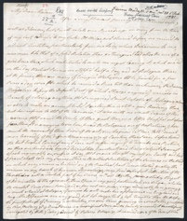
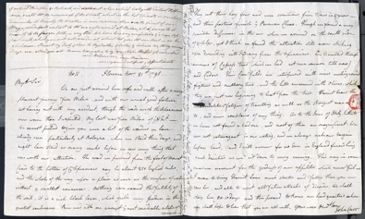
Learning Activities: Letters from John and Harriet Carr About Travelling during the Grand Tour 1791

Topic: The Grand Tour, Travel Writing, Arts & Culture, Women’s Education
Subject areas: History, Art, Literacy, Geography

Background | Activity | Resources
We learn that John and Harriet have recently arrived in Florence having travelled from Milan through Parma and Bologna. John writes of the poor state of the roads across the Apennine Mountains. There were few passable roads across the Mountains and in winter they were often blocked by snow.  John’s letter tells us more about their journey – ‘The road we pursued from the foot of Mount Cenis to the bottom of the Apennines may be about 250 English miles, and the whole of the way upon a plain as even as the surface of water without ye smallest eminence’. | See: Where is John writing from?  See: Where have John and Harriet recently travelled through?  See: What was the state of the roads across the Apennine Mountains?  See: How do the mountains often get blocked during the winter?  See: How does John describe the countryside? | https://norfolkrecordofficeblog.org/2019/06/01/exploits-on-the-grand-tour/  https://grandtour.bncf.firenze.sbn.it/tale/how-the-journey-was-made/itineraries/stages?set_language=en&cl=en
Think: What impression do you get of the areas described from the tone of John’s letter?
Think: What impression do you get of John from the letter?
Think: Does John give an accurate representation of the locations?
Think: What literary or linguistic devices are used in the letter?
Do: Before reading the context or translation, study the letter for 10 seconds. What is your first impression?
Do: Before reading the context or translation, study the letter for 30 seconds. Are there any words or phrases that stand out to you?
Do: Before reading the context or translation, study the letter for 60 seconds. Can you work out what the main topics, themes or messages are?
Do: Highlight any words or phrases that are unfamiliar to you.
Do: Try to work out what Harriet is saying from your highlighted sections.
Do: Write a translation of the sections of the letter that are unfamiliar to you.
Do: Create an illustration of one of the scenes described in John’s letter.
Do: Plot on a map the route and sites mentioned in the letter.
Do: Turn John’s descriptions of the area into a pamphlet for travellers. Point out what they might like to see and advise them on when to take precautions.
Do: Recreate John’s letter as a travel article.
Almost all of Harriet’s Grand Tour letters include reference to her interest in art and her efforts to improve her own artistic knowledge and skills.  The letter gives an impression of Harriet’s interests, her desire to widen her knowledge and her enjoyment of the Grand Tour. Upper class women did not attend school at this time and were educated at home by governesses. Home education was often limited, focussing on ‘accomplishments’ such as dancing and needlework. Harriet’s letter demonstrates that the Grand Tour provided women with exposure to the arts and science and the opportunity to undertake serous study. | See: How were upper class women educated at this time?  See: What was home education for women often limited to?  See: What were Harriet’s main interests on the Grand Tour?  See: Where does Harriet mention having visited? | http://omeka.wellesley.edu/piranesi-rome/exhibits/show/grandtouritaly/womengrandtouritaly  https://localhistories.org/life-for-women-in-the-18th-century/  https://www.bl.uk/romantics-and-victorians/articles/female-education-reading-and-jane-austen
Think: Does Harriet write in the same style that people write in today?
Think: Does Harriet address her mother in the same way that you would talk to a close relative?
Think: What impression do you get of Harriet from the letter?
Think: What literary or linguistic devices are used in the letter?
Think: Why did women not receive a formal education?
Think: Why were ‘accomplishments’ such as dancing and needlework valued over a formal education for women?
Think: How did the Grand Tour allow women to extend their educations?
Do: Compare John and Harriet’s letters. What are the similarities and differences between the two?
Do: Discuss what you can learn about travel during the 18th century from the two letters.
Do: Discuss how the letters show the different priorities of the two travellers.
Do: Discuss how the letters show the different opportunities and experiences for men and women during the Grand Tour.
Do: Research female educationalists from this time.
Do: Create a diagram showing the ideas of different female educationalists from this time, including Catharine Macauley and Mary Wollstonecraft.
Do: Write a letter condemning the limitations of education for women during the 18th century.
Do: Imagine you are an 18th century female educationalist. Come up with a campaign to increase female education.
Do: Create an advertisement to encourage young ladies from the 18th century to go on their own Grand Tour to extent their education.
Do: Discuss how the number of and social class of women on the Grand Tour restrict the amount of 18th century women who could extend their education.
Do: Come up with a way to reach and further educate 18th century women who were not part of the social class who could go on the Grand Tour.

