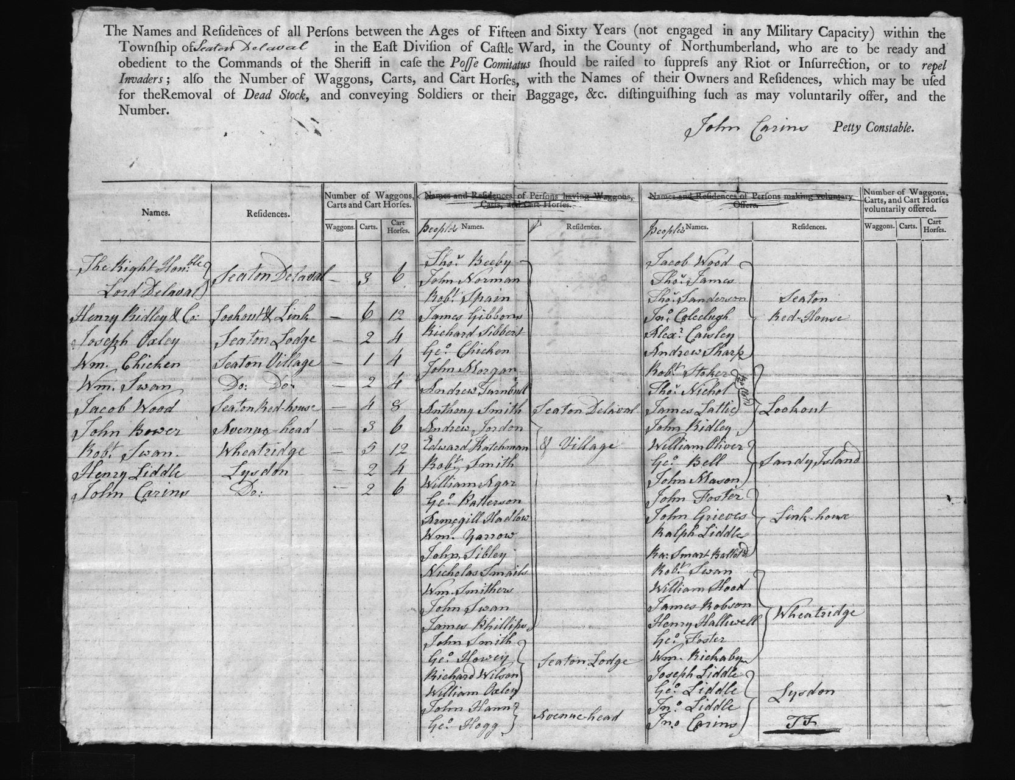
Returns of Men and Carts, 1797
Reference: QSB 90/5/35| Suggested age groups: KS2, KS3, KS4, lifelong learners | Military History, French Revolutionary Wars

French Revolutionary Wars
The French Revolutionary Wars were a series of conflicts across Europe lasting from 1792 to 1801, in which France fought against Britain, Austria, Prussia, Russia and several other European monarchies. The conflict is divided into two periods: the War of the First Coalition (1792-1797) and the War of the Second Coalition (1798-1802).
The conflicts were a direct result of the French Revolution (1789-1799) which stemmed from discontent towards absolute monarchy, dissatisfaction with the Estate System and the bourgeoise, poor harvests, inflated costs, decreased wages, and riots. European nations were shocked to learn of events in France and were fearful of the spread of revolution across the continent.

Returns of Men and Carts
This document is described as Returns of Persons, Waggons and Carts and Cart Horses for Carrying Soldiers and Baggage. The documents list all ‘persons’ aged between 15 and 60 ‘not engaged in any military capacity’ by township.
This document shows the returns for Seaton Delaval.

The ‘persons’ are males with occasional references to females as owners of waggons, carts or cart horses. There are also occasional references to men exempted from service because of disability. The document was drawn up under the posse comitatus (Latin for force of the county). This was an ancient right that allowed the sheriff of each county to raise a voluntary force to maintain public order.

Fears of French Invasion
The printed header to the documents notes the purpose of the force to include ‘to repel invaders’. This return was drawn up in 1797 when both the British government and the wider population were particularly concerned about revolutionary activity in France and feared a French invasion. It was planned that as well as repelling invaders, the voluntary force might be used to evacuate civilians from coastal areas. The returns show the deep concern felt in Britain about the revolutionary activity in France.

The Battle of Fishguard
The Battle of Fishguard took place on 22nd-24th February 1797, where a small number of enemy French Revolutionary forces successfully sailed into Fishguard Bay in southwest Wales. It is regarded as the last invasion of mainland Britain. The invasion collapsed after two days with the invading forces seeming to lose enthusiasm for the attack. They surrendered to a local militia force on 25th February 1797.

Jemima Nicholson, known as “Jemima Fawr” (Jemima the Great), the 47-year-old wife of the Fishguard cobbler, was regarded as the heroine of Fishguard. During the invasion Jemima marched to Llanwnda beach, where the French forces had set up camp, with a pitchfork and rounded up twelve Frenchmen. She ‘persuaded’ them to accompany her back to town where she locked them inside St Mary’s Chruch and then left to look for more.

Other Online Resources

Battle of Fishguard
Article on the last invasion of Britain: https://www.historic-uk.com/HistoryUK/HistoryofWales/The-Last-Invasion-of-Britain/
Page on Jemima Nicholas: https://janeausten.co.uk/blogs/uncategorized/jemima-nicholas-heroine-fishguard

French Revolutionary Wars
Britannica page on the French Revolutionary Wars: https://www.britannica.com/event/French-revolutionary-wars
Military Maps page on the French Revolutionary Wars: https://militarymaps.rct.uk/french-revolutionary-wars-1792-1802
Oxford timeline of the French Revolutionary Wars: https://www.oxfordreference.com/view/10.1093/acref/9780191737817.timeline.0001
National Archives resources on the French Revolution: https://www.nationalarchives.gov.uk/education/resources/french-revolution/
BBC page on the French Revolution with video by Andrew Marr: https://www.bbc.co.uk/teach/class-clips-video/history-ks3-gcse-the-french-revolution/zb9d2sg

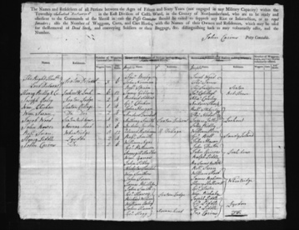
Learning Activities: Returns of Men and Carts, 1797

Topic: Military History, French Revolutionary Wars
Subject areas: History, Literacy, Geography

Background | Activity | Resources
This document is described as Returns of Persons, Waggons and Carts and Cart Horses for Carrying Soldiers and Baggage. The documents list all ‘persons’ aged between 15 and 60 ‘not engaged in any military capacity’ by township.  This document shows the returns for Seaton Delaval.  The ‘persons’ are males with occasional references to females as owners of waggons, carts or cart horses. There are also occasional references to men exempted from service because of disability. The document was drawn up under the posse comitatus (Latin for force of the county). This was an ancient right that allowed the sheriff of each county to raise a voluntary force to maintain public order. | See: What type of document is this?  See: What is listed in this document?  See: When was this document created?  See: Why was this document created?  See: Which town is this Returns for?  See: How many waggons are recorded?  See: How many carts are recorded?  See: How many cart horses are recorded?  See: Did France invade Britain during this time period?  See: When did the Battle of Fishguard take place?  See: Who was Jemima Nicholas (Jemima Fawr) and how was she involved in the Battle of Fishguard? | https://www.historic-uk.com/HistoryUK/HistoryofWales/The-Last-Invasion-of-Britain/  www.oldmapsonline.org  https://janeausten.co.uk/blogs/uncategorized/jemima-nicholas-heroine-fishguard
Think: Which conflict were Britain and France engaged in during 1797?
Think: Why was there a fear that France would invade Britain?
Think: If Britain was to be invaded during this time, where might invaders have landed?
Think: What happened at the Battle of Fishguard?
Think: Why did French invading forces lose enthusiasm for the invasion?
Think: How would the waggons, carts and horses be used if an invasion did take place?
Think: What can you infer about Seaton Delaval from this document?
Think: What can you infer about the British government from this document?
Think: What can you infer about attitudes towards France from this document?
Think: What can you infer about the British military from this document?
Do: Create a table to show the different political ideals and conventions had by Britain and France during 1797.
Do: Discuss why Britain was concerned about revolutionary activity in France.
Do: Look at a map of Britain during the late 18th century. Think about trade routes, natural defences etc. Mark areas on the map where the threat of invasion might have been higher.
Do: Research the French invasion of Fishguard, Wales during 1797. Create a timeline of the invasion.
Do: Write an account of the invasion of Fishguard from the perspective of one of the invading French soldiers.
Do: Write an account of the invasion of Fishguard from the perspective of one the Fishguard townsfolk.
Do: Create a commemorative drawing of Jemima Nicholson’s capture of French forces during the Battle of Fishguard.
Do: Design a document showing volunteers how to make use of their waggons, carts, and horses in the event of an invasion. Think about literacy levels at this time, and how to communicate without writing.
Do: Use this document alongside the Britons to Arms poster [NOTE – HYPERLINK ON LEARN] to discuss how Britain prepared for an impending French invasion.
Do: Use this document alongside the Britons to Arms poster [NOTE – HYPERLINK ON LEARN] to discuss how widely spread the threat of a French invasion was felt throughout Britain.

