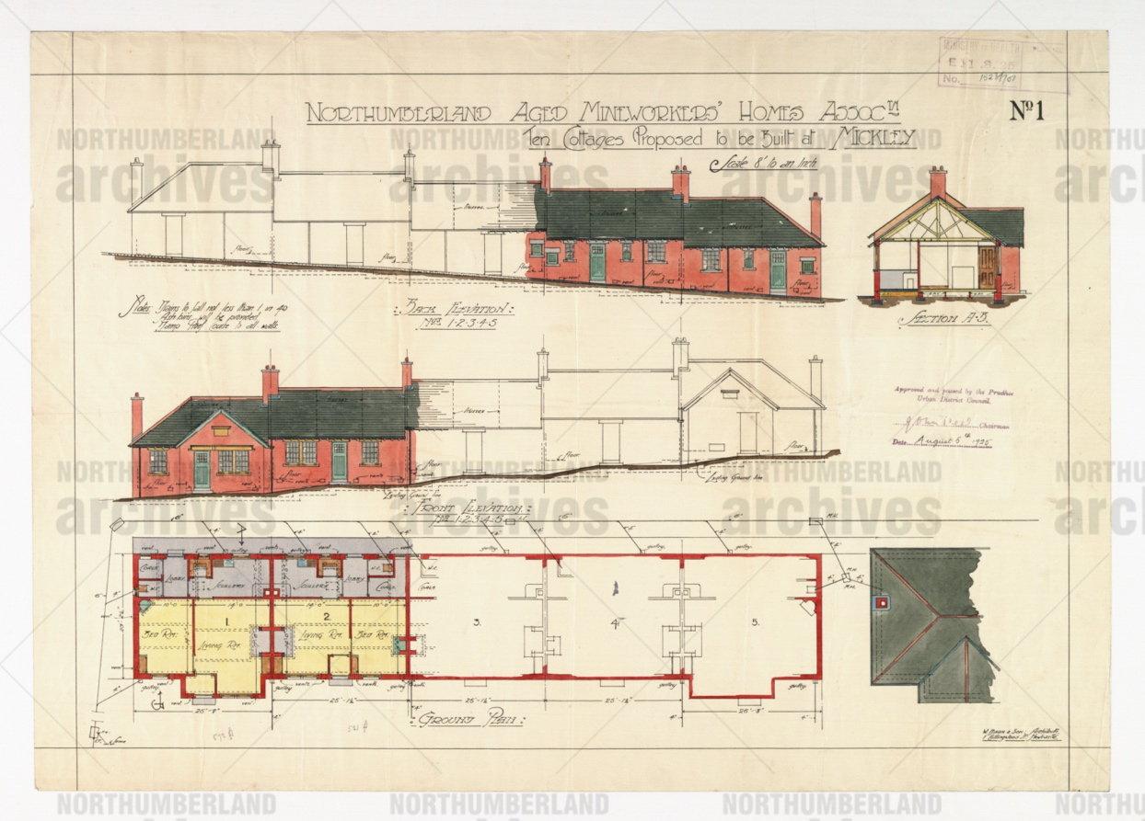
Plan for Aged Miners’ Homes, Mickley, 1925
Reference: LPR G1/345B | Suggested age groups: KS1, KS2, KS3, KS4, lifelong learners | Mining, Culture, Inter-generational, Disabilities

Aged Miners
Most miners lived in houses that were owned by the colliery
and were linked to their job. When a miner retired, he could only stay in the house if he shared it with two or more unmarried sons who were
working at the pit. If the sons moved into their own homes, the retired
miner and his wife could be asked to leave.

Northumberland Aged Mineworkers Homes Association
In 1900 the Northumberland Aged Mineworkers Homes Association was established to help relieve this problem of housing for elderly miners. The Association was started by the Northumberland Miners Association, supported by local Co-operative Societies and the Deputies' Association and Mechanics' Union. Union branches encouraged their members to contribute a small amount of money per week to the Association.

The first group of cottages were built at East Chevington near Broomhill in 1902. There was always a long waiting list for homes. William Cobb from Byker, who was 68 years old and married, was the first applicant to be drawn out of the hat for a cottage at East Chevington.
The Northumberland Aged Minerworkers’ Homes Association (NAMHA) stills owns and maintains over 500 cottages across the county. There is a similar charity in County Durham.

Aged Miners Homes, Mickley
The cottages on the plans were built on Eastgate Bank, Mickley (NE43 7LX) and are still standing as of 2022. Many of the houses built by NAMHA can be recognised by plaques or signs on the buildings.

Other Online Resources

Miners’ Housing
The National Archives education website, page with photograph of miners’ housing: https://www.nationalarchives.gov.uk/education/resources/twenties-britain-part-two/miners-housing/
Beamish Museum website, page about Aged Miners’ Homes exhibition: https://www.beamish.org.uk/exhibits/aged-miners-homes/
Mining Institute website, list of resources available at the Mining Institute, Newcastle about miners’ housing(pdf) https://mininginstitute.org.uk/wp-content/uploads/2016/02/Miners-housing-Jan16.pdf
Historic England website, listed buildings database, entry for 1-8 Leatherland Road, Shilbottle (Aged Miners’ Houses): https://historicengland.org.uk/listing/the-list/list-entry/1041722

Mineworkers’ Homes Association
Northumberland Aged Mineworkers’ Homes Association website, includes a page on their history: https://www.namha.org.uk/
Durham Aged Mineworkers’ Homes Association website, includes page on history of organisation: https://www.durhamhomes.org.uk/

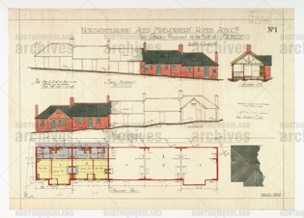
Learning Activities: Plan for Aged Miners’ Homes, Mickley, 1925

Topic: Mining, Culture, Tradition, Inter-generational, Disabilities
Subject areas: History, Literacy, Art

Background | Activity | Resources
Most miners lived in houses that were owned by the colliery and were linked to his job. When he retired, he could only stay in the house if he shared it with two or more unmarried sons who were working at the pit. If the sons moved into their own homes the retired miner and his wife could be asked to leave.  In 1900 the Northumberland Aged Mineworkers Homes Association was established to help relieve this problem of housing for elderly miners. | See: What is shown on this plan?  See: Where did most miners live?  See: What conditions must a miner meet to stay in his house after retiring?  See: When was the Northumberland Aged Mineworkers Homes Association established?  See: What was the aim of Northumberland Aged Mineworkers Homes Association? | https://earth.google.com/web/  https://www.cdc.gov/niosh/mining/topics/respiratorydiseases.html  https://www.nursingtimes.net/clinical-archive/public-health-clinical-archive/occupational-skin-and-lung-disease-in-coalfield-communities-17-06-2019/  https://www.beamish.org.uk/exhibits/aged-miners-homes/  https://www.nationalarchives.gov.uk/education/resources/twenties-britain-part-two/miners-housing/  https://www.namha.org.uk/
Think: Why were retired miners asked to leave their homes?
Think: What were miners’ houses like?
Think: Why were aged miners’ homes set up?
Think: How were aged miners’ houses different to the homes the miners lived in before retirement?
Think: Who lives in aged miners’ homes today?
Think: What health challenges might aged miners have faced?
Think: Why are there plaques or signs on the buildings identifying aged miners’ homes?
Do: Debate whether it was fair for retired miners to be asked to leave their homes.
Do: Look up the aged miners’ homes in Mickley on Google Earth. Do they look the same today as they did on the plan?
Do: Create a map showing where aged miners’ homes were developed in Northumberland.
Do: Mark on your map the locations of ages miners’ homes in Northumberland that still exist today.
Do: Create a design of what the inside of one of the aged miners’ homes might have looked like.
Do: Create a model of a street of aged miners’ homes.
Do: Analyse the design for the aged miners’ homes in the plan. Discuss whether they meet the health needs of a retired miner.
Do: Come up with your own design for an aged miners’ house considering health and mobility needs a retired miner might have.
Do: Create a health poster showing of the long-term health risks to the mining community.
Do: Write a newspaper article about William Cobb from Byker becoming the first name drawn out of the hat for a cottage at East Chevington.

