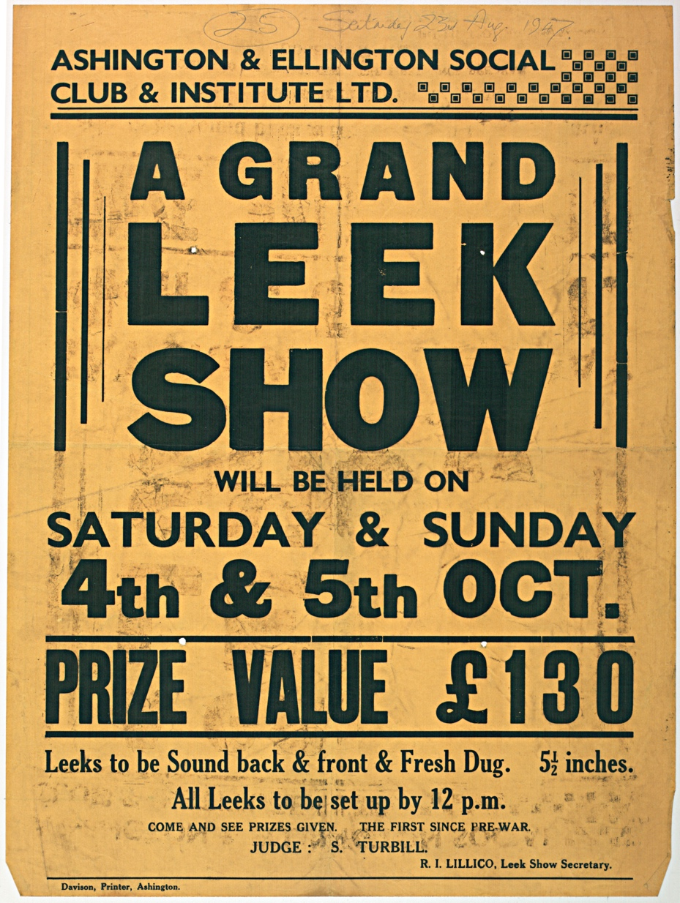
Poster for Leek Show, 1947
Reference: NRO 08073/122 | Suggested age groups: KS1, KS2, KS3, KS4, lifelong learners | Mining, Culture, Tradition, Language

Leek Growing Competitions
Leek growing competitions were incredibly popular in the north east of England. For many years, Ashington held the World Championship Leek and Onion competition. The Northern Club in Ashington held the last World Championship in 2008.

Many of the Working Men’s Clubs in the area had their own “Leek Club” and an annual competition. Northumberland archives holds the records of a Leek Club at Red Row Working Men’s Club that date from the 1920s.

Competition was fierce and men were extremely proud of their leeks. Men developed their own “special brews” to fertilise their leeks. These brews were often a closely guarded secret that was passed on from father to son.

Growing leeks and competing in leek shows was an almost exclusively male pastime.

Money
Prizes for leek competitions were usually in cash. £130 in 1947 is about equivalent to £5,400 in 2021.

Other Online Resources
Chronicle newspaper website, article about Leek Shows (2019): https://www.chroniclelive.co.uk/news/north-east-news/once-proud-north-east-tradition-16870077
BBC website, article about Leek growing, includes short (1.5 mins) video (2015): https://www.bbc.co.uk/news/av/uk-england-tyne-34552255
BBC website, article about leek growing (includes Bob Bell, ex-miner from Ashington): https://www.bbc.co.uk/tyne/content/articles/2007/11/29/leeks_and_onions_feature.shtml
You Tube website, BBC1 Look Stranger programme about growing leeks in Ryton (County Durham), includes recipe for “magic brew” (19 minutes) https://www.youtube.com/watch?v=Vm1BHOkbM3k
YouTube website, BBC2 40 Minutes documentary “The Mighty Leek” (1987) about World Championships at Ashington Northern Club (logo across the image and poor quality recording): https://www.youtube.com/watch?v=Q7tG7QSHKrE
North East Labour History Journal (2016), includes article about leek growing: https://nelh.net/wp-content/uploads/2018/11/North-East-History-Issue-47.pdf
Bank of England website, inflation calculator: https://www.bankofengland.co.uk/monetary-policy/inflation/inflation-calculator

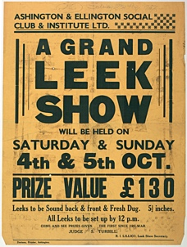
Learning Activities: Poster for Leek Show, 1947

Topic: Mining, Culture, Tradition, Language
Subject areas: History, biology, cookery, art, literacy

Background | Activity | Resources
Leek growing competitions were incredibly popular in the north east of England. For many years, Ashington held the World Championship Leek and Onion competition. The Northern Club in Ashington held the last World Championship in 2008.  Competition was fierce and men were extremely proud of their leeks. Men developed their own “special brews” to fertilise their leeks. | See: What is a leek growing competition?  See: What is a leek show?  See: Where were leek growing competitions popular?  See: What is the aim of a leek show?  See: Who took part in leek shows?  See: Where was the World Championship Leek and Onion competition held? | https://www.bankofengland.co.uk/monetary-policy/inflation/inflation-calculator  https://www.gardenersworld.com/how-to/grow-plants/how-to-grow-leeks  https://www.chroniclelive.co.uk/lifestyle/nostalgia/gallery/leek-growing-north-east-over-7775171  https://www.bbc.co.uk/tyne/content/articles/2007/11/29/leeks_and_onions_feature.shtml  https://www.youtube.com/watch?v=Vm1BHOkbM3k
Think: Why were leeks the vegetable of choice?
Think: Were there competitions for growing other types of vegetable?
Think: How big were the winning leeks?
Think: What might have been in the “special brews” used to grow the leeks?
Think: What conditions does a leek need to grow well?
Think: How are leeks grown?
Think: What happened to the leeks after the competition?
Think: Why was leek growing an almost exclusively male pastime?
Think: Do vegetable growing competitions still take place today?
Do: Use the Bank of England inflation calculator to work out how much £130 in 1947 is worth today.
Do: Discuss what you can infer about the prestige of leek shows based on the value of the prize.
Do: Look up how to grow leeks.
Do: Come up with a “special brew” to make leeks grow extra big.
Do: Try growing your own leek. How big can you get it to grow?
Do: Write an instruction guide on how to grow a leek.
Do: Look at videos and photographs of leek growing in the north east. What is the biggest leek you can find?
Do: Come up with a recipe book of leek inspired dishes.
Do: Have a leek growing competition.
Do: Create a poster to advertise your leek show. Think about other activities you might include – could you compete to make the best leek recipe? Will leeks be the only vegetable you’ll grow or could you compete to grow other things too? E.g., tallest sunflower, biggest courgette etc.
Do: Create a vegetable patch for your school or home.
Do: Discuss the benefits of growing your own food.

