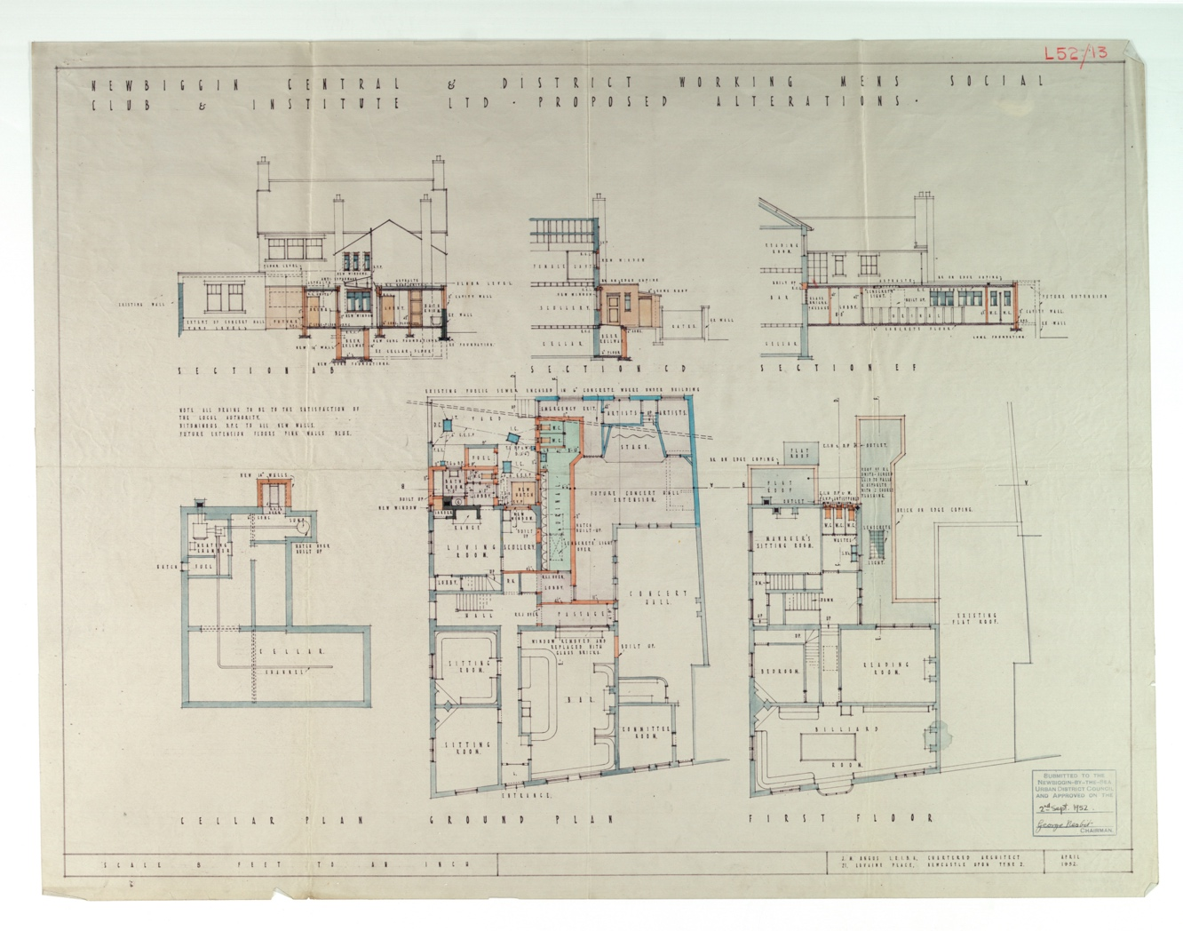
Plan of Newbiggin Working Men’s Club, 1952
Reference: LNU/G/1/632 | Suggested age groups: KS1, KS2, KS3, KS4, lifelong learners | Mining, Culture, Tradition, Leisure, Victorians, Social Reform

The History of Working Men’s Clubs
The first Working Men’s Clubs in England started in the 1860s. At this time, the middle and upper classes were worried about how working men spent their free time.

The Victorians ran reading rooms and mechanics’ institutes to give working men a healthy and educational alternative to going to the pub. Reading rooms had newspapers and books for men to read on site, while mechanics’ institutes also offered talks.

Henry Solly
Henry Solly was a minister, social reformer, and supporter of the temperance movement. The temperance movement campaigned against drinking alcohol. He shared the Victorian fears of the way that working people spent their free time, but he pointed out that working men needed leisure, not just “improvement” or education. He started setting up clubs, based in part, on the gentlemen’s clubs of London, but for working men. His idea was that they would be able to get together, talk and relax.

In 1862 Henry Solly helped to establish the Club and Institute Union (CIU) which many social clubs belong to today. In 1867 he left the CIU for several years because the Union decided to allow alcohol in its clubs. By the time of his death in 1902 there were 992 clubs in the CIU and over 380,000 individual members.

Club life
Individual clubs were run by a committee who were elected every year. The clubs were run as a co-operative rather than as a business. Any money made was put back into the club.

Members would pay subscription fees (subs) which allowed them entrance to the club. Until 2007 many clubs only allowed male members. Any women that wanted to go the club would have to be signed in by a member.

Clubs had bars which served a limited range of alcoholic drinks more cheaply than pubs. They also put on a range of entertainment including bingo, singers, and comedians. The “club circuit” was an important source of income for many performers. Clubs also had sports teams that would compete against other local clubs at football, darts, dominoes, cribbage, and snooker. They also held leek competitions.

Working Men’s Clubs were an important part of the community right across the country, but especially in coal mining areas. In the 1960s Ashington had at least 19 Working Men’s Clubs.

Plan of Newbiggin Working Men’s Club
WC = water closet or toilet
Billiard room – a room for playing games like snooker or pool
Scullery – room used for washing up and other domestic chores

Other Online Resources

Working Men’s Clubs
Club Historian’s website, includes some club histories and memories of members and staff: http://www.clubhistorians.co.uk/index.html
Ragged University website, page with article about Working Men’s Clubs: https://www.raggeduniversity.co.uk/2015/08/24/working-mens-clubs-and-education-into-the-20th-century-by-ruth-cherrington/
Club and Institute Union (CIU) website, homepage: https://www.wmciu.org.uk/ (Under Branches and Clubs – list of all the current CIU Clubs in Northumberland)
History Workshop website, page about the history of Working Men’s Clubs: https://www.historyworkshop.org.uk/who-cares-about-working-mens-clubs/
Voices from the North East podcast, episode about Working Men’s Clubs (people from Ashington talking about their memories): https://www.listennotes.com/podcasts/voices-from-the/41-the-social-clubs-KdGoC9YjDAr/

Henry Solly
Dictionary of Unitarian and Universalist Biography, entry for Henry Solly: https://uudb.org/articles/henrysolly.html
Infed website, page with extended extract taken from Solly H. (1904) Working Men’s Social Clubs and Educational Institutes (revised by B. T. Hall), London: Simpkin, Marshall, Hamilton, Kent and Co. First edition 1867 https://infed.org/mobi/henry-solly-the-origin-and-nature-of-working-mens-clubs-and-institutes/

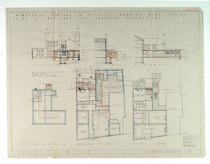
Learning Activities: Plan of Newbiggin Working Men’s Club, 1952

Topic: Mining, Culture, Tradition, Leisure, Victorians, Social Reform
Subject areas: Literacy, History, Art, Games, Drama

Background | Activity | Resources
The first Working Men’s Clubs in England started in the 1860s. At this time, the middle and upper classes were worried about how working men spent their free time.  Clubs had bars which served a limited range of alcoholic drinks more cheaply than pubs. They also put on a range of entertainment including bingo, singers, and comedians. The “club circuit” was an important source of income for many performers. Clubs also had sports teams that would compete against other local clubs at football, darts, dominoes, cribbage, and snooker. They also held leek competitions.  Working Men’s Clubs were an important part of the community right across the country, but especially in coal mining areas. In the 1960s Ashington had at least 19 Working Men’s Clubs. | See: What are Working Men’s Clubs?  See: Where are Working Men’s Clubs found?  See: Who went to Working Men’s Clubs?  See: What types of activities were held at Working Men’s Clubs?  See: What types of rooms are shown on the plan of Newbiggin Working Men’s Club? | https://museumsnorthumberland.org.uk/whats-on/the-ashington-group-gallery/  https://httpartistichorizons.org/2020/09/27/the-pitmen-artists-of-ashington/  https://www.listennotes.com/podcasts/voices-from-the/41-the-social-clubs-KdGoC9YjDAr/
Think: What would have taken place in each of the rooms shown on the plan?
Think: Why were Working Men’s Clubs an important part of the community?
Think: Why were Working Men’s Clubs important to the mining community?
Think: Why weren’t women members of Working Men’s Clubs?
Think: How would working class women have spent their time?
Think: What leisure activities were undertaken by working class women?
Think: How were Working Men’s Clubs different to pubs?
Think: What types of educational classes might have been held at a Working Men’s Club?
Think: Who were The Ashington Group?
Do: Play a game of bingo.
Do: Come up with phrases that a bingo caller might use for each of the numbers.
Do: Learn how to play cribbage.
Do: Come up with a comedy routine that could be toured on the “club circuit”.
Do: Hold a sports day with activities inspired by those competed in by groups from Working Men’s Clubs.
Do: Look at some of the paintings showing Working Men’s Clubs by The Ashington Group (Pitmen Painters). What is your impression of Working Men’s Clubs from the images?
Do: Listen to the “Social Club” podcast about people from Ashington reminiscing. What can you learn about Working Men’s Clubs and people’s opinions of them from the podcast?
Do: Compare the scenes shown in The Ashington Group paintings to the memories described in the podcast. Do the two give the same impression?
Do: In groups script a play scene inspired by one aspect of the Working Men’s Club. You could take inspiration from The Ashington Group paintings and the memories told on the podcast presenting the life and characters in a Working Men’s Club.
Do: Act out your scene. Each group’s scene could be put together to create a play about life in a working man’s club.
Do: Come up with an idea for a contemporary and inclusive version of a Working Men’s Club. Think about who would attend and the types of activities that would be offered.
Do: Create an architectural layout plan for your club.
The first Working Men’s Clubs in England started in the 1860s. At this time, the middle and upper classes were worried about how working men spent their free time.  Henry Solly was a minister, social reformer, and supporter of the temperance movement. The temperance movement campaigned against drinking alcohol. He shared the Victorian fears of the way that working people spent their free time, but he pointed out that working men needed leisure, not just “improvement” or education. He started setting up clubs, based in part, on the gentlemen’s clubs of London, but for working men. His idea was that they would be able to get together, talk and relax.  In 1862 Henry Solly helped to establish the Club and Institute Union (CIU) which many social clubs belong to today. In 1867 he left the CIU for several years because the Union decided to allow alcohol in its clubs. By the time of his death in 1902 there were 992 clubs in the CIU and over 380,000 individual members. | See: What is a Working Men’s Club  See: When were Working Men’s Clubs first introduced?  See: Why were Working Men’s Clubs first introduced?  See: Who used Working Men’s Clubs?  See: Who was Henry Solly?  See: What did Henry Solly suggest that working men needed aside from “improvement” and education?  See: What did Henry Solly set up for working men?  See: What was the temperance movement? | https://www.wmciu.org.uk/  https://uudb.org/articles/henrysolly.html  https://infed.org/mobi/henry-solly-the-origin-and-nature-of-working-mens-clubs-and-institutes/  http://people.loyno.edu/~history/journal/1992-3/smith-r.htm  https://www.sheffield.gov.uk/content/dam/sheffield/docs/libraries-and-archives/archives-and-local-studies/research/Temperance%20study%20guide%20v1-8.pdf  https://www.parliament.uk/about/living-heritage/transformingsociety/livinglearning/19thcentury/  https://victorianweb.org/history/socialism/chronology.html  https://www.bbc.co.uk/history/british/victorians/reforming_acts_01.shtml
Think: Do Working Men’s Clubs still exist today?
Think: Do Working Men’s Clubs operate the same way today as they did in the past?
Think: Why weren’t women members of Working Men’s Clubs?
Think: What is a gentleman’s club?
Think: What is the difference between a gentleman’s club and a Working Men’s Club?
Think: What is social reform?
Think: Why was there a need for social reform in Britain?
Think: Why were Victorians from the middle and upper classes worried about how working men spent their free time?
Think: How did working men spend their time before Working Men’s Clubs were introduced?
Do: Survey how many Working Men’s Clubs there were in your local area during the 1860s, 1900s, 1960s and today. What can you learn from this trend?
Do: Research the key areas of social reform in Victorian Britain.
Do: Discuss why social reform was needed in Victorian Britain.
Do: Discuss how the temperance movement and “improvement” of the working class showed a class inequality in Victorian Britain.
Do: Create a timeline showing the chronology of social change in Britain during the 19th century.
Do: Identify where in the timeline the introduction of Working Men’s Clubs sits. What other changes were going on at this time and what does this say about society and reform?
Do: In groups debate for and against the Victorian upper and middle class being concerned about how the working class spent their time. Consider this in terms of class equality and social reform.

