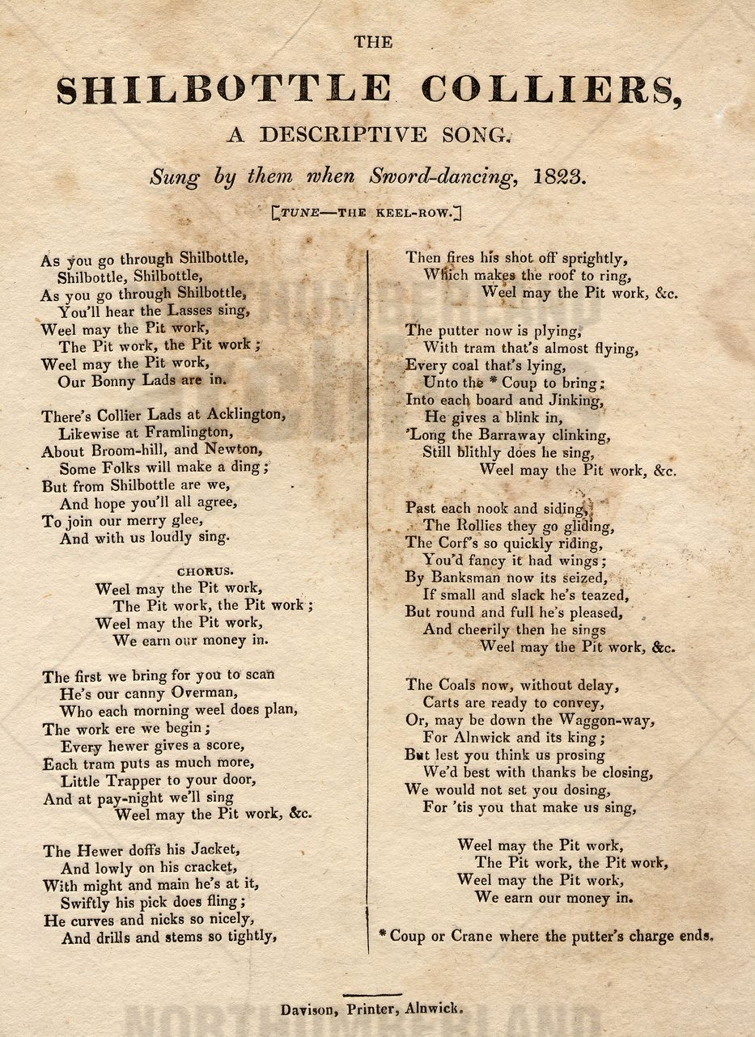
The Shilbottle Colliers: Song Lyrics, 1823
Reference: ZMD 167/3/133 | Suggested age groups: KS1, KS2, KS3, KS4, lifelong learners | Mining, Music, Culture, Language, Tradition

The Keel Row
The Keel Row is a traditional Northumbrian song. It isn’t clear how old the song is, but it had been around a long time before these new words were written to the tune.
The original song is about the work of keelmen. Keels were large shallow boats used for transporting coal along the Tyne. Keelmen would load and sail the keels to the mouth of the Tyne where they were loaded into larger ships for sea travel. This was hard physical work, dangerous and badly paid.

Sword dancing
Sword Dancing is a traditional form of Northumbrian dance, usually performed by men. It is also called rapper dancing. Each of the dancers hold a blade with a handle at each end. They interlink to make patterns with the blades.
It isn’t sure how old sword dancing is. The 1930 Pathe film (see link below) claims that it is 100 years old. This document shows that it was probably older than that.

Shilbottle
Shilbottle is an ancient village about four miles away from Alnwick, to the southeast. The village had a coal mine since 1728, until its closure in 1981.

The song – words and meanings
Each of the verses in this song describe the process of the mine workings. The Overman gives the orders, the hewer extracts the coal. The coal is transported from the coalface by the putter. The banksman then inspects the coal that is brought to the surface. Waggonways then take it to Alnwick.

weel – Northumberland dialect for well.
Acklington, Framlington, Broomhill, Newton - other Northumberland villages nearby (Long)Framlington, Newton-by-the-Sea
overman – in charge of the day-to-day working of a colliery.
score – the standard number of tubs (for transporting coal) at each pit. Usually 20. The wages of the hewer and putter were worked out according to the score.
tram – wooden carriage that the tubs (or corfs) were transported on.
trapper – small child who worked in the mine (before 1842 they were likely to be under 10 years old). Their job was to open and close doors in the mine so that the trams could pass through.
hewer – man who works at the coal face getting the coal out.
cracket – small stool used by the hewer so that he could keep in uncomfortable positions (see link below).
stem – pack explosives into a drilled hole.
fires his shot – sets off the explosives.
putter – man who transports coal from hewer at the coal face to the mine shaft.
coup – crane that brings corves to the surface.
jinking (or jenking) – narrow passage way through a pillar of coal.
rolley – carriage used to carry tubs or corves, usually pulled by a horse.
corf (pluaral corves) –baskets placed on rolley or tram to transport coal in the mine. Tubs did the same thing but were made or wood or iron.
banksman – takes the tubs off the crane or winding machine at the surface. Weighs and records that amount of coal mined each day.

Other Online Resources

Keel Row
Beth’s Notes website, page for Keel Row, including sheet music and video: https://www.bethsnotesplus.com/2019/03/keel-row.html

Sword dancing
You Tube website, Pathe News film of Sword dancers in Winlaton (1930, 2 minutes): https://www.youtube.com/watch?v=J6GA48ep2gI
Youtube website, film of Newcastle Kingsmen daning at Cumberland Arms, Newcastle (2007, 4 minutes): https://www.youtube.com/watch?v=EOtnZEsbQew

Shilbottle
Northumberland Archives website, online exhibition about Shilbottle, including maps and documents: https://northumberlandarchives.com/exhibitions/communities/home.html
Durham Mining Museum website, page about Shilbottle Colliery: http://www.dmm.org.uk/colliery/s015.htm

Language
Healey Hero’s website, page about crackets: http://www.healeyhero.co.uk/rescue/glossary/cracket.htm
Durham Mining Museum website, glossary of mining terms: http://www.dmm.org.uk/books/terms.htm

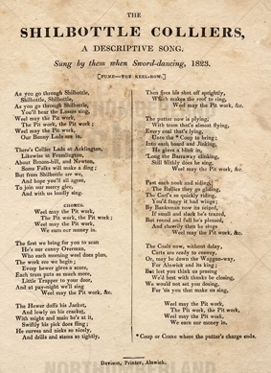
Learning Activities: The Shilbottle Colliers: Song Lyrics, 1823

Topic: Mining, MUSIC, Culture, Language, Tradition
Subject areas: English, History, Music, Art, Dance, Geography

Background | Activity | Resources
Shilbottle is an ancient village about four miles away from Alnwick, to the southeast. The village had a coal mine since 1728, until its closure in 1981.  Each of the verses in this song describe the process of the mine workings. The Overman gives the orders, the hewer extracts the coal. The coal is transported from the coalface by the putter. The banksman then inspects the coal that is brought to the surface. Waggonways then take it to Alnwick. | See: Where is Shilbottle?  See: When did coal mining begin in Shilbottle?  See: When did coal mining end in Shilbottle?  See: What is the Shilbottle Colliers song about?  See: Which other villages are mentioned in the song?  See: Which mining related jobs are mentioned in the song? | https://www.livingnorth.com/article/learn-about-the-distinctive-northumbrian-language  https://northumbrian-words.com/glossary-of-northumbrian-dialect-words/  https://www.bl.uk/collection-items/northumberland-dialect-ian-farmhouse  https://www.worldwidewords.org/weirdwords/ww-pit1.htm  https://www.theguardian.com/uk/2007/jul/30/books.britishidentity  https://www.fusilier.co.uk/#  https://tangledworm.com/2019/04/21/the-collieries-of-north-east-england/  https://englandsnortheast.co.uk/coal-railways-north-east/  https://bailiffgatecollections.co.uk/about-us/our-area/coal-mining/
Think: What can you infer about life in the mine from the song lyrics?
Think: What can you learn about the mining community from the song lyrics?
Think: What can you infer about the miners’ attitudes towards their jobs from the song lyrics?
Think: Were the miners proud of their jobs and mining culture?
Think: What impression might people in Shilbottle today have on mining and mining cuture?
Think: What type of language is used in the song lyrics?
Think: How is the local dialect and accent shown in the song lyrics?
Think: What is a “Pitmatic” dialect?
Think: Did the miners in this area talk using the same types of language in day to day life as used in the song?
Think: How does the industry and class of a region influence dialect?
Think: Do people in Shilbottle today still talk this way?
Do: Create an illustration for each verse of the song to show what is being told in each verse.
Do: Create a profile for each job or role mentioned in each of the song verses to show what different workers in the mine were responsible for.
Do: Annotate the song to show the different language and linguistic choices made in the lyrics.
Do: Compare Shilbottle during the 1830s to present day Shilbottle. How has the village changed?
Do: Can you find evidence to show the impact the closure of mines had on Shilbottle?
Do: Can you find evidence of mining culture continuing to be present in Shilbottle and the surrounding areas?
Do: Use a map to find the other villages mentioned in the song.
Do: Look at the present-day version of each of the villages. What impact has the loss of mining had on each village?
Do: Highlight each word in the song that is unfamiliar to you.
Do: On a card write each of the unfamiliar words, one word per card. On a second card write the definitions for each of the words, one definition per card. Swap cards with a partner, try to match up the unfamiliar words to their definitions.
Do: Create a dialect dictionary of the words used in the mining community.
The Keel Row is a traditional Northumbrian song. It isn’t clear how old the song is, but it had been around a long time before these new words were written to the tune.  Sword Dancing is a traditional form of Northumbrian dance, usually performed by men. It is also called rapper dancing. Each of the dancers hold a blade with a handle at each end. They interlink to make patterns with the blades.  It isn’t sure how old sword dancing is. The 1930 Pathe film (see link below) claims that it is 100 years old. This document shows that it was probably older than that.  Each of the verses in this song describe the process of the mine workings. | See: What is The Keel Row?  See: What is a keel?  See: What is a keelman?  See: Which tune was the Shilbottle Colliers song, sang to?  See: When was the Shilbottle Colliers song sang?  See: Who was the Shilbottle Colliers song sang by?  See: What is sword dancing?  See: Who would have usually sword danced? | https://www.makingmusic.org.uk/resource/introduction-folk-music  https://libguides.ncl.ac.uk/c.php?g=130223&p=851022  http://northumbriafolk.org.uk/lyrics.html  https://www.bradtguides.com/northumbrian-folk-music-traditions/
Think: Who might have written the Shilbottle Colliers song?
Think: Why might the Shilbottle Colliers song have been written?
Think: Why is the song set to the tune of The Keel Row?
Think: At what event or occasion might sword dancing have taken place?
Think: Why was sword dancing usually performed by men?
Think: When might sword dancing take place today?
Think: Would this song still be sung today?
Think: When might this song be sung today?
Think: What is a folk song?
Think: Why are folk songs important?
Think: What can we learn from folk songs?
Think: What is traditional Northumbrian music?
Think: What is a ceilidh?
Do: Sing The Keel Row.
Do: Sing the Shilbottle Colliers song.
Do: Can you find any other mining folk songs from Northumberland?
Do: Compare other mining folk songs to the Shilbottle Colliers song. What similarities and differences do they show about life and work in the mine, and mining culture?
Do: Write your own song about mining to the tune of The Keel Row.
Do: Write your own folk song to celebrate the culture of your own community.
Do: Try sword dancing – perhaps using sticks.
Do: Experiment with making different shapes while sword dancing.
Do: Try singing the Shilbottle Colliers song while sword dancing.
Do: Choreograph a sword dance to go with your mining song.
Do: Can you find any other traditional Northumbrian dances?
Do: Choreograph a sword dance or another traditional dance to go with your folk song.
Do: Hold a ceilidh to showcase your songs and dances.

