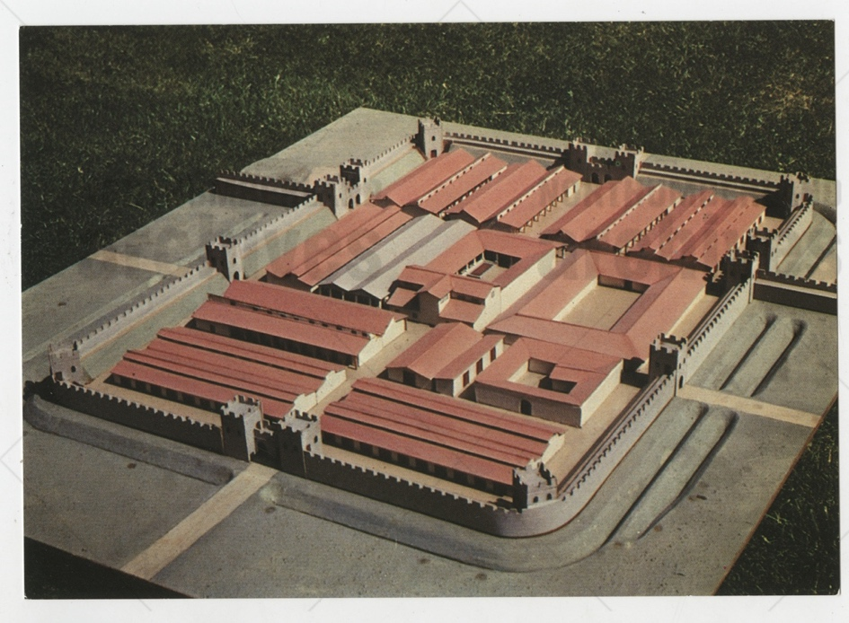
Postcard of a Model of the Cavalry Fort at Benwell, about 1970
Reference: NRO 06649/2/8/40 | Suggested age groups: KS1, KS2, KS3, KS4, lifelong learners | Roman Empire, Roman Forts, Life of a Soldier, Roman Buildings, Hadrian’s Wall, Roman Gods

Condercum Fort – Benwell
Condercum was the name of the Roman fort on the present-day location of the Condercum Estate in Benwell, a western suburb of Newcastle upon Tyne. It was the third fort on Hadrian’s Wall following Segedunum in Wallsend and Pons Aelius in Newcastle.
The fort was situated on a level hilltop and was likely built between AD 122 and AD 124 by soldiers from the Second Augustan Legion (Legio II Augusta). Estimates show that the fort likely measured 170 metres north to south by 120 metres east to west, and housed a garrison of about 500 cavalrymen and their horses. The fort contained a commandant’s house, headquarters, barracks, two granaries, workshops, stables, and a hospital.
The remains of the north section of the fort were destroyed by the building of a reservoir during the 19th century. Despite being partially excavated, the south section of the fort was built over during the 1920s and 1930s. There are no visible signs of the fort remaining today.

The Vallum
The Vallum was a unique earthwork defence, unique to the Roman frontier. It ran from nearly coast to coast along the south of Hadrian’s Wall. It contained a ditch, about 6 metres wide and 3 metres deep. It was flanked by two mounds measuring about 6 metres wide and 2 metres wid, set back about 9 metres from the ditch edges.
At Condercum Fort, the Vallum lay to the south to protect the Wall from attacks and was built in about AD 130. The Vallum could only be crossed at forts. Condercum had a gate and a stone causeway which provided access between the Wall and Vallum. The outline of the stone causeway where the road from the south crossed the Vallum on its way to Condercum Fort survives today. It can be seen at Denhill Park, NE15 6QH.

Benwell Roman Temple
About 60 metres to the east of the Fort, in the vicus, a civilian settlement beside the fort, stood a temple to the God Antenociticus. The temple was built in about AD 178-180.

Antenociticus was likely a local God adopted by the Romans once they arrived in Britain. Unusually, there is no mention of Antenociticus anywhere else in Britain or the Roman Empire. The temple was discovered and excavated in 1862. During its excavation, it was found altars, the head of a statue of Antenociticus. It is thought that the temple was destroyed by fire during the 2nd century.

The remains of the temple can be seen today in the Broomridge Avenue housing estate, NE15 6QP.

Reading List
Books available at Northumberland Libraries. Click to browse the online catalogue here.
The Living Roman Fort by Stephen Johnson (2000). ISBN: 0750030631.
Picture the Past: Life in a Roman fort by Jane Shuter (2005). ISBN: 0431113068.
Roman Fort by Mick Manning (2004). ISBN: 184507050X.
Roman city guidebook by Jill A. Laidlaw (2009). ISBN: 9781408112892.
Roman invaders and settlers by David Thorold (2005). ISBN: 0237530376.
Gods and Goddesses in the daily life of the Ancient Romans by Peter Hicks (2003). ISBN:
0750235829.
What did the Ancient Romans do for me? By Patrick Catel (2011). ISBN: 9780431082646

Other Online Resources
Article on the mystery of Antenociticus: https://www.icysedgwick.com/antenociticus/
Tyne & Wear Museums video on Antenociticus: https://www.youtube.com/watch?v=dLwQxpIprDk&ab_channel=TWMuseums
Tynedale Hadrian’s Wall Group page on Condercum Fort: https://www.u3ahadrianswall.co.uk/wordpress/benwell-roman-fort-condercum-cavalry-fort-west-of-newcastle/
English Heritage page on Benwell Temple: https://www.english-heritage.org.uk/visit/places/benwell-roman-temple-hadrians-wall/
English Heritage page on Benwell Vallum crossing: https://www.english-heritage.org.uk/visit/places/benwell-vallum-crossing
Roman Britain page on Condercum Fort: https://www.roman-britain.co.uk/places/condercum/
English Heritage page on the history of Benwell Temple: https://www.english-heritage.org.uk/visit/places/benwell-roman-temple-hadrians-wall/history/

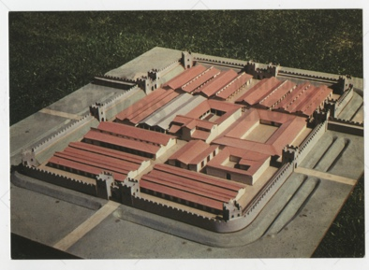
Learning Activities: Postcard of a Model of the Cavalry Fort at Benwell, about 1970

Topic: Roman Empire, Hadrian’s Wall, life of a soldier, Roman Forts, Roman Buildings, Roman Gods
Subject areas: History, Literacy, Geography, Religious Studies
Background | Activity | Resources
Condercum was the name of the Roman fort on the present-day location of the Condercum Estate in Benwell, a western suburb of Newcastle upon Tyne. It was the third fort on Hadrian’s Wall following Segedunum in Wallsend and Pons Aelius in Newcastle. | See: Where was Condercum Fort?  See: What happened to the remains of Condercum Fort?  See: What was the Vallum?  See: How big was the Vallum?  See: What was Benwell Temple?  See: Who was Antenociticus?  See: Why was Antenociticus a mystery? | https://www.youtube.com/watch?v=dLwQxpIprDk&ab_channel=TWMuseums  https://www.english-heritage.org.uk/visit/places/benwell-roman-temple-hadrians-wall/  https://www.english-heritage.org.uk/visit/places/benwell-roman-temple-hadrians-wall/history/  https://www.icysedgwick.com/antenociticus/  https://education.nationalgeographic.org/resource/gods-and-goddesses-ancient-rome
Think: Who were the Roman Gods?
Think: What might a Roman temple have looked like?
Think: What would have been inside a Roman temple?
Think: Why did the Romans build the Vallum?
Think: What would it be like to live in a house that was built on the site of a Roman fort?
Do: Use Google Maps to look at the areas that the Benwell Fort, Vallum and Temple would have been.
Do: Plot on a present-day map where the fort would have been.
Do: Draw what you think Benwell might have looked like during the Roman times.
Do: In groups, debate whether it was right or wrong to destroy the remains of the fort by building a reservoir and houses.
Do: Create a guidebook on Condercum Fort, Vallum crossing and Temple.
Do: Create a model of the Benwell Temple.
Do: Create a model of the Vallum.
Do: Research what was found when the Benwell Temple was excavated. Make a list of the items that were found.
Do: Research Antenociticus and come up with ideas of what he was the God of and why he doesn’t appear anywhere else.
Do: Visit Great North Museum to see the items excavated from the Benwell Temple.

