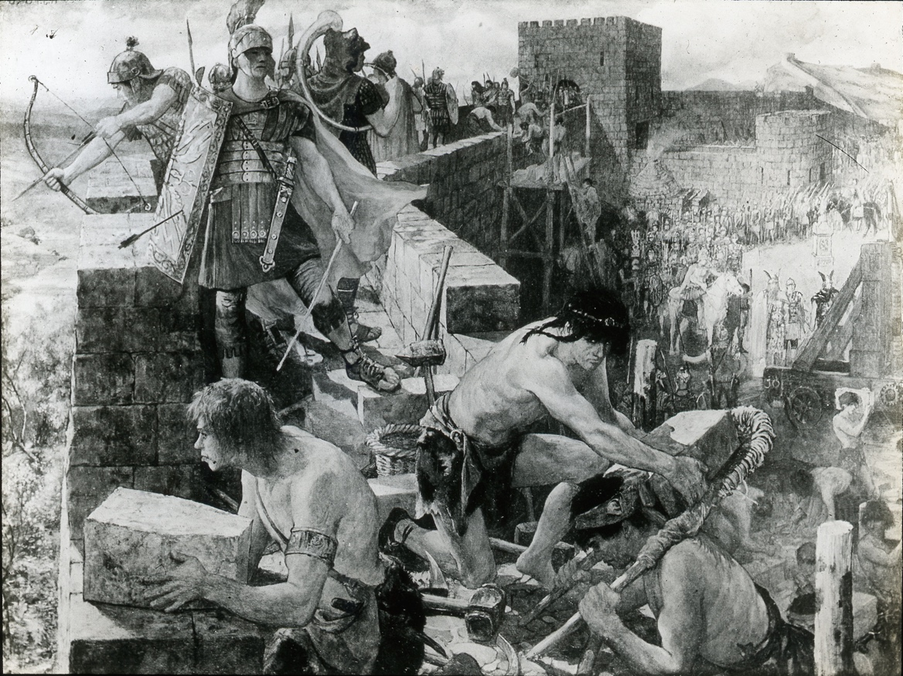
Glass slide of sketch of the building of Hadrian’s Wall, showing builders and soldiers, about 1900
Reference: NRO 10491/4 | Suggested age groups: KS1, KS2, KS3, KS4, lifelong learners | Roman Empire, Hadrian’s Wall, Life of a Soldier, engineering

Hadrian’s Wall
This glass slide shows workers building Hadrian’s Wall, overseen by Roman soldiers.

Hadrian’s Wall spans 80 Roman miles (73 present day miles or 117 kilometres) from coast to coast across northern England, making it the largest Roman archaeological feature in Britain. It runs from Segedunum in Wallsend on the River Tyne in the east, to Bowness-on-Solway in the west.

Hadrian’s Wall marked the frontier between Roman Britannia and the unconquered Caledonia to the north and provided a defensive barrier between the two. The Wall also provided years of work for thousands of soldiers who were responsible for building, maintaining, and manning it, along with the Milecastles and turrets built along the Wall.

Building Hadrian’s Wall
The building of the Wall began in AD 122 during the reign of Emperor Hadrian. Despite its size, the Wall was completed in only 6 years, by AD 128. Hadrian never saw the completed Wall for himself – he left Britannia in AD 122 after commissioning the construction of the Wall and never returned.

The building of the Wall was undertaken by all three Roman legions in Britannia at the time. It was initially planned to be 3 metres wide, made of stone, with a large ditch and mound in front of it.

Reading List
Books available at Northumberland Libraries. Click to browse the online catalogue here.
Hadrian’s Wall: Rome and the limits of empire by Adrian Goldsworthy (2022). ISNB: 9781803288109.
Hadrian’s Wall through time by Alan Whitworth (2012). ISBN: 9781445608945.
Hadrian and his wall by Paul Frodsham (2013). ISBN: 9780957286030.
Hadrian’s Empire: when Rome ruled the world by Danny Danzinger (2005). ISBN: 0340833602.
Bundle with the Britons by Gary Northfield (2016). ISBN: 9781406369496.
Roman Britain by Ruth Brocklehurst (2012). ISBN: 9781409566267.
The Roman soldier’s handbook by Lesley Sims (2014). ISBN: 9781409567745.
A Roman soldier’s handbook by Alison Hawes (2009). ISBN: 9781408112908.
Roman Soldiers by Peter Hepplewhite (2014). ISBN: 9781445137544.
Peter Kent’s big book of armour by Peter Kent (2010). ISBN: 9780753418840.
Going to war in Roman times by Moira Butterfield (2003). ISBN: 0749651733.

Other Online Resources
History page on Hadrian’s Wall: https://www.history.com/topics/ancient-rome/hadrians-wall#section_4
English Heritage page on Hadrian’s Wall: https://www.english-heritage.org.uk/visit/places/hadrians-wall/
Hadrian’s Wall Country page on the history of the Wall: https://hadrianswallcountry.co.uk/explore/the-history-of-the-wall/
Segedunum page on the building of Hadrian’s Wall: https://segedunumromanfort.org.uk/learning/the-building-and-development-of-hadrian-s-wall
History extra page on the building of Hadrian’s Wa;;L https://www.historyextra.com/period/roman/hadrians-wall-romans-facts-archaeology-tourism-game-of-thrones-jon-snow-watcher-english-heritage/

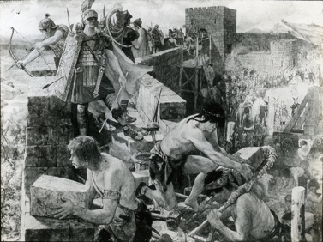
Learning Activities: Glass slide of sketch of the building of Hadrian’s Wall, showing builders and soldiers, about 1900

Topic: Roman Empire, Hadrian’s Wall, life of a soldier, engineering
Subject areas: History, Literacy, Art & Design, Geography
Background | Activity | Resources
This glass slide shows workers building Hadrian’s Wall, overseen by Roman soldiers.  Hadrian’s Wall spans 80 Roman miles (73 present day miles or 117 kilometres) from coast to coast across northern England, making it the largest Roman archaeological feature in Britain. It runs from Segedunum in Wallsend on the River Tyne in the east, to Bowness-on-Solway in the west. | See: What does this sketch show?  See: Where is Hadrian’s Wall?  See: How long did it take to build Hadrian’s Wall?  See: Who build Hadrian’s Wall?  See: When was this sketch made?  See: What tools can you see being used in the sketch? | https://www.romanobritain.org/8-military/mil_legions-of-britain.php  https://www.u3ahadrianswall.co.uk/wordpress/roman-legions-in-britain/  https://www.antoninewall.org/  https://segedunumromanfort.org.uk/learning/the-building-and-development-of-hadrian-s-wall
Think: How was Hadrian’s Wall built?
Think: What tools did the Roman’s use to build structures?
Think: How many design plans did Hadrian’s Wall go through before the final design was made?
Think: What is a Roman Legion?
Think: What was it like to be a Roman soldier?
Think: What did Roman soldiers wear?
Think: Are there any other Roman Walls in Britain?
Think: What is Antonine Wall?
Think: Why was this sketch made?
Think: Is this sketch an accurate representation of the building of Hadrian’s Wall?
Do: Discuss whether you think the sketch is an accurate representation of what the building of Hadrian’s Wall might have looked like.
Do: Draw your own representation of the building of Hadrian’s Wall.
Do: Choose one of the figures in the sketch. Write a diary entry from their perspective.
Do: Script a conversation that might be taking place during the scene of the sketch.
Do: Discuss how natural geographical features such as rivers and crags were used as natural defensive barriers were used in the design of Hadrian’s Wall.
Do: Research Antonine Wall. Compare it to Hadrian’s Wall.
Do: Come up with your own design for a Roman Wall.
Do: Create a model of your Roman Wall design.
Do: Research the Roman legions in Britain at the time of Hadrian’s Wall being built.
Do: Make a profile for each of the three Roman legions in Britain at the time of Hadrian’s Wall being built. Include a drawing of their emblem.
Do: Come up with your own Roman legion emblem design.
Do: Create a check list of what you would need to become a Roman Legionnaire.

