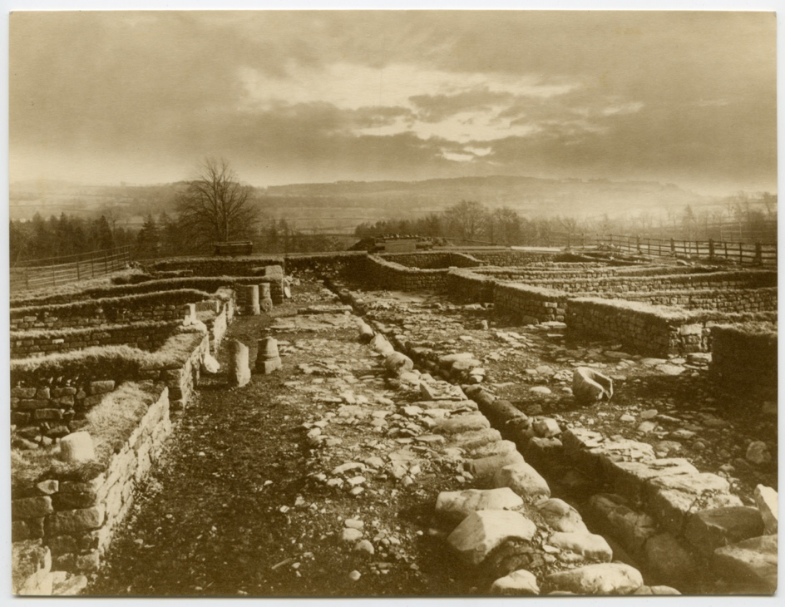
Photograph of the Barrack Blocks at Chesters Fort, about 1886
Reference: NRO 01876/C/7/8 | Suggested age groups: KS1, KS2, KS3, KS4, lifelong learners | Roman Empire, Roman Forts, Life of a Soldier, Roman Buildings, Hadrian’s Wall, Excavation

Chesters Fort
Chesters, known as Cilurnum during the Roman period, was a cavalry fort on Hadrian’s Wall near the village of Walwick in Northumberland. It was built in about AD 124 and was occupied until the Romans left Britain during the 5th century. It housed an auxiliary unit of 500 cavalrymen. Auxiliary troops were those who were not citizens of Rome. The fort guarded Chesters Bridge.

Chesters Barrack Blocks
The barracks consisted of two blocks facing each other across a central road with a drain down the centre. There were probably about ten rooms on each side, although only five are now visible. There were likely eight soldiers to a room, the rooms may have been divided using wooden partitions. There would have been a veranda in front of the rooms, some of the half columns the front of the veranda can still be seen leaning up against the rooms.
At the far end of the barracks was a larger house for the centurion in charge of each block.

Excavation of Chesters Fort
During the early 19th century, Nathaniel Clayton the owner of Chesters House and Estate covered over the remains of the fort with hundreds of tons of earth to create a landscaped parkland down to the River Tyne. Before doing so, he collected a number of Roman artefacts.

When his son, the noted antiquarian John Clayton, inherited the estate in 1832 he undid his father’s landscaping to expose the fort, excavate the ruins, and create a small museum for the discovered artefacts. John Clayton also made excavations at Housesteads Fort, Brocolitia Roman Temple, and Carvoran. He is credited as being responsible for saving much of the central portion of Hadrian’s Wall.

Chesters is the most complete Roman cavalry fort in Britain and is now open to the public under the care of English Heritage.

J.P. Gibson - Photographer
This photograph was taken by John Pattison Gibson (1838-1912), a photographer and archaeologist from Hexham.

Gibson had a particular interest in Hadrian’s Wall, took part in several excavations, and used his photographs to document the findings between about 1890 and 1910. The photographs provide a unique record of the Wall and surrounding countryside at this time.

His first significant archaeological discovery was the Mucklebank Wall turret in 1891 which he happened upon thanks to a rabbit hole. He was involved in the excavation of the turret in 1892 and later he assisted in the excavations at Great Chesters from 1894-1896.

Between 1907-1908 he worked with Frank Gerald Simpson in excavating the small fort at Haltwhistle Burn and then once again in 1909, together with F.G. Simpson, he excavated Milecastle 48. The excavation report was published the following year and is one of the most important excavation reports published on a site on Hadrian's Wall.

The Gibson Collection is housed at Northumberland Archives. Images from the collection can be viewed in the virtual exhibition Photographing the Roman Wall, then and now created in collaboration between Northumberland Archives and Northumberland Libraries as part of the Hadrian’s Wall 1900 Festival – a celebration of the 1900th anniversary of the Wall.

Reading List
Books available at Northumberland Libraries. Click to browse the online catalogue here.
The Living Roman Fort by Stephen Johnson (2000). ISBN: 0750030631.
Picture the Past: Life in a Roman fort by Jane Shuter (2005). ISBN: 0431113068.
Roman Fort by Mick Manning (2004). ISBN: 184507050X.
Roman city guidebook by Jill A. Laidlaw (2009). ISBN: 9781408112892.

Other Online Resources
Archaeology article on Chesters Roman Fort: https://archaeology.co.uk/articles/specials/hadrians-wall/chesters.htm
Tynedale Hadrian’s Wall Group page on Chesters: https://www.u3ahadrianswall.co.uk/wordpress/chesters-museum/
Plan of Chesters Fort: https://www.english-heritage.org.uk/siteassets/home/visit/places-to-visit/chesters-roman-fort/history/chesters-roman-fort-phased-plan.pdf
Historic England page on Chesters Roman Fort: https://www.english-heritage.org.uk/visit/places/chesters-roman-fort-and-museum-hadrians-wall/history/

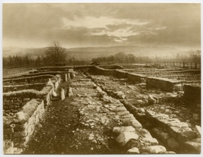
Learning Activities: Photograph of the Barrack Blocks at Chesters Fort, about 1886

Topic: Roman Empire, Hadrian’s Wall, life of a soldier, Roman Forts, Roman Buildings, Excavation
Subject areas: History, Literacy, Archaeology, Art & Design
Background | Activity | Resources
Chesters, known as Cilurnum during the Roman period, was a cavalry fort on Hadrian’s Wall near the village of Walwick in Northumberland. It was built in about AD 124 and was occupied until the Romans left Britain during the 5th century. It housed an auxiliary unit of 500 cavalrymen. Auxiliary troops were those who were not citizens of Rome. The fort guarded Chesters Bridge. | See: Where is Chesters Fort?  See: When was Chesters Fort built?  See: What were the barracks like at Chesters Fort?  See: What evidence of the barracks can you see in the photograph?  See: What did Nathaniel Clayton do to Chesters Fort?  See: When was Chesters Fort excavated? | https://www.english-heritage.org.uk/siteassets/home/visit/places-to-visit/chesters-roman-fort/history/chesters-roman-fort-phased-plan.pdf  https://www.masterclass.com/articles/how-to-create-your-own-flipbook-animation  https://animoto.com/blog/guides/how-to-make-a-stop-motion-video  https://archaeology.co.uk/articles/specials/hadrians-wall/chesters.htm
Think: What is a cavalry?
Think: Why did Chesters Bridge need to be defended?
Think: What were the names of the different types of soldiers in the Roman Army?
Think: What were the roles of the different types of soldiers in the Roman Army?
Think: Who would have lived in a Roman fort?
Think: What was life like in a Roman fort?
Think: What is an archaeologist and what do they do?
Do: Debate whether it was right or wrong for Nathaniel Clayton to cover over Chesters Fort.
Do: Create a floor plan of what the barrack blocks at Chesters Fort would have looked like when it was built.
Do: Use the plan of Chesters to create a model of the Fort.
Do: Find evidence of other forts built along Hadrian’s Wall.
Do: Research what life was like in a Roman fort.
Do: Create a timetable to show the day-to-day life of a Roman soldier who might have been stationed at Chesters Fort.
Do: Imagine you are a Roman soldier who was stationed at Chesters who has time-travelled to visit the Fort today. Write down what their impression of the present-day Fort might be.
Do: Create an animation of how Chesters Fort might have changed over time. Think about its construction, burial, excavation, and the present-day use of the Fort.

