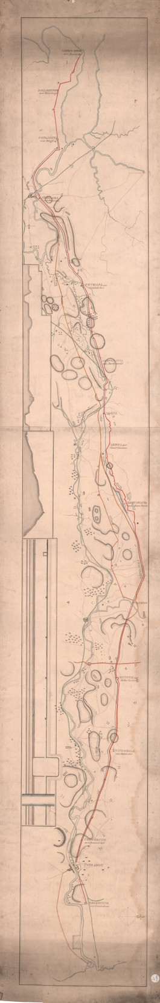
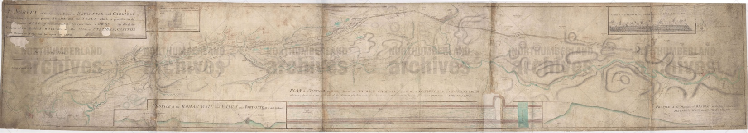
Plans of Hadrian’s wall, about 1746 - 1850
Reference: SANT PLA/7/2/1/1A & 2 | Suggested age groups: KS1, KS2, KS3, KS4, lifelong learners | Roman Empire, Hadrian’s Wall

Hadrian’s Wall
Hadrian’s Wall spans 80 Roman miles (73 present day miles or 117 kilometres) from coast to coast across northern England, making it the largest Roman archaeological feature in Britain. It runs from Segedunum in Wallsend on the River Tyne in the east, to Bowness-on-Solway in the west.

The building of the Wall began in AD122 during the reign of Emperor Hadrian. Hadrian’s Wall marked the boundary between Roman Britannia and the unconquered Caledonia to the north and provided a defensive barrier between the two. The Wall also provided years of work for thousands of soldiers who were responsible for building, maintaining, and manning it, along with the Milecastles and turrets built along the Wall.

Plans of Hadrian’s wall
These plans showing Hadrian’s Wall are part of a series of large-scale archaeological plans held in the Society of Antiquaries of Newcastle upon Tyne collection at Northumberland Archives.
The first plan (SANT PLA/7/2/1/1A) was made in about 1746 as a survey for the new military road between Newcastle and Carlisle. The plan says "A Survey of the Country between Newcastle and Carlisle, Representing the several present Roads and the Tract which is proposed for the New Intended Road of Communication between these Towns. As also the Course of the Roman Wall with all the Military Stations, Castalla and Roman Ways that lye upon this Survey".
The second plan (SANT PLA/7/2/1/2) was made in about 1850. The red line on the plan shows the route of Hadrian’s Wall from Segedunum in the east to Bowness-on-Solway in the west. The plan is labelled with both the Roman names of various locations, along with the names that the locations were then known by.

Military Road
The Military Road is the name given to the B6318 which runs from Heddon-on-the-Wall in the east to Greenhead in the west. The road was built by Hanoverian forces in order to suppress the Jacobite Risings in order to transport troops from Newcastle to the west. Construction of the road began in 1746.
The road runs alongside Hadrian’s Wall for most of its length, some stretches of the road are built on the foundations of the Wall. Most of the road is straight, resembling the style of Roman roads. Unusually, the Military Way Roman built road which runs along the southern side of Hadrian’s Wall is a rare example of a non-straight Roman road.
The construction of the Military Road has been cited as one of the most damaging operations to Hadrian’s Wall in recorded history. Sandstone and limestone were salvaged from the Wall and used in the construction of the road.

Reading List
Books available at Northumberland Libraries. Click to browse the online catalogue here.
Hadrian’s Wall: Rome and the limits of empire by Adrian Goldsworthy (2022). ISNB: 9781803288109.
Hadrian’s Wall through time by Alan Whitworth (2012). ISBN: 9781445608945.
Hadrian and his wall by Paul Frodsham (2013). ISBN: 9780957286030.
Hadrian’s Empire: when Rome ruled the world by Danny Danzinger (2005). ISBN: 0340833602.
Bundle with the Britons by Gary Northfield (2016). ISBN: 9781406369496.
Roman Britain by Ruth Brocklehurst (2012). ISBN: 9781409566267.
Assassin by Tony Bradman (2011). ISBN: 9781842999790.

Other Online Resources
English Heritage page on Hadrian’s Wall: https://www.english-heritage.org.uk/visit/places/hadrians-wall/
Hadrian’s Wall Country page on the history of the Wall: https://hadrianswallcountry.co.uk/explore/the-history-of-the-wall/
Heddon History Society page on the history of the Military Road: http://heddonhistory.weebly.com/blog/military-road
English Heritage page on Roman roads: https://www.english-heritage.org.uk/visit/inspire-me/blog/blog-posts/how-to-spot-a-roman-road

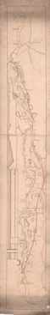
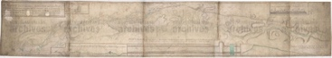
Learning Activities: Plans of Hadrian’s wall, about 1746-1850

Topic: Roman Empire, Hadrian’s Wall
Subject areas: History, Geography, Literacy
Background | Activity | Resources
Hadrian’s Wall spans 80 Roman miles (73 present day miles or 117 kilometres) from coast to coast across northern England, making it the largest Roman archaeological feature in Britain. It runs from Segedunum in Wallsend on the River Tyne in the east, to Bowness-on-Solway in the west.  The Military Road is the name given to the B6318 which runs from Heddon-on-the-Wall in the east to Greenhead in the west. The road runs alongside Hadrian’s Wall for most of its length. | See: How long is Hadrian’s Wall in Roman miles?  See: How long is Hadrian’s Wall in present day measurements?  See: Where is Hadrian’s Wall?  See: What are the Roman names of locations listed on the 1850 map?  See: What are the “now” names of locations listed on the 1850 map?  See: What is the Military Road?  See: What has been cited as one of the most damaging operations to Hadrian’s Wall? | https://www.english-heritage.org.uk/visit/inspire-me/blog/blog-posts/how-to-spot-a-roman-road  https://www.english-heritage.org.uk/visit/places/hadrians-wall/
Think: How big was Hadrian’s Wall when it was built?
Think: How much of Hadrian’s Wall remains today?
Think: Why did the names of locations on Hadrian’s Wall change?
Think: What do the other lines represent on the 1850 plan?
Think: Was the Military Road needed?
Think: How did building the Military Road damage Hadrian’s Wall?
Think: Why were Roman roads straight?
Do: Create a similarities and differences table. Compare the two plans and fill in on your table showing the similarities and differences.
Do: Search the 1746 names of locations on the plan. Can you find the names that these locations are known as today?
Do: Search the 1850s names of locations on the plan. Can you find the names that these locations are known as today?
Do: Create an updated version of the plans. Include the Roman names, 1746 names, 1850s names, and present-day names of locations.
Do: In groups, debate whether it was necessary to damage Hadrian’s Wall while building the Military Road.
Do: Use the plans to come up with alternative ways that the Military Road could have been made in order to preserve Hadrian’s Wall. Create your own plan to show the route you come up with.
Do: Debate whether historic structures such as Hadrian’s Wall should be preserved.
Do: Use Google Maps to find Roman roads in Britain.
Do: Draw diagrams of the Roman roads that you find. What are their main characteristics?

